**Year-End Tax process**

**Standard Tax Process**

* Standard tax flow is in (tax_process_flow.pdf)

**Standard tax folders:**

Processing folder: /d/tax/<CID>

Data files folder: /d/tax/<CID>/datafile/ (The scanned data files must be in this folder before process)

Old process backup folder: /d/tax/<CID>/backup/ (old process files are moved to backup folder)

Archival file folder: /d/pdf_afp/<CID>/<CID>tax/

**Main Scripts:**

**tax_process.sh**

**Purpose**: Main script to process standard tax for all CIDs, Call the pre-processing scripts, Do the format step/ the print step, Create etax/archival files, Call post processing scripts. The required arguments will show when you start process.

**prepare_data_file.sh**

**Purpose:** Calling by tax_process.sh, Decrypt/unzip tax forms, separate one line IRS test data to one account per line, call other scripts: 1099sep_new.pl/ *spec_handle*.pl

**1099sep_new.pl**

**Purpose:** Breaks up 1 big IRS data file into separate smaller data files by form (for1 files).

**tax_get_patterns.pl**

**Purpose:** Translates the pattern for account number, ssn, and/or phone numbers using the database. The database tables are explained under Tax Pattern Tables in IS database section.

**tax_afp2pdf.pl**

**Purpose:** Processing for PDF archival process. It Contain custom index logic to build customized PDF output and PDF index output for clients that require specifically customized PDF (index) output.

**TAX_PDF_DVD.pl**

**Purpose:** Processing for searchable DVD archival clients.

**Customized plug-in processing scripts:**

**Preprocessing scripts for special handling**

**Purpose**: Cross referencing member number/extra fields, adding suppression mail codes, etc.

**Naming convention for all tax forms:** /d/master/prep/<CID>/<CID>_spec_handle.pl

**Naming convention for specific tax forms:** /d/master/prep/<CID>/<CID>_spec_handle_<formType>gen.pl

**Preprocessing scripts for reformatting data**

**Purpose**: Converting other data types (MISA, flat files, XML, etc. ) to IRS data types

**Naming convention**:/d/master/prep/<CID>/<CID>_ reformat_<formType>gen.pl

**Post processing scripts after all process**

**Purpose:** Creating report, copy report to client pickup, etc.

**Naming convention**:/d/master/prep/<CID>/<CID>_post_handle.pl

**Post processing scripts for etax process**

**Purpose:** Duplicate etax index lines to add extra account numbers

**Naming convention**:/d/master/prep/<CID>/<CID>_ etax_post_handle_<formType>gen.pl

**Tax Pattern Tables in IS database**

**Table names:** TAX_PHONE_PATTERN

Purpose: Formatting or hardcoding bank/CU phone# display

**Table names:** TAX_SSN_TIN_TABLE

Purpose: Masking SSN/TIN display for paper display (and/or) e-tax display

**Table names:** TAX_ACCTNUM_MAIN

Purpose: Customized positions for account/suffix numbers , customized criteria for splitting between account# and suffix# (example. by ‘-‘, by postions)

**Table names:** TAX_ACCTNUM_REF

Purpose: This table has CID list and key reference to TAX_ACCTNUM_MAIN table for display and etax/TXT indexing)

**How to update pattern tables:**

The latest pattern entries are in : /d/iss/Terrence/2018_tax/tax_sql/tax_insert_table.sql

Commands to update tables are in: /d/iss/Terrence/2018_tax/tax_sql/command.txt

Follow this to update tables:

1. Copy /d/iss/Terrence/2018_tax/tax_sql/tax_insert_table.sql to /d/iss/Terrence/2018_tax/tax_sql/tax_insert_table_mmddyyyyHHMM.sql (to backup old version)
2. Edit /d/iss/Terrence/2018_tax/tax_sql/tax_insert_table.sql for new updates
3. Run commands in /d/iss/Terrence/2018_tax/tax_sql/command.txt to update prod/parallel/test database

**Where are the Tax Resources?**

Standard taxes do not have CID specific resources. The resources are by tax forms.

The Tax projects are in QA folder (:\qa\TaxYYYY\).

**Standard Tax Control files:**

**Naming convention**: <FormType>gen.control

1042sgen.control 1099agen.control 1099divgen.control 1099oidgen.control 1099sagen.control 5498gen.control 1098egen.control 1099bgen.control 1099igen.control 1099qgen.control 1099sgen.control 5498sagen.control

1098gen.control 1099cgen.control 1099miscgen.control 1099rgen.control 5498esagen.control

**Additional control files:**

tax_acct_mask.control - Using for customized account masking requests

tax_archival_key.control - Using for archival encrypt and zip keys methods

tax_endorsement.control – Using for endorsement flags

tax_infotrac.control - Using for infotrac and OLP flags (Infotrac and OLP are on for all standard tax. Add to this control file, if a client needs to turn off.

tax_zeroFormat.control – Using for customized zero format. If a value is empty, the value will show “.00”. If a client does not like “.00”, then add the value in here.

tax_combine_interest.control - Using for 1099INT aggregate. For the same SSN# and address, 1099I forms can be aggregate into one form (instead of mailing multiple forms).

**Standard Tax DFAs**

**Naming convention**: <FormType>GEN_<YY>.dfa

1042SGEN_17.dfa 1099AGEN_17.dfa 1099DIVGEN_17.dfa 1099OIDGEN_17.dfa 1099SAGEN_17.dfa 5498GEN_17.dfa 1098EGEN_17.dfa 1099BGEN_17.dfa 1099IGEN_17.dfa 1099QGEN_17.dfa 1099SGEN_17.dfa 5498SAGEN_17.dfa 1098GEN_17.dfa 1099CGEN_17.dfa 1099MISCGEN_17.dfa 1099RGEN_17.dfa 5498ESAGEN_17.dfa

**Standard Tax OGL/OVL**

**Naming convention**: <shortFormType><YY><F or B>.OGL / OVL

Overlays for front forms:

09817F.OGL 49817F.OGL 98E17F.OGL 99B17F.OGL 99D17F.OGL 99M17F.OGL 99Q17F.OGL 99S17F.OGL ESA17F.OGL 42S17F.OGL 8SA17F.OGL 99A17F.OGL 99C17F.OGL 99I17F.OGL 99O17F.OGL 99R17F.OGL 9SA17F.OGL

Overlays for backers:

09817B.OGL 49817B.OGL 98E17B.OGL 99B17B.OGL 99D17B.OGL 99M17B.OGL 99Q17B.OGL 99S17B.OGL ESA17B.OGL 42S17B.OGL 8SA17B.OGL 99A17B.OGL 99C17B.OGL 99I17B.OGL 99O17B.OGL 99R17B.OGL 9SA17B.OGL

**Understanding IRS Publications:**

IRS publication includes data mapping, tax forms layouts, backers and new updates. Every year, IRS release new tax publications.

The new releases are in <https://apps.irs.gov/app/picklist/list/formsPublications.html>. You can search by publication numbers or form numbers.

p1220.pdf – This is the main publications for 1098 and 1099 forms

p1187.pdf – This is the 1042s publications.

f1098.pdf, f1099a.pdf, … - These PDFs are for forms layouts and backers

**Important pages in publications:**

**(What’s New for Tax Year XXXX) – This page in p1220.pdf tells the new update for this year.**

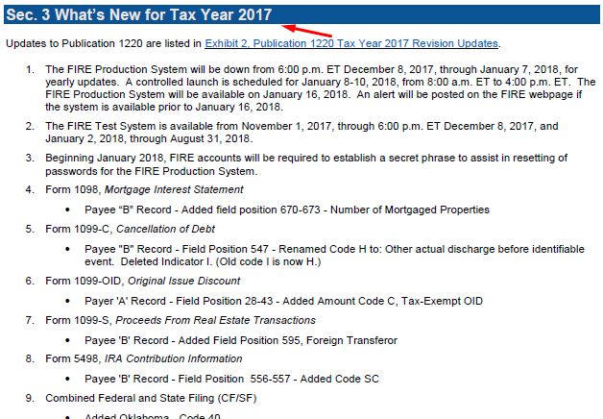

**Payer “A” Record – Record Layout**

Record A (in p1220.pdf) includes bank information/tax form type/Amount type’s information.

Summary for Record A (in p1220.pdf): See detail instructions in publication p1220.pdf

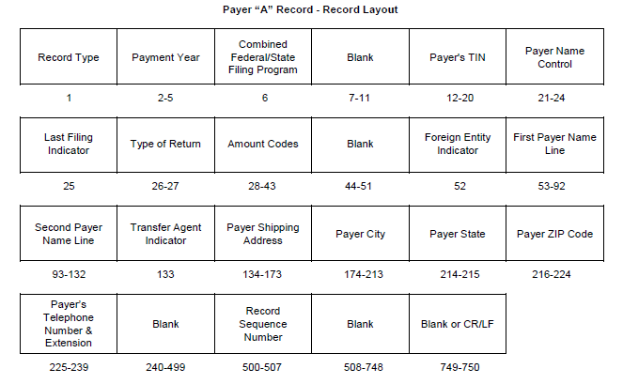

**Payer “B” Record – Record Layout**

Record B (in p1220.pdf) includes individual account information.

Summary for Record B (in p1220.pdf): See detail instructions in publication p1220.pdf

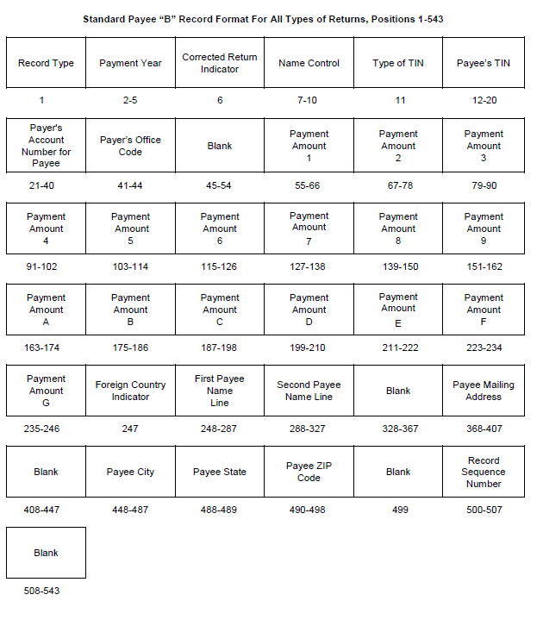

**Payer “W” Record – Record Layout** (for 1042s ONLY)

Record A (in p1187.pdf) includes bank information/tax form type/Amount type’s information.

Summary for Record W (in p1187.pdf): See detail instructions in publication p1187.pdf

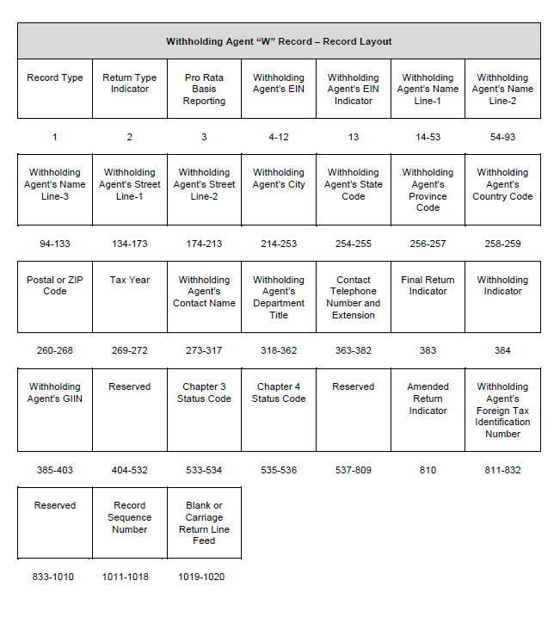

**Payer “Q” Record – Record Layout** (for 1042s ONLY)

Record Q (in p1187.pdf) includes individual account information.

Summary for Record Q (in p1187.pdf): See detail instructions in publication p1187.pdf

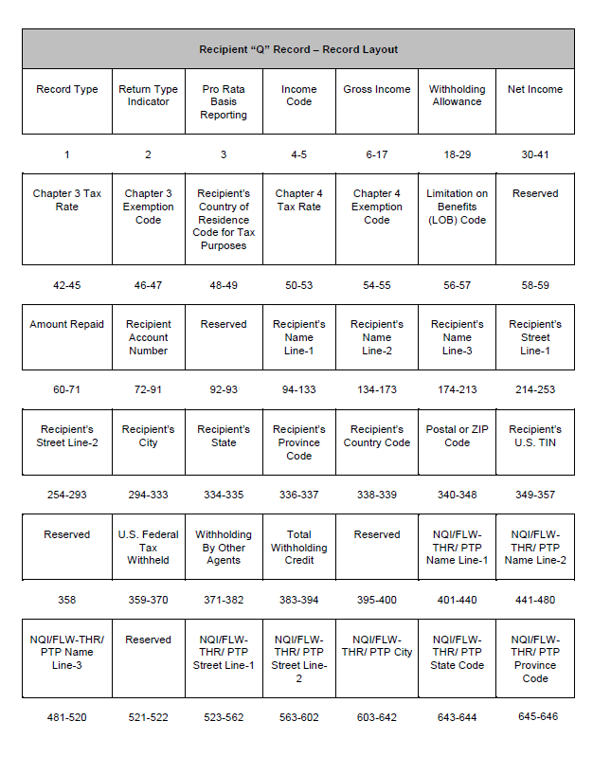

**Non-Standard Tax (Jack Henry)**

The most common non-standard tax format we have is the Jack Henry tax format. Clients using this format send us print image files that we have custom DFAs to handle.

For example, NTSB has NTSBYTAX.dfa and BANB has BANBYTAX.dfa.

These forms are setup like statements.

They have their own processing shell: (example = /home/master/ntsb_yt_process.sh)

They have their own control files following DL structures: (example = /home/control/ntsbyta.control and /home/control/ntsbyt901.control)

They also use their own insert file.

The data file is fed into the DFA similar to how a normal statement is processed.

If you look at the ntsb_yt_process.sh you can see that it does everything normal statement processes do.

**Resources:**

**Non-standard (Jack-Henry) full backers OVL/OGL**

Naming convention: <shortFormType><YY><F or B>.OGL / OVL

098172.OGL 498172.OGL 98E172.OGL 99B172.OGL 99D172.OGL 99M172.OGL 99Q172.OGL 99S172.OGL ESA172.OGL 42S172.OGL 8SA172.OGL 99A172.OGL 99C172.OGL 99I172.OGL 99O172.OGL 99R172.OGL 9SA172.OGL