Mahbub,

I want to clarify a few things:

1.       InfoImage tax forms will not look identical to IRS sample forms. The form’s size and boxes size may be different due to print area and the way we display the information.

2.       I am hoping you can make update to 2015 OGL tax forms and save them for 2016. Changes should be minimum to no change.

3.       During the update, you need to ensure all the boxes are present and the headings are correct. And we should follow the orientation(the order of the boxes) of 2016 tax forms. But the position and size may be different.

4.       There are information on the tax forms we purpose left out from the OGL but being display by the DFA programs.  For example:

PAYER BORROWER NAME, Street Address, City, State, Zip, etc. And I don’t need line between them. Like I said, if you using 2015 OGL for enhancement, you will save a lot of time.

I upload all the standard 2015 DFA, OVL, OGL to JEF # 23738. The name is standard_irs_2015.zip. I have placed them in your client pickup once and I noticed they are not there anymore.

But first, you should import 1099int first. The zip file is inside prj_dfa.zip. This project contains external modules.

Terrence

Mahbub,

I upload test files and DFA /project files onto JEF # 23738 (parent JEF). They are tax_test_data.zip and prj_dfa.zip. We need to integrate the tax form and backer into the DFA. Part of the integration is to align the form and the data. First, import 1099int first. For others, you can just copy the project files and the DFA files.

In general, the PAYER heading are output from DFA not overlay. There are reasons behind this. We done tax for more than 10 years. Our experience tell us it is better to have control for some field at the DFA level. Anytime you see double print, you need to remove them from the overlay. Here is the screen shot for 1098:

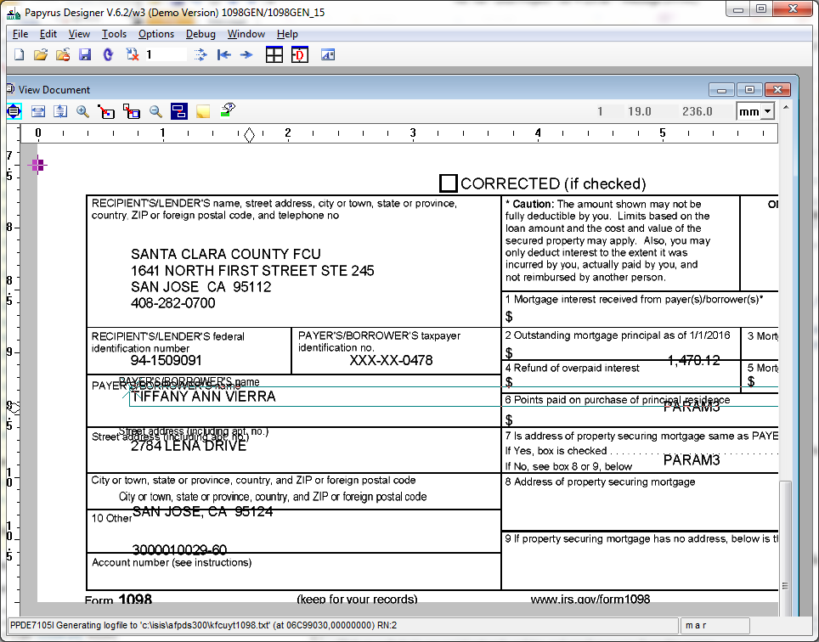

Most of the form just require alignment issues and remove double print heading from the overlay. However, the following form require more works:

1099OID is really off.

1099B require COPY –B only

1099MISC – you might not have enough printing area. Try print the form starting at 3.5 (look for margin). You will need copy 2 and copy b only.

1099R – I don’t know what went wrong here. It is really really off. So I provide you 2015 screen shot.

