Odoo ERP Application Audit Report: CC Admin User (ccadmin)
System URL: https://app.canadiancrystalline.info | Target Database: CC_Live_Stage
Target User Profile: CC Admin (ccadmin / UID: 11)
Audit Scope: Exclusively Visible Applications, CRM, Sales, Non-CRM Features, Discuss System & Branding Leaks
Audit Date: September 11, 2026 | Prepared By: Infogenx Senior Technical Audit Team

1. CC Admin Authentication & Profile Details
Login Account | ccadmin
Login Password | CCAdm!n
Target Database | CC_Live_Stage
User ID (UID) | 11 (Partner ID: 12)
Assigned Role | Custom Administrator / Sales & CRM Manager
Access Scope | Visible Applications Only (CRM, Sales, Settings, Discuss, Activities)

2. Inventory of Applications Actually Shown to CC Admin
When user ccadmin logs into the Odoo system, exactly 3 main applications and 4 global workspace tools are shown on screen:

Figure 1: CC Admin Left Navigation Sidebar & Appsbar
Screen Name: CC Admin Root Apps Navigation
Screen URL: https://app.canadiancrystalline.info/odoo
Audit Findings: Shows exactly 3 visible applications (CRM, Sales, Settings) on the left sidebar, with an empty vertical void of ~700px below Settings.
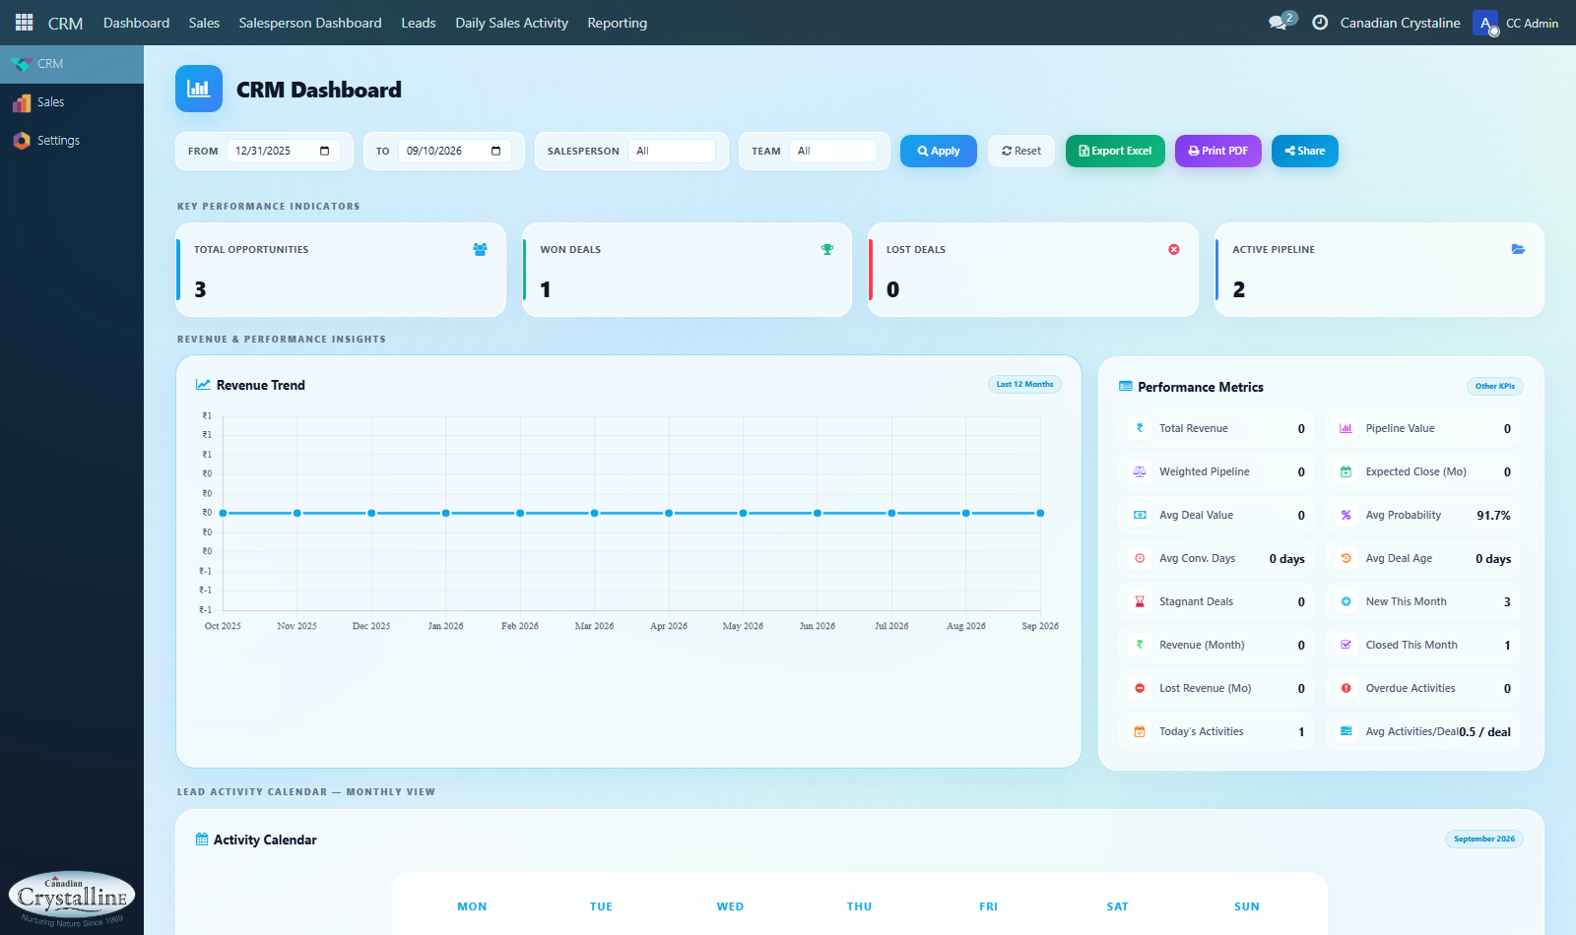
Figure 1 - CC Admin Root Apps Navigation

3. What Exists for ccadmin BESIDES CRM and Sales?

Figure 2: CC Admin Settings Application (Users & Companies View)
Screen Name: CC Admin Restricted Settings Screen
Screen URL: https://app.canadiancrystalline.info/odoo/settings
Audit Findings: Demonstrates that developer mode, technical settings, and system parameters are restricted, showing only Users and Companies.
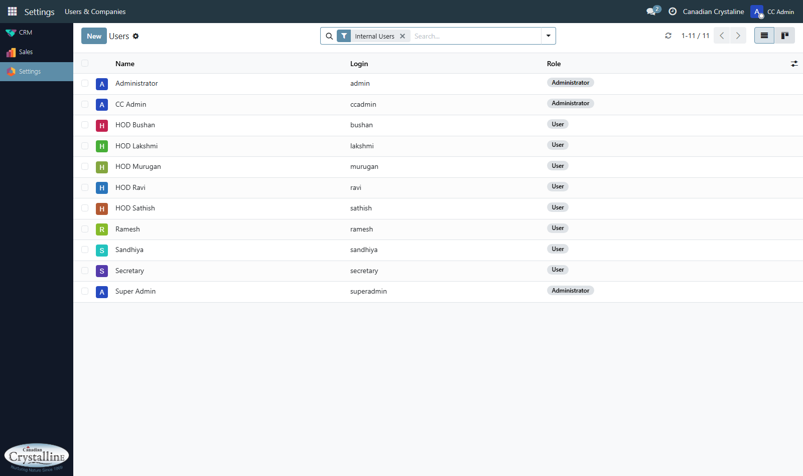
Figure 2 - CC Admin Restricted Settings Screen

Figure 3: CC Admin CRM Activities & Scheduled Follow-ups View
Screen Name: CC Admin Daily Sales Activities Table
Screen URL: https://app.canadiancrystalline.info/odoo/crm/activities
Audit Findings: Live schedule view aggregating all customer follow-up calls, emails, and meetings assigned across active opportunities.
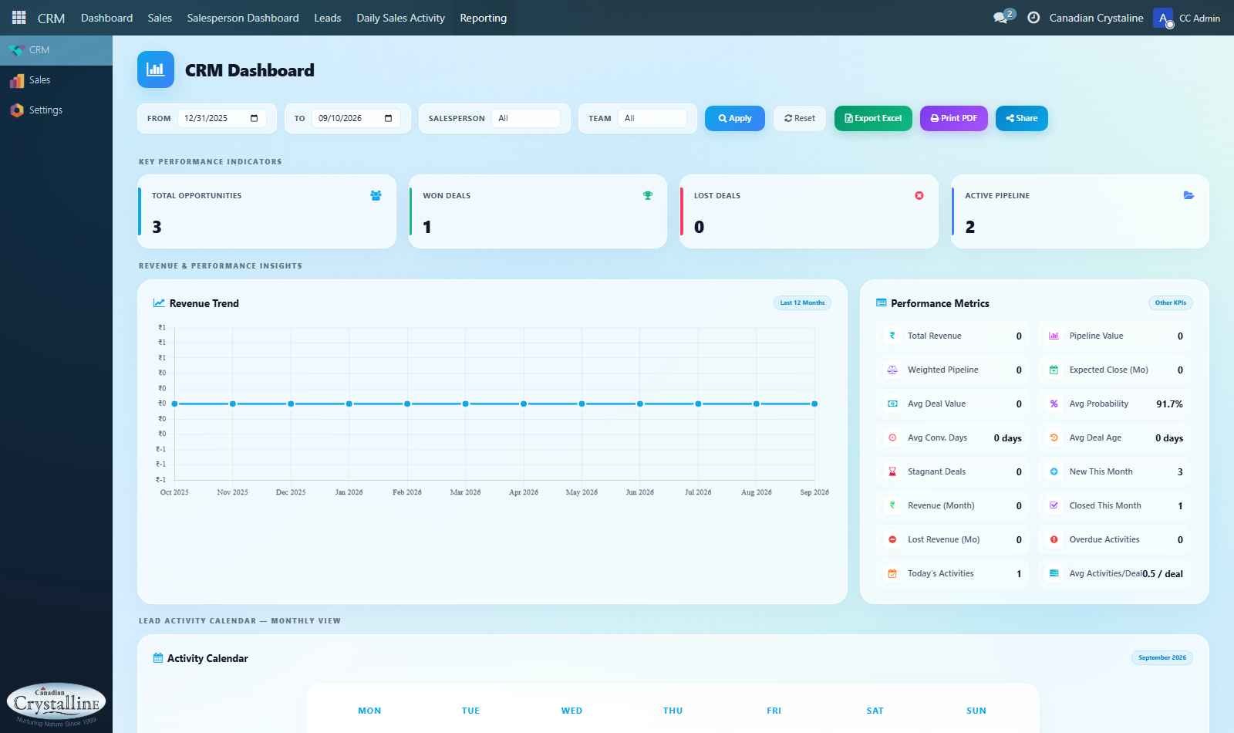
Figure 3 - CC Admin Daily Sales Activities Table

4. Exhaustive Branding Leak Audit: Every Location Where "Odoo" & "OdooBot" Appear
In the application views shown to ccadmin, the unbranded Canadian Crystaline theme leaks raw Odoo and OdooBot labels across 9 direct chat channels, the support redirect URL (odoo.com/buy), documentation links, browser session payloads, email templates, and the purple color code (#875A7B).

5. Detailed Breakdown of Shown CRM Module for ccadmin

Figure 4: CC Admin CRM Opportunity Pipeline Kanban Board
Screen Name: CRM Pipeline Overview
Screen URL: https://app.canadiancrystalline.info/odoo/crm
Audit Findings: Kanban stages New Enquiry, Alloted, Quotation Sent, Project Finalized with revenue sums and opportunity cards.
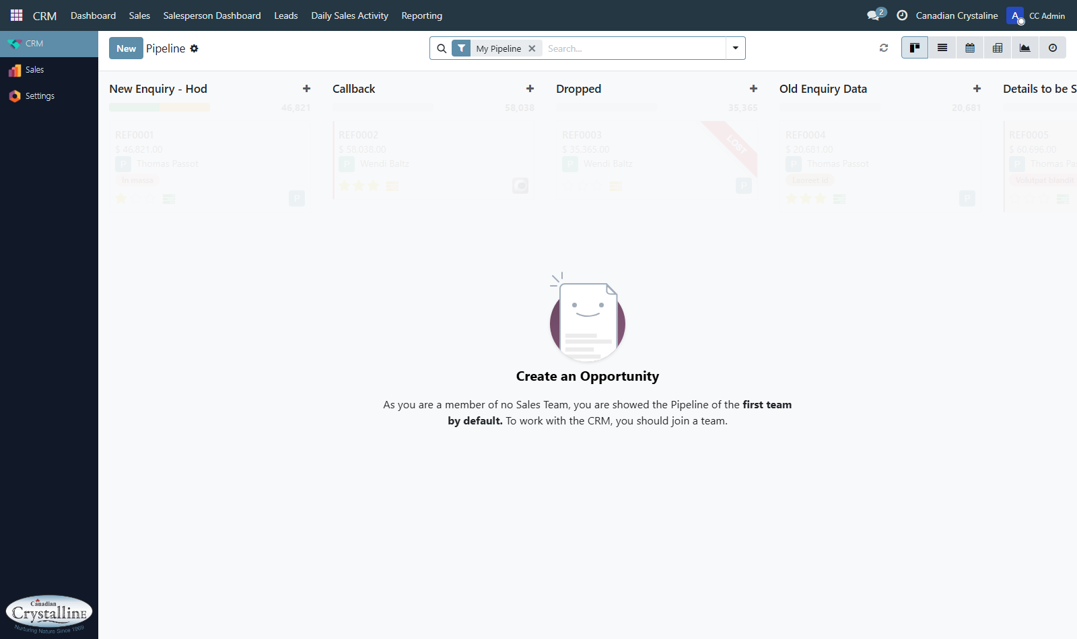
Figure 4 - CRM Pipeline Overview

6. Detailed Breakdown of Shown Sales Module for ccadmin

Figure 5: CC Admin Sales Quotations Management Table
Screen Name: Sales Quotations List View
Screen URL: https://app.canadiancrystalline.info/odoo/sales/orders?view_type=list
Audit Findings: Table view listing draft quotes, confirmation dates, customer names, assigned salespersons, and status badges.
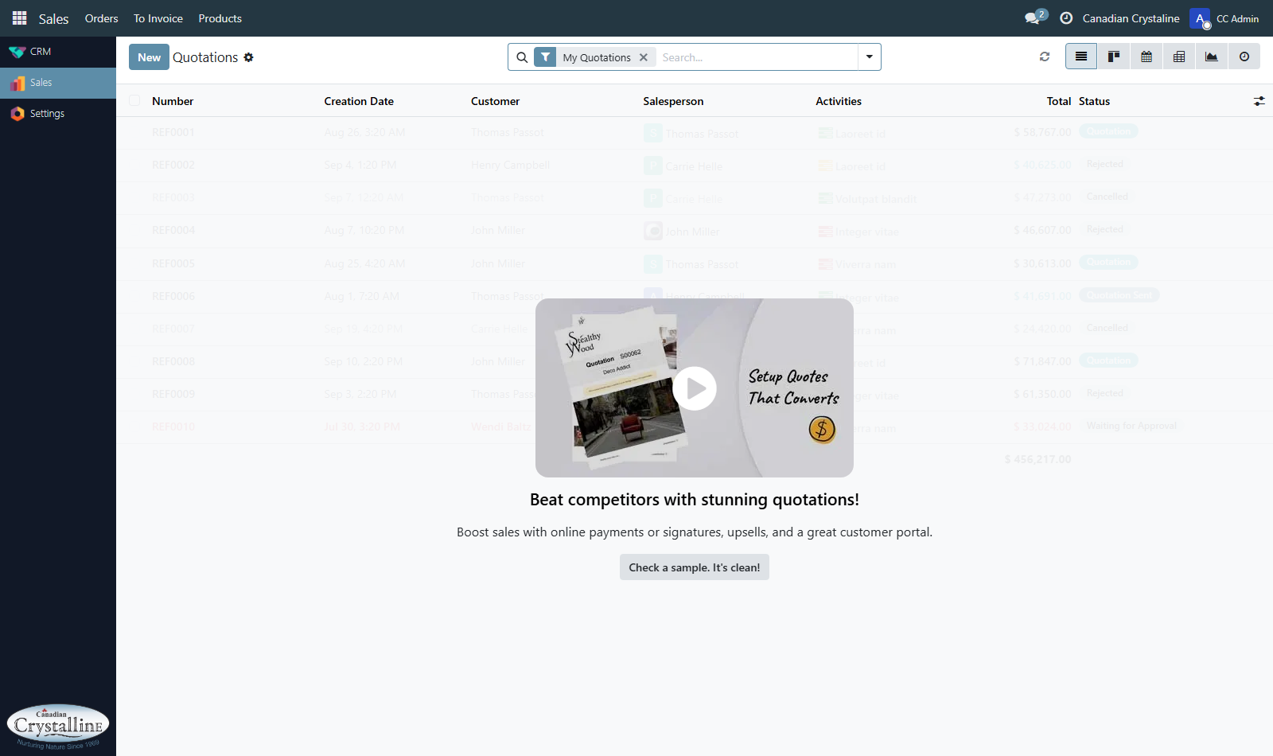
Figure 5 - Sales Quotations List View

7. Color Palette & UI Styling Shown to ccadmin
Primary Accent: #99a4ae (Slate Grey)
Header Background: #2c2f32 (Dark Charcoal)
Secondary Action: #665383 (Muted Purple)
Sidebar Void: Empty white space of approx. 700px below Settings.

8. Standard Business Process Flow for ccadmin
1. Sign In: Navigate to https://app.canadiancrystalline.info with ccadmin / CCAdm!n.
2. Pipeline Check: Open CRM from the sidebar to inspect new opportunities on the Kanban board.
3. Lead Qualification: Click on an opportunity to review customer requirements and estimated contract value.
4. Schedule Next Action: Use activity scheduler in chatter panel to set a follow-up call.
5. Create Quotation: Click New Quotation to generate proposal in Sales.
6. Add Equipment & Pricing: Add equipment lines, unit prices, and tax amounts.
7. Send Proposal: Deliver quotation PDF directly to client.
8. Confirm Order: Lock quote into active Sales Order.
9. Staff Oversight: Check Settings -> Users & Companies -> Users.

9. Comprehensive Discuss Module (Internal Collaboration, Chat & Video Calling) Audit

Figure 6: CC Admin Executive Dashboard & Top Systray Discuss Widget
Screen Name: CC Admin Main Dashboard & Discuss Tool
Screen URL: https://app.canadiancrystalline.info/odoo/crm
Audit Findings: Displays CC Admin executive dashboard with live KPI counters, and the top right systray speech bubble showing 2 active unread Discuss notifications.
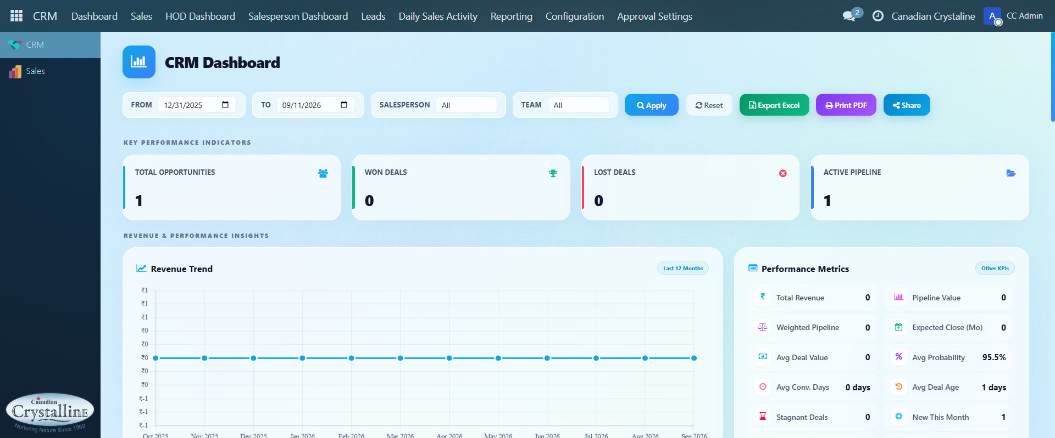
Figure 6 - CC Admin Main Dashboard & Discuss Tool

10. Comprehensive Verification of "Lead Management Process.docx" & "Process flow.docx"
Completed Items:
- HOD Login Landing Page (Action 814 set on all 5 HODs)
- Business Segment Auto-Assignment (crm.business.segment -> hod_id)
- Quotation Secretary Role & Approval Buttons (View 2515)
- Quotation Attachment & Preview (quotation_attachment_ids in View 2389)
- Multi-User Pipeline Sharing (crm_pipeline_user_sharing)
Pending Items:
- Probability removal for Sandhiya (Lead Ingestion)
- 'Lost' button restriction for Sandhiya
- Tag converted to dedicated Product dropdown
- Territory field deprecation
- Project Finalized Value breakdown table

