# B.M.S. College of Engineering

## (Autonomous Institution affiliated to VTU, Belagavi)

**Bengaluru – 19**

**Department of Computer Science and Engineering**



# Verilog Program List

### 19CSPC34

Laboratory Manual

(AUTONOMOUS SCHEME 2019)

**SUBMITTED BY:**

1. **SARVESHMURTHY ANJANAMURTHY N (1BM18CS144)**
2. **SOUNDARYA LAKSHMI ANAND (DIP)**
3. **SWATHI V (DIP)**
4. **MD YASEEN AHMED (DIP)**
5. **TRIVENI Y (DIP)**

**B.M.S. College of Engineering**

***(Autonomous Institution affiliated to VTU, Belagavi)***

**Bengaluru - 19**

**Department of Computer Science and Engineering**



**Laboratory Certificate**

#### This is to certify that Mr. SARVESHMURTHY ANJANAMURTHY N

**has satisfactorily completed the course of Experiments in Practical prescribed by the Department during the year**  **2019 - 2020**

**Name of the Candidate:**  **SARVESHMURTHY ANJANAMURTHY N**

**USN No.: 1BM18CS144 Semester: 3rd**

|  |  |
| --- | --- |
| **Marks** | |
| **Max. Marks** | **Obtained** |
| **10** |  |

**Marks in Words**

**Signature of the staff in-charge Head of the Department Date:**

**B.M.S. College of Engineering**

***(Autonomous Institution affiliated to VTU, Belagavi)***

**Bengaluru - 19**

**Department of Computer Science and Engineering**



**Laboratory Certificate**

**This is to certify that Mr.**  **SOUNDARYA LAKSHMI ANAND**

**has satisfactorily completed the course of Experiments in Practical prescribed by the Department during the year**  **2019 - 2020**

**Name of the Candidate:**  **SOUNDARYA LAKSHMI ANAND**

**USN No.: Semester: 3rd**

|  |  |
| --- | --- |
| **Marks** | |
| **Max. Marks** | **Obtained** |
| **10** |  |

**Marks in Words**

**Signature of the staff in-charge Head of the Department Date:**

**B.M.S. College of Engineering**

***(Autonomous Institution affiliated to VTU, Belagavi)***

**Bengaluru - 19**

**Department of Computer Science and Engineering**



**Laboratory Certificate**

**This is to certify that Mr.**  **SWATHI V**

**has satisfactorily completed the course of Experiments in Practical prescribed by the Department during the year**  **2019 - 2020**

**Name of the Candidate:**  **SWATHI V**

**USN No.: Semester:**  **3rd**

|  |  |
| --- | --- |
| **Marks** | |
| **Max. Marks** | **Obtained** |
| **10** |  |

**Marks in Words**

**Signature of the staff in-charge Head of the Department Date:**

**B.M.S. College of Engineering**

***(Autonomous Institution affiliated to VTU, Belagavi)***

**Bengaluru - 19**

**Department of Computer Science and Engineering**



**Laboratory Certificate**

**This is to certify that Mr. MD YASEEN AHMED**

**has satisfactorily completed the course of Experiments in Practical prescribed by the Department during the year**  **2019 - 2020**

**Name of the Candidate:**  **MD YASEEN AHMED**

**USN No.: Semester: 3rd**

|  |  |
| --- | --- |
| **Marks** | |
| **Max. Marks** | **Obtained** |
| **10** |  |

**Marks in Words**

**Signature of the staff in-charge Head of the Department Date:**

**B.M.S. College of Engineering**

***(Autonomous Institution affiliated to VTU, Belagavi)***

**Bengaluru - 19**

**Department of Computer Science and Engineering**



**Laboratory Certificate**

**This is to certify that Mr. TRIVENI Y**

**has satisfactorily completed the course of Experiments in Practical prescribed by the Department during the year**  **2019 - 2020**

**Name of the Candidate: TRIVENI Y**

**USN No.: Semester: 3rd**

|  |  |
| --- | --- |
| **Marks** | |
| **Max. Marks** | **Obtained** |
| **10** |  |

**Marks in Words**

**Signature of the staff in-charge Head of the Department Date:**

**Verilog Program List**

**19CSPC34**

Laboratory Manual

|  |  |
| --- | --- |
| **Serial No.** | **Title** |
|  | **CYCLE I**  **Structural Modeling** |
| 1. | Write HDL implementation for the following Logic  a. AND/OR/NOT  Simulate the same using structural model and depict the timing diagram for valid inputs. |
| 2. | Write HDL implementation for the following Logic  a. NAND/NOR  Simulate the same using structural model and depict the timing diagram for valid inputs. |
| 3. | Write HDL implementation for the following Logic  Simulate the same using structural model and depict the timing diagram for valid inputs. |
| 4. | Write HDL implementation for a 4:1 Multiplexer. Simulate the same using structural model and depict the timing diagram for valid inputs. |
| 5. | Write HDL implementation for a 2-to-4 decoder. Simulate the same using structural model and depict the timing diagram for valid inputs. |
| 6. | Write HDL implementation for a 4-to-2 encoder. Simulate the same using structural model and depict the timing diagram for valid inputs. |

|  |  |
| --- | --- |
|  |  |
|  | **CYCLE II**  **Behavior Modeling** |
| 7. | Write HDL implementation for a RS flip-flop using behavioral model. Simulate the same using Behavior model and depict the timing diagram for valid inputs. |
| 8. | Write HDL implementation for a JK flip-flop using behavioral model. Simulate the same using Behavior model and depict the timing diagram for valid inputs. |
| 9. | Write HDL implementation for a 4-bit right shift register using behavioral model. Simulate the same using Behavior model and depict the timing diagram for valid inputs. |
| 10. | Write HDL implementation for a 3-bit up-counter using behavioral model. Simulate the same using Behavior model and depict the timing diagram for valid inputs. |
|  | **CYCLE III**  **Dataflow Modeling** |
| 11. | Write HDL implementation for AND/OR/NOT gates using data flow model. Simulate the same using Dataflow model and depict the timing diagram for valid inputs. |
| 12. | Write HDL implementation for a 3-bit full adder using data flow model. Simulate the same using Dataflow model and depict the timing diagram for valid inputs. |

**Verilog Program List-19CSPC34**

**SCHEME OF CONDUCT AND EVALUATION**

**CLASS: III SEMESTER YEAR: 2019-20**

**EVALUATION SCHEME Tutorial Test: 1 hour**

|  |  |  |  |  |
| --- | --- | --- | --- | --- |
| **Expt. No.** | **TITLE** | Max. Marks | **Marks Obtained** | **Signature** |
| 1. | K-Map and Quine Mcclusky Method | 2 |  |  |
| 2. | AND/OR/NOT | 3 |  |  |
| 3. | NAND/NOR |  |
| 4. | Logic diagram |  |
| 5. | Multiplexer |  |
| 6. | Decoder |  |
| 7. | Encoder |  |
| 8. | RS |  |
| 9. | JK |  |
| 10. | Shift right |  |
| 11. | Counter |  |
| 12. | AND/OR/NOT – data flow |  |
| 13. | 3-bit full adder |  |
|  | **Test: Viva – 2 Marks + Writeup – 1 Mark + Execution – 2**  **Marks** | 5 |  |  |
|  | **TOTAL MARKS** | 10 |  |  |
|  |  | |  |  |

#### Verilog Program List-19CSPC34

**Rubrics**

|  |  |  |  |  |  |  |
| --- | --- | --- | --- | --- | --- | --- |
| **Sl.No** | **Criteria** | **Excellent** | **Good** | **Average** | **Poor** | **Max Score** |
|  |  | | | | | |
| A | Design & specifications | 1 | 0.5 | 0.25 | **0** | **1** |
| B | Expected output | 2 | 1 | 0.5 | **0** | **2** |
|  | **Record** | | | | | |
| C | Simulation/ Conduction of  the experiment | 3 | 2 | 1 | **0** | **3** |
| D | K-Map and Quine Mcclusky  Method | 2 | 1 | 0.5 | **0** | **2** |
| **Viva** | | | | |  | **2** |
| **Total** | | | | |  | **10** |
|  |  | | | | | |

**STRUCTURAL MODELING**

**Experiment 1**

1. Write HDL implementation for the following Logic
   1. AND/OR/NOT

Simulate the same using structural model and depict the timing diagram for valid inputs.

**MAIN MODULE (OR GATE GIVEN)**

**module or_gate(A,B,Y);**

input A,B; // *defines two input port* output Y; // *defines one output port* or g1(Y,A,B);

/\**Gate declaration with predefined keyword or representing logic OR, g1 is optional user defined gate identifier* */

**endmodule**

**module testor;**

reg A,B; wire x;

or_gate org(A,B,x); initial

begin

A= 1’b0; B=1’b0; #20

A= 1’b0; B=1’b1; #20

A= 1’b1; B=1’b0; #20

A= 1’b1; B=1’b1; #20

$finish; end

**endmodule**

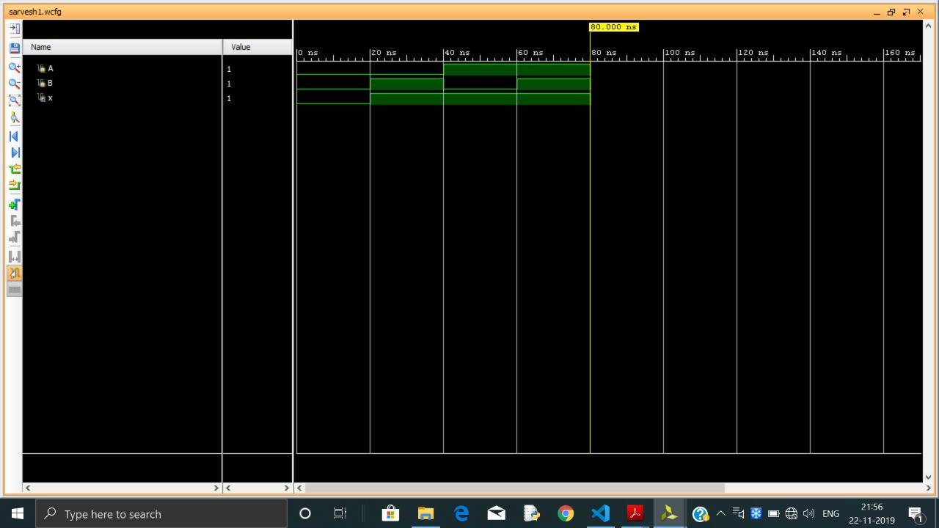

**Experiment 2**

Write HDL implementation for the following Logic

a. NAND/NOR

Simulate the same using structural model and depict the timing diagram for valid inputs.

**MAIN MODULE(FOR NAND GATE)**

**module nand_gate(A,B,Y);**

input A,B;

// *defines two input port*

output Y;

// *defines one output port* nand g1(Y,A,B); **endmodule**

**TEST MODULE**

**module testnand;**

reg A,B; wire x;

nand_gate nandg(A,B,x); initial

begin

A= 1’b0; B=1’b0; #20

A= 1’b0; B=1’b1; #20

A= 1’b1; B=1’b0; #20

A= 1’b1; B=1’b1; #20

$finish; end

**endmodule**

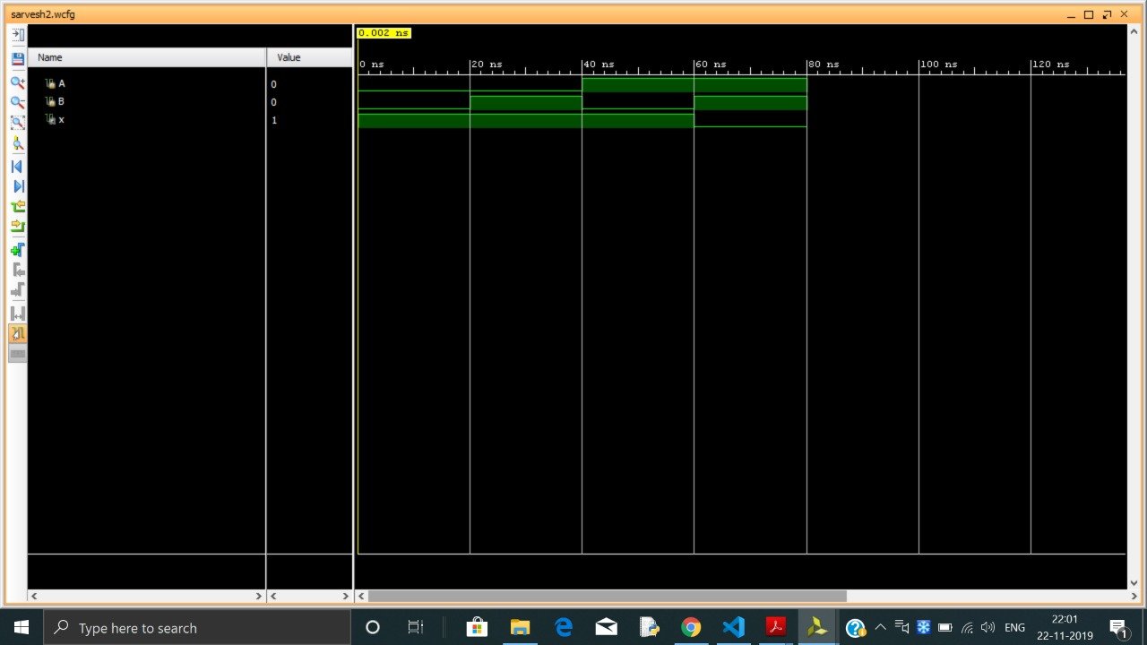

**Experiment 3**

Write HDL implementation for the following Logic

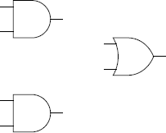

Simulate the same using structural model and depict the timing diagram for valid inputs.

**MAIN MODULE**

**module** addor(A,B,C,D,Y);

**input** A,B,C,D;

**output** Y;

**wire** and_opl, and_op2; **and** gl(and_opl,A,B); **and** g2(and_op2,C,D);

*// g2 represents lower A.ND*

**or** g3(Y,and_opl,and_op2);

// *g3 represents the OR gate*

**endmodule TEST MODULE**

module test andor; reg a,b,c,d;

wire y;

addor ao(a,b,c,d,y); initial

begin

a=0; b=1; c=1; d=1; #10 a=0; b=0; c=1; d=0; #10

$finish; end

endmodule

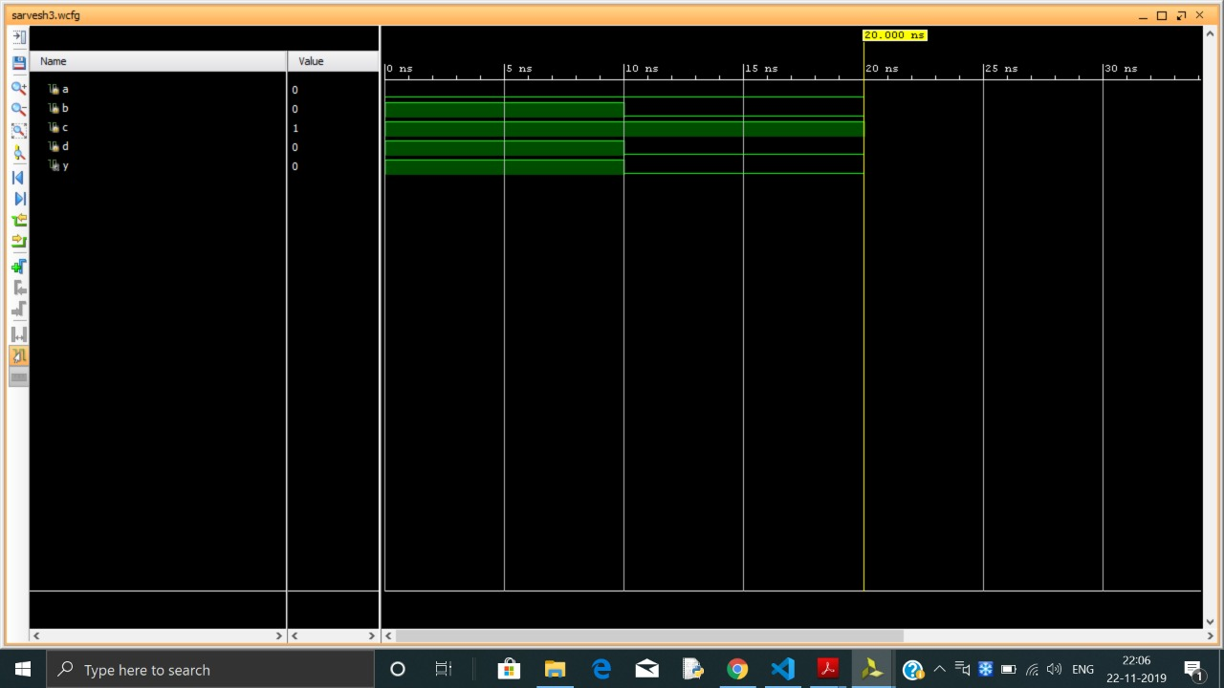

**Experiment 4**

Write HDL implementation for a 4:1 Multiplexer. Simulate the same using structural model and depict the timing diagram for valid inputs.

**MAIN MODULE**

**module** Multiplexer4to1(Do, Din, En); input En;

input [3:0] Din; output Do;

reg [1:0]Do;

always @ (En or Din) begin

if (En) begin case (Din)

4'b0001: Do = 2’b00;

4'b0010: Do = 2’b01;

4'b0100: Do = 2’b10;

4'b1000: Do = 2’b11;

default: Do=2'bzz; endcase

end end

endmodule

#### TESTBENCH MODULE

**module** multiplexer_tb; reg [3:0] Din;

reg En; wire Do;

Multiplexer4to1 mux(

);

.Do(Do),

.Din(Din),

.En(En)

initial begin

// Initialize Inputs En = 1;

Din = 4'b0001; #100; Din = 4'b0010; #100; Din = 4'b0100; #100; Din = 4'b1000; #100;

end

endmodule

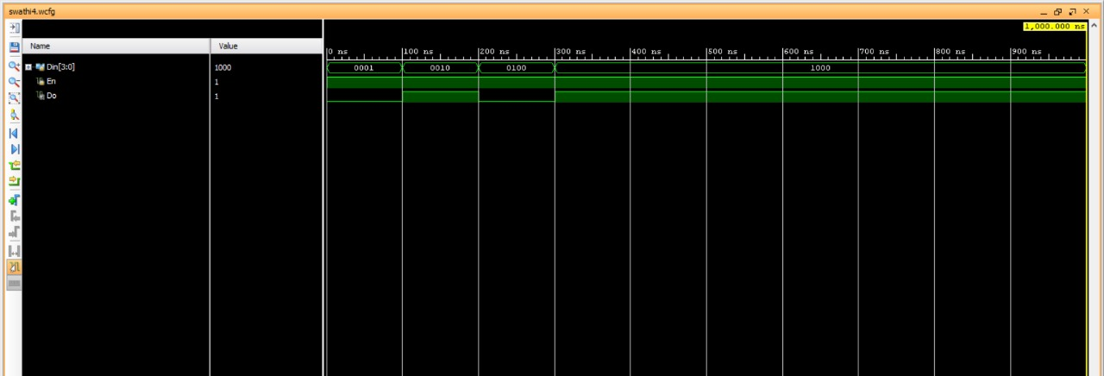

**Experiment 5**

Write HDL implementation for a 2-to-4 decoder. Simulate the same using structural model and depict the timing diagram for valid inputs.

**MAIN MODULE**

**module** decoder_case(Do, Din, En); input En;

input [1:0] Din; output [3:0]Do;

reg [3:0]Do;

always @ (En or Din) begin

if (En) begin case (Din)

default: Do=4'bzzzz; endcase

end end

endmodule

2'b00: Do = 4'b0001;

2'b01: Do = 4'b0010;

2'b10: Do = 4'b0100;

2'b11: Do = 4'b1000;

#### TEST BENCH MODULE

**module** decoder_tb_v; reg [1:0] Din;

reg En;

wire [3:0] Do;

**decoder_case** uut(

.Do(Do),

.Din(Din),

.En(En)

);

initial begin

// Initialize Inputs En = 1;

Din =2'b00; #100; Din = 2'b01; #100; Din = 2'b10; #100;

Din = 2'b11; #100;

end

endmodule

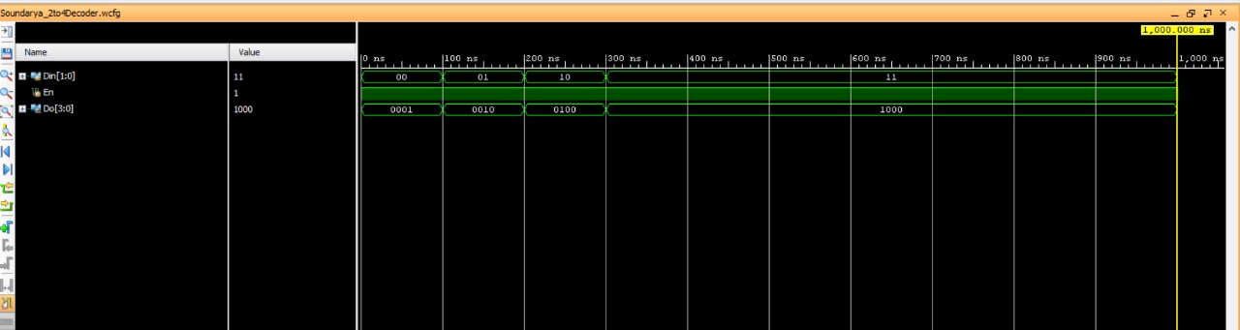

**Experiment 6**

Write HDL implementation for a 4-to-2 encoder. Simulate the same using structural model and depict the timing diagram for valid inputs.

**MAIN MODULE**

**module** Encoder(Do, Din, En); input En;

input [3:0] Din; output [1:0]Do;

reg [1:0]Do;

always @ (En or Din) begin

if (En) begin case (Din)

4'b0001: Do = 2'b00;

4'b0010: Do = 2'b01;

4'b0100: Do = 2'b10;

4'b1000: Do = 2'b11;

default: Do=2'bzz; endcase

end end

endmodule

#### TESTBENCH MODULE

**module** encoder_tb_v; reg [3:0] Din;

reg En;

wire [1:0] Do;

**Encoder** uut(

.Do(Do),

.Din(Din),

.En(En)

);

initial begin

// Initialize Inputs En = 1;

Din = 4'b0001; #100; Din = 4'b0010; #100; Din = 4'b0100; #100;

Din = 4'b1000; #100;

end

endmodule

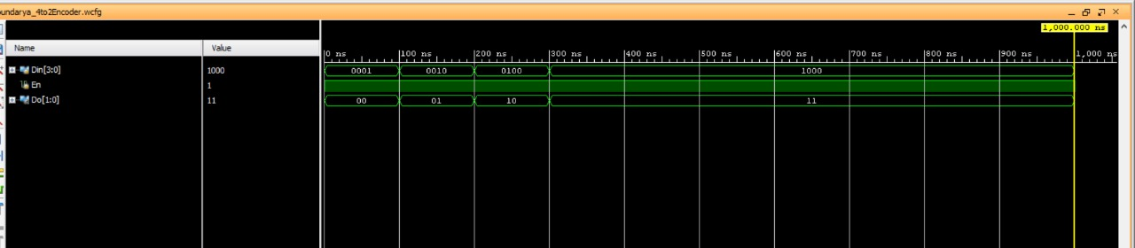

**BEHAVIOR MODELING**

**Experiment 7**

Write HDL implementation for a SR flip-flop using behavioral model. Simulate the same using behavioral model and depict the timing diagram for valid inputs.

**MAIN MODULE**

module SR_FF (sr, clk, q, qb); input [1:0] sr;

input clk;

output reg q=1'b0; output reg qb;

always @ (posedge clk) begin

case (sr)

endcase end

endmodule

2'b00 : q = q ;

2'b01 : q = 1'b0 ;

2'b10 : q = 1'b1 ;

2'b11 : q = 1'bz ; qb =~ q;

**TEST MODULE**

module testsrflipf; reg [1:0] A;

reg c;

wire x, xb;

SR_FF srff(A,c,x,xb); initial c=1'b0;

always #5 c=~c; initial

begin

A=2'b00; #10 A=2'b01;#10 A=2'b10;#10 A=2'b11;

#20 $finish; end

endmodule

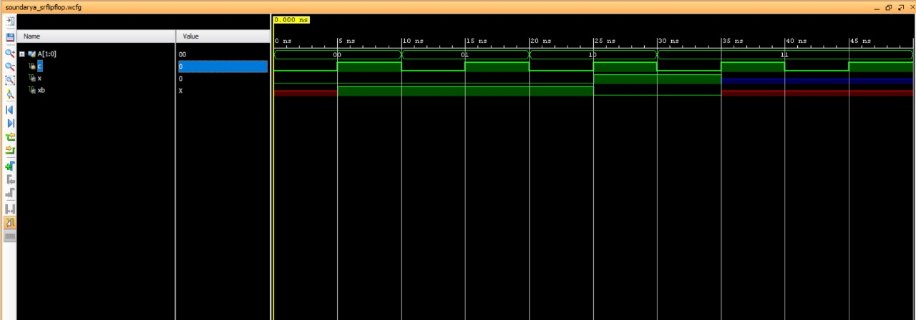

**Experiment 8**

Write HDL implementation for a JK flip-flop using behavioral model. Simulate the same using behavioral model and depict the timing diagram for valid inputs.

#### MAIN MODULE

module JK_FF (jk, clk, q, qb); input [1:0] jk;

input clk;

output reg q=1'b0; output reg qb;

always @ (posedge clk) begin

case (jk)

endcase

2'b00 : q = q ; 2'b01 : q = 1'b0 ;

2'b10 : q = 1'b1 ;

2'b11 : q = ~q ;

end endmodule

qb =~ q;

**TEST MODULE**

module testjkflipf; reg [1:0] A;

reg c;

wire x, xb;

JK_FF jkff(A,c,x,xb); initial c=1'b0;

always #5 c=~c; initial

begin

A=2'b00; #10 A=2'b01;#10 A=2'b10;#10 A=2'b11;

#20 $finish; end

endmodule

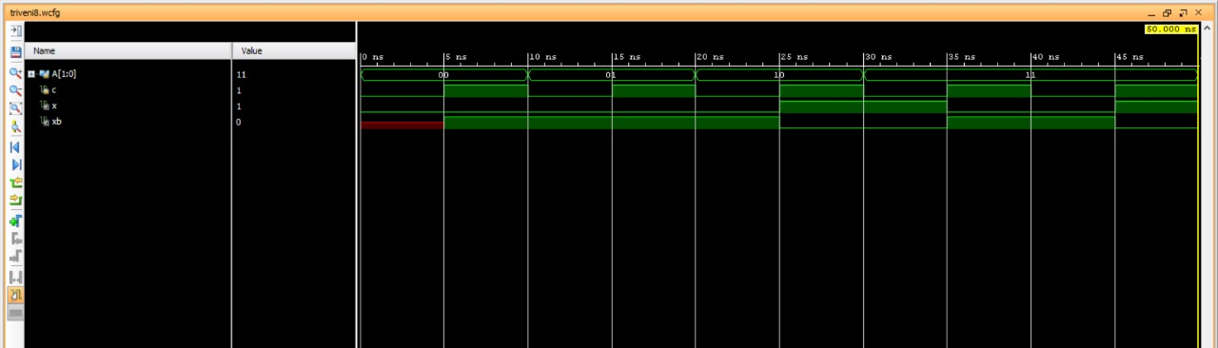

**Experiment 9**

Write HDL implementation for a 4-bit right shift register using behavioral model. Simulate the same using behavioral model and depict the timing diagram for valid inputs.

**MAIN MODULE**

module Rshiftregister( input clk, input clrb, input SDR, output reg [3:0] Q );

//serial in, parallel out

always @ ( posedge(clk), negedge(clrb))

if (~clrb) Q<=4'b0000; else

Q<={SDR,Q[3:1]};

endmodule

**TEST MODULE**

module testRshiftregister; reg clk,clrb,SDR;

wire [3:0]Q;

Rshiftregister RS(clk, clrb, SDR, Q ); initial

begin

clk =1; clrb=0;

SDR=1;

#100

clrb=1; SDR=1; #150 SDR=0;

#200 $finish; end

//initial and always run in parallel and starts its execution at 0ns always #5 clk=~clk;

endmodule

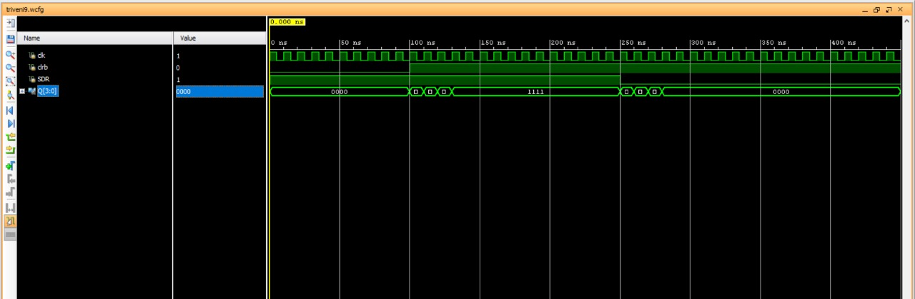

**Experiment 10**

Write HDL implementation for a 3-bit up-counter using behavioral model. Simulate the same using behavioral model and depict the timing diagram for valid inputs.

#### Main Module

module counter_behav ( count,rst,clk); input rst, clk;

output reg [2:0] count; always @(posedge (clk)) if (rst)

count<= 3'b000; else

count<= count + 1; endmodule

#### TEST MODULE

module testmod; reg r,c;

wire [2:0] ct;

counter_behav countbeh (ct,r,c); initial

begin

r =1;

c=0; #100 r=0;

#200 $finish; end

//initial and always run in parallel and starts its execution at 0ns always #5 c=~c;

endmodule

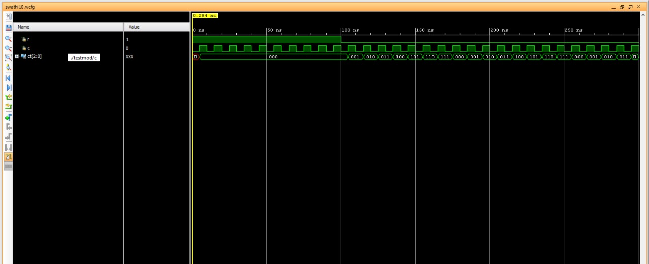

**DATA FLOW MODELING**

**Experiment 11**

Write HDL implementation for AND/OR/NOT gates using data flow model. Simulate the same using data flow model and depict the timing diagram for valid inputs.

#### MAIN MODULE

module gates(input a, b, output [2:0]y); assign y[2]= a & b; // AND gate

assign y[1]= a | b; // OR gate assign y[0]= ~a; // NOT gate endmodule

#### TESTBENCH MODULE

modulegates_tb; wire [2:0]y;

reg a, b;

gatesdut(.y(y), .a(a), .b(b)); initial

begin

a = 1'b0; b = 1'b0; #50;

a = 1'b0; b = 1'b1; #50;

a = 1'b1; b = 1'b0; #50;

a = 1'b1; b = 1'b1; #50;

end endmodule

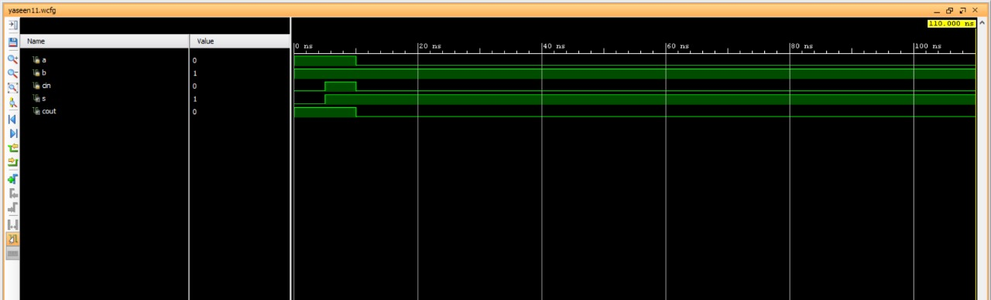

**Experiment 12**

Write HDL implementation for a 3-bit full adder using data flow model. Simulate the same using data flow model and depict the timing diagram for valid inputs.

**MAIN MODULE**

module fa(a,b,cin,s,cout); input a,b,cin;

output s,cout; assign s =a^b^cin;

assign cout = (a&b) | (b&cin) | (cin&a); endmodule

**TEST MODULE**

module fa_test; reg a,b,cin; wire s, cout;

fa f1(a,b,cin,s,cout); initial

begin

a=1; b=1; cin=0; #5

a=1; b=1; cin=1; #5

a=0; b=1; cin=0; #100 $finish;

end endmodule

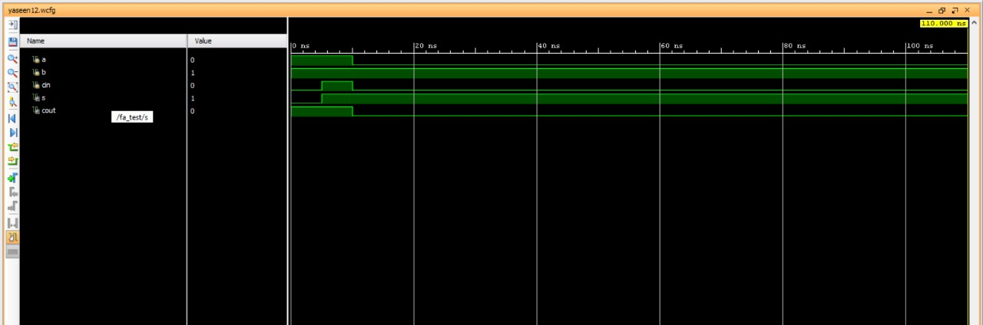

**Signature of the staff in-charge**