BMS COLLEGE OF ENGINEERING

Department of CSE

Course Title: **Object Oriented Java Programming**  Semester : **III**

Course Code: **19CS3PCOOJ**

**Exercises for Lab Test - 1**

1. Imagine a publishing company that markets both book and audiocassette. The company uses the publication class to store the title (a string) and price (type double) of a publication.

The publication class is extended by two other classes: book and tape. The book class contains the member variable page_count (type int), and the tape class contains the member variable playing_time (type double). Ask the user to fill in data with getdata() and then display the data with putdata( ). Create m book objects and n tape objects. Display details of the book that has more than 500 pages.

2. Write a Java program to create a class series that can be of two types – ap (arithmetic progression) and gp (geometric progression). Class series should have two functions – getValues() and getNterm(){nth term of that series} which are further implemented in classes ap and gp. In main() create an array of n references  to series which can be either ap or gp depending on user’s choice. Generate ‘n’ term() and calculate the sum.

3. Create a class Solid that defines the abstract member functions Calculate_area() and Calculate_volume(). The class Solid will be extended by cylinder, cone and sphere classes.

1. Cylinder: Volume: 2πrh, Surface area: 2πrh +πr2

2. Cone: Volume: πr2h/3 Surface area: πr(r+√h2+r2)

3. Sphere: Volume: (4/3) πr3 Area: 4 πr2

Show that the reference variable of Solid class can invoke the member functions Calculate_area() and Calculate_volume().

4. Write a java program to create a class **Student** whose data members are usn, name and phoneno. Derive a class **Marks** from Student to include an array of CIE marks and an array of SEE marks of each course and their corresponding credits in another array. Derive a class Result which calculates the grade for each course. Create n students objects and then display the above details of students who have scored better in SEE compared to CIE.

5. Write a Java program to create a class PLAYER with instance variables name, matches_played and average. This class has an abstract method cal_average(String,int,int). String:name, int:matches-played, int:average. Derive two classes BATSMAN and BOWLER from PLAYER. Class BATSMAN has an instance variable runs_scored. Class BOWLER has an instance variable runs_given. Create m BATSMAN objects and n BOWLER objects. Calculate and display the average runs scored by each BATSMAN and average runs given by each BOWLER.

6. Develop a Java Program to create a class EMPLOYEE with data member: empno,name. Derive two classes REGULAR with data member regular_pay and another class OVERTIME from class REGULAR with data member: addn_pay. Include a method in OVERTIME that calculate the total pay by adding the above two. Create n OVERTIME objects. Display the details of employees who have earned more in overtime than the regular pay.

7. Develop a Java program to create a class Personal to hold details like name, age, department. Derive a class Student from Personal which has the data member- cgpa. Derive another class Faculty from Personal which has the data member- no_publications. Create n Student and m Faculty objects. Accept and display their details. Display the name of the youngest student. Display the details of the faculty with maximum number of publications.

8. An educational institution wishes to maintain a database of its employees. The database is divided into number of classes whose hierarchical relationships are shown in the figure given below.

|  |
| --- |
| STAFF |
| CODE,  NAME |

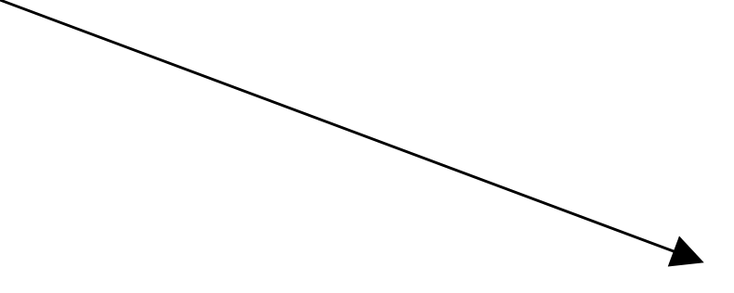

|  |
| --- |
| TEACHER |
| SUBJECT |
| TYPIST |
| SPEED |

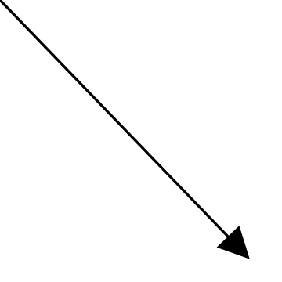

|  |
| --- |
| OFFICER |
| GRADE |
| REGULAR |
|  |
| CASUAL |
| DAILY WAGES |

Include methods to store and retrieve employee data as and when required. Count the number of typist objects created using static variables. Display the details of the officer requested by the user given the grade.

|  |
| --- |
| Develop a Java program to create an abstract class named Shape that contains two integers and an empty method named printArea( ). Provide three classes named Rectangle, Triangle and Circle such that each one of the classes extends the class Shape. Each one of the classes contain only the method printArea( ) that prints the area of the given shape. |
| Develop a Java program to create a class Bank that maintains two kinds of account for its customers, one called savings account and the other current account. The savings account provides compound interest and withdrawal facilities but no cheque book facility. The current account provides cheque book facility but no interest. Current account holders should also maintain a minimum balance and if the balance falls below this level, a service charge is imposed.  Create a class Account that stores customer name, account number and type of account. From this derive the classes Curr-acct and Sav-acct to make them more specific to their requirements. Include the necessary methods in order to achieve the following tasks:   1. Accept deposit from customer and update the balance. 2. Display the balance. 3. Compute and deposit interest 4. Permit withdrawal and update the balance   Check for the minimum balance, impose penalty if necessary and update the balance. |