
LORDS INSTITUTE OF ENGINEERING & TECHNOLOGY
Approved by AICTE | Affiliated to Osmania University |
Accredited ‘A’ grade by NAAC | Accredited by NBA

LABORATORY MANUAL

Data Handling & Data Visualization
B.E VII Semester Academic Year: (2026-2027)

NAME OF THE FACULTY: __________________________________
___________________________________________________________
___________________________________________________________
BRANCH: __________________________________________________
YEAR/ SEM: ________________________________________________
COURSE CODE:____________________________________________

Vision and Mission of Institution

VISION
Lords Institute of Engineering and Technology strives for excellence in professional education through quality, innovation and teamwork and aims to emerge as a premier institute in the state and across the nation.

MISSION
To impart quality professional education that meets the needs of present and emerging technological world.

- To strive for student achievement and success, preparing them for life, career and leadership.
- To provide a scholarly and vibrant learning environment that enables faculty, staff and students to achieve personal and professional growth.

To contribute to advancement of knowledge, in both fundamental and applied areas of engineering and technology.

VISION & MISSION OF THE DEPARTMENT

To Develop the world's next generation Data scientist by offering top-notch engineering education with cutting edge technologies
MISSION:
DM1: Providing students to understand the principles of Data Science with hands on experience.
DM2: Offering students to analyze the data through effective teaching learning methods and cutting-edge technologies in multi-disciplinary fields.
DM3: Preparing students for RSD. Industrial design, entrepreneurship and employment.
DM4: Encouraging students with interaction and industry institute partnership through various organizations.

Program Outcomes (POs):
Engineering Graduates will be able to:
S. No | Program Outcomes (POs):
1. | Engineering knowledge: Apply the knowledge of mathematics, science, engineering fundamentals, and an engineering specialization to the solution of complex engineering problems.
2. | Problem analysis: Identify, formulate, review research literature, and analyse complex engineering problems reaching substantiated conclusions using first principles of mathematics, natural sciences, and engineering sciences.
3. | Design/Development of solutions: Design solutions for complex engineering problems anddesignsystemcomponentsorprocessesthatmeetthespecifiedneedswithappropriateconsideration for the public health and safety, and the cultural, societal, and environmental considerations.
4. | Conduct investigations of complex problems: Use research-based knowledge and research methods including design of experiments, analysis and interpretation of data, and synthesis is of the information to provide valid conclusions.
5. | Modern tool usage: Create, select, and apply appropriate techniques, resources, and modern engineering and IT tools including prediction and modelling to complex engineering activities with an understanding of the limitations.
6. | The engineer and society: Apply reasoning informed by the contextual knowledge to assess societal, health, safety, legal and cultural issues and the consequent responsibilities relevant to the professional engineering practice.
7. | Ethics: Apply ethical principles and commit to professional ethics and responsibilities and norms of the engineering practice.
8. | Individual and team work: Function effectively as an individual, and as a member or leader in diverse teams, and in multidisciplinary settings.
9. | Communication: Communicate effectively on complex engineering activities with the engineering community and with society at large, such as, being able to comprehend and write effective reports and design documentation, make effective presentations, and give and receive clear instructions.
10. | Project management and finance: Demonstrate knowledge and understanding of the engineering and management principles and apply these to one’s own work, as a member and leader in a team, to manage projects and in multi-disciplinary environments.
11. | Life-long learning: Recognize the need for, and have the preparation and ability to engage in independent and life-long learning in the broadest context of technological change.

Program Specific Outcomes (PSO’s):
PSO1 | Professional Skills:The ability to research, understand and implement computer programs in the areas related to algorithms, system software, multimedia, web design, big data analytics, and networking for efficient analysis and design of computer-based systems of varying complexity.
PSO2 | Problem-Solving Skills:The ability to apply standard practices and strategies in software service management using open-ended programming environments with agility to deliver a quality service for business success.

GENERAL LABORATORY INSTRUCTIONS
- Students are advised to come to the laboratory at least 5 minutes before (to starting time), those who come after 5 minutes will not be allowed into the lab.
- Plan your task properly much before to the commencement, come prepared to the lab with the program / experiment details.
- Student should enter into the laboratory with:

  - Laboratory observation notes with all the details (Problem statement, Aim, Algorithm, Procedure, Program, Expected Expected Output, etc.,) filled in for the lab session.
  - Laboratory Record updated up to the last session experiments.
  - Formal dress code and Identity card.

- Sign in the laboratory login register, write the TIME-IN, and occupy the computer system allotted to you by the faculty.
- Execute your task in the laboratory, and record the results / Expected Output in the lab observation note book, and get certified by the concerned faculty.
- All the students should be polite and cooperative with the laboratory staff, must maintain the discipline and decency in the laboratory.
- Computer labs are established with sophisticated and high-end branded systems, which should be utilized properly.
- Students / Faculty must keep their mobile phones in SWITCHED OFF mode during the lab sessions. Misuse of the equipment, misbehaviours with the staff and systems etc., will attract severe punishment.
- Students must take the permission of the faculty in case of any urgency to go out. If anybody found loitering outside the lab / class without permission during
- working hours will be treated seriously and punished appropriately.
- Students should SHUT DOWN the computer system before he/she leaves the lab after completing the task (experiment) in all aspects. He/she must ensure the system / seat is kept properly.

CODE OF CONDUCT FOR THE LABORATORY

- All students must observe the dress code while in the laboratory
- Footwear is NOT allowed
- Foods, drinks and smoking are NOT allowed
- All bags must be left at the indicated place
- The lab timetable must be strictly followed
- Be PUNCTUAL for your laboratory session
- All programs must be completed within the given time
- Noise must be kept to a minimum
- Workspace must be kept clean and tidy at all time
- All students are liable for any damage to system due to their own negligence
- Students are strictly PROHIBITED from taking out any items from the laboratory
- Report immediately to the lab programmer if any damages to equipment

BEFORE LEAVING LAB:
- Arrange all the equipment and chairs properly.
- Turn off / shut down the systems before leaving.
- Please check the laboratory notice board regularly for updates.

Lab In – charge
Course Code | Course Title |  |  |  |  |  | Core/Elective
U21CD7L1 | Data Handling and Data Visualization Lab |  |  |  |  |  | Core
Prerequisite | Contact Hours per Week |  |  |  | CIE | SEE | Credits
Prerequisite | L | T | D | P | CIE | SEE | Credits
Basics of Data Science | - | - | - | 3 | 25 | 50 | 1.5
Course Objectives
The course will introduce the students to
- Understand the various types of data, apply and evaluate the principles of data visualization.
- Acquire skills to apply visualization techniques to a problem and its associated dataset.
- Understand the fundamental concepts of data science.
- Understand different types of data scientists.
- Summarize the insurers’ use of predictive analytics and data science and the roles of data scientists and data science team

Course Outcomes:
After successful completion of the course, student will be able to:
      - . Identify the different data types, visualization types to bring out the insight.
      - Relate the visualization towards the problem based on the dataset to analyze and bring out valuable insight on a large dataset.
      - Demonstrate the analysis of a large dataset using various visualization techniques and tools.
      - Identify the different attributes and showcasing them in plots. Identify and create various visualizations for geospatial and table data.
      - Ability to create and interpret plots using R/Python.

List of Experiments:

1. Collecting and plotting data.
2. Statistical Analysis - such as Multivariate Analysis, PCA, LDA, Correlation regression and analysis of variance.
3. Financial analysis using Clustering, Histogram and HeatMap.
4. Time-series analysis stock market.
5. Visualization of various massive dataset Finance - Healthcare-Census-Geospatial.
6. Visualization on Streaming dataset (Stock market dataset, weather forecasting).
7. Market-Basket Data analysis-visualization.
8. Text visualization using web analytics.

Suggested reading:
1. Matthew Ward, Georges Grinstein and Daniel Keim, "Interactive Data Visualization

2. Foundations, Techniques, Applications", 2010.

3. Colin Ware, "Information Visualization Perception for Design", 2nd edition, Margon Kaufmann Publishers, 2004.

- Acquiring and plotting data:

- Write a program to acquire data from data set and plot a pie chart.

# Import libraries
from matplotlib import pyplot as plt
import numpy as np
# Creating dataset
cars = ['AUDI', 'BMW', 'FORD', 'TESLA', 'JAGUAR', 'MERCEDES']
data = [23, 17, 35, 29, 12, 41]
# Creating plot
fig = plt.figure(figsize =(10, 7))
plt.pie(data, labels = cars)
# show plot
plt.show()

Expected Output:
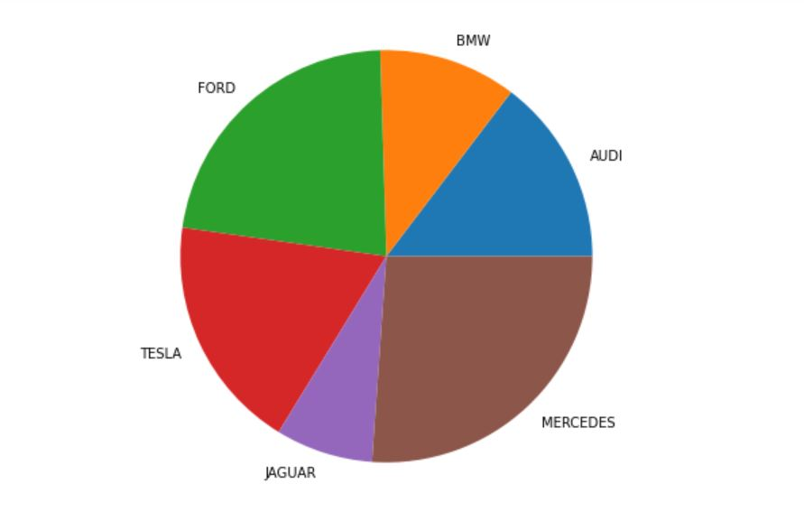

- Write a program to acquire data from data set and plot a pie chart using explode data.

#Import libraries
import numpy as np
import matplotlib.pyplot as plt
# Creating dataset
cars = ['AUDI', 'BMW', 'FORD', 'TESLA', 'JAGUAR', 'MERCEDES']
data = [23, 17, 35, 29, 12, 41]
# Creating explode data
explode = (0.1, 0.0, 0.2, 0.3, 0.0, 0.0)
# Creating color parameters
colors = ( "orange", "cyan", "brown", "grey", "indigo", "beige")
# Wedge properties
wp = { 'linewidth' : 1, 'edgecolor' : "green" }
# Creating autocpt arguments
def func(pct, allvalues):
absolute = int(pct / 100.*np.sum(allvalues))
return "{:.1f}%\n({:d} g)".format(pct, absolute)
# Creating plot
fig, ax = plt.subplots(figsize =(10, 7))
wedges, texts, autotexts = ax.pie(data,
autopct = lambda pct: func(pct, data),
explode = explode,
labels = cars,
shadow = True,
colors = colors,
startangle = 90,
wedgeprops = wp,
textprops = dict(color ="magenta"))
# Adding legend
ax.legend(wedges, cars,
title ="Cars",
loc ="center left",
bbox_to_anchor =(1, 0, 0.5, 1))
plt.setp(autotexts, size = 8, weight ="bold")
ax.set_title("Customizing pie chart")
# show plot
plt.show()

Expected Output:
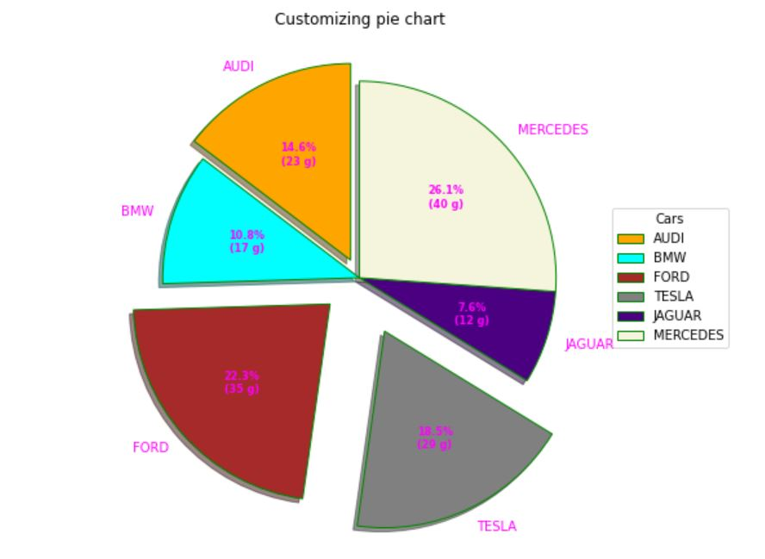
- Write a program to acquire data from data set and plot a pie chart using nested pie chart.

# Import libraries
from matplotlib import pyplot as plt
import numpy as np
# Creating dataset
size = 6
cars = ['AUDI', 'BMW', 'FORD', 'TESLA', 'JAGUAR', 'MERCEDES']
data = np.array([[23, 16], [17, 23],
[35, 11], [29, 33],
[12, 27], [41, 42]])
# normalizing data to 2 pi
norm = data / np.sum(data)*2 * np.pi
# obtaining ordinates of bar edges
left = np.cumsum(np.append(0,
norm.flatten()[:-1])).reshape(data.shape)
# Creating color scale
cmap = plt.get_cmap("tab20c")
outer_colors = cmap(np.arange(6)*4)
inner_colors = cmap(np.array([1, 2, 5, 6, 9,
10, 12, 13, 15,
17, 18, 20 ]))
# Creating plot
fig, ax = plt.subplots(figsize =(10, 7),
subplot_kw = dict(polar = True))
ax.bar(x = left[:, 0],
width = norm.sum(axis = 1),
bottom = 1-size,
height = size,
color = outer_colors,
edgecolor ='w',
linewidth = 1,
align ="edge")
ax.bar(x = left.flatten(),
width = norm.flatten(),
bottom = 1-2 * size,
height = size,
color = inner_colors,
edgecolor ='w',
linewidth = 1,
align ="edge")
ax.set(title ="Nested pie chart")
ax.set_axis_off()
# show plot
plt.show()

Expected Output:
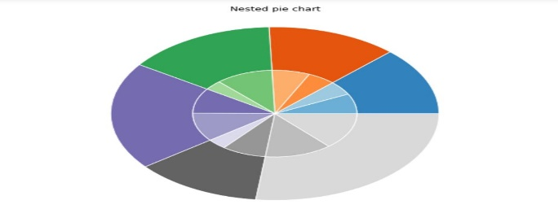

- Write a program to acquire data from data set and plot a pie chart using histogram.

import numpy as np
import seaborn as sns
import matplotlib.pyplot as plt
sns.set(style="ticks")
x = np.random.randn(100)
f, (ax_box, ax_hist) = plt.subplots(2, sharex=True,
gridspec_kw={"height_ratios": (.15, .85)})
sns.boxplot(x, ax=ax_box)
sns.distplot(x, ax=ax_hist)
ax_box.set(yticks=[])
sns.despine(ax=ax_hist)
sns.despine(ax=ax_box, left=True)

Expected Output:

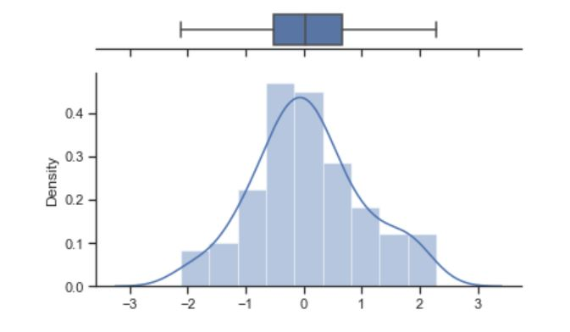

- Write a program to acquire data from data set and plot a pie chart using histogram.

np.random.seed(2022)
x = np.random.randn(100)
f, (ax_box, ax_hist) = plt.subplots(2, sharex=True, gridspec_kw={"height_ratios": (.15, .85)})
sns.boxplot(x=x, ax=ax_box)
sns.histplot(x=x, bins=12, kde=True, stat='density', ax=ax_hist)
ax_box.set(yticks=[])
sns.despine(ax=ax_hist)
sns.despine(ax=ax_box, left=True)

Expected Output:
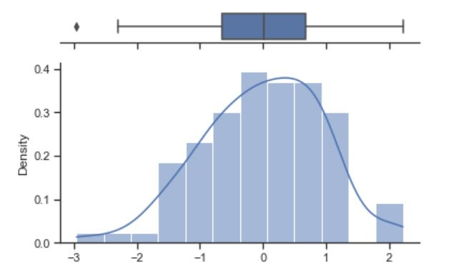
- Write a program to acquire data from data set and plot a pie chart using fancy histogram chart.

import seaborn as sns
def histogram_boxplot(data, xlabel = None, title = None, font_scale=2, figsize=(9,8), bins = None):
""" Boxplot and histogram combined
data: 1-d data array
xlabel: xlabel
title: title
font_scale: the scale of the font (default 2)
figsize: size of fig (default (9,8))
bins: number of bins (default None / auto)
example use: histogram_boxplot(np.random.rand(100), bins = 20, title="Fancy plot")
"""
sns.set(font_scale=font_scale)
f2, (ax_box2, ax_hist2) = plt.subplots(2, sharex=True, gridspec_kw={"height_ratios": (.15, .85)}, figsize=figsize)
sns.boxplot(data, ax=ax_box2)
sns.distplot(data, ax=ax_hist2, bins=bins) if bins else sns.distplot(data, ax=ax_hist2)
if xlabel: ax_hist2.set(xlabel=xlabel)
if title: ax_box2.set(title=title)
plt.show()
histogram_boxplot(np.random.randn(100), bins=20, title="fancy plot", xlabel="some values")

Expected Output:
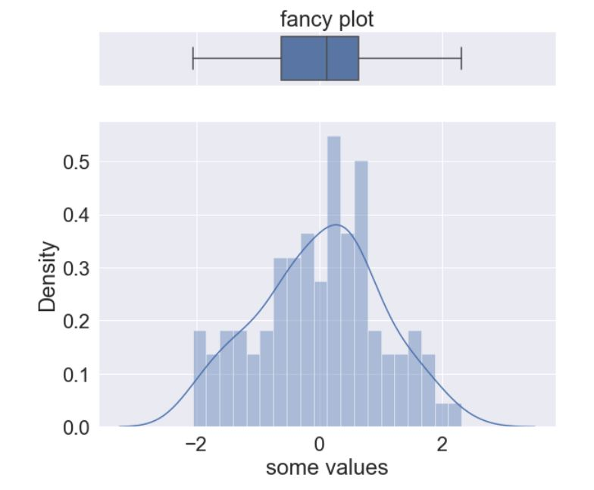

2) Statistical Analysis – such as Multivariate analysis, PCA, LDA, Correlation regression and analysis of variance

- Compare lda number of components with naive bayes algorithm for classification
from numpy import mean
from numpy import std
from sklearn.datasets import make_classification
from sklearn.model_selection import cross_val_score
from sklearn.model_selection import RepeatedStratifiedKFold
from sklearn.pipeline import Pipeline
from sklearn.discriminant_analysis import LinearDiscriminantAnalysis
from sklearn.naive_bayes import GaussianNB
from matplotlib import pyplot

# get the dataset
def get_dataset():
X, y = make_classification(n_samples=1000, n_features=20, n_informative=15, n_redundant=5, random_state=7, n_classes=10)
return X, y

# get a list of models to evaluate
def get_models():
models = dict()
for i in range(1,10):
steps = [('lda', LinearDiscriminantAnalysis(n_components=i)), ('m', GaussianNB())]
models[str(i)] = Pipeline(steps=steps)
return models

# evaluate a give model using cross-validation
def evaluate_model(model, X, y):
cv = RepeatedStratifiedKFold(n_splits=10, n_repeats=3, random_state=1)
scores = cross_val_score(model, X, y, scoring='accuracy', cv=cv, n_jobs=-1, error_score='raise')
return scores

# define dataset
X, y = get_dataset()
# get the models to evaluate
models = get_models()
# evaluate the models and store results
results, names = list(), list()
for name, model in models.items():
scores = evaluate_model(model, X, y)
results.append(scores)
names.append(name)
print('>%s %.3f (%.3f)' % (name, mean(scores), std(scores)))
# plot model performance for comparison
pyplot.boxplot(results, labels=names, showmeans=True)
pyplot.show()

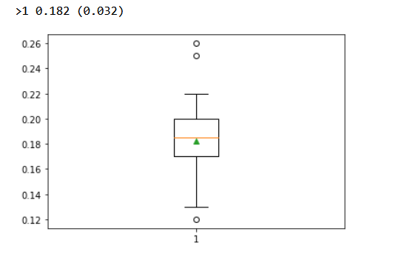

- High-dimensional PCA Analysis with px.scatter_matrix

import plotly.express as px

df = px.data.iris()
features = ["sepal_width", "sepal_length", "petal_width", "petal_length"]

fig = px.scatter_matrix(
df,
dimensions=features,
color="species"
)
fig.update_traces(diagonal_visible=False)
fig.show()

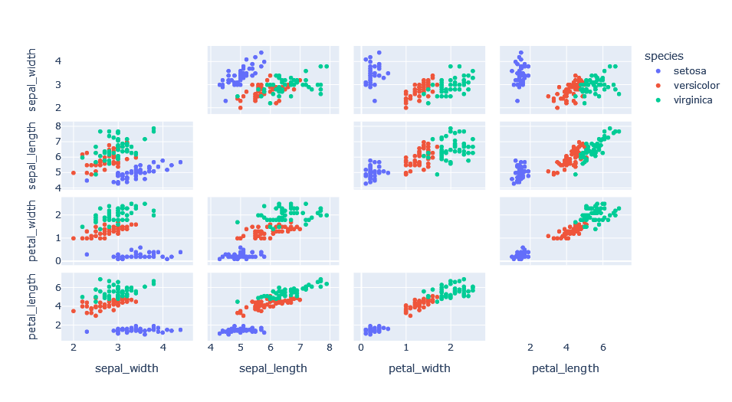

import plotly.express as px
from sklearn.decomposition import PCA

df = px.data.iris()
features = ["sepal_width", "sepal_length", "petal_width", "petal_length"]

pca = PCA()
components = pca.fit_transform(df[features])
labels = {
str(i): f"PC {i+1} ({var:.1f}%)"
for i, var in enumerate(pca.explained_variance_ratio_ * 100)
}

fig = px.scatter_matrix(
components,
labels=labels,
dimensions=range(4),
color=df["species"]
)
fig.update_traces(diagonal_visible=False)
fig.show()

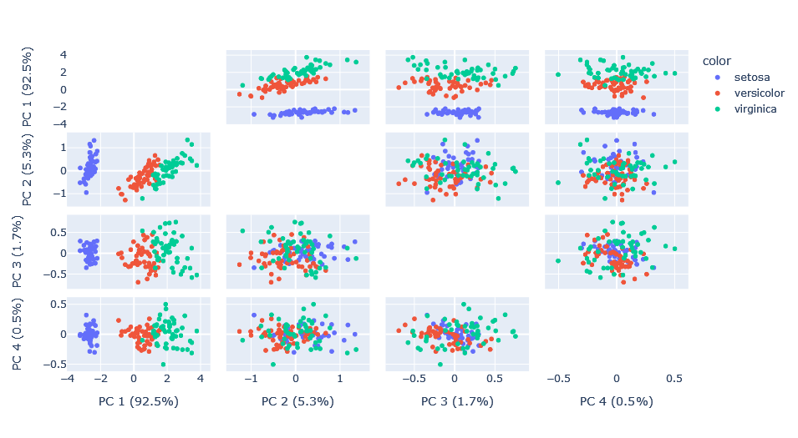

- Statistical analysis of correlation regression
import numpy as np
import pandas as pd
import matplotlib.pyplot as plt
from sklearn.linear_model import LinearRegression

# Generating synthetic data
np.random.seed(42)
x = np.random.rand(50) * 10
y = 2 * x + 1 + np.random.randn(50) * 2

# Creating a DataFrame
data = pd.DataFrame({'X': x, 'Y': y})

# Correlation analysis
correlation = data.corr()
print("Correlation Matrix:")
print(correlation)

# Linear regression
x_values = data['X'].values.reshape(-1, 1)
y_values = data['Y'].values.reshape(-1, 1)

regression_model = LinearRegression()
regression_model.fit(x_values, y_values)

# Getting regression parameters
slope = regression_model.coef_[0][0]
intercept = regression_model.intercept_[0]

print("\nLinear Regression:")
print(f"Slope (Coefficient): {slope}")
print(f"Intercept: {intercept}")

# Visualization
plt.figure(figsize=(10, 6))

# Scatter plot
plt.scatter(x, y, label='Data Points')

# Regression line
regression_line = slope * x + intercept
plt.plot(x, regression_line, color='red', label='Regression Line')

# Labels and title
plt.xlabel('X')
plt.ylabel('Y')
plt.title('Correlation and Regression Analysis')
plt.legend()

# Show the plot
plt.show()

Expected Output:
Correlation Matrix:
X Y
X 1.000000 0.951177
Y 0.951177 1.000000

Linear Regression:
Slope (Coefficient): 1.9553132007706207
Intercept: 1.1933785489377744
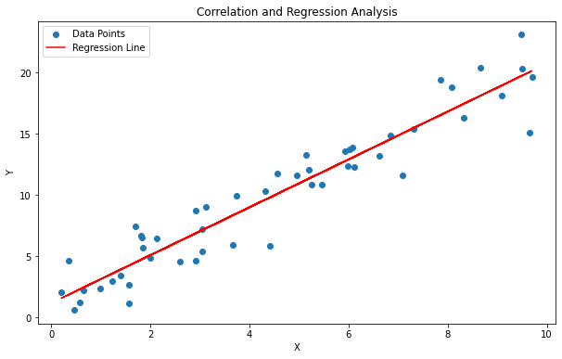

- Statistical analysis of analysis of variance
import numpy as np
import pandas as pd
import matplotlib.pyplot as plt
from scipy.stats import f_oneway

# Generating synthetic data for three groups
np.random.seed(42)

group1 = np.random.normal(loc=20, scale=5, size=30)
group2 = np.random.normal(loc=25, scale=5, size=30)
group3 = np.random.normal(loc=30, scale=5, size=30)

# Creating a DataFrame
data = pd.DataFrame({
'Group 1': group1,
'Group 2': group2,
'Group 3': group3
})

# One-way ANOVA
statistic, p_value = f_oneway(group1, group2, group3)

# Print ANOVA results
print("One-way ANOVA Results:")
print(f"F-statistic: {statistic}")
print(f"P-value: {p_value}")

# Visualization
plt.figure(figsize=(10, 6))

# Boxplot
data.boxplot()
plt.title('One-way ANOVA - Boxplot')
plt.ylabel('Values')

# Show the plot
plt.show()

Expected Output:
One-way ANOVA Results:
F-statistic: 40.97563597701803
P-value: 2.893768135071631e-13
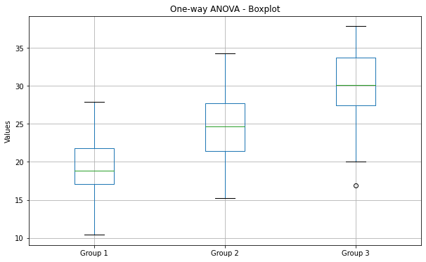

3) Financial analysis using clustering, Histogram and Heatmap

- Clustering
import numpy as np
import pandas as pd
import matplotlib.pyplot as plt
from sklearn.cluster import KMeans
from sklearn.preprocessing import StandardScaler
from sklearn.datasets import make_blobs

# Generating synthetic financial data
np.random.seed(42)

# Creating three clusters of financial data
data, labels = make_blobs(n_samples=300, centers=3, random_state=42)

# Creating a DataFrame
financial_data = pd.DataFrame(data, columns=['Feature1', 'Feature2'])

# Standardizing the data
scaler = StandardScaler()
scaled_data = scaler.fit_transform(financial_data)

# Applying KMeans clustering
num_clusters = 3
kmeans = KMeans(n_clusters=num_clusters, random_state=42)
financial_data['Cluster'] = kmeans.fit_predict(scaled_data)

# Visualizing the clusters
plt.figure(figsize=(10, 6))

for cluster in range(num_clusters):
cluster_data = financial_data[financial_data['Cluster'] == cluster]
plt.scatter(cluster_data['Feature1'], cluster_data['Feature2'], label=f'Cluster {cluster + 1}')

plt.scatter(kmeans.cluster_centers_[:, 0], kmeans.cluster_centers_[:, 1], s=200, c='red', marker='X', label='Centroids')
plt.title('Financial Data Clustering')
plt.xlabel('Feature 1')
plt.ylabel('Feature 2')
plt.legend()

# Show the plot
plt.show()

Expected Output:
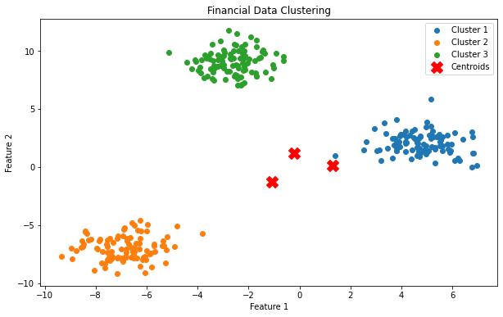

- Histogram
import numpy as np
import pandas as pd
import matplotlib.pyplot as plt

# Generating synthetic financial data (returns of a stock)
np.random.seed(42)
stock_returns = np.random.normal(loc=0.001, scale=0.02, size=1000)

# Creating a DataFrame
financial_data = pd.DataFrame({'Returns': stock_returns})

# Plotting the histogram
plt.figure(figsize=(10, 6))
plt.hist(financial_data['Returns'], bins=30, color='blue', alpha=0.7)
plt.title('Stock Returns Histogram')
plt.xlabel('Returns')
plt.ylabel('Frequency')

# Show the plot
plt.show()

Expected Output:
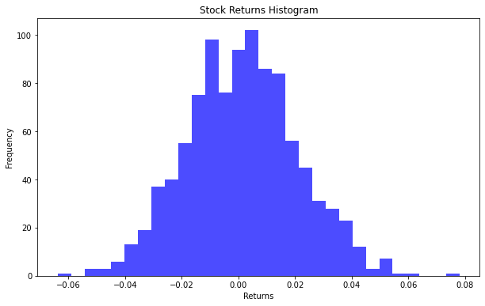

- Heatrmap
import numpy as np
import pandas as pd
import seaborn as sns
import matplotlib.pyplot as plt

# Generating synthetic financial data (correlated metrics)
np.random.seed(42)

# Creating a DataFrame with synthetic financial metrics
financial_metrics = {
'Revenue': np.random.normal(loc=100, scale=20, size=100),
'Expenses': np.random.normal(loc=70, scale=15, size=100),
'Profit': np.random.normal(loc=30, scale=10, size=100),
'Debt': np.random.normal(loc=50, scale=15, size=100)
}

financial_data = pd.DataFrame(financial_metrics)

# Calculating correlation matrix
correlation_matrix = financial_data.corr()

# Plotting the heatmap
plt.figure(figsize=(10, 8))
sns.heatmap(correlation_matrix, annot=True, cmap='coolwarm', fmt='.2f', linewidths=0.5)
plt.title('Financial Metrics Correlation Heatmap')

# Show the plot
plt.show()

Expected Output:
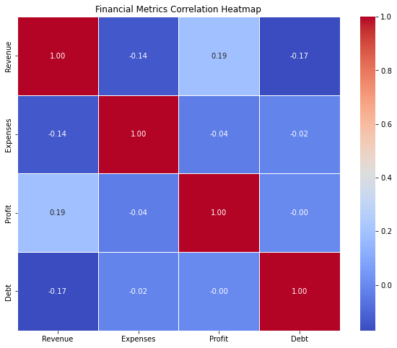

4) Time Series Analysis-Stock market
Step 1:
!pip install yfinance
Step 2:
import pandas as pd
import numpy as np
import matplotlib.pyplot as plt
import yfinance as yf

# Fetching historical stock data (e.g., Apple Inc.)
ticker_symbol = "AAPL"
start_date = "2020-01-01"
end_date = "2022-12-31"

stock_data = yf.download(ticker_symbol, start=start_date, end=end_date)

# Displaying the first few rows of the stock data
print(stock_data.head())

# Plotting the closing prices over time
plt.figure(figsize=(14, 7))
stock_data['Close'].plot(label=f'{ticker_symbol} Closing Price')
plt.title(f'{ticker_symbol} Stock Price Over Time')
plt.xlabel('Date')
plt.ylabel('Closing Price (USD)')
plt.legend()
plt.show()

# Calculating and plotting daily returns
stock_data['Daily Return'] = stock_data['Close'].pct_change()
plt.figure(figsize=(14, 7))
stock_data['Daily Return'].plot(label=f'{ticker_symbol} Daily Return')
plt.title(f'{ticker_symbol} Daily Returns Over Time')
plt.xlabel('Date')
plt.ylabel('Daily Return')
plt.legend()
plt.show()

# Rolling mean and standard deviation for smoothing
window_size = 30
stock_data['Rolling Mean'] = stock_data['Close'].rolling(window=window_size).mean()
stock_data['Rolling Std'] = stock_data['Close'].rolling(window=window_size).std()

# Plotting with rolling mean and standard deviation
plt.figure(figsize=(14, 7))
stock_data['Close'].plot(label=f'{ticker_symbol} Closing Price')
stock_data['Rolling Mean'].plot(label=f'{ticker_symbol} Rolling Mean', color='red')
stock_data['Rolling Std'].plot(label=f'{ticker_symbol} Rolling Std', color='orange')
plt.title(f'{ticker_symbol} Stock Price with Rolling Mean and Standard Deviation')
plt.xlabel('Date')
plt.ylabel('Closing Price (USD)')
plt.legend()
plt.show()

Expected Output:
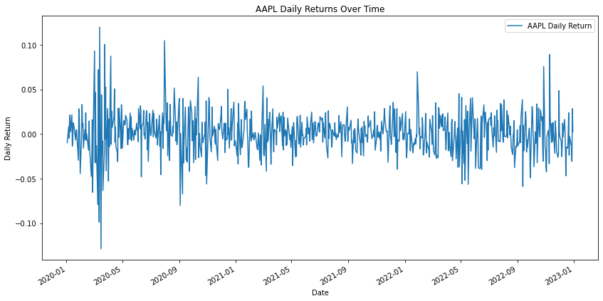
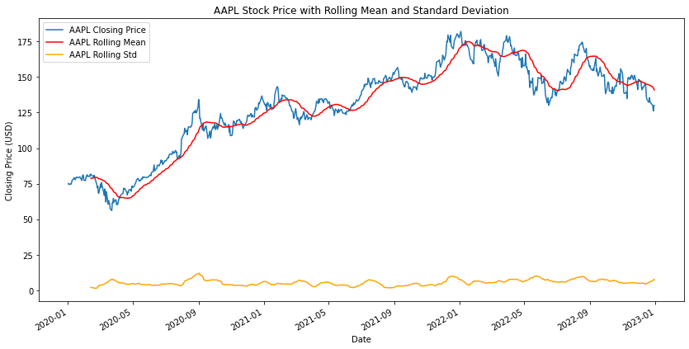

5. Visualization of various massive dataset - Finance - Healthcare-Census-Geospatial.
a) Finance:
Step 1:-
import pandas as pd
import numpy as np
from datetime import datetime, timedelta
# Generate synthetic data
np.random.seed(42)
date_today = datetime.now()
days = pd.date_range(date_today, date_today + timedelta(29), freq='D')
data = {'Date': days, 'StockPrice': np.random.randint(100, 200, size=(30,))}
df = pd.DataFrame(data)
# Save the dataset to a CSV file
df.to_csv('finance_dataset.csv',index=False)
Step 2:
import pandas as pd
import matplotlib.pyplot as plt
# Read the dataset from the CSV file
df = pd.read_csv('finance_dataset.csv')
# Convert the 'Date' column to datetime format
df['Date'] = pd.to_datetime(df['Date'])

# Plotting the financial data
plt.figure(figsize=(10, 6))
plt.plot(df['Date'], df['StockPrice'], marker='o', linestyle='-', color='b')

# Adding labels and title
plt.title('Stock Prices Over Time')
plt.xlabel('Date')
plt.ylabel('Stock Price')

# Display the plot
plt.grid(True)
plt.show()

Expected Output:-
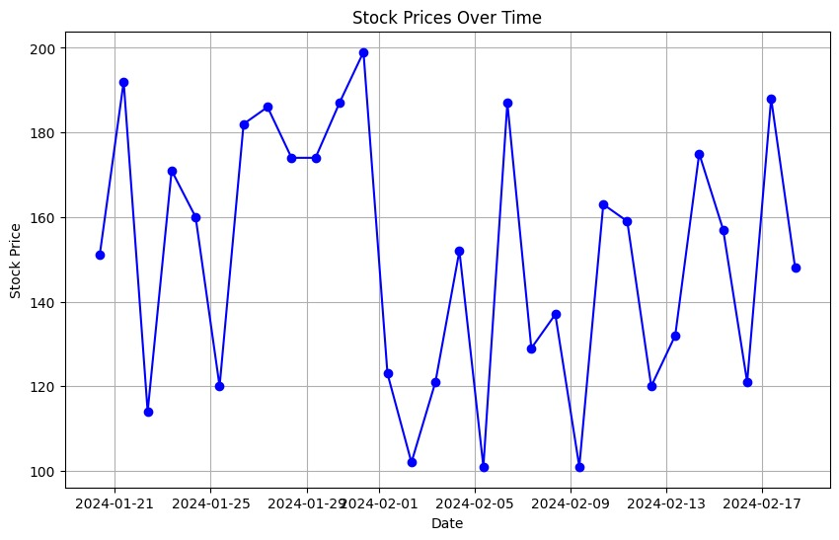

b) Healthcare:
Dataset: https://drive.google.com/file/d/1YQKfblYW9L4p-JOn2XRibr7VMa3STh86/view?usp=sharing

import pandas as pd
import seaborn as sns
import matplotlib.pyplot as plt

# Load your healthcare dataset (replace 'path/to/your/healthcare_dataset.csv' with the actual path)
healthcare_data = pd.read_csv('healthcare_dataset.csv')

# Display basic information about the dataset
print("Dataset Overview:")
print(healthcare_data.info())

# Display the first few rows of the dataset
print("\nFirst Few Rows of the Dataset:")
print(healthcare_data.head())

# Descriptive statistics of numerical columns
print("\nDescriptive Statistics:")
print(healthcare_data.describe())

# Handling missing data
print("\nHandling Missing Data:")
print(healthcare_data.isnull().sum())

# Data visualization

# Example: Bar plot for patient gender distribution
plt.figure(figsize=(8, 5))
sns.countplot(x='Gender', data=healthcare_data)
plt.title('Patient Gender Distribution')
plt.xlabel('Gender')
plt.ylabel('Count')
plt.show()

# Example: Box plot for age distribution by gender
plt.figure(figsize=(10, 6))
sns.boxplot(x='Gender', y='Age', data=healthcare_data)
plt.title('Age Distribution by Gender')
plt.xlabel('Gender')
plt.ylabel('Age')
plt.show()

# Example: Heatmap for correlation between numerical variables
plt.figure(figsize=(10, 8))
sns.heatmap(healthcare_data.corr(), annot=True, cmap='coolwarm', fmt='.2f', linewidths=0.5)
plt.title('Correlation Heatmap')
plt.show()

Expected Output:
Dataset Overview:
<class 'pandas.core.frame.DataFrame'>
RangeIndex: 10000 entries, 0 to 9999
Data columns (total 15 columns):
# Column Non-Null Count Dtype
--- ------ -------------- -----
0 Name 10000 non-null object
1 Age 10000 non-null int64
2 Gender 10000 non-null object
3 Blood Type 10000 non-null object
4 Medical Condition 10000 non-null object
5 Date of Admission 10000 non-null object
6 Doctor 10000 non-null object
7 Hospital 10000 non-null object
8 Insurance Provider 10000 non-null object
9 Billing Amount 10000 non-null float64
10 Room Number 10000 non-null int64
11 Admission Type 10000 non-null object
12 Discharge Date 10000 non-null object
13 Medication 10000 non-null object
14 Test Results 10000 non-null object
dtypes: float64(1), int64(2), object(12)
memory usage: 1.1+ MB
None

First Few Rows of the Dataset:
Name Age Gender Blood Type Medical Condition \
0 Tiffany Ramirez 81 Female O- Diabetes
1 Ruben Burns 35 Male O+ Asthma
2 Chad Byrd 61 Male B- Obesity
3 Antonio Frederick 49 Male B- Asthma
4 Mrs. Brandy Flowers 51 Male O- Arthritis

Date of Admission Doctor Hospital \
0 2022-11-17 Patrick Parker Wallace-Hamilton
1 2023-06-01 Diane Jackson Burke, Griffin and Cooper
2 2019-01-09 Paul Baker Walton LLC
3 2020-05-02 Brian Chandler Garcia Ltd
4 2021-07-09 Dustin Griffin Jones, Brown and Murray

Insurance Provider Billing Amount Room Number Admission Type \
0 Medicare 37490.983364 146 Elective
1 UnitedHealthcare 47304.064845 404 Emergency
2 Medicare 36874.896997 292 Emergency
3 Medicare 23303.322092 480 Urgent
4 UnitedHealthcare 18086.344184 477 Urgent

Discharge Date Medication Test Results
0 2022-12-01 Aspirin Inconclusive
1 2023-06-15 Lipitor Normal
2 2019-02-08 Lipitor Normal
3 2020-05-03 Penicillin Abnormal
4 2021-08-02 Paracetamol Normal

Descriptive Statistics:
Age Billing Amount Room Number
count 10000.000000 10000.000000 10000.000000
mean 51.452200 25516.806778 300.082000
std 19.588974 14067.292709 115.806027
min 18.000000 1000.180837 101.000000
25% 35.000000 13506.523967 199.000000
50% 52.000000 25258.112566 299.000000
75% 68.000000 37733.913727 400.000000
max 85.000000 49995.902283 500.000000

Handling Missing Data:
Name 0
Age 0
Gender 0
Blood Type 0
Medical Condition 0
Date of Admission 0
Doctor 0
Hospital 0
Insurance Provider 0
Billing Amount 0
Room Number 0
Admission Type 0
Discharge Date 0
Medication 0
Test Results 0
dtype: int64
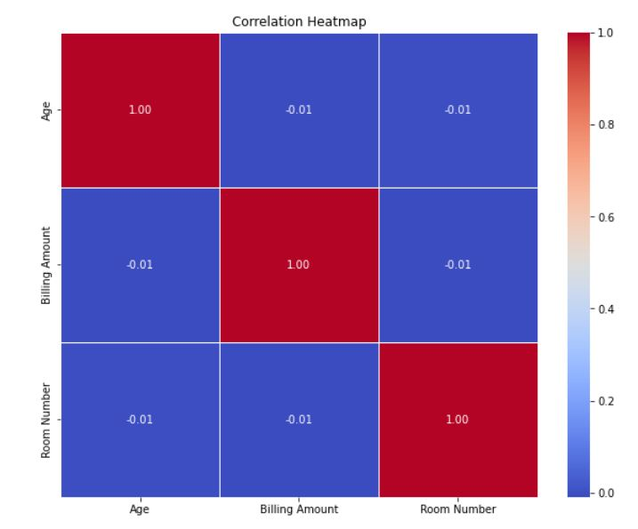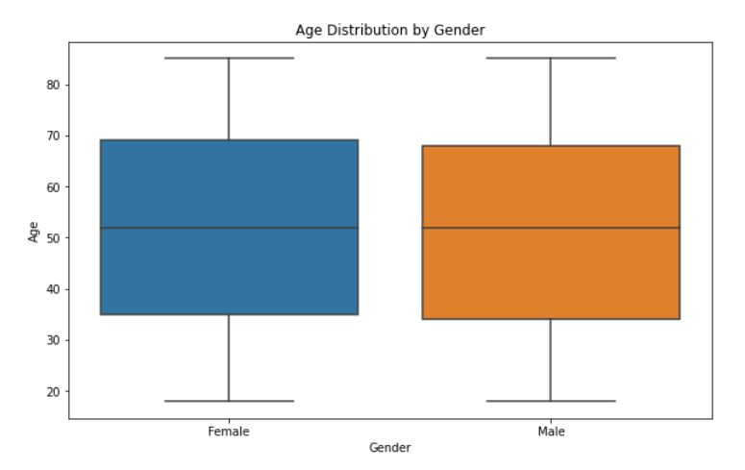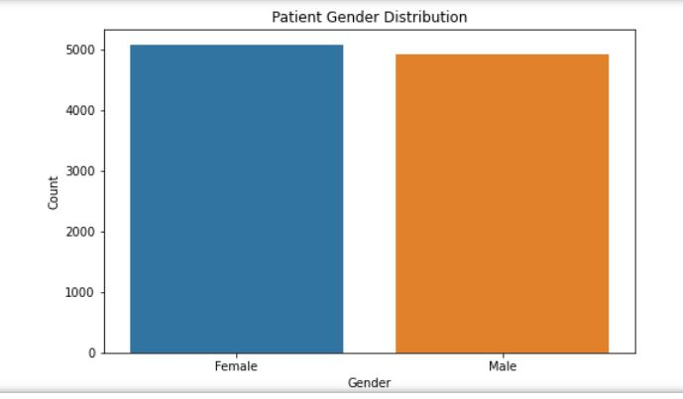

- Census
import matplotlib.pyplot as plt
import pandas as pd

# Assuming you have a pandas DataFrame with columns 'Age' and 'Population'
# Replace this with your actual data loading mechanism
# Example data creation:
data = {
'Age': ['0-4', '5-9', '10-14', '15-19', '20-24', '25-29'],
'Population': [120000, 150000, 180000, 200000, 250000, 220000]
}

df = pd.DataFrame(data)

# Plotting the data
plt.figure(figsize=(10, 6))
plt.bar(df['Age'], df['Population'], color='skyblue')
plt.xlabel('Age Group')
plt.ylabel('Population')
plt.title('Population Distribution by Age Group')
plt.show()

Expected Output:

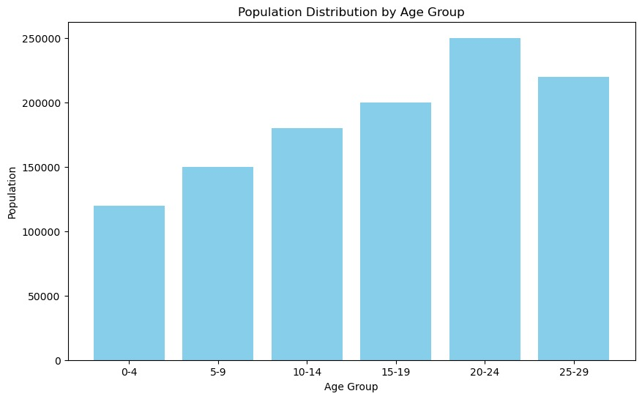

- Geopatial
Step 1:-
!pip install geopandas folium
Step 2:-
import geopandas as gpd
import folium
# Create a GeoDataFrame with example geospatial data
data = {
'City': ['City A', 'City B', 'City C', 'City D'],
'Country': ['Country 1', 'Country 2', 'Country 1', 'Country 3'],
'Latitude': [34.0522, 40.7128, 41.8781, 37.7749],
'Longitude': [-118.2437, -74.0060, -87.6298, -122.4194],
}
geometry = gpd.points_from_xy(data['Longitude'], data['Latitude'])
geo_df = gpd.GeoDataFrame(data, geometry=geometry)
# Display the GeoDataFrame
print("GeoDataFrame Information:")
print(geo_df)
# Plot the GeoDataFrame
geo_df.plot(marker='o', color='red', markersize=50, figsize=(10, 6))
plt.title('Geospatial Data Visualization')
plt.xlabel('Longitude')
plt.ylabel('Latitude')
plt.show()
# Create an interactive map using folium
my_map = folium.Map(location=[geo_df['Latitude'].mean(), geo_df['Longitude'].mean()], zoom_start=4)
# Add markers to the map
for index, row in geo_df.iterrows():
folium.Marker(
location=[row['Latitude'], row['Longitude']],
popup=f"{row['City']}, {row['Country']}",
icon=folium.Icon(color='blue')
).add_to(my_map)
# Save the map as an HTML file (optional)
my_map.save('geospatial_map.html')
# Display the map
my_map

Expected Output:-
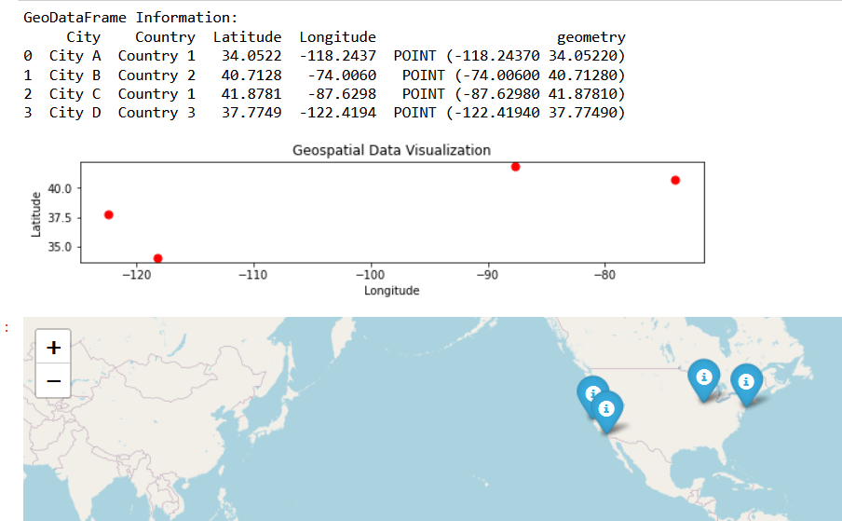

6. Visualization on Streaming dataset (Stock market dataset, weather forecasting).

- Stockmarket
Dataset: https://drive.google.com/file/d/1ODwDMeX97fbfR-gi3VbEC4WgLjUBjAyA/view?usp=sharing

import pandas as pd
import matplotlib.pyplot as plt

# Assuming you have a stock market dataset in a CSV file, load it into a DataFrame
# Replace 'your_dataset.csv' with the actual file path
df = pd.read_csv('Twitter Stock Market Dataset.csv')

# Display the first few rows of the dataset
print(df.head())

# Plotting the stock prices
plt.figure(figsize=(10, 6))
plt.plot(df['Date'], df['Close'], label='Close Price', color='blue')
plt.title('Stock Market Prices Over Time')
plt.xlabel('Date')
plt.ylabel('Close Price')
plt.legend()
plt.show()

Expected Output:
Date Open High Low Close Adj Close \
0 2013-11-07 45.099998 50.090000 44.000000 44.900002 44.900002
1 2013-11-08 45.930000 46.939999 40.685001 41.650002 41.650002
2 2013-11-11 40.500000 43.000000 39.400002 42.900002 42.900002
3 2013-11-12 43.660000 43.779999 41.830002 41.900002 41.900002
4 2013-11-13 41.029999 42.869999 40.759998 42.599998 42.599998

Volume
0 117701670.0
1 27925307.0
2 16113941.0
3 6316755.0
4 8688325.0
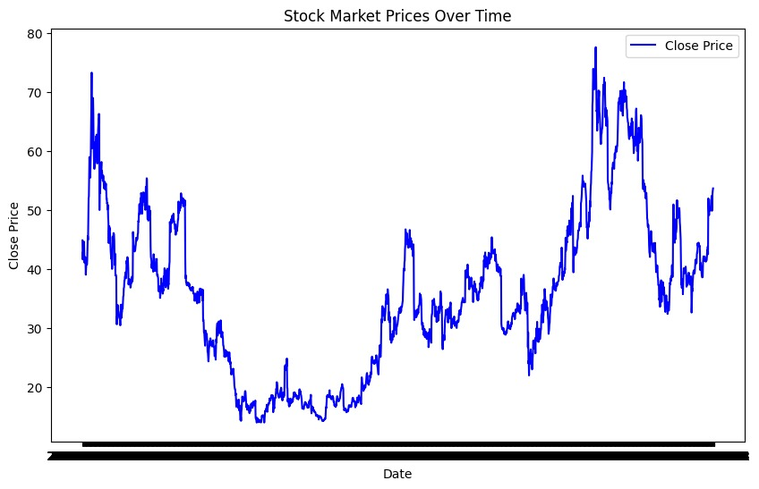

- Weather forecasting
Dataset: https://drive.google.com/file/d/1tdmXYJudSINdVLMkQ9bNvhtRGibwneiz/view?usp=sharing

!pip install plotly
import pandas as pd
import plotly.express as px

# Assuming you have a weather forecasting dataset in a CSV file, load it into a DataFrame
# Replace 'your_weather_forecast_data.csv' with the actual file path
df = pd.read_csv('Weather.csv')

# Check and clean column names
df.columns = df.columns.str.strip()

# Plotting interactive temperature over time
fig = px.line(df, x='pune', y='9', title='Weather Forecast: Temperature Over Time', labels={'9': 'Temperature (Celsius)'})
fig.show()

Expected Output:

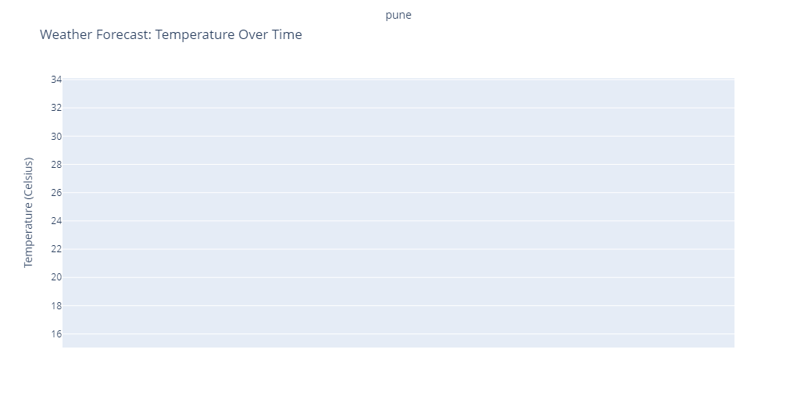

7. Market-Basket Data analysis-visualization.
!pip install mlxtend
import pandas as pd
from mlxtend.frequent_patterns import apriori
from mlxtend.frequent_patterns import association_rules
import matplotlib.pyplot as plt
import networkx as nx

# Sample transaction data (replace with your actual data)
data = {'TransactionID': [1, 1, 2, 2, 2, 3, 3, 4, 4, 4],
'Item': ['A', 'B', 'A', 'B', 'C', 'A', 'B', 'B', 'C', 'D']}
df = pd.DataFrame(data)

# Perform one-hot encoding
basket = (df.groupby(['TransactionID', 'Item'])['Item']
.count().unstack().reset_index().fillna(0)
.set_index('TransactionID'))

# Convert counts to binary values (1 or 0)
basket_sets = basket.applymap(lambda x: 1 if x > 0 else 0)

# Apply Apriori algorithm
frequent_itemsets = apriori(basket_sets, min_support=0.2, use_colnames=True)

# Generate association rules
rules = association_rules(frequent_itemsets, metric="confidence", min_threshold=0.7)

# Visualization: Plotting Network Graph of Association Rules
fig, ax = plt.subplots(figsize=(10, 6))
G = nx.from_pandas_edgelist(rules, 'antecedents', 'consequents')
pos = nx.spring_layout(G)
nx.draw(G, pos, with_labels=True, font_size=10, node_size=2000, node_color="skyblue", font_color="black", font_weight="bold", ax=ax)
plt.title("Association Rules Network Graph")
plt.show()

Expected Output:
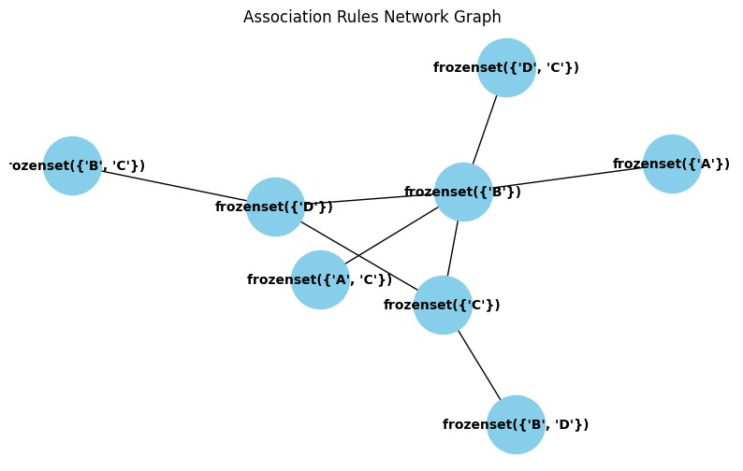

8. Text visualization using web analytics.
DataSet: https://drive.google.com/file/d/14P6d7faPAQqVg4ZKGH_RncF367Q8xUgh/view?usp=sharing
Program:
!pip install pandas wordcloud matplotlib
import pandas as pd
import matplotlib.pyplot as plt

# Assuming you have a web analytics dataset
# Replace 'Web_Analytics_Dataset.csv' with the actual file path
df = pd.read_csv('Web Analytic_Dataset.csv')

# Print column names to identify the available columns
print("Available columns:", df.columns)

# Choose relevant metrics for visualization
metrics_to_visualize = ['Users', 'Pageviews', 'Bounce Rate']

# Plotting web analytics metrics
plt.figure(figsize=(12, 6))
for metric in metrics_to_visualize:
plt.bar(df['Month of the year'], df[metric], label=metric, alpha=0.7)

plt.title('Web Analytics Metrics Over Time')
plt.xlabel('Month of the year')
plt.ylabel('Metrics Value')
plt.legend()
plt.show()
Expected Output:
Available columns: Index(['Source / Medium', 'Year', 'Month of the year', 'Users', 'New Users',
'Sessions', 'Bounce Rate', 'Pageviews', 'Avg. Session Duration',
'Conversion Rate (%)', 'Transactions', 'Revenue', 'Quantity Sold'],
dtype='object')
