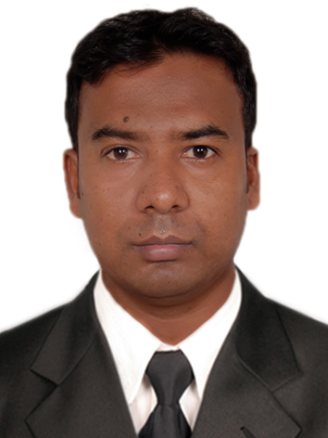
MD. AL EMRAN
 +8801740301508  emran.eco37@gmail.com

 CAREER OBJECTIVES

I would like to build up my career of Textile Engineering Sector through using my creativity, efficiency, proficiency and hard working so that my respective organization can achieve its goal in the circumstance of the global challenge and competition. I always prefer to take the challenges as opportunities for building up myself.

`  EXPERIENCE:

 |  |  | Organization Name | : Aman Tex Ltd.(aman Group)
 |  |  | Location | : Masterbari,Mawna,Sreepur, Gazipur
 |  |  | Designation | : Supervisor (Knitting Production)
 |  |  | Duration | : 01 Year 09 months

EXPERIENCE:

 |  |  | Organization Name | : Giant Textile Ltd (Giant Group)
 |  |  | Location | : Baniarchala,Mohona,Vabanipur, Gazipur
 |  |  | Designation | : Shift In charge (Knitting Production)
 |  |  | Duration | : 03 Years 02 Months

EXPERIENCE:

 |  |  | Organization Name | : Arkay Knit Dyeing Mills Ltd.(Palmal Group)
 |  |  | Location | : Zirani, Bazar, Ashulia,Savar.
 |  |  | Designation | : Production Officer (Knitting Production)
 |  |  | Duration | : 01 Year (Running)


DUTIES/RESPONSIBILITIES

- Production follow to meet the daily shift production & send by Email to management
- Follow up all Machine Program as per planning.
- Follow up Shift Manpower (Supervisor, Operator & Helper)
- Program wise Yarn follow up.
- Daily Grey Fabric Delivery Follow up
- Check Product quality throughout the day to maintain proper productivity. & Follow up Customer Complain
- Any other work assign by management

 EDUCATIONAL QUALIFICATION

B.Sc. in Textile Engineering:

Institute

: University of South Asia.

Major

: Wet Processing Technology.

Passing Year

: 2019

Result

: 2.50 (out of 4.00)

Diploma in Textile Engineering:

Institute

: Dinajpur Textile Institute, Dinajpur

Major

: Bangladesh Technical Education Board, Dhaka

Passing Year

: 2014

Result

: 2.95 (out of 4.00)

Secondary School Certificate:

Institute

: Textile Vocational Institute, Sirajganj

Major

: Bangladesh Technical Education Board, Dhaka

Group

Passing Year

: Dyeing Printing & Finishing

: 2010

Result

: 4.00 (out of 5.00)

COMPUTER SKILLS

- Microsoft package
- Others

: MS Word, MS Excell, MS Powerpoint
: Emailing, Internet Browsing.

LANGUAGE PROFICIENCY


Language | Speaking | Reading | Writing
Bengali | Excellent | Excellent | Excellent
English | Good | Excellent | Excellent


PERSONAL INFORMATION

Name

Father’s Name

Mother’s Name

Date of Birth

Gender

Religion

Marital Status

Nationality

Mailing Address

Permanent Address

: Md. Al Emran

: Md. Abdus Sattar

: Mrs. Asrafun Nesa

: 31/12/1993

: Male

: Islam

: Unmarried

: Bangladeshi

: Village: Baipail,Post: Ashlia Upazila:Savar, District: Dhaka.

: Village: Goaljani,Post: Purnimagati (6760),Upazila: Ullapara, District: Sirajganj.



INTERESTS

I’m able to work in a team Environment, Reading Newspaper Traveling, Swimming, Gardening and in Challenging works.


REFERENCE

MD.Tanvir

Senior. Manager

Arkay Knit Dyeing Mills Ltd. (Palmal Group)

Zirani, Bazar, Ashulia,Savar

+8801793772311,

.DECLARATION

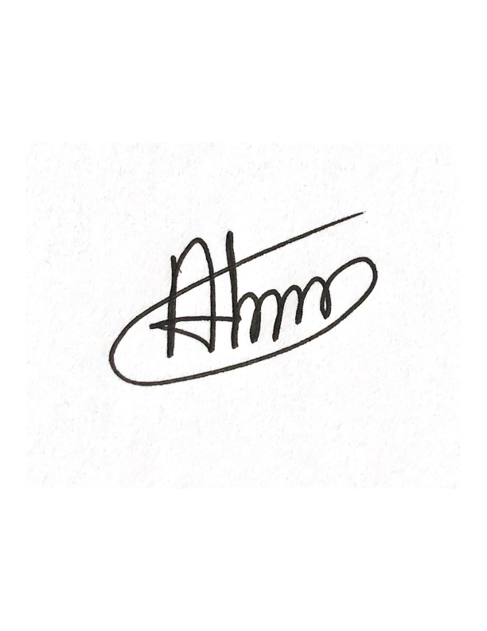I do hereby declare and certify that all the information’s stated above in this curriculum vitae are true and complete to the best of my knowledge and belief.

_{Date: 07-05-2023}

……………………
Md. Al Emran

