**Program:**

//st id: 194028

//report_title: implementation bresenham line drawing algorithm

#include<bits/stdc++.h>

#include<graphics.h>

using namespace std;

int xc,yc,dx,dy;

void bresenham1(int x1,int y1,int x2,int y2)

{

int x,y,endx;

int d = 2*dy-dx;

int incr = 2*dy;

int incr2 = 2*(dy-dx);

if(dx<0)

{

x = x2;

y = y2;

endx = x1;

}

else

{

x = x1;

y = y1;

endx = x2;

}

putpixel((xc)+x,(yc)+y,WHITE);

while(x<endx)

{

if(d<0)

{

d+=incr;

x++;

}

else

{

d+=incr2;

x++;

y++;

}

putpixel((xc)+x,(yc)+y,WHITE);

}

}

void bresenham2(int x1,int y1,int x2,int y2)

{

int x,y,endx;

int d = 2*dx-dy;

int incr = 2*dx;

int incr2 = 2*(dx-dy);

if(dx<0)

{

x = x2;

y = y2;

endx = x1;

}

else

{

x = x1;

y = y1;

endx = x2;

}

putpixel((xc)+x,(yc)+y,WHITE);

while(x<endx)

{

if(d<0)

{

d+=incr;

x++;

}

else

{

d+=incr2;

x++;

y++;

}

putpixel((xc)+x,(yc)+y,WHITE);

}

}

int main()

{

initwindow(600,500);

int a = getmaxx();

int b = getmaxy();

xc=a/2,yc=b/2;

rectangle(0,0,a,b);

line(xc,0,xc,b);

line(0,yc,a,yc);

int x1,y1,x2,y2;

cout<<"Initial Point: ";

cin>>x1>>y1;

cout<<"End Point: ";

cin>>x2>>y2;

dx=x2-x1;

dy=y2-y1;

float m=float(dy)/(dx);

if(m>1)

bresenham1(x1,y1,x2,y2);

else

bresenham2(x1,y1,x2,y2);

while(!kbhit())

{

delay(200);

}

return 0;

}

**Output:**

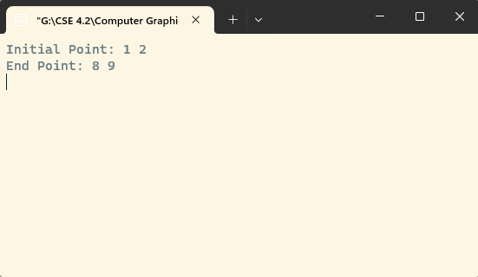

**Fig: input initial point and end point**

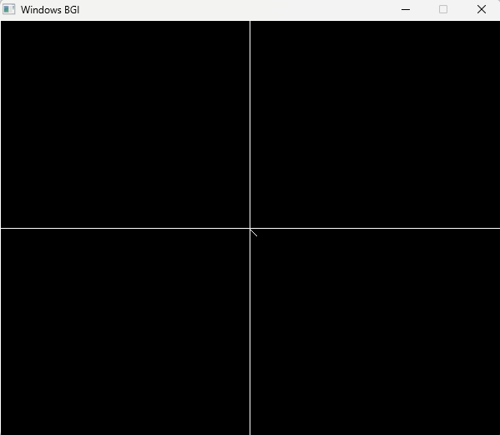

**Fig: picture of line drawing**