**Program:**

//st id: 194028

//report_title: implementation bresenham’s circle drawing algorithm

#include<bits/stdc++.h>

#include<graphics.h>

using namespace std;

int x,y;

void drawing(int X,int Y,int h,int k)

{

int a=x/2,b=y/2;

putpixel(a+(X+h),b+(Y+k),15);

putpixel(a+(Y+h),b+(X+k),15);

putpixel(a+(-Y+h),b+(X+k),15);

putpixel(a+(-X+h),b+(Y+k),15);

putpixel(a+(-X+h),b+(-Y+k),15);

putpixel(a+(-Y+h),b+(-X+k),15);

putpixel(a+(Y+h),b+(-X+k),15);

putpixel(a+(X+h),b+(-Y+k),15);

}

int main()

{

initwindow(800,600,"Screen");

x=getmaxx();

y=getmaxy();

rectangle(0,0,x,y);

line(0,y/2,x,y/2);

line(x/2,0,x/2,y);

int h,k;

cout<<"Coordinate of center: ";

cin>>h>>k;

cout<<"Radius of circle: ";

int r;

cin>>r;

int X=0,Y=r,d=3-2*r;

while(X<=Y)

{

drawing(X,Y,h,k);

if(d<0)

{

d=d+4*X+6;

X++;

}

else

{

d=d+4*(X-Y)+10;

X++;

Y--;

}

}

while(!kbhit())

{

delay(200);

}

}

**Output:**

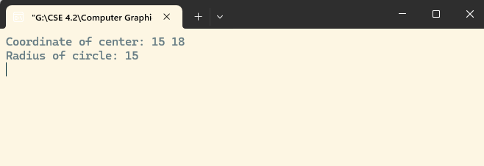

**Fig: input initial point and end point**

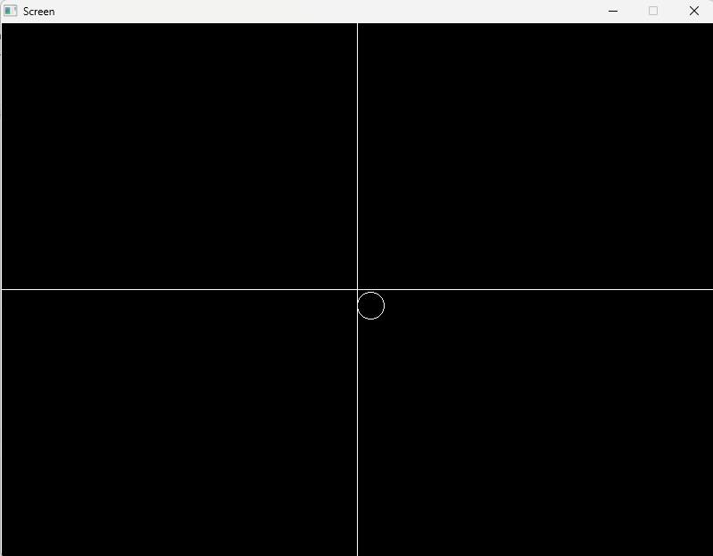

**Fig: picture of line drawing**