1) Problem Description & Solution Approach
Problem Overview
The Eastgate Center at Penn State Harrisburg requires an autonomous delivery robot to navigate a grid-based office layout. The robot must transport documents from a reception desk to various offices while optimizing for:
- Shortest path distance considering terrain variations
- Obstacle avoidance (desks, walls, restricted areas)
- Dynamic environment handling (new obstacles may appear)
- Efficient navigation through slow zones (e.g., carpeted areas with higher traversal costs)
Solution Approach: A* Search Algorithm
Why A?* A* combines:
- g(n): Actual cost traveled from start to current node
- h(n): Heuristic estimate from current node to goal
- f(n) = g(n) + h(n): Total estimated cost
This guarantees optimal paths when the heuristic is admissible (never overestimates true cost).
Key Implementation Features
1. 8-Directional Movement Support
- Orthogonal moves (up, down, left, right): Cost = 1
- Diagonal moves (all 4 diagonals): Cost = √2 ≈ 1.414
- Diagonal blocking logic: Prevents unrealistic corner-cutting through obstacles
2. Terrain-Aware Heuristic
Standard Manhattan distance doesn't account for slow zones. The custom heuristic:
h(n) = manhattan_distance(n, goal) × average_terrain_cost
This provides:
- Admissibility: Still underestimates (adjusted by average, not max cost)
- Consistency: Values decrease monotonically toward goal
- Better guidance: Steers robot away from slow zone areas
3. Terrain Cost Integration
- Normal zones: Cost multiplier = 1
- Slow zones (carpet): Cost multiplier = 2
- Movement cost = direction_cost × terrain_cost
  - Example: Diagonal through slow zone = 1.414 × 2 = 2.828
4. Dynamic Obstacle Handling
- If obstacles appear, the algorithm reruns with updated grid
- Closed set prevents revisiting explored nodes
- Priority queue ensures optimal ordering
2) Output Solutions with Explanatory Notes
Test Case 1: Standard Navigation (0,0) → (4,4)
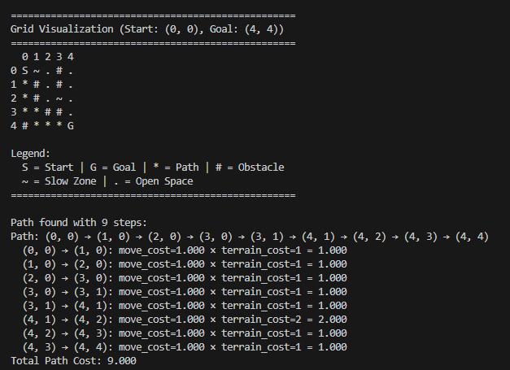
- Path avoids most slow zones except necessary crossing at (4,2)
- Robot forced to travel right edge of grid

Test Case 2: Different Start Point (2,0) → (4,4)
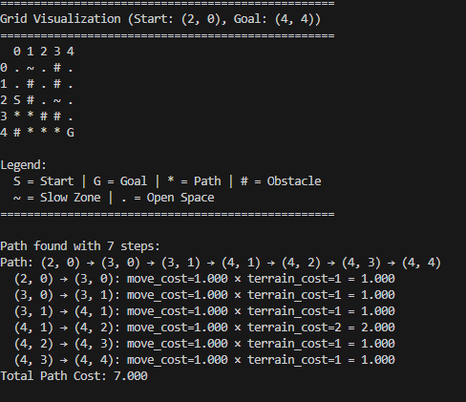
- Shorter straight-line distance to goal
- Still avoids slow zone at (0,1) by starting lower
- Crosses slow zone at (4,2) - unavoidable due to goal position

Test Case 3: Dynamic Obstacle Addition
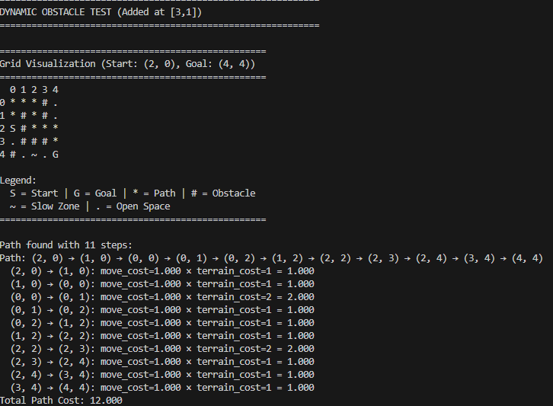
- Algorithm successfully reroutes around new obstacle
- Takes longer path through upper portion of grid

3) Answer/solutions parts (h) and (i)
(h) Why Must the Heuristic Be Admissible?
Admissibility Definition: A heuristic h(n) is admissible if h(n) <= actual cost from n to goal for all nodes n.
- Optimality Guarantee
  - A* only finds optimal paths with admissible heuristics
  - Non-admissible heuristics can overestimate and cause A* to accept suboptimal solutions
  - Example: If h estimates 10 but true cost is 5, A* might wrongly choose this path

(i)How Do Diagonal Moves Affect Optimality?
Impact on Path Quality:
- Reduced Total Distance
  - Diagonal moves enable shorter geometric paths
  - Distance reduction: Diagonal = 1.414 vs. two orthogonal moves = 2.0
  - Savings: ~29% per diagonal move used
- Maintained Optimality
  - Diagonals don't compromise optimality if properly costed
  - A* still finds optimal path with correct costing

4) Assumptions Made
Grid Representation
  - Assumption: 0 = passable, 1 = obstacle (as provided in the question)
  - Robot occupies exactly one cell (no size consideration)
  - Grid boundaries are hard limits (no wrapping)
- Terrain Costs
  - Assumption: Costs apply uniformly across cells (enter cost = same everywhere in cell)
  - Slow zones don't affect turning (cost only for movement)
- Movement Model
  - Assumption: Robot can move in 8 directions simultaneously available
  - No acceleration/deceleration (instant movement)
  - No rotational cost (can face any direction instantly)

