1. Create database

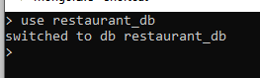

1. Insert Values using the insertOne



1. Insert values using InsertMany

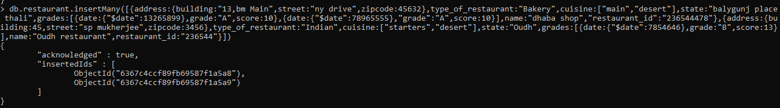

4.Display all the records.

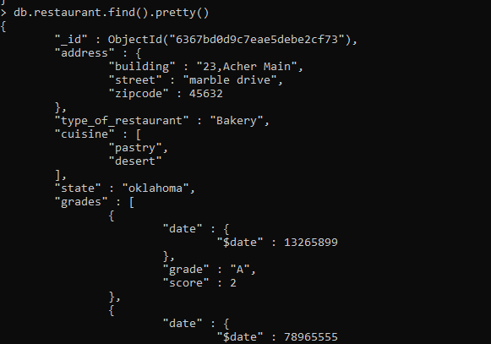

5.Display all restaurant that is type Bakery.

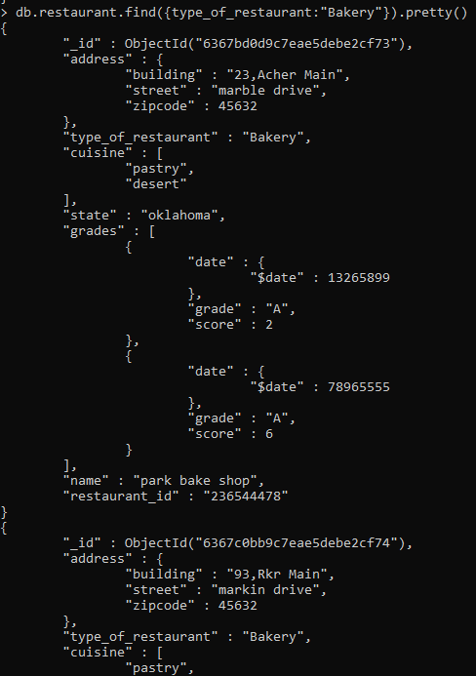

6.Find cuisine that serves main or Chinese

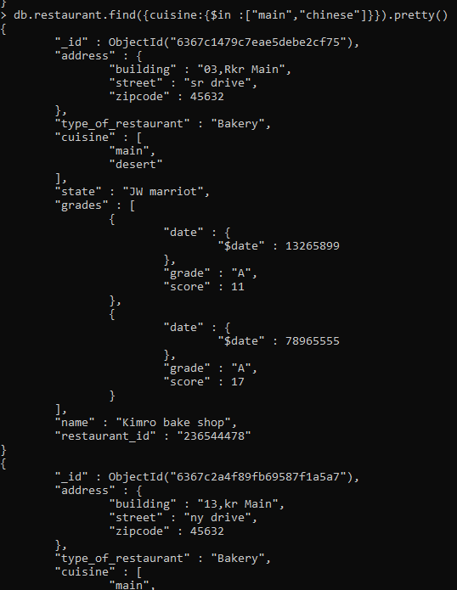

6.Display the fields where score greater than 10

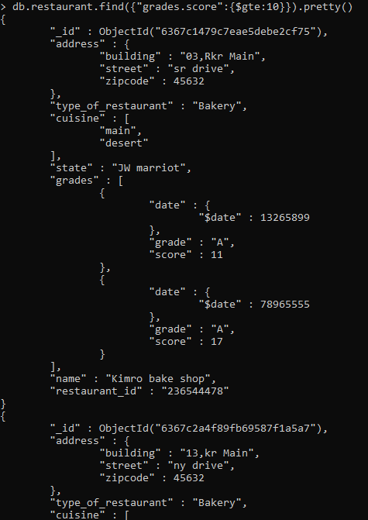

7. Total score

