Game Design Document

Fill up the Following document

1. Write the title of your project.

To Do List

1. What is the goal of the game?

To store all the inputs given by the user as tasks to be done

1. Write a brief story of your game?

The viewer can input tasks to be done and press the enter button

So the tasks get stored in databse under the task number and reset

displayed as text in task coloumn,one can reset it by clicking on he

1. Which are the playing characters of this game?

* Playing characters are the ones which respond to the user based on the input from the user
* Cars, monkeys, dinos, wizards etc, are the playing characters in the game.

|  |  |  |
| --- | --- | --- |
| Number | Character Name | What can this character do? |
| 1 |  |  |
| 2 |  |  |
| 3 |  |  |
| 4 |  |  |
| 5 |  |  |
| 6 |  |  |
| 7 |  |  |
| 8 |  |  |

1. No characters
2. Which are the Non Playing Characters of this game?

* Non Playing characters are the ones which don't have an action or a behaviour when the user interacts with the game.
* Hurdles, stones, bananas, coins, etc are non playing characters in the game.

|  |  |  |
| --- | --- | --- |
| Number | Character Name | What can this character do? |
| 1 |  |  |
| 2 |  |  |
| 3 |  |  |
| 4 |  |  |
| 5 |  |  |
| 6 |  |  |
| 7 |  |  |
| 8 |  |  |

No characters

Draw your imagination of this game. What does this game look like?

* Draw the game either on your computer or on paper,
* Add images of scenes of the game to show each of the playing and non-playing characters at least once.

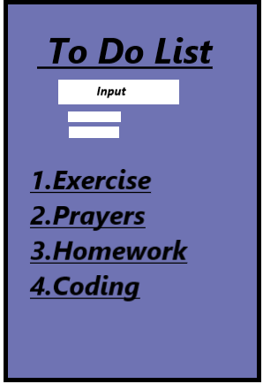

How do you plan to make your game engaging?

Its organizes all the tasks to be done in a period of time (day,week,month,etc), this will make the users to give a regular visit to this list.