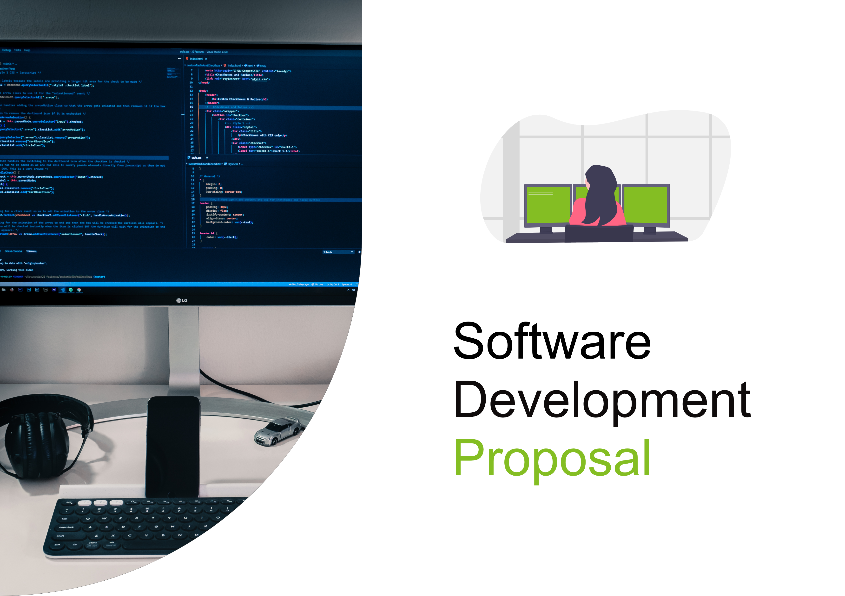
Daikibo Industrials
Real-Time Manufacturing Status Dashboard
Software Development Proposal
Prepared for Daikibo Industrials
Daikibo Industrials | Real-Time Manufacturing Status Dashboard

1. Overview
This proposal outlines the development of a private, real-time manufacturing status dashboard for Daikibo Industrials. The dashboard will provide a centralised view of the health status of monitored manufacturing equipment across Daikibo's four factories.
The solution will monitor nine machines in each factory, covering a total of 36 machines. Users will access the dashboard only through the client's intranet and will authenticate using their existing company-wide accounts through the internal authentication server.
The dashboard will be delivered as a single-page application showing the current status of all monitored devices. Information will be organised by factory and device, with collapsible and expandable views allowing users to move from a factory-level overview to individual devices and review their status history.

2. Scope
The project will include the design, development, testing and intranet integration of the manufacturing status dashboard. The following functionality is included in the proposed scope:
- Real-time status overview for all 36 monitored machines across the four Daikibo factories.
- A single-page dashboard listing the current health status of every monitored device.
- Factory-level grouping so users can quickly identify the status of equipment at each factory.
- Expandable and collapsible factory sections to provide a clear high-level or detailed view.
- Expandable and collapsible device sections showing the current status and available status history.
- Integration with the client's internal authentication server so users can sign in with their existing company accounts.
- Intranet-only access to keep the dashboard within the client's internal network.
- A straightforward interface designed for quick monitoring of manufacturing equipment.
The dashboard will follow the factory/device hierarchy represented by the wireframe in the provided proposal template, with users able to expand the required level of detail without leaving the main page.

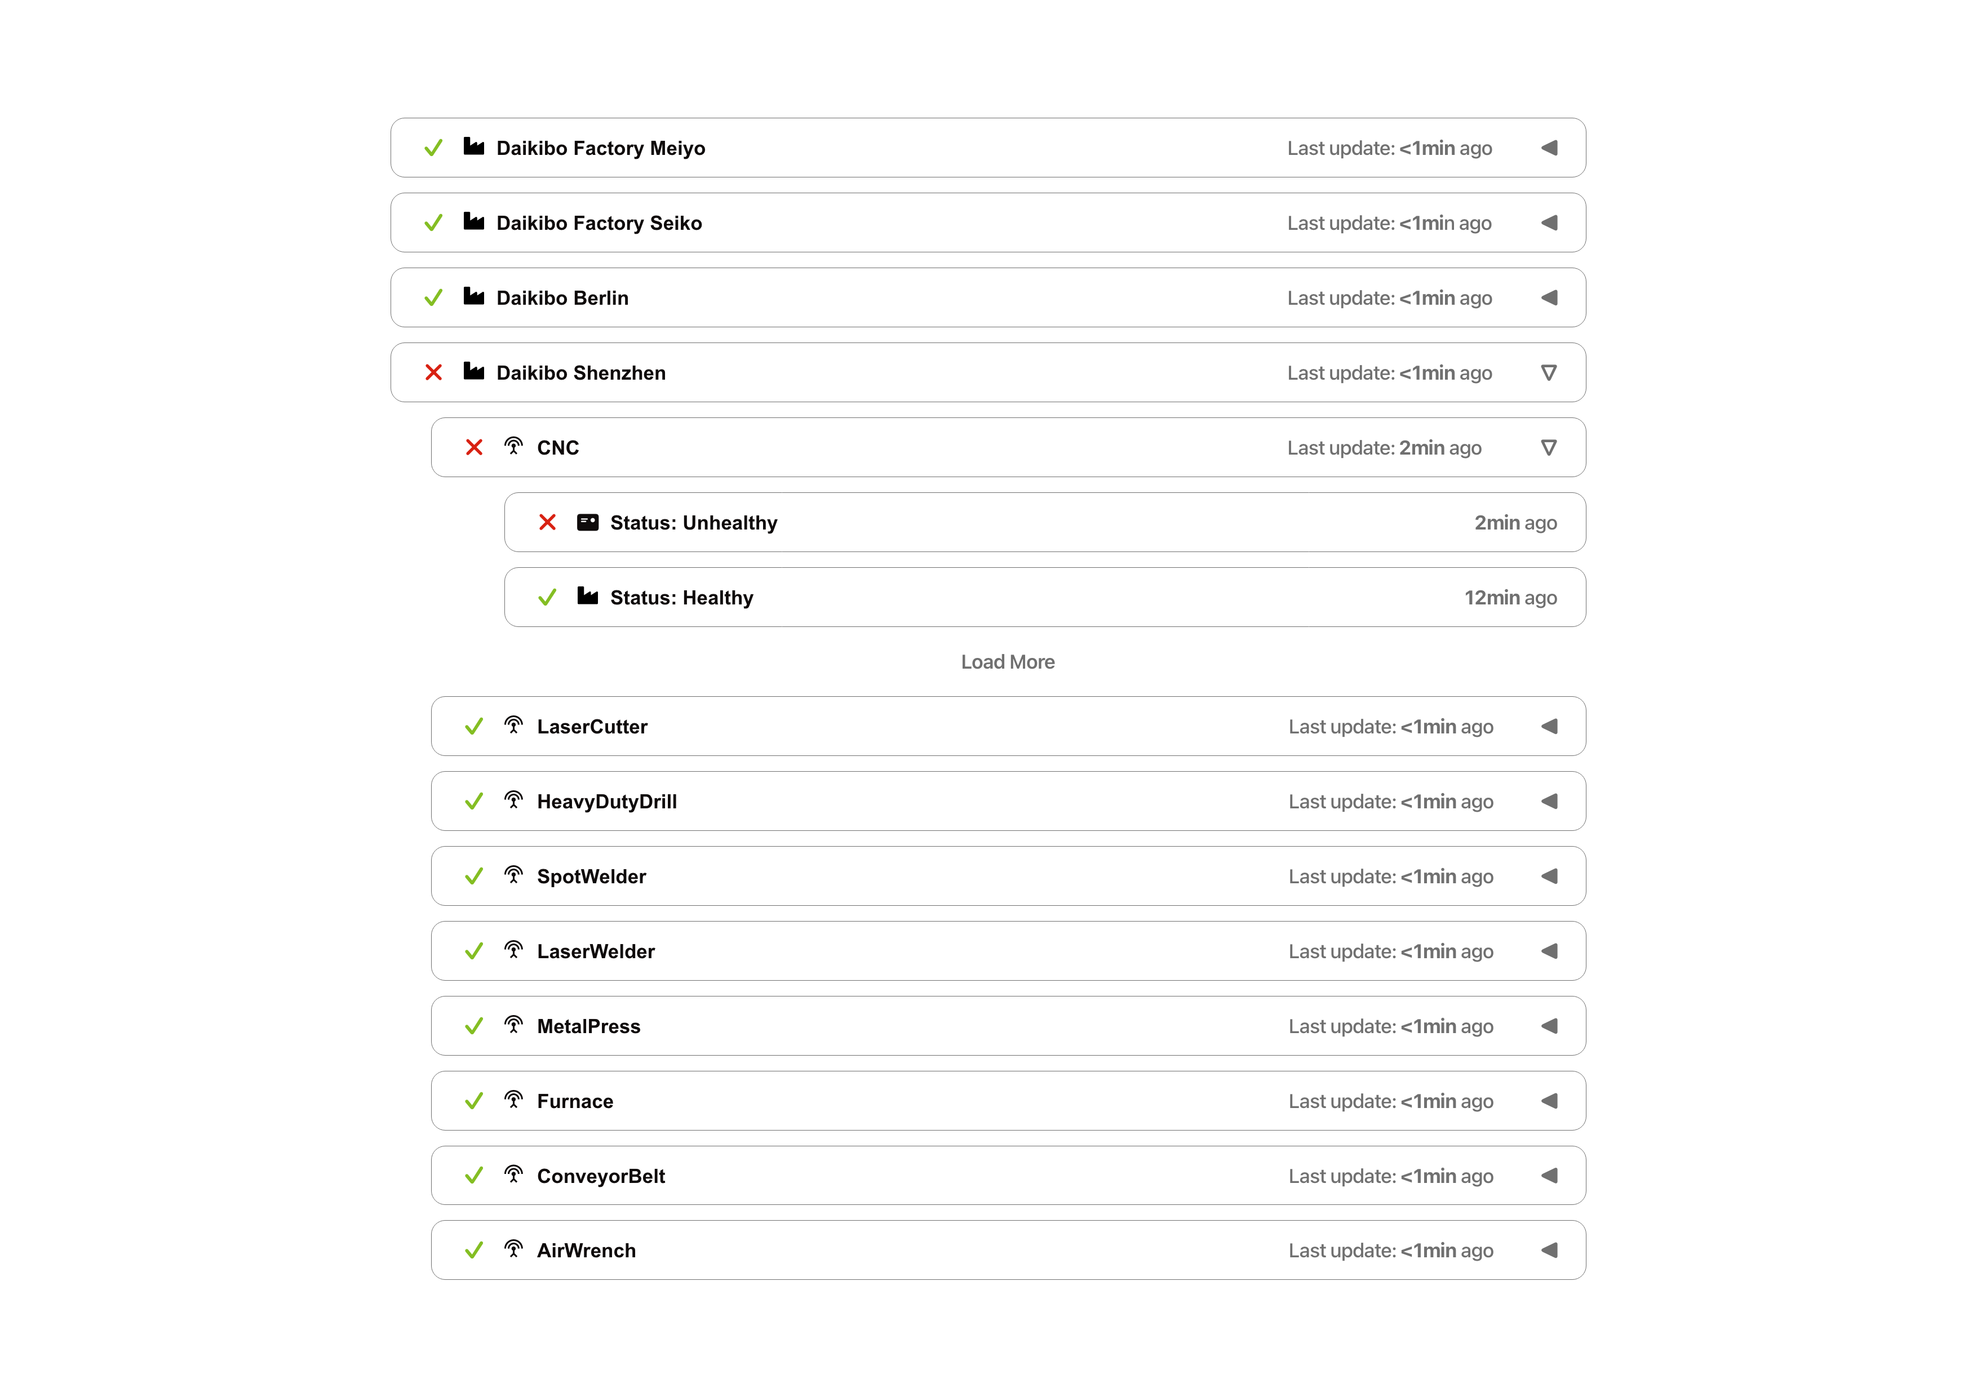
Figure 1 — Dashboard wireframe: factory and device status hierarchy

3. Estimate
The following estimate covers development of the dashboard, functional and integration testing, and deployment/integration within the client's intranet.
Activity | Hours | Description
Development | 80 | Dashboard UI, real-time status display, factory/device expand-collapse behaviour, status history and authentication integration.
Testing | 24 | Functional, usability, authentication, data/status display and regression testing.
Integration | 16 | Client intranet integration, internal authentication server integration and deployment support.
Total | 120 | Total estimated effort for the project.

4. Timeline
The project is expected to be completed through the following milestones. The schedule is indicative and may be refined following confirmation of the client's technical and intranet requirements.
- 1 September 2024 — Design starts
- 6 September 2024 — Requirements and dashboard design finalised
- 13 September 2024 — Core dashboard development completed
- 18 September 2024 — Authentication and intranet integration completed
- 23 September 2024 — Testing and defect fixing completed
- 27 September 2024 — Client review and final adjustments
- 30 September 2024 — Production deployment and project handover

5. Support
Daikibo can rely on continuous product support following deployment of the dashboard. Support will include investigation and resolution of software defects, handling of support tickets, assistance with operational issues and maintenance required to keep the product reliable.
The support service can also accommodate future enhancements and new functionality as the client's manufacturing monitoring requirements evolve. This provides a path for the dashboard to be maintained and improved beyond the initial implementation.
Ongoing support will help ensure that the dashboard remains a dependable tool for monitoring the health of Daikibo's manufacturing equipment and supporting day-to-day operational visibility.

