EWB PYTHON WITH AI INTERNSHIP
PROJECT DOCUMENTATION

1. Project Title
Student Performance Analytics System
Student Name: Md Zeeshan
Internship: Python with AI — EWB
Project technologies: Python, NumPy and Pandas

2. Objective
The objective of this project is to analyze student marks and attendance from a CSV dataset. It calculates total marks, summarizes class performance, compares subject-wise marks, identifies top-performing students, checks attendance below 75%, and displays student grades and pass/fail results.

3. Technologies Used
- Python — program logic, loops and reusable functions.
- Pandas — reading the CSV file, working with tabular data, calculating summaries and selecting records.
- NumPy — calculating total marks in the reusable function.
- CSV — storing the student dataset.

4. Dataset Description
The project uses students.csv, containing 20 student records. Its columns are Roll_No, Name, Python, Java, C++, and Attendance. The three subject-mark columns are used to calculate total marks. Attendance is used to find students below 75% attendance.
The dataset supplied for this documentation contains 20 rows, with subject marks and attendance values for each listed student.

5. Implementation
- The program loads students.csv into a Pandas DataFrame using read_csv().
- It creates a Total column by adding the Python, Java and C++ marks.
- The class performance function calculates the number of students, average total marks, highest and lowest total marks, pass/fail counts, and the subject with the highest average.
- Subject-wise functions identify the highest marks, average marks and lowest marks for Python, Java and C++.
- The top-performer function uses nlargest() to display the three students with the highest total marks.
- The attendance function calculates average attendance and lists students whose attendance is below 75%.
- The results function loops through the dataset, uses the pass/fail function, assigns a grade to students who pass, and displays the results table.
- The functions.py file uses NumPy to calculate total marks and contains functions for average marks, grades and pass/fail decisions.

6. Key Features
- Calculate total marks for each student.
- Display class-level average, highest and lowest total marks, and pass/fail counts.
- Show subject-wise maximum, average and minimum marks.
- Display the top three students by total marks.
- Calculate average attendance and list students below 75%.
- Display grades and pass/fail results for all 20 students.

7. Output / Screenshots (optional)
The screenshots below were generated from the submitted main.py, functions.py and students.csv content by running the program. They show the program's actual printed results.
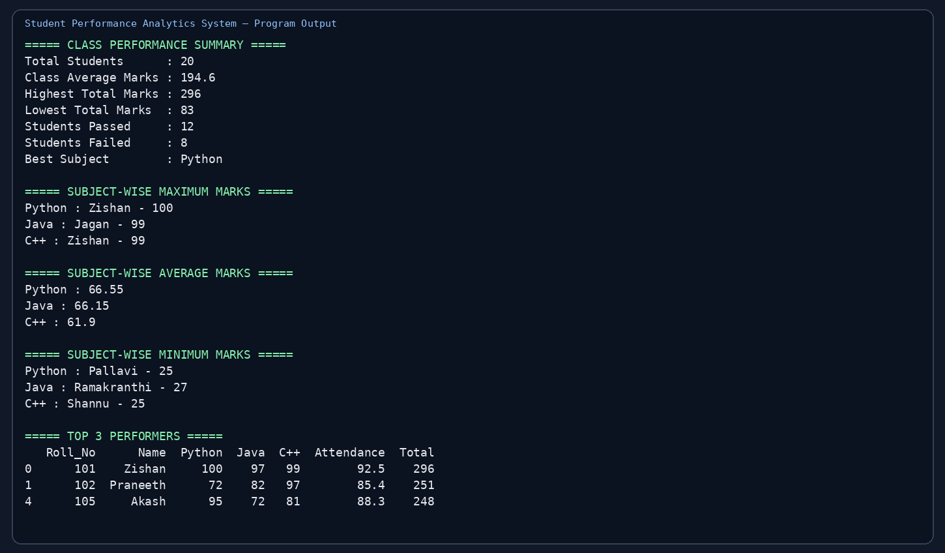
Figure 1. Class summary, subject-wise analysis and top performers.
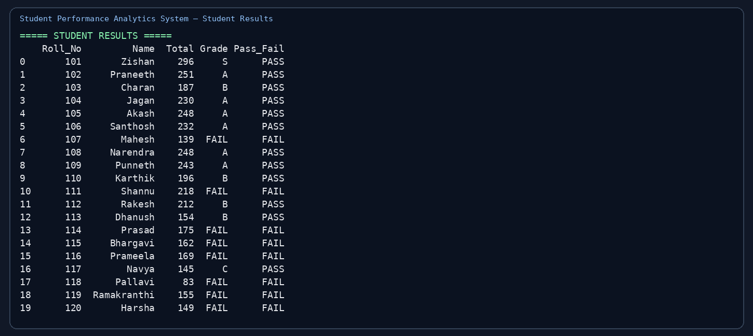
Figure 2. Student grades and pass/fail results.

8. Final Outcome
The program ran successfully with the supplied dataset and printed a class performance summary, subject-wise statistics, top three performers, attendance analysis, and student results. In this run, it processed 20 students, reported a class average total of 194.60, a highest total of 296, a lowest total of 83, 12 students passed, and 8 students failed. Python had the highest subject average in this dataset.

9. Challenges & Learning
- Grade boundary testing: tested values around the grade conditions to check the returned grade.
- None result: a boundary test initially returned None; the grade condition was adjusted so the tested boundary returned a grade.
- Pass/fail handling: ensured that a student who fails any subject is shown with Grade = FAIL in the results table.
- Data analysis practice: learned to load CSV data, calculate summaries, compare subject marks and filter attendance records using Pandas and NumPy.

10. GitHub Repository
Repository URL:
https://github.com/mdzeeshan14160/Student-Performance-Analytics-System
The repository URL above was provided for this documentation. Please confirm the repository contains the final code, students.csv, README and this documentation before submitting the link in the EWB Google Form.

