# Lab 1 Pre-lab Example

Team Information

**Lab number:** Lab 1

**Date:** 09/24/2015

**Team Members:**

**Team Number/Name:** 207

# Hardware

## Part 1

Team Member Responsibilities

**Software Design:** Matthew Dzurick

**Hardware Design:** Avinash Tiwari

**Quality Assurance:** Toan Chu

**Systems Integrator:** Dalton Hirst

Draw the schematics or create a table detailing the connections for Part 1 of Lab 1. An example of the level of detail that is expected is given below.

|  |  |  |  |  |  |  |  |  |  |  |  |  |  |  |  |  |  |  |  |  |  |  |  |  |  |
| --- | --- | --- | --- | --- | --- | --- | --- | --- | --- | --- | --- | --- | --- | --- | --- | --- | --- | --- | --- | --- | --- | --- | --- | --- | --- |
| Expansion  Board J  10 | | | | | | | | | | | | | | | | | | | | | | | | | |
| 59 | 57 | 55 | 53 | 51 | 49 | 47 | 37 | 35 | 33 | 31 | 29 | 27 | 25 | 23 | 21 | 19 | 17 | 15 | 13 | 11 | 9 | 7 | 5 | 3 | 1 |

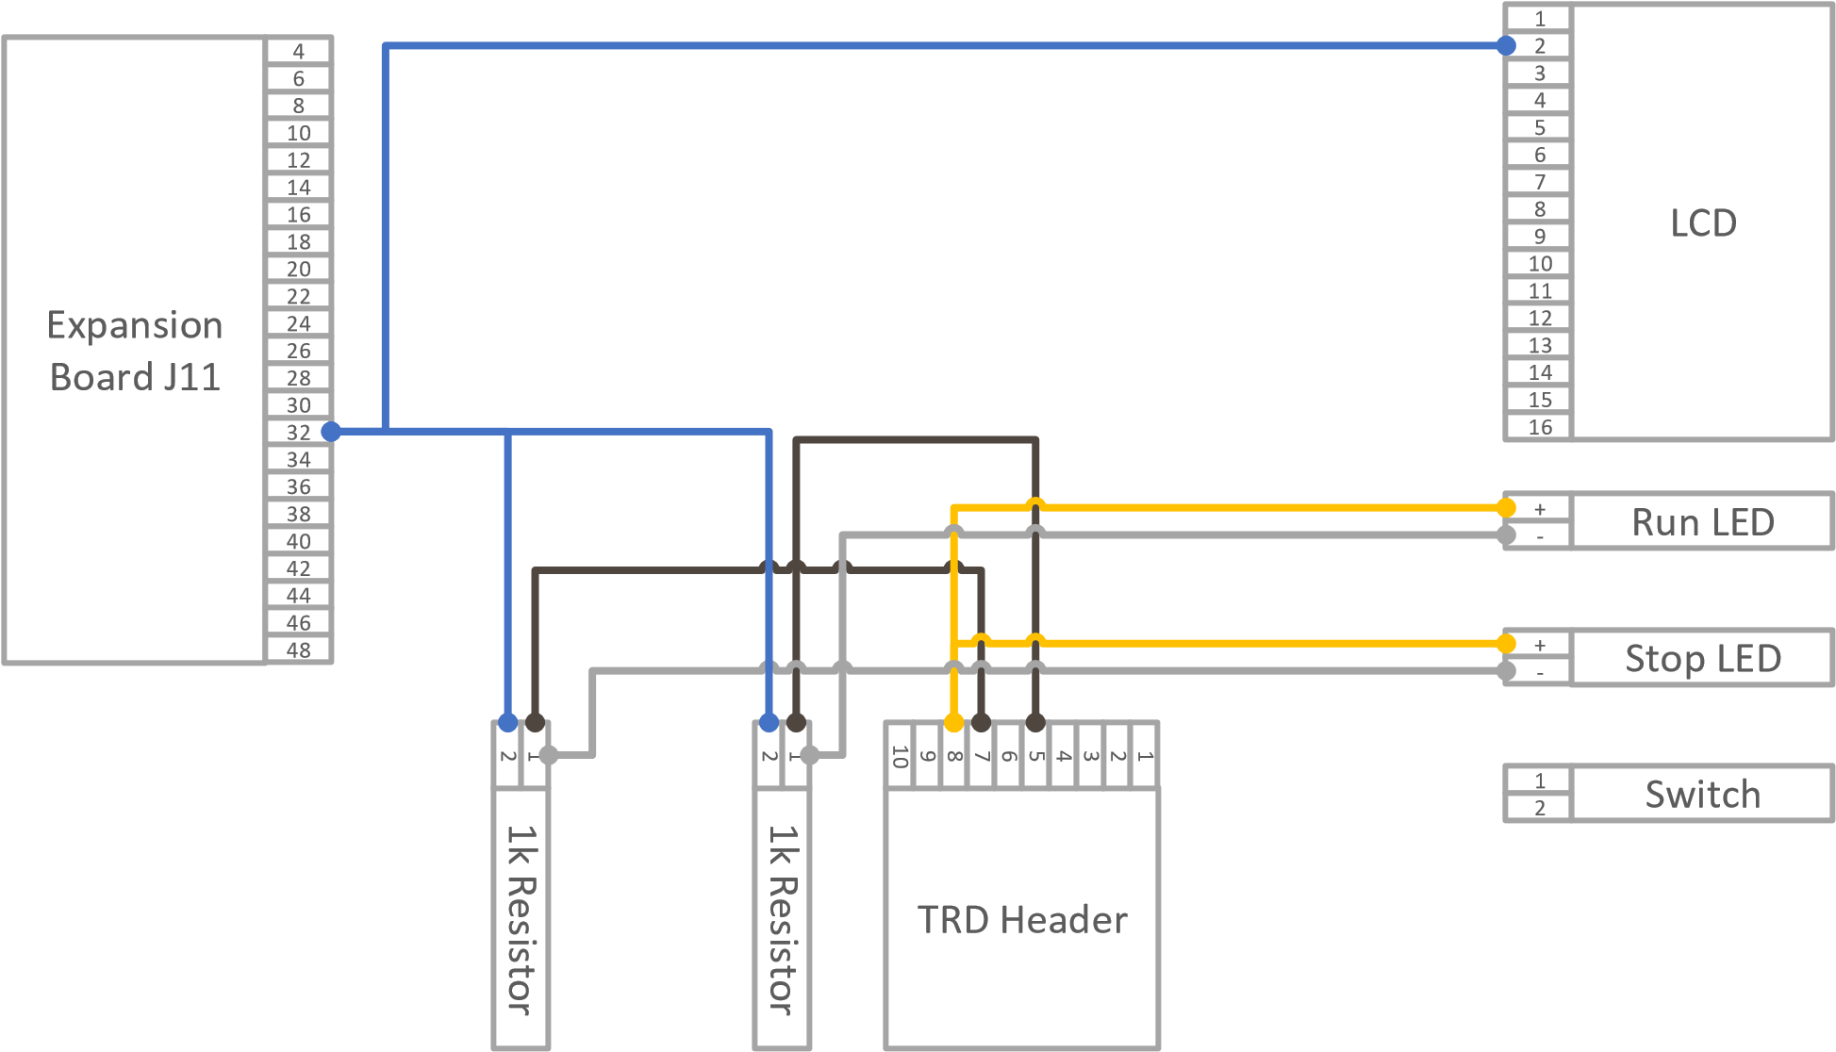

## Part 2

Draw the schematics or create a table detailing the connections for Part 2 of Lab 1. You can choose to use a table or use a diagram.

## Part 3

Draw the schematics or create a table detailing the connections for Part 3 of Lab 1. You can choose to use a table or use a diagram.

# Tests

## Part 1

List the tests that you intend to do based on the Lab 1 procedures. Describe the name of the test, the tool you intend to use, and a description of the test. Do this for each part in Lab 1.

|  |  |  |
| --- | --- | --- |
| **Test Name** | **Tool** | **Description** |
| Continuity Test | Digital Multi-meter | Test all wire connectors, solder joints, and wire-wraps for continuity |
| Power Test | Digital Multi-meter | Test that any created circuits have power correctly flowing |
| Grounding Test | Digital Multi-meter | Test that any switches connected to ground actually ground a powered circuit |
| Component  Test | Digital Multi-meter | Test that appropriate pins on the switch are connected |

You may also include any software tests that you intend to make.

|  |  |  |
| --- | --- | --- |
| **Test Name** | **Input** | **Description** |
| timerTick Test |  | Test that timerTick indeed ticks at the correct interval |
| displayTime Test | “10000” | Test that this function assigned the appropriate register to “10:00:00.” |
| Register Test |  | Test that the register configurations for the timer work. |

Part 2 Part 3

# Software

## Part 1

List the relevant control registers for controlling the LEDs in Part 1 of Lab 1.

|  |  |
| --- | --- |
| **Device:** | **Register(s):** |
| **Digital I/O** |  |

Also describe the function of the microcontroller software as a finite-state machine.

## Part 2

List the relevant control registers for controlling the LCD in Part 2 of Lab 1.

|  |  |
| --- | --- |
| **Device:** | **Register(s):** |
| **Timer** |  |

## Part 3

Also describe the function of the microcontroller software as a finite-state machine in Part 3 of Lab 1.