The workbook will contain 5 sheets.
1. Raw_Sales_Data
2. Product_Variable_Cost
3. Cost_Sheet
4. Fixed_Costs
5. CMA_Template

STEP 1 — Understand the Dataset
- Students open the Excel workbook and review the sheets.

Sheet 1 — Raw_Sales_Data
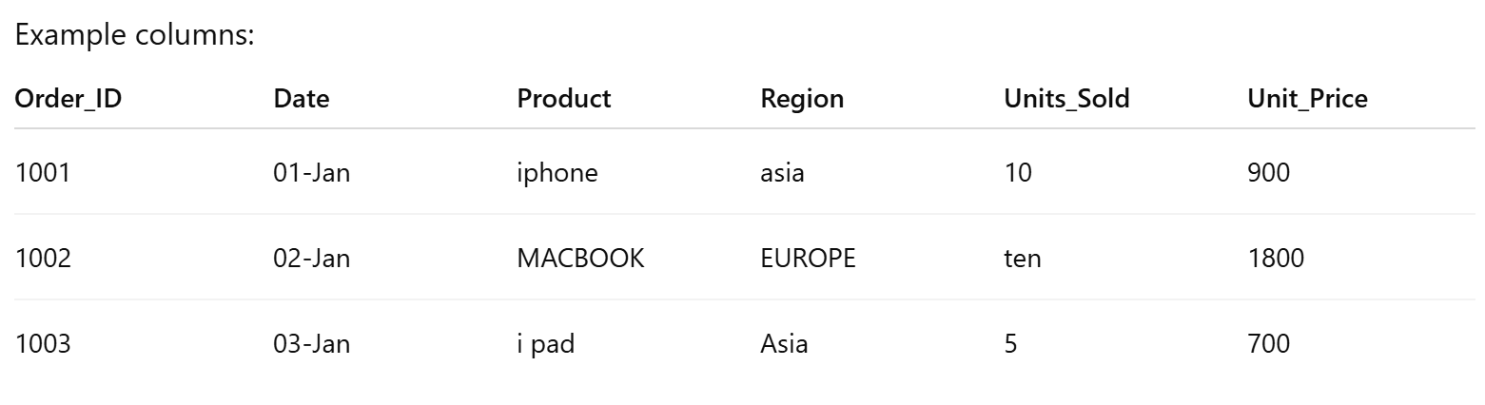

Problems intentionally included:
• inconsistent product names
• inconsistent regions
• text values in numeric column
• messy formatting

Copilot Prompt
Explain the structure of the dataset and identify possible data quality issues.
Students learn data auditing.

STEP 2 — Clean Product Names
Goal
Standardize product names.
Examples
iphone → iPhone
MACBOOK → MacBook
i pad → iPad

Copilot Prompt
Clean the Product column so iphone, MACBOOK and i pad
become iPhone, MacBook and iPad.

Excel Formula
=PROPER(C2)

STEP 3 — Standardize Regions
Example
asia → Asia
EUROPE → Europe
north america → North America

Copilot Prompt
Standardize the Region column to Asia, Europe and North America.

STEP 4 — Fix Units Sold
Sometimes dataset contains text like:
ten
five
three
Students convert to numeric values.

Copilot Prompt
Convert the Units_Sold column into numeric values and replace text
values like "ten" with numbers.
Students learn data cleaning with AI assistance.

STEP 5 — Convert Dataset into Excel Table
Select dataset → Ctrl + T
Name table
tbl_sales
Benefits
• dynamic formulas
• automatic pivot tables
• easier analysis

Copilot Prompt
Convert this dataset into an Excel table for easier analysis.

STEP 6 — Create Sales Column
Add new column
Sales
Formula
=[@Units_Sold] * [@Unit_Price]
Example
Units Sold = 10
Unit Price = 900

Sales = 9000

Copilot Prompt
Create a Sales column by multiplying Units_Sold by Unit_Price.

STEP 7 — Product Variable Cost Lookup
Go to sheet Product_Variable_Cost
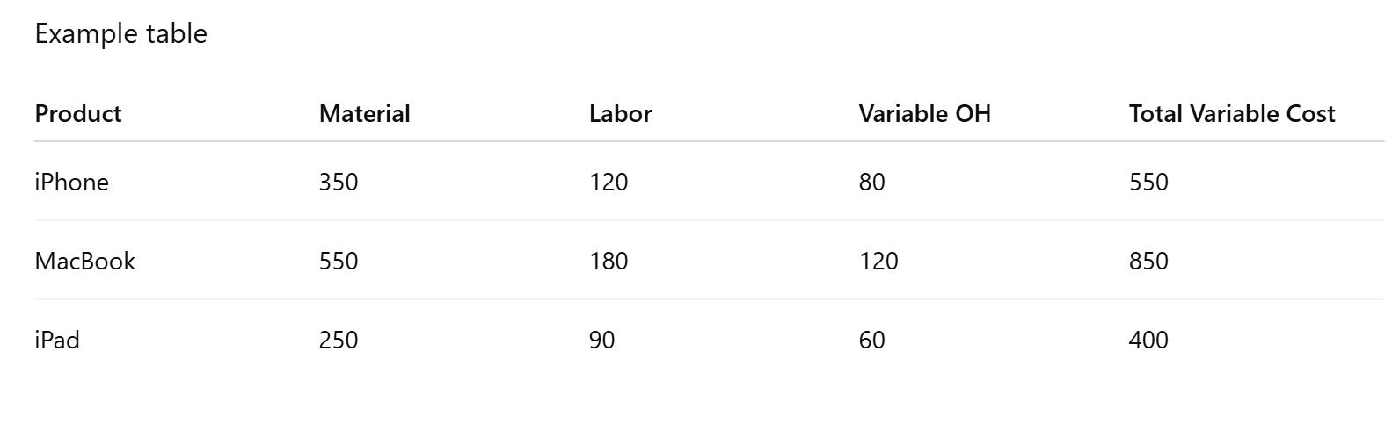

Students bring Total Variable Cost per unit into the sales sheet.

Formula
=XLOOKUP([@Product],Product_Variable_Cost!A:A,Product_Variable_Cost!E:E)
Students learn XLOOKUP function.

Copilot Prompt
Bring Total Variable Cost from Product_Variable_Cost sheet
using the Product column.

STEP 8 — Calculate Total Variable Cost
Formula
Total Variable Cost = Units_Sold * Variable Cost per Unit
Excel formula
=[@Units_Sold] * [@Variable_Cost]

STEP 9 — Contribution Analysis
Students calculate Contribution.
Formula
Contribution = Sales - Total Variable Cost
Excel
=[@Sales] - [@Total_Variable_Cost]

Contribution Margin %
Contribution / Sales
Excel
=[@Contribution] / [@Sales]
Students learn Contribution Margin analysis.

STEP 10 — Fixed Cost Sheet
Sheet Fixed_Costs
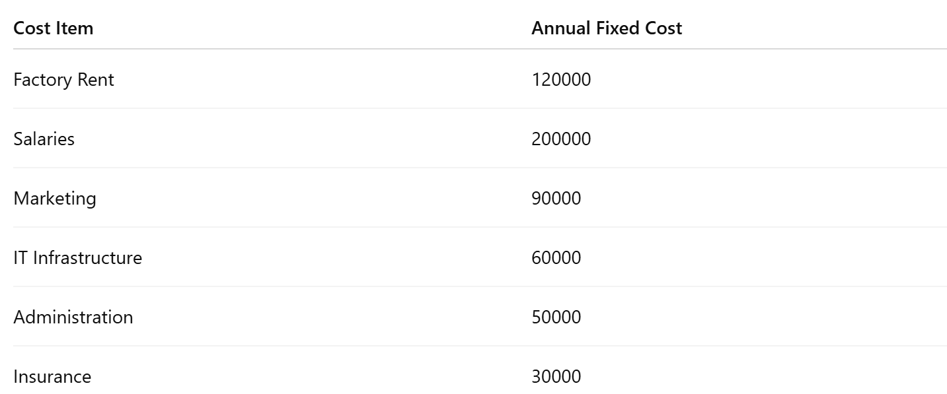Total Fixed Cost
Formula
=SUM(B2:B7)
Example
Total Fixed Cost = 550000

STEP 11 — Break-Even Analysis
Break-even is where
Total Revenue = Total Cost

Contribution per Unit
Selling Price - Variable Cost

Break Even Units
Fixed Cost / Contribution per Unit

Break Even Sales
Fixed Cost / Contribution Margin Ratio

Copilot Prompt
Calculate break-even sales and break-even units using contribution margin.
Students learn Cost-Volume-Profit analysis.

STEP 12 — Margin of Safety
Measures how much sales can fall before losses occur.

Formula
Margin of Safety = Actual Sales - Break Even Sales

MOS %
MOS / Actual Sales

Copilot Prompt
Calculate the margin of safety based on actual sales and break-even sales.

STEP 13 — Pivot Table Analysis
Insert Pivot Table.

Pivot 1 — Sales by Product
Rows
Product
Values
Sum of Sales

Copilot Prompt
Create a pivot table showing sales by product.

Pivot 2 — Sales by Region
Rows
Region
Values
Sales

Copilot Prompt
Create a pivot table showing sales by region.

Pivot 3 — Contribution by Product
Rows
Product
Values
Contribution

Students learn profitability analysis.

STEP 14 — Build CFO Dashboard
Create sheet
CFO_Dashboard

KPI Cards
Create cards showing:
- Total Sales
- Total Variable Cost
- Contribution
- Operating Profit
- Break Even Sales

Charts

Chart 1
Sales by Product
Bar chart

Chart 2
Contribution by Product
Column chart

Chart 3
Sales by Region
Pie chart

Chart 4
Cost Breakdown
Pie chart

Copilot Prompt
Create a financial dashboard showing sales performance,
contribution, profit, and cost breakdown.

STEP 15 — Advanced CMA Concepts (For Teaching Discussion)
After the dashboard, we can explain advanced topics.

1. Contribution per Unit
Selling Price - Variable Cost

2. Contribution Margin Ratio
Contribution / Sales

3. Break-Even Point
Sales level where profit = 0.

4. Margin of Safety
Safety buffer before losses.

5. Profit-Volume Ratio (P/V Ratio)
Contribution / Sales

6. Target Profit Analysis
Sales required to achieve desired profit.

7. Operating Leverage
Contribution / Operating Profit
Measures profit sensitivity to sales changes.

8. Sales Mix Analysis
Profit contribution from different products.

9. Shutdown Point
Minimum sales required to cover variable costs.

10. Make-or-Buy Decision
Compare:
Internal manufacturing cost
vs
Supplier cost
Used in strategic cost management.

