**Topic 1: Prompt Engineering**

Assignment 1: Zero-shot vs Few-shot Prompting

**Objective**

The objective of this assignment is to understand the difference between **zero-shot** and **few-shot prompting** in Large Language Models (LLMs). Zero-shot prompting means giving the model a direct query without examples, while few-shot prompting provides a few labeled examples before the query to guide the model’s response.

Input:

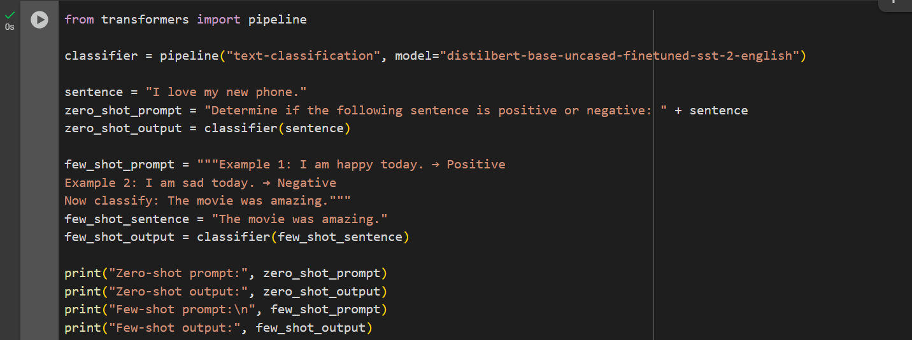

Output:

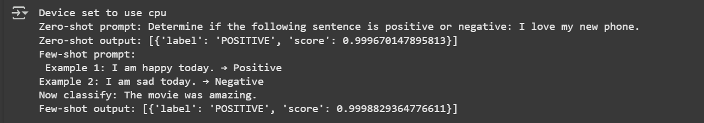

Observations:

For **simple tasks like sentiment analysis**, both zero-shot and few-shot prompting gave correct results.

**Zero-shot** works well for straightforward queries but may struggle with ambiguous sentences.

**Few-shot** prompting provides more context and improves accuracy, especially for more complex or domain-specific tasks.

In this experiment, both approaches gave the same output (“Positive”), but few-shot prompting would likely outperform in more nuanced cases.

**Assignment 2:** Role-based & Chain-of-Thought Prompting

* **Role-based prompting** tailors tone and complexity to the audience (e.g., high school students).
* **Step-by-step prompting** ensures structured reasoning, making complex processes easier to follow systematically.

**Input:**

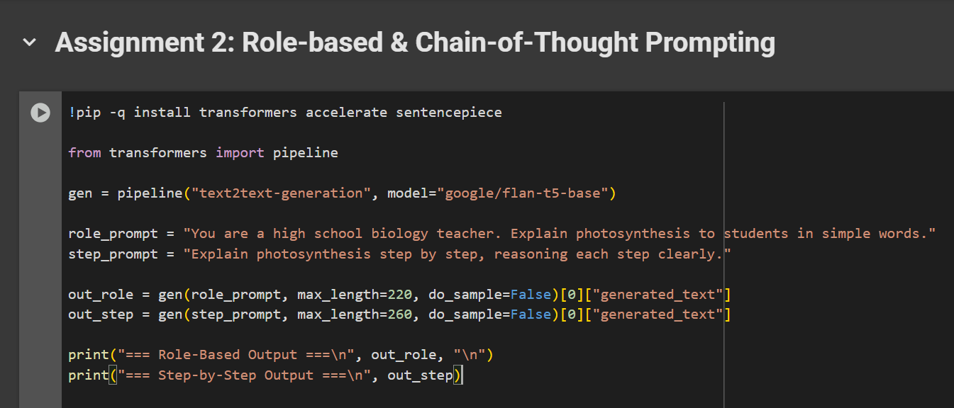

**Output:**

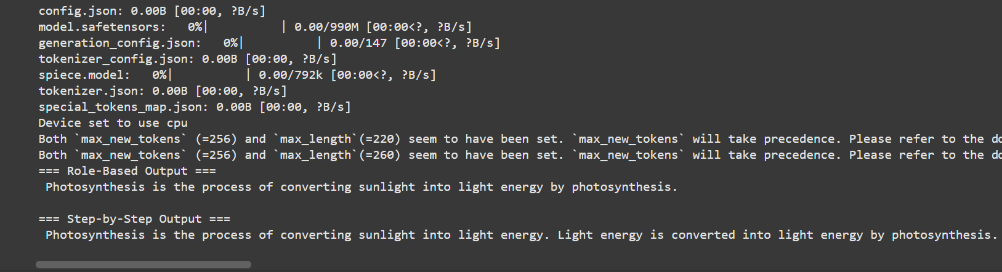

Both the Tasks are performed in Google colab link:

<https://colab.research.google.com/drive/1oeuy1utGoKXHvFbcWci3Rybqslv4hmbQ?usp=sharing>