Project Synopsis – News Portal

1. Project Title:
News Portal

2. Objective:
To develop a responsive, dynamic, and user-friendly web application where users can post, edit, delete, read, search, and categorize news articles in real-time and admin can approve and delete the posted news.

3. Scope:
- - User can manage news content (add/edit/delete).
- - Users can view news by category (Politics, Technology, Sports, etc.).
- -Admin can review the news posted by users and will approve or disapprove it.
- - Responsive design for mobile and desktop.
- - Option for search, filter, and latest news highlights.

4. Modules:
- User Module:
- - View categorized news
- - Search functionality
- - Create, update, delete news articles
- - Manage categories and images
- Admin Module:
- - Login authentication
- - Manage Posted News (Approve / Delete)

5. Tools & Technologies:
- - Frontend: React, CSS, Bootstrap
- - Backend: Node JS, Express JS
- - Database: MongoDB
- - Tools: Visual Studio Code

6. Day-wise Development Plan:

- General Zone
Day 1&2 (Designing of General Zone’s Home Page):
- Menus and Slider

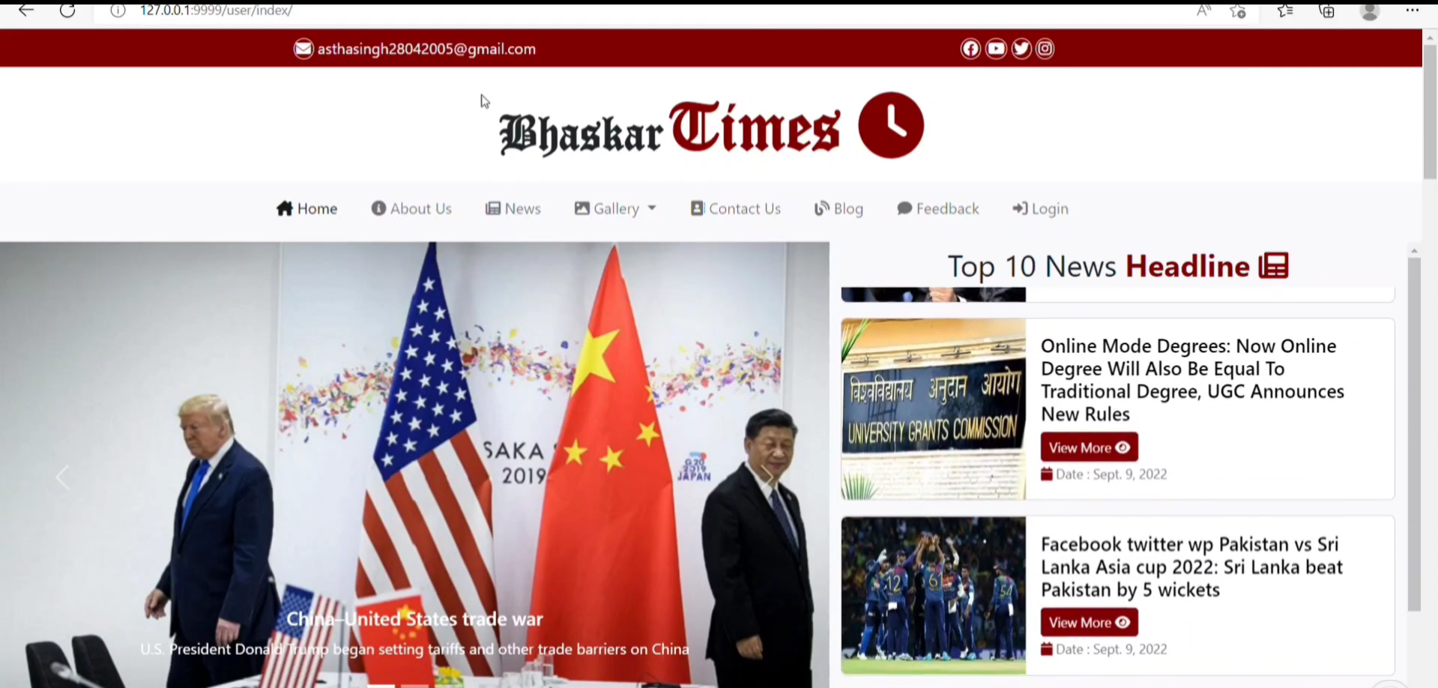

- News Category

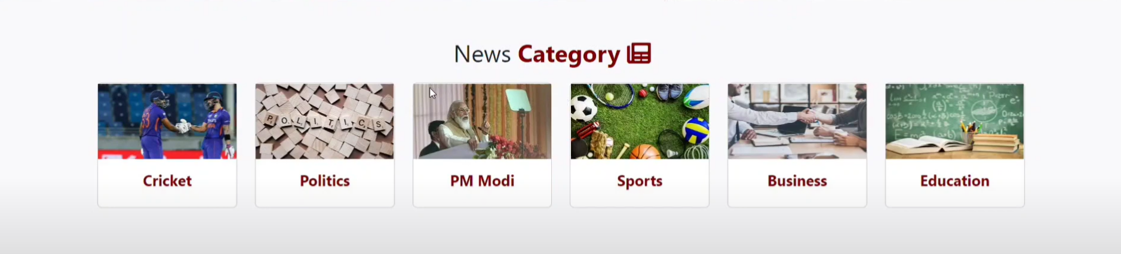

- News Details

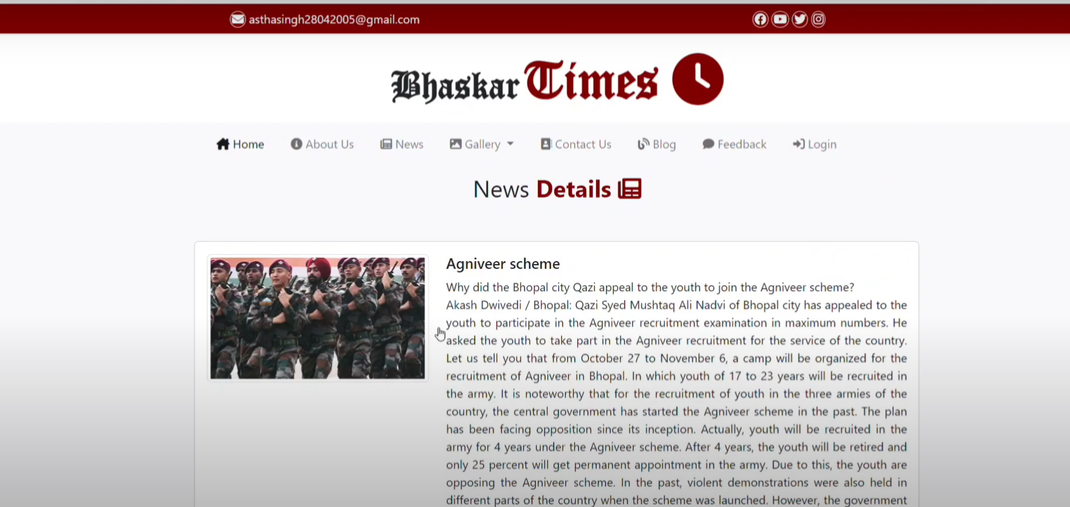

- Latest News

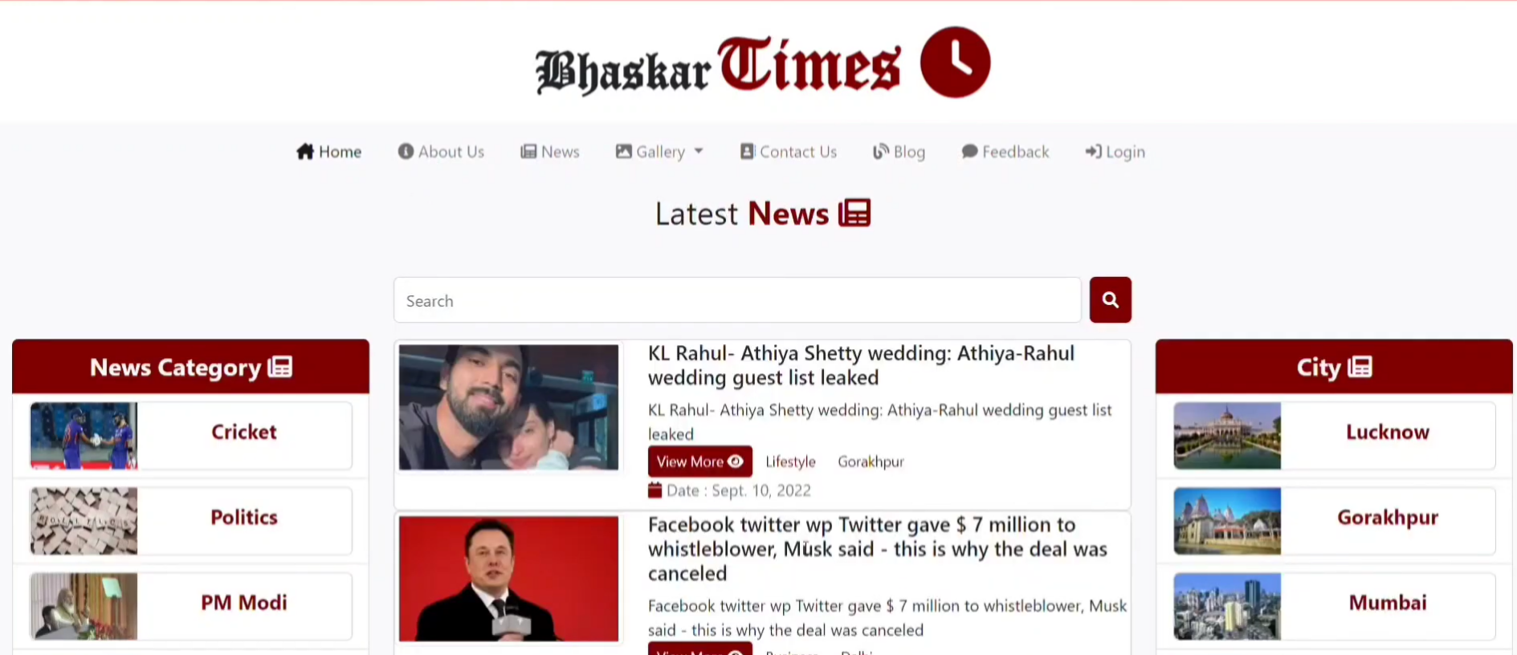

- Latest Videos

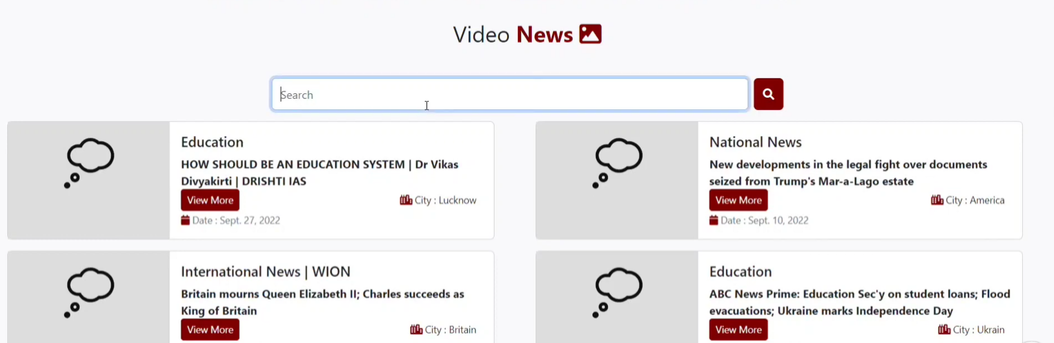

- Cities

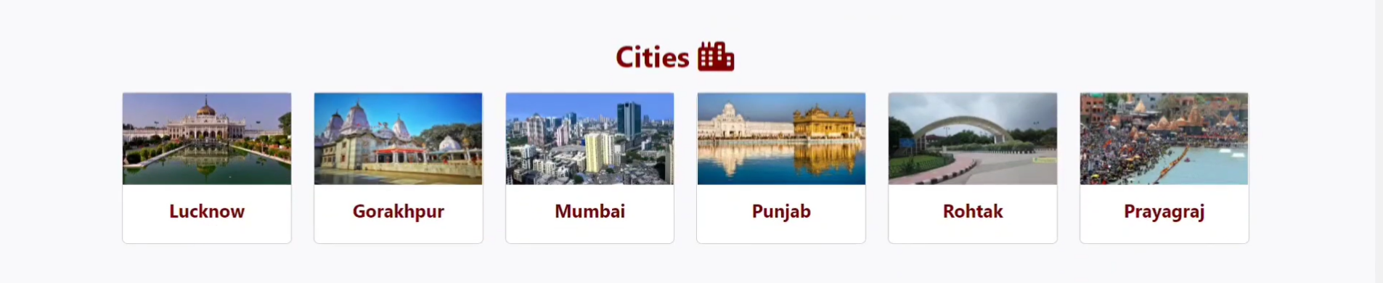

- Image Gallery

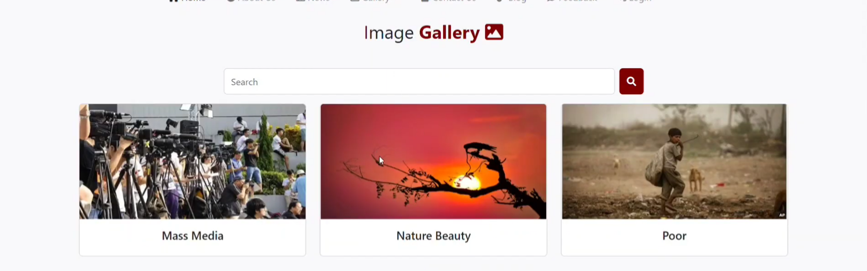

- Contact Us

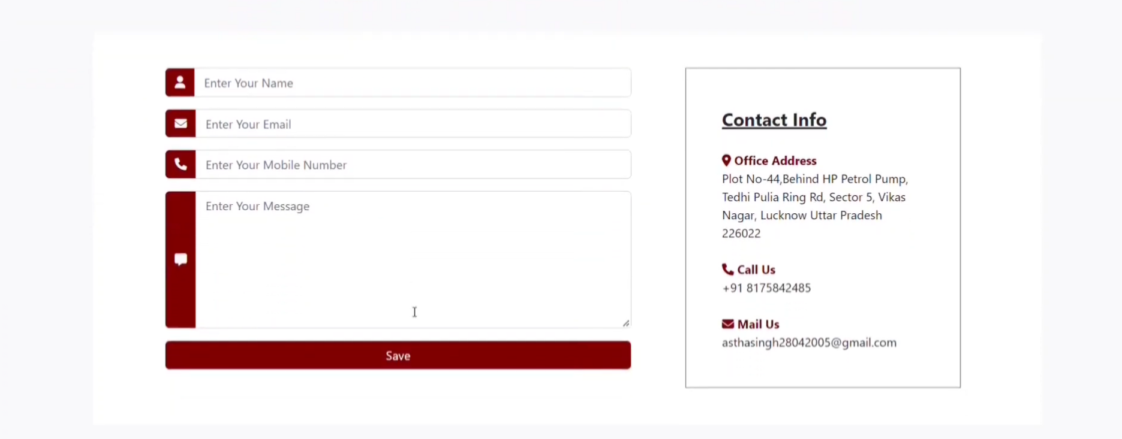

- About Us

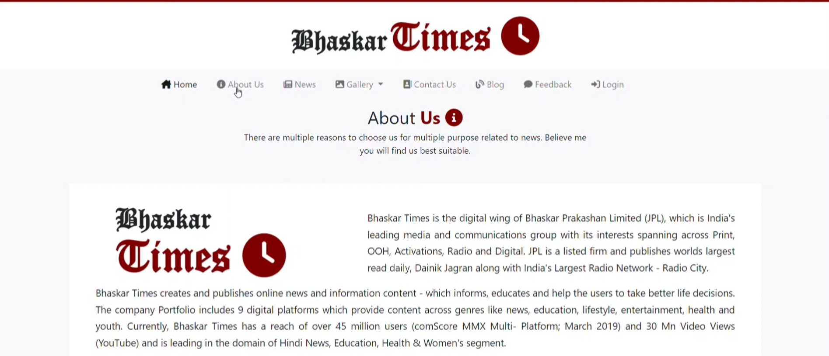

- Feedback

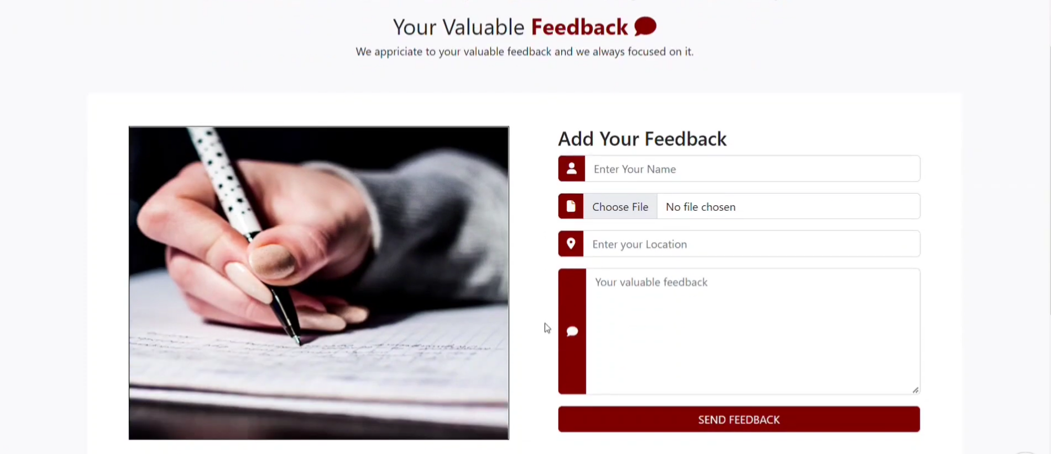

- Footer

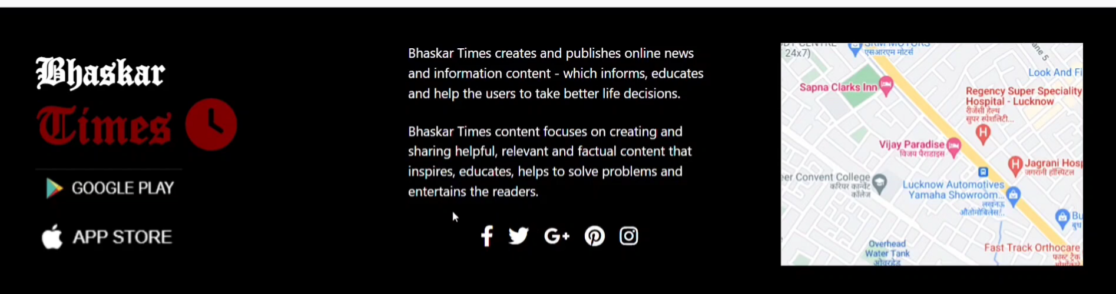

- Admin Zone
Day 3 (Designing and Coding of Admin Registration & Login):
- Admin Registration
Admin Registration through Postman API.
- Admin Login



Day 4 (Designing and Coding of Admin Edit Profile & Posted news table & Logout):
- Admin Edit Profile

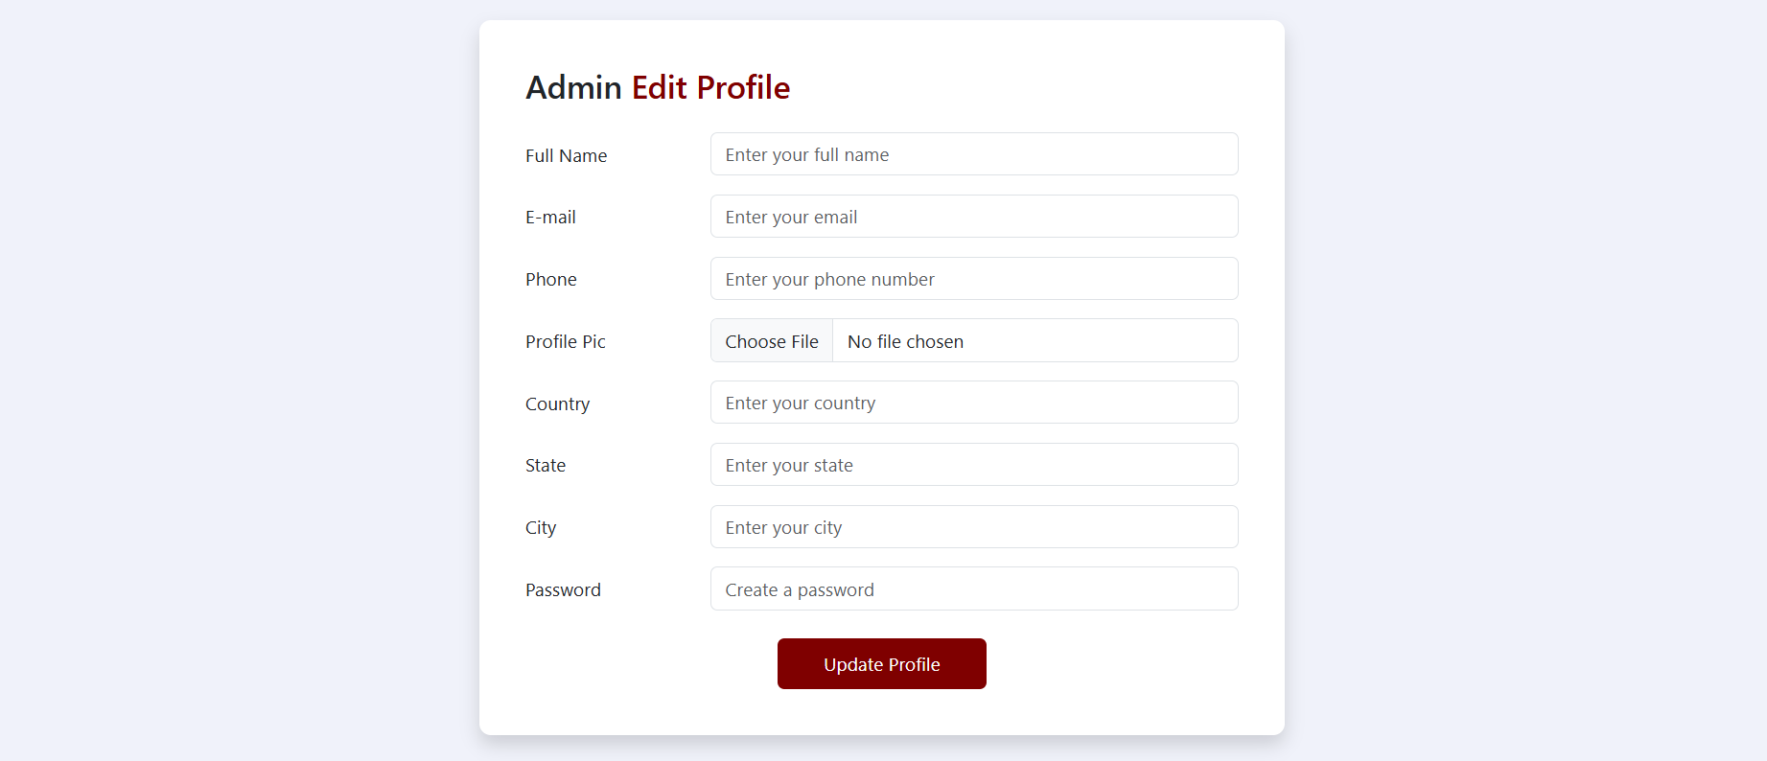

- Posted News Table

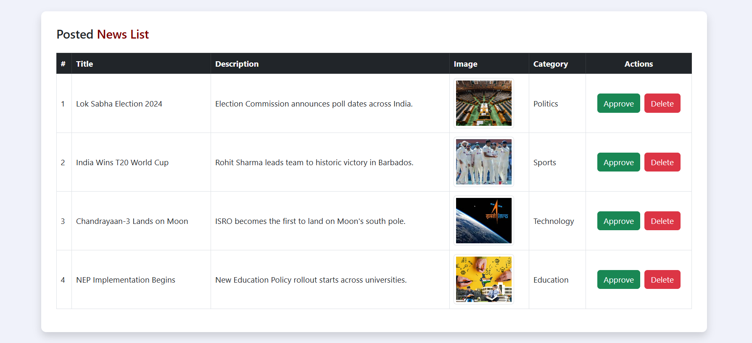

- Logout
Logout page will destroy the created session at the time of login in Admin Zone and redirect at login page.

- User Zone
Day 5 (Designing and Coding of Registration & Login):
- User Registration

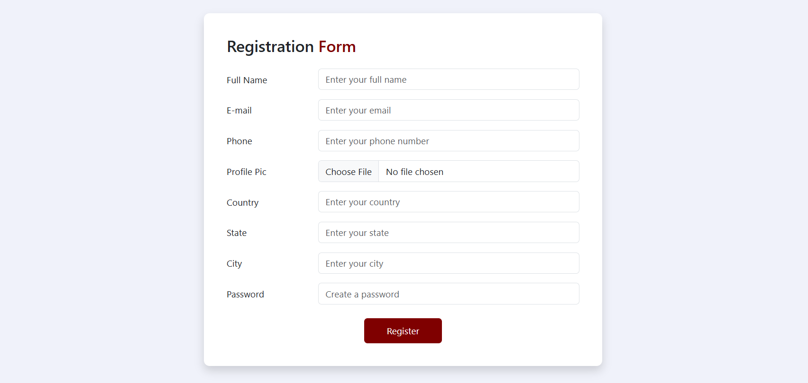

- User Login



Day 6 (Designing and Coding of Post News):
- Post News

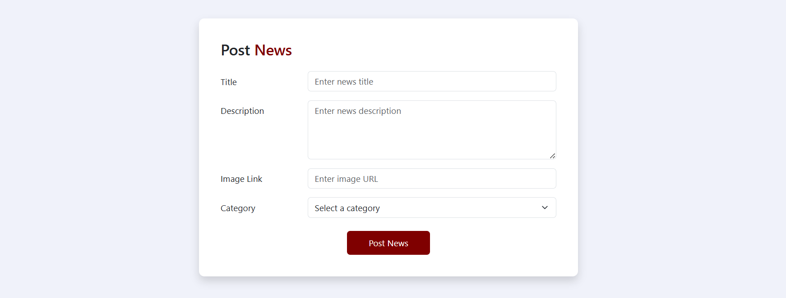

Day 7 (Designing and Coding of All News & Your News):
- All News



- Your News

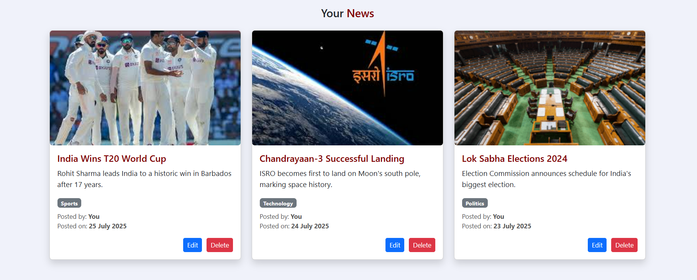

Day 8 (Designing and Coding of Edit News and Delete News):
- Edit News

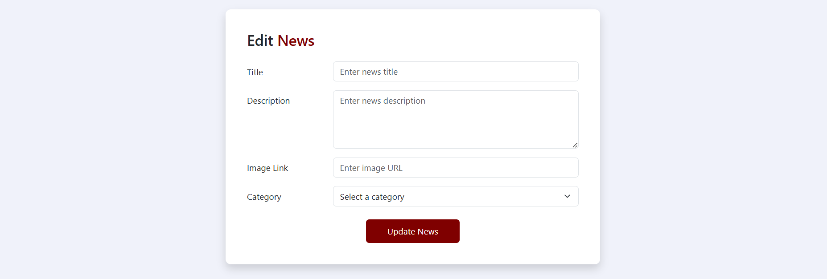

- Delete News
Delete News page will Delete the currently selected news.

Day 9 (Designing and Coding of Edit Profile & Logout):
- Edit Profile

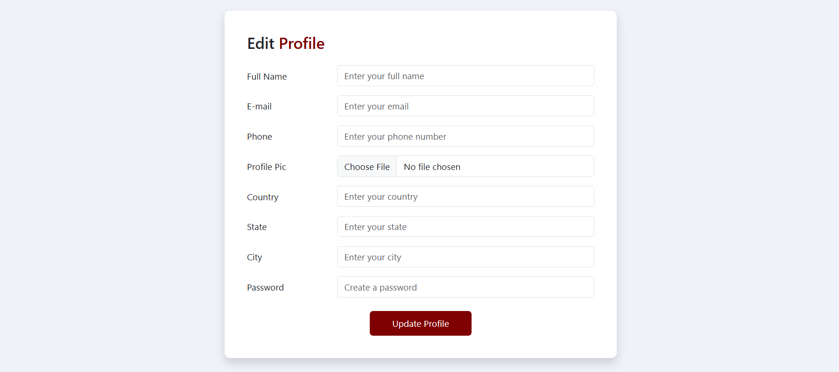

- Logout
Logout page will destroy the created session at the time of login in Admin Zone and redirect at login page.

Folder Structure

