Egypt University of Informatics
Computer and Information Systems
Data Analysis Course
The Analysis of Sleep Hours and Coffee Consumption
Submitted by: Adham Yehia, Mark Medhat, Mazen Ashraf, Adam wael

Introduction
Coffee and sleep are connected in everyday life in a way most people recognize. When someone is tired, the first solution is often another cup of coffee. That idea sounds obvious, but we wanted to check whether it actually appears in the data instead of just repeating it as a common assumption.
This report looks at whether sleep hours are related to the amount of coffee a person drinks in a day. It is a simple question, but it matters because coffee use is also linked to stress, sleep quality, heart rate, and daily routine. Using 10,000 records, we tested the relationship with summary statistics, graphs, and standard hypothesis tests. The result is a real negative relationship, although the effect is not very strong.

Research Question
The main research question is whether people who sleep fewer hours tend to drink more coffee than people who sleep more.

Hypothesis
Null hypothesis: There is no correlation between sleep hours and daily coffee intake (rho = 0).
Alternative hypothesis: There is a negative correlation between sleep hours and daily coffee intake, so people who sleep less tend to drink more coffee.
Significance level: alpha = 0.05

Population of Interest
The population of interest is adults (18+) who consume coffee regularly or occasionally. The dataset we used draws from a global pool, so the population represented is "adult coffee-drinkers from a broad mix of countries." Gender is roughly balanced, ages range from 18 to 80, and occupations span office work, healthcare, service, student life, and others.

Sampling Method
The dataset is fairly balanced across countries, age ranges, and occupations, with most countries contributing close to 500 records. Gender is also close to balanced (Female: 5,001, Male: 4,773, Other: 226). That balance is useful because it reduces the chance that one country or one type of job dominates the whole dataset. We did not take a smaller sample from it; we used all 10,000 rows in the analysis.

Bias Identification
We considered several potential sources of bias while analyzing this data:
- Self-report bias: Sleep hours and coffee intake are self-reported in the original survey format. People often round sleep times ("about 7 hours") and may under-report coffee consumption, especially heavy drinkers. We cannot correct for this from the data alone.
- Confounders: Stress, age, and occupation could all affect both sleep and coffee intake. When we checked subgroups, the pattern stayed negative across gender and occupation groups, but it was much weaker across stress-level groups. That means the main result still looks real, but we should be careful not to overstate subgroup consistency.

- Selection toward coffee drinkers: Non-drinkers seem to be a minority in this dataset, so the results are probably more representative of people who drink at least some coffee than of the full general population.

Survey Questions / Collected Data / Dataset
We used the Global Coffee Health Dataset from Kaggle, which contains 10,000 records. Each row represents one individual and includes 16 fields:
- ID - unique identifier
- Age - years (18-80)
- Gender - Female / Male / Other
- Country - country of residence (~20 countries)
- Coffee_Intake - cups of coffee per day (0-8.2)
- Caffeine_mg - estimated caffeine intake in mg per day
- Sleep_Hours - average hours of sleep per night (3-10)
- Sleep_Quality - self-reported: Poor / Fair / Good / Excellent
- BMI - body mass index
- Heart_Rate - resting heart rate in bpm
- Stress_Level - Low / Medium / High
- Physical_Activity_Hours - hours of exercise per week
- Health_Issues - None / Mild / Moderate / Severe
- Occupation - Office / Healthcare / Service / Student / Other
- Smoking, Alcohol_Consumption - binary indicators (0/1)
Number of samples used: 10,000 (no records were dropped).
Data cleaning was minimal. The Health_Issues column had 5,941 blank values, which we interpreted as "no reported health issue" and filled with "None" rather than dropping the rows. No other column had missing values, and no outliers needed removal - the ranges were plausible throughout.

Analysis

Distributions of sleep and coffee
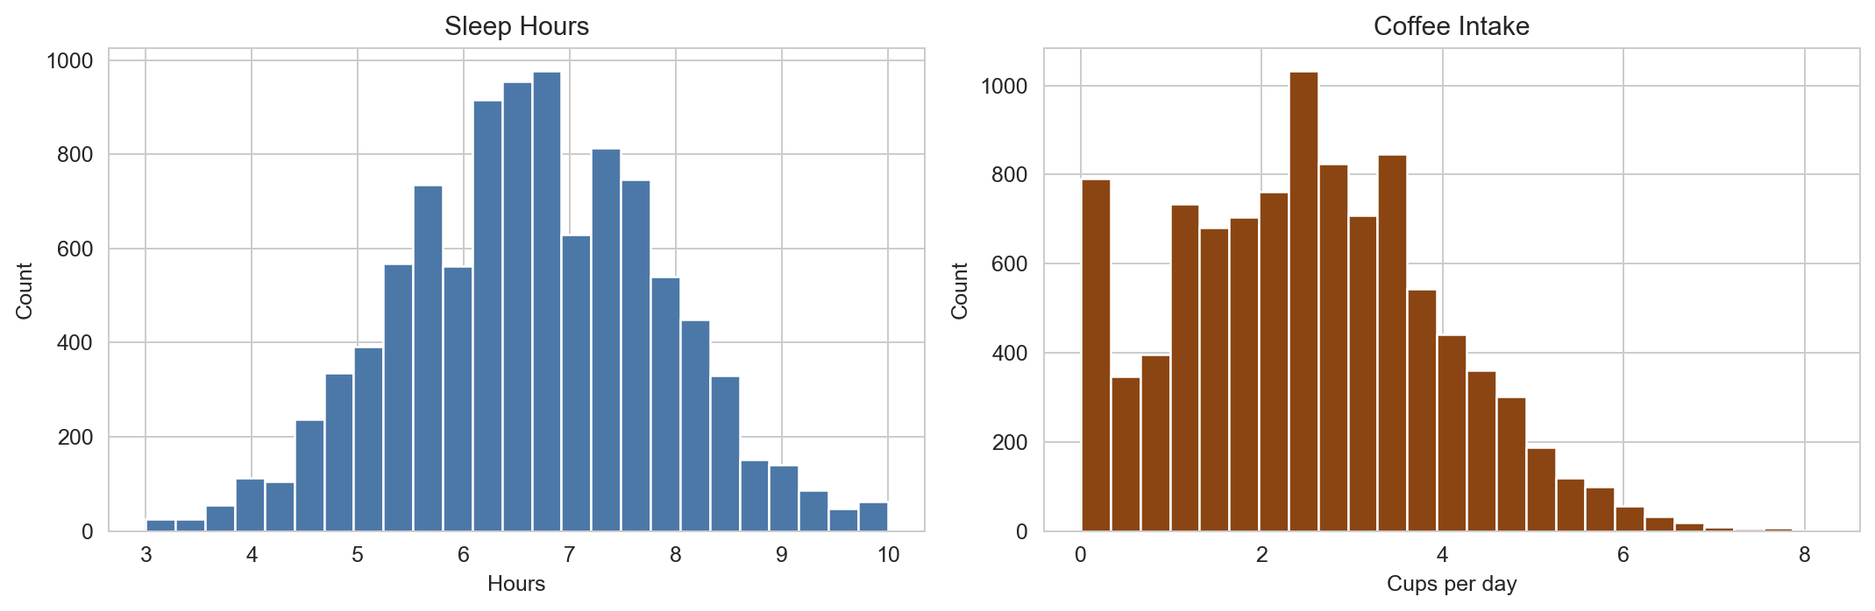
Figure 1: Distribution of sleep hours (left) and daily coffee intake (right). Sleep hours cluster around 7, while coffee intake is right-skewed with a tail extending toward 8 cups per day.
The sleep hours distribution is roughly symmetric and centered near 7 hours, which matches expectations for a general adult population. Coffee intake is right-skewed: most people drink 1-4 cups a day, and the long tail captures a smaller group of heavy drinkers who push the average up to 2.51 cups.

Sleep hours vs coffee intake
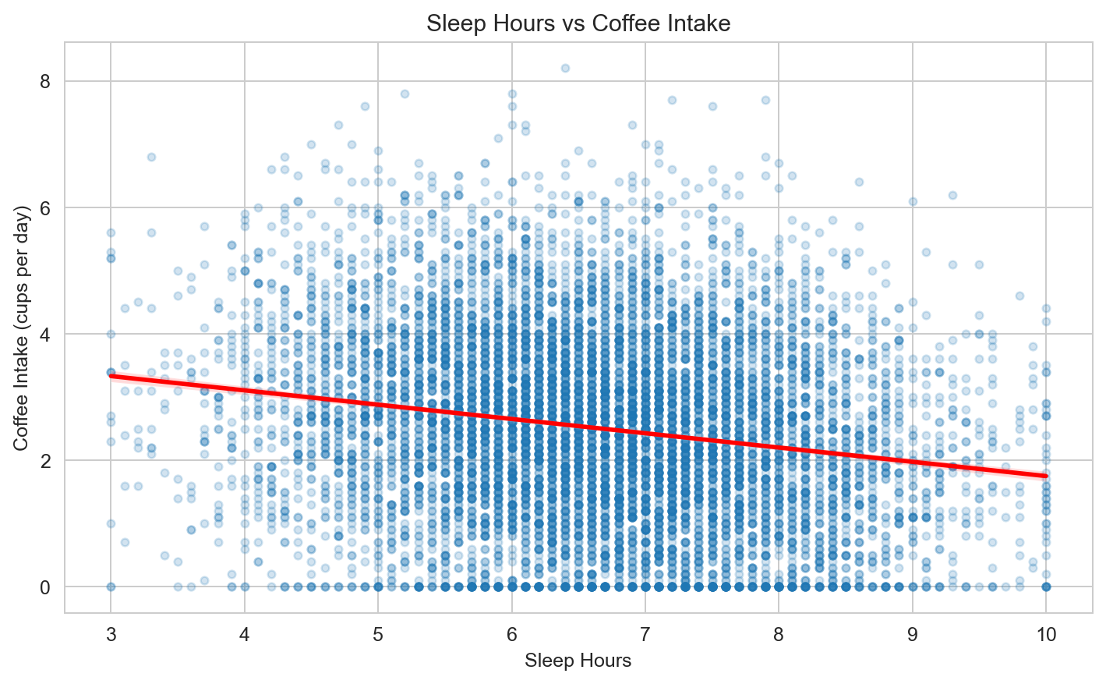
Figure 2: Scatter plot of sleep hours against coffee intake, with a linear trend line. The downward slope indicates that as sleep hours increase, coffee consumption tends to decrease.
The trend line has a negative slope (y = -0.226x + 4.01), so people who sleep more tend to drink slightly less coffee. The spread of the points is still wide, which tells us sleep is only one part of the story, not the whole explanation.

Coffee intake by sleep group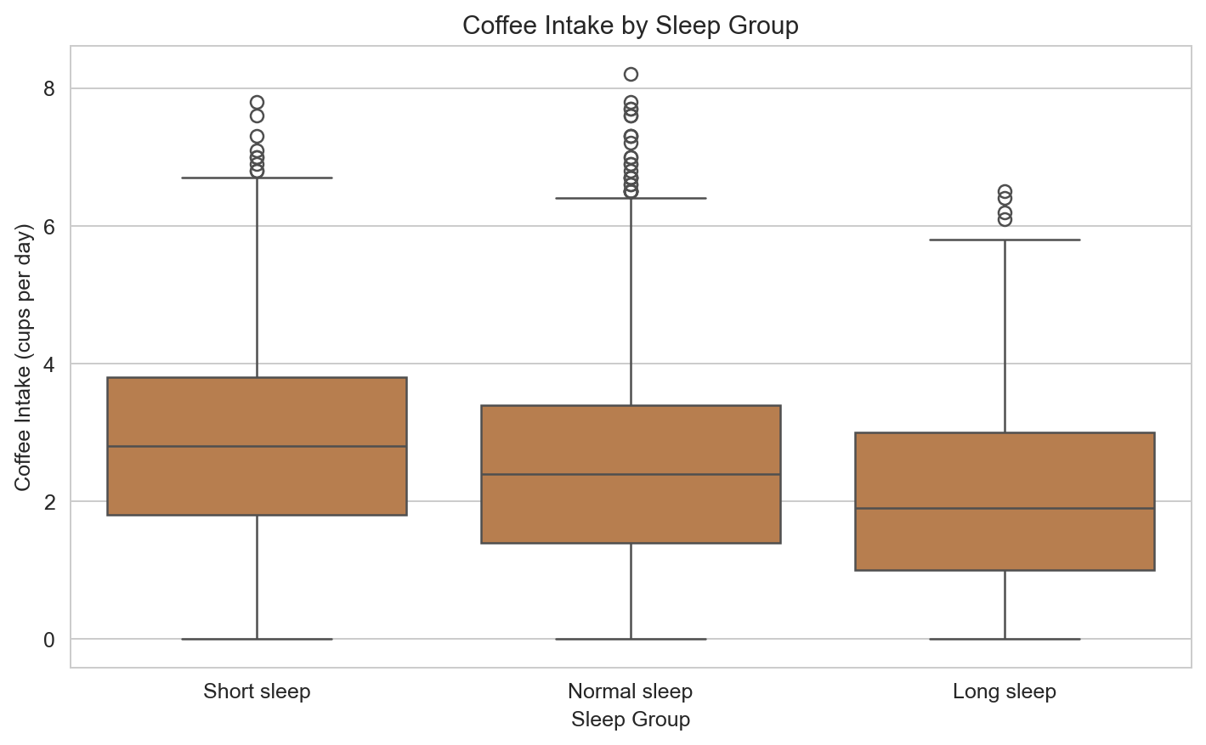

Figure 3: Box plot of coffee intake across three sleep groups. Short sleepers (<6h) have the highest median coffee intake, while long sleepers (>8h) have the lowest.
Grouping people into short, normal, and long sleepers makes the relationship easier to read. Short sleepers consume a mean of 2.84 cups/day, normal sleepers 2.45, and long sleepers 2.04. That is a difference of about 0.80 cups between the shortest and longest sleepers, or about 40% more coffee for the short-sleep group.

Correlation across all numeric variables
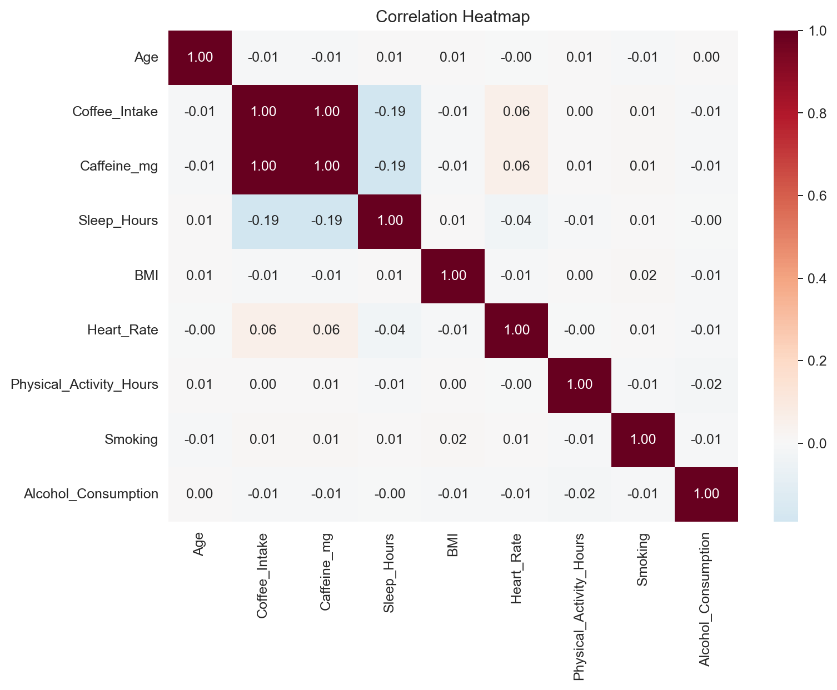
Figure 4: Correlation heatmap of all numeric variables. After caffeine (which essentially measures the same thing as coffee intake), sleep hours has the strongest correlation with coffee consumption.
The heatmap confirms that no other numeric variable has a stronger relationship with coffee intake than sleep hours (ignoring Caffeine_mg, which is derived from coffee intake). Age, BMI, heart rate, and physical activity show only minor correlations. This is good evidence that we are testing the right variable.

Sleep quality vs coffee intake
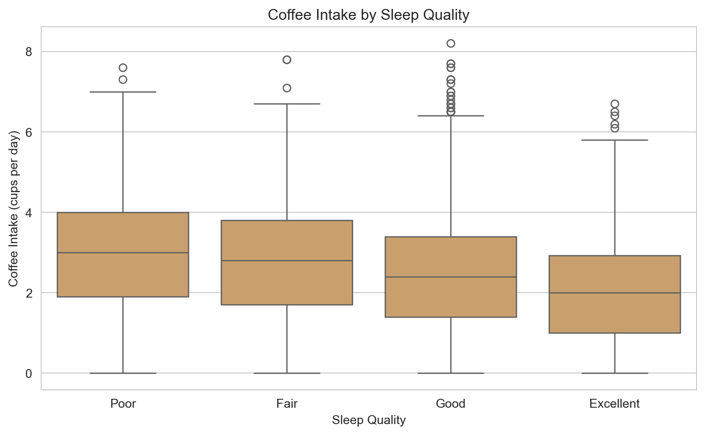
Figure 5: Coffee intake broken down by self-reported sleep quality. People reporting poor sleep drink noticeably more coffee than those reporting excellent sleep.
The sleep quality graph points in the same direction as the sleep-hours graph: people reporting poorer sleep tend to drink more coffee. This shows another useful association, but it does not prove an independent effect by itself.

Hypothesis Testing Steps
Step 1: State the hypotheses.
- H0: There is no correlation between sleep hours and coffee intake (rho = 0).
- H1: There is a negative correlation between sleep hours and coffee intake (rho < 0).
Step 2: Choose the statistical tests and significance level.
- Pearson correlation - for the linear relationship between the two variables.
- Spearman correlation - as a non-parametric robustness check (does not assume linearity).
- One-way ANOVA - to test whether mean coffee intake differs across sleep groups (Short / Normal / Long).
- alpha = 0.05 (standard).
Step 3: Compute the test statistics and p-values.
- Pearson: r = -0.1903, p about 3.5 x 10^-82
- Spearman: r = -0.1901, p about 5.7 x 10^-82
- ANOVA: F = 150.87, p about 2.8 x 10^-65
Step 4: Make a decision.
All three p-values are far below alpha = 0.05, so we reject the null hypothesis H0. The correlation is negative and statistically significant, but the effect size is modest: r squared is about 0.036, which means sleep hours explain only about 3.6% of the variation in coffee intake.

Conclusion
The data supports the idea that sleep and coffee consumption are negatively related. In the full dataset, people who sleep less tend to drink more coffee, and short sleepers consume about 40% more coffee per day than long sleepers.
The pattern is clear in the overall sample and it also stays negative across gender and occupation groups. Across stress-level groups, though, it becomes weaker and is not consistent enough to describe as the same everywhere.
So the safest conclusion is that the relationship is real in this dataset, but not strong, and not enough to prove causation. Other factors such as routine, culture, stress, and work schedule likely matter too.

Any Potential Issues
Several limitations are worth stating clearly:
- The dataset is synthetic. That means the patterns may reflect how the data was generated, not necessarily how real people behave. Because of that, this project should be treated mainly as a demonstration of the analysis method.
- There are no Egypt-specific records in the Country column, so we could not make the Egypt comparison we originally had in mind.
- Self-report style variables are another limitation. In a real version of this kind of study, sleep hours and coffee intake would usually rely on people estimating their own habits, which can introduce error.
- The direction of the relationship is still uncertain. Less sleep may lead to more coffee, more coffee may make sleep worse, or both may be affected by a third factor such as stress or work schedule.
- Non-drinkers do appear to be a minority in the dataset, so the results are more representative of people who drink at least some coffee than of the full general population.
Even with those limits, the project still gives a clear example of how to use descriptive statistics, graphs, and hypothesis testing to answer a realistic question.

