# Assignment ( week 0 ) [MUKUL AGGARWAL 2401030239](mailto:2401030239@mail.jiit.ac.in)

## Question 1)

#include <iostream>

#include<vector>

#include <unordered_map>

using namespace std;

int main(){

vector<int> arr = {1, 2, 3, 5, 2, 9, 7, 3, 5};

unordered_map<int, int> oho;

for(int num : arr){

oho[num]++;

}

for(auto it : oho){

cout<<it.first<<" occurs "<<it.second<<" times.\n";

}

}

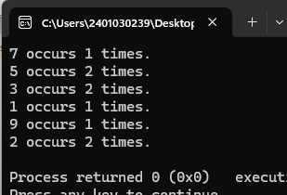

## Question 2)

#include <iostream>

#include<vector>

#include <unordered_map>

using namespace std;

int main(){

vector<int> arr = {1, 2, 3, 5, 2, 9, 7, 3, 5};

int n = arr.size();

if(n==1){

cout<<"no change";

return 0;

}

cout<<"elements before rotation : ";

for(int num : arr){

cout<<num;

}

cout<<"\nelements after rotation : ";

int a = arr[0];

for(int i=0; i<n-1; i++){

arr[i]=arr[i+1];

}

arr[n-1]=a;

for(int num : arr){

cout<<num;

}

return 0;

}

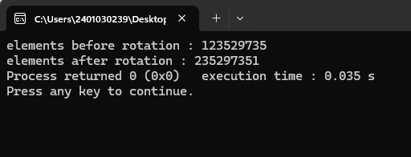

## Question 3)

#include <iostream>

#include<vector>

#include <unordered_map>

using namespace std;

int main(){

vector<int> arr = {32, 54, -6, -15};

int n = arr.size();

int small, big;

if(arr[0]<arr[1]){

small = arr[0]; big = arr[1];

}else{small = arr[1]; big = arr[0];}

for(int num : arr){

if(num<big && num>small){

big = num;

}else if(num<small){

big = small;

small = num;

}

}

cout<<big;

return 0;

}

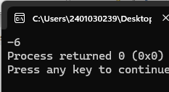

## Question 4)

#include <iostream>

using namespace std;

int main() {

int n;

cout << "Enter number of elements: ";

cin >> n;

int* arr = new int[n];

cout << "Enter " << n << " elements (odd and even integers): ";

for (int i = 0; i < n; i++) {

cin >> arr[i];

}

for (int i = 0; i < n; i++) {

if (arr[i] % 2 == 0) {

cout << arr[i] << " ";

}

}

for (int i = 0; i < n; i++) {

if (arr[i] % 2 != 0) {

cout << arr[i] << " ";

}

}

cout << endl;

delete[] arr;

return 0;

}

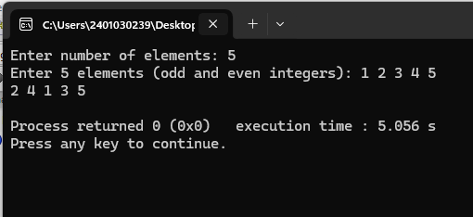

## Question 5)

#include <iostream>

#include <vector>

using namespace std;

int main() {

int n;

cin >> n;

vector<int> socks(2*n);

for (int i = 0; i < 2*n; i++) {

cin >> socks[i];

}

vector<bool> onTable(n+1, false);

int currentCount = 0;

int maxCount = 0;

for (int i = 0; i < 2*n; i++) {

int sock = socks[i];

if (!onTable[sock]) {

onTable[sock] = true;

currentCount++;

if (currentCount > maxCount) {

maxCount = currentCount;

}

} else {

onTable[sock] = false;

currentCount--;

}

}

cout << maxCount << endl;

return 0;

}

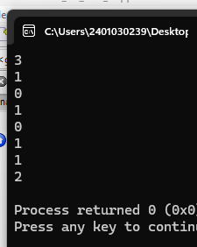

## Question 6)

#include <iostream>

#include <cstdlib>

#include <ctime>

using namespace std;

int main() {

int n;

cout << "Enter the number of elements: ";

cin >> n;

int* A = new int[n];

srand(time(0));

for (int i = 0; i < n; ++i) {

A[i] = rand() % 100;

}

cout << "Array elements are: ";

for (int i = 0; i < n; ++i) {

cout << A[i] << " ";

}

cout << endl;

delete[] A;

return 0;

}

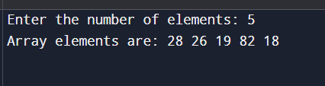

## Question 7)

#include <iostream>

#include <unordered_map>

using namespace std;

int countSubarraysPositive(int arr[], int n, int k) {

int start = 0, end = 0, sum = 0, count = 0;

while (end < n) {

sum += arr[end];

while (sum > k && start <= end) {

sum -= arr[start];

start++;

}

if (sum == k) {

count++;

}

end++;

}

return count;

}

int countSubarraysPositive(int arr[], int n, int k) {

int start = 0, end = 0, sum = 0, count = 0;

while (end < n) {

sum += arr[end];

while (sum > k && start <= end) {

sum -= arr[start];

start++;

}

if (sum == k) {

count++;

}

end++;

}

return count;

}

## Question 8)

1. Incorrect memory allocation type (allocating int size for float).
2. Incorrect memory allocation (allocating less than int size).
3. sizeof(a) and sizeof(b) both return size of pointer (e.g., 8 on 64-bit).
4. a is uninitialized
5. 5
6. 8 or 4
7. 5
8. 12345