**SSH to your AWS Workstation**

**ssh devops@<public-ip-addr**> of your Workstation  
Password is : **Dev0p$!!/**

1. To list all the images available on the local repo run the below command.

|  |
| --- |
| $ su  # docker images |

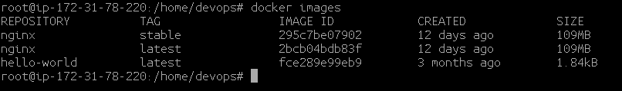

2. To run a container from the local image run -

|  |
| --- |
| # docker run -d -p 80:80 --name dockerdemo nginx |

The above command will run the nginx container with the default latest tag and in detached mode (-d) with ports 80 of nginx container mapped to the port 80 of Host machine. The --name switch is used to name the docker container.

3. To check the running Containers

|  |
| --- |
| # docker ps |

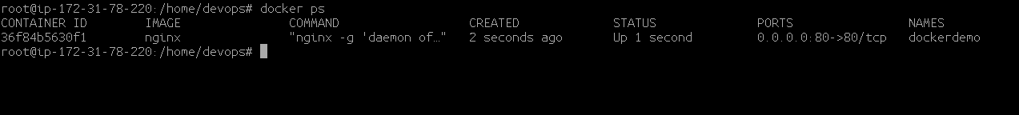

4. Open the web browser and browse to <Public-ip-address of your Workstation>

You will be able to see the nginx welcome page that is running on the

docker container.

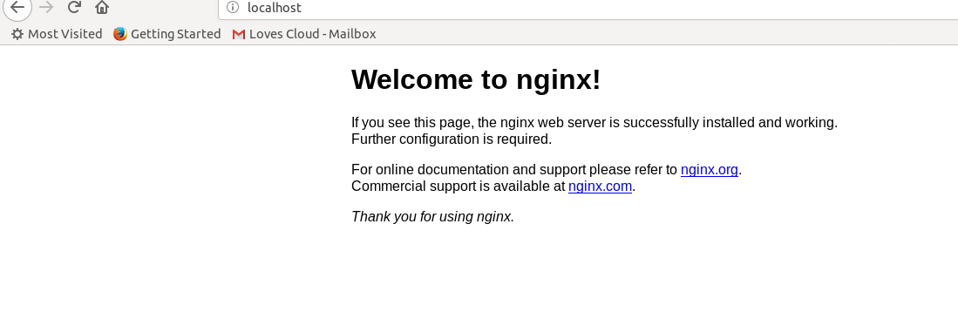

5. To stop a container from the

|  |
| --- |
| # docker stop dockerdemo |

6.And, to start a stopped container do

|  |
| --- |
| # docker start dockerdemo |

7. You can also run the docker containers for the alpine image.

|  |
| --- |
| # docker run -d -p 8080:80 --name dockerdemo_alpine alpine:3.7 |

Here we are using tag to run the container ( alpine:3.7)

Remember that the port 80 of the host is being used by the nginx container and if you try to run the alpine run container on the same port, it will fail as the port is already being used by the nginx container.

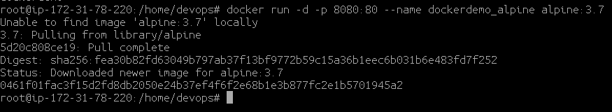

**8. STOP the containers before proceeding to the next lab**

|  |
| --- |
| # docker stop dockerdemo |

9. Check all the container in stopped state

|  |
| --- |
| # docker ps -a |

10. To stop all the container in stopped state run the below command.

|  |
| --- |
| # docker rm $(docker ps -a -q) |