Installing Portainer to visualize the docker containers running on your Docker host.

On the docker host run the below command to pull the dockerized image of portainer and run it.

SSH to your AWS Workstation

**ssh devops@<public-ip-addr**> of your Workstation  
Password is : **Dev0p$!!/**

|  |
| --- |
| **$ sudo su** (password is Dev0p$!!/ ) |

1. Run the below command to deploy the Portainer Container.

|  |
| --- |
| # docker run -d -p 9000:9000 -v /var/run/docker.sock:/var/run/docker.sock -v portainer_data:/data --name portainer portainer/portainer |

You'll just need to access the port 9000 of the EC2 Instance <public IP> where portainer is running using your browser.

Note: the **-v /var/run/docker.sock:/var/run/docker.sock** option can be used in Linux environments only.

2. The Portainer Container is running on port 9000 , and can be accessed from the public IP of the AWS Workstation on **Port 9000**

Example

<http://52.90.69.11:9000>

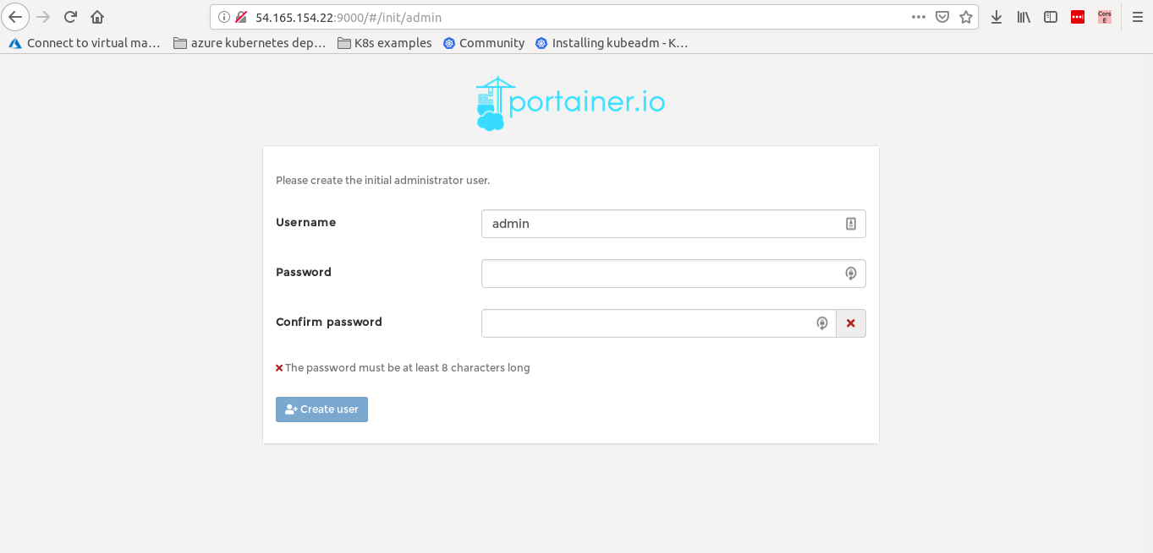

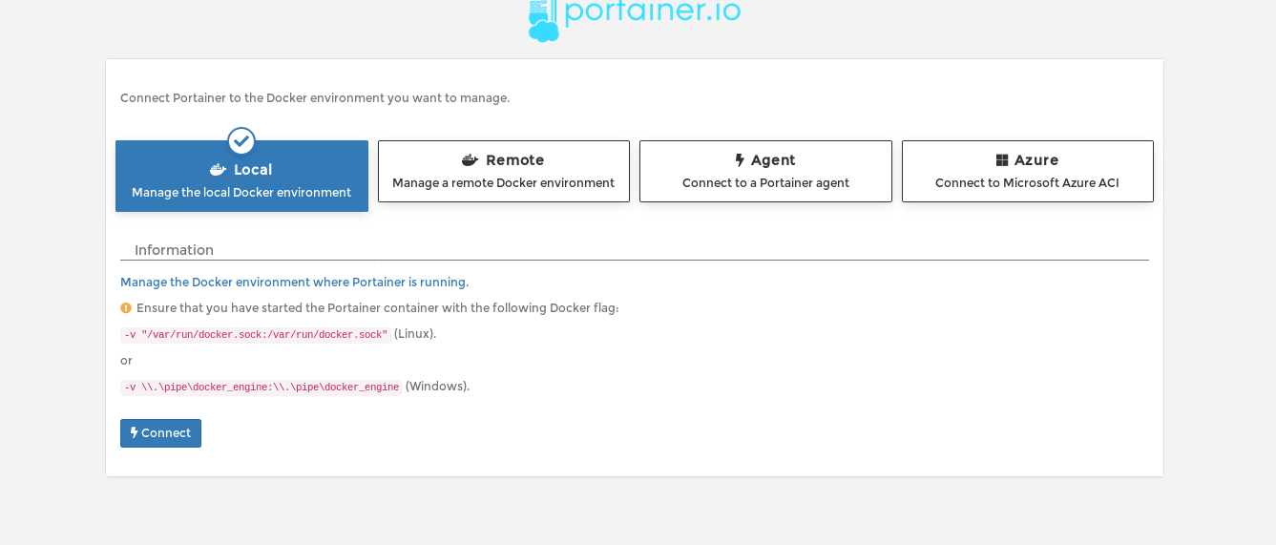

3. Next click on the **local > Connect** and you will be able to see all the docker containers running your docker host.

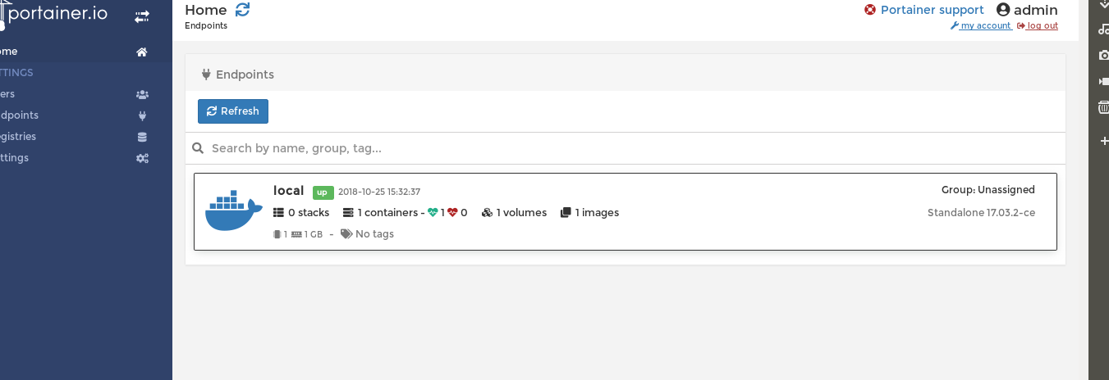

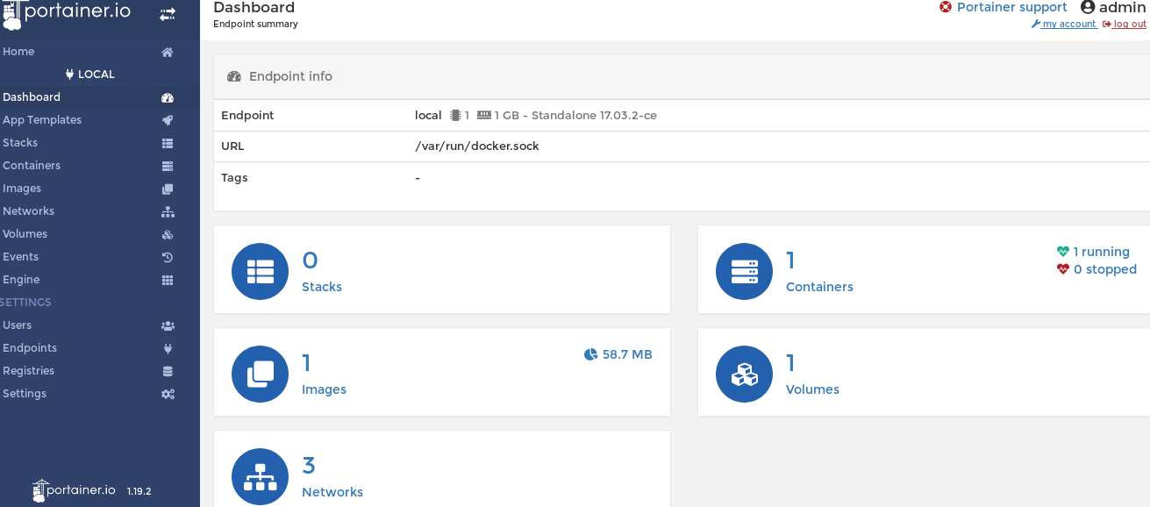

You can also launch new container from the Portainer Dashboard under containers > Add container.

