**SSH to your AWS Workstation**

**ssh devops@<public-ip-addr**> of your Workstation  
Password is : **Dev0p$!!/**

1. SSH to your AWS Workstation.

|  |
| --- |
| $ sudo su |

2.Clone the Gitrepo that contains the python code.

|  |
| --- |
| # cd /home/devops/ # git clone https://github.com/LovesCloud/java-docker-mercedes.git |

|  |
| --- |
| # cd java-docker-mercedes # mvn clean # mvn package |

3. Now create a Dockerfile to Dockerize the JAVA application

|  |
| --- |
| # vim Dockerfile |

Add the below content to the Dockerfile

|  |
| --- |
| FROM tomcat:8.0.51-jre8-alpine COPY target/ /target CMD java -jar /target/dependency/webapp-runner.jar /target/*.war |

(:wq Save and Exit)

4. Build the docker image by running the below command.

|  |
| --- |
| # docker build . -t java-app # docker images |



5. Run a Docker container from the created Image.

|  |
| --- |
| # docker run -d -p 80:8080 --name my-java-app java-app # docker ps |

The JAVA Docker Container running on port 80, and can be accessed from the public IP of your AWS Workstation on default Port 80

|  |
| --- |
| http://<Public-IP-Workstation> |

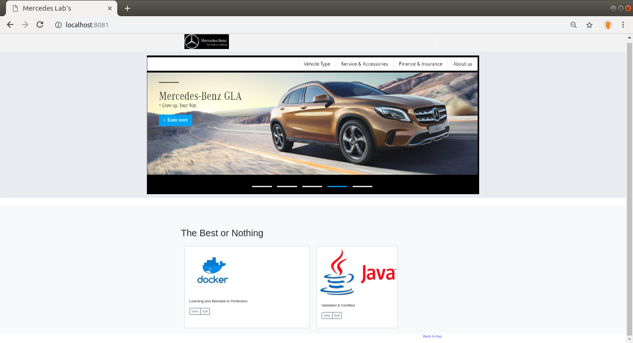

**STOP THE CONTAINER BEFORE PROCEEDING TO THE NEXT LAB**

6. Stop the Docker container by running the below command

|  |
| --- |
| # docker stop my-java-app |