**(A) Push the Java-app docker image to your Docker Hub Account**

1. Log into the Docker Hub from the command line

|  |
| --- |
| # docker login --username=yourhubusername |

1. Check the image ID using

|  |
| --- |
| # docker images |

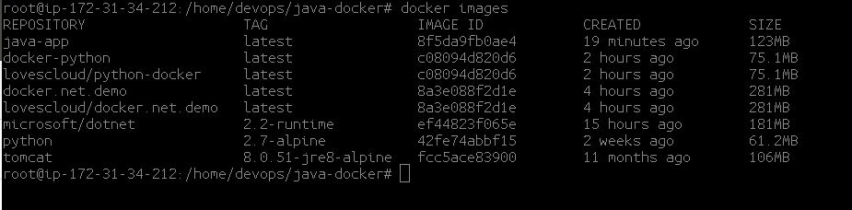

1. Tag your image

|  |
| --- |
| # docker tag <Image-ID> yourhubusername/java-docker:latest |

Example   
# docker tag 8f5da9fb0ae4 lovescloud/java-docker

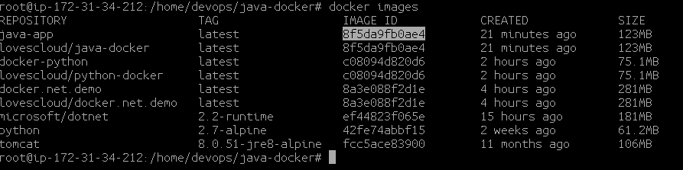

1. Push your image to the repository you created

|  |
| --- |
| # docker push yourhubusername/java-docker |

Example

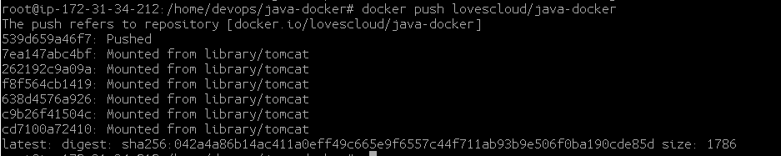

**(B) Push the python-docker image to your Docker Hub Account**

1. Check the image

|  |
| --- |
| # docker images |

and what you will see will be similar to  
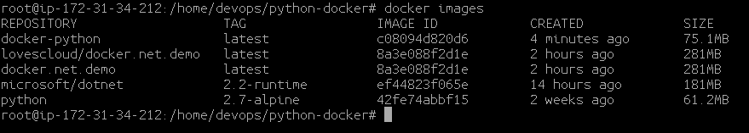

1. Tag your image

|  |
| --- |
| # docker tag c08094d820d6 yourhubusername/python-docker:latest |

**Example**

|  |
| --- |
| # docker tag c08094d820d6 lovescloud/python-docker:latest |

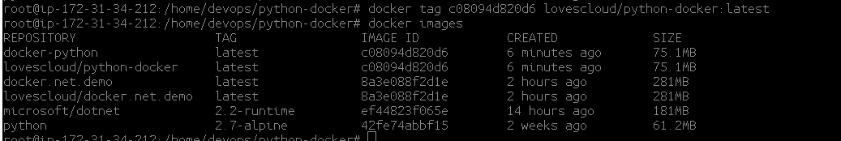

1. Push your image to the repository you created

|  |
| --- |
| # docker push yourhubusername/python-docker |

**(C) Push the dotnet docker image to your Docker Hub Account**

1. Check the image

|  |
| --- |
| # docker images |

and what you will see will be similar to  
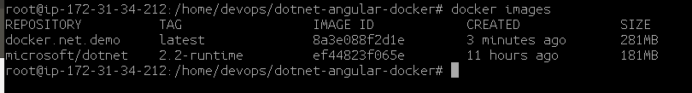

1. Tag your image

|  |
| --- |
| # docker tag b536f24d0c41 yourhubusername/dotnet-docker:firsttry |

Example

|  |
| --- |
| # docker tag 8a3e088f2d1e lovescloud/docker.net.demo:latest |

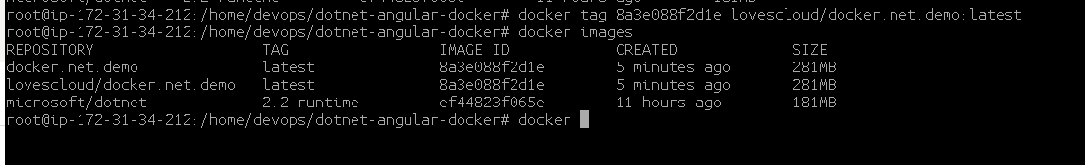

1. Push your image to the repository you created

|  |
| --- |
| # docker push yourhubusername/dotnet-docker |

