**SSH to your AWS Workstation**

**ssh devops@<public-ip-addr**> of your Workstation  
Password is : **Dev0p$!!/**

1. Clone the Git Repo

|  |
| --- |
| $ sudo su  # cd /home/devops  # git clone https://github.com/LovesCloud/Docker-compose-demo-mercedes.git |

|  |
| --- |
| # cd Docker-compose-demo-mercedes |

2. Create a docker-compose.yml

|  |
| --- |
| # vim docker-compose.yaml |

3. Paste the below code to the **docker-compose.yaml**

|  |
| --- |
| version: '3' services:  backend:  build: ./python/  ports:  - "5000"  links:  - redis  frontend:  build: ./ui/  ports:  - "80:80"  links:  - backend  redis:  image: "redis:alpine"  ports:  - "6379" |
|  |

4. Run the below command to build

|  |
| --- |
| # docker-compose build |

5. Run the below command to run compose

|  |
| --- |
| # docker-compose up -d |

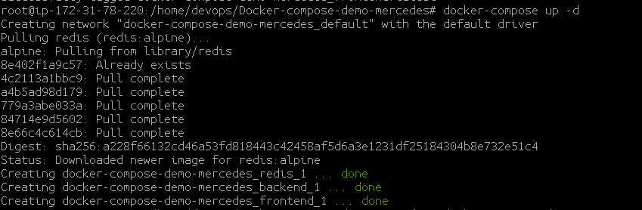

6. Check the running containers

|  |
| --- |
| # docker ps |

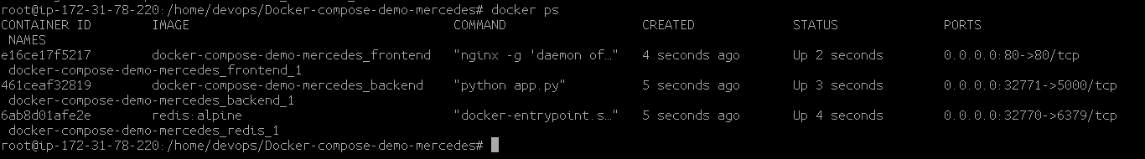

**7. Access the webpage from the Public IP of your AWS Workstation on Port 8081**

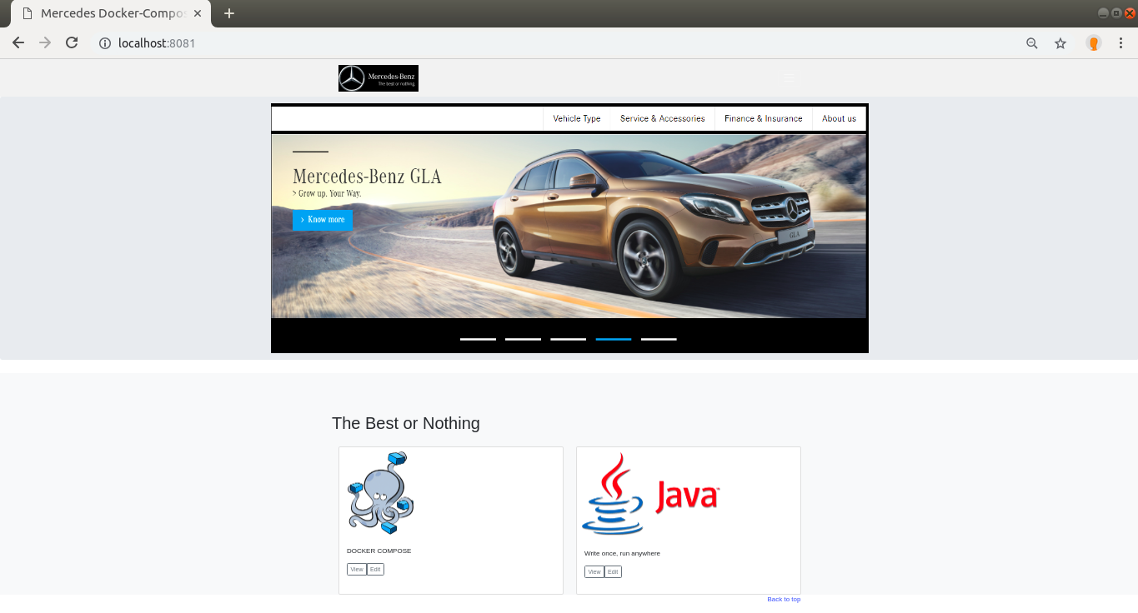

8. Stop the docker compose stack

|  |
| --- |
| # docker-compose down |

