1. Login to the Grafana Dashboard with the below URL.

<http://18.191.103.37:31190>

2. Goto Home > kubernetes cluster monitoring (via prometheus)

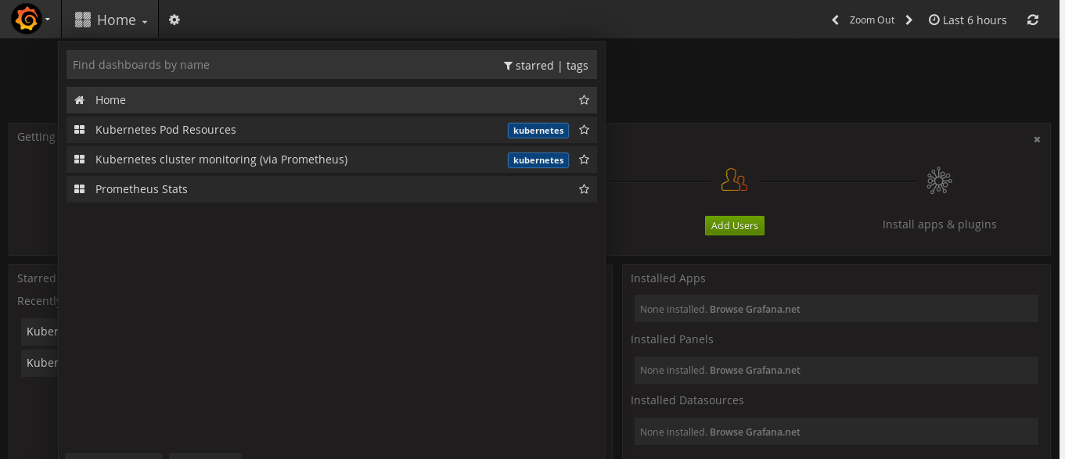

3. Check the Overall Cluster Performance form the Dashboard

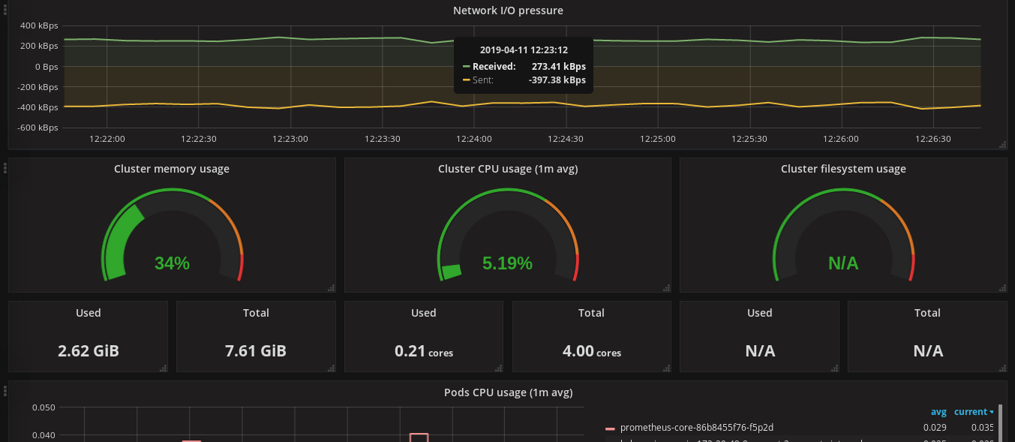

**4. Check your Pod CPU Utilization by selecting your POD name from the PODS Column in the Right**

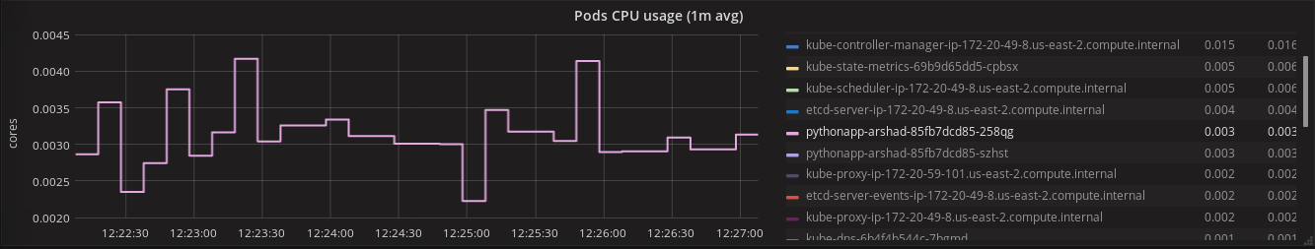

**5. Similarly check your PODS memory usage and network I/O as shown in the below screenshot.**  
