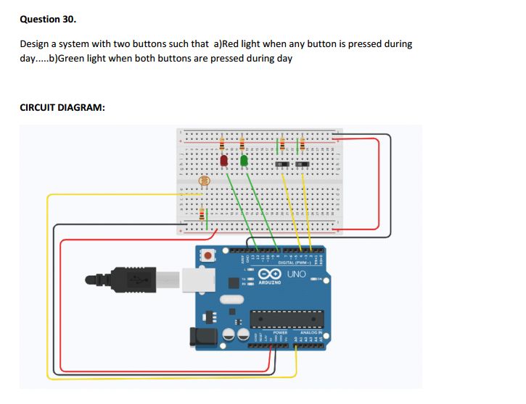

**THEORY:**   
  
As per the circuit diagram, we have made a circuit using 2 LED, 2 switches ,LDR and resistors. The LDR Output is fed to the analog pins of the Arduino.

The analog pins senses the voltage and gives some analog value to Arduino. The analog value changes accordingly to the resistance of the LDR which is changed by the intensity of light falling on LDR.

So, as the light falls on the LDR the resistance of it get decreased and hence voltage value increases.

Based on this value, we analyse if it’s day or night and carry out our results.  
  
Intensity of light ↓ - Resistance↑ - Voltage at analog pin↓   
  
**LEARNING AND OBSERVATIONS:**  
As per the Arduino code, if the analog value falls above 300 we consider it as day and the Red LED turns ON if we press any of the two switches. And if we press both the switch together, the Green LED starts glowing. If the value comes below 300   
we consider it as dark and the light turns OFF.   
  
  
**PROBLEMS AND TROUBLESHOOTING:**   
You should take care whether the board in the arduino\uno or not and also selection of port in tools. This is the main problem where we  
get confusion   
  
**PRECAUTIONS:**   
While installing led’s in bread board we should take care whether the ’n’ terminals of LDR is connected or not.Here the ‘n’ terminals   
should be connected similarly, we should check whether the ‘p’ terminals are connected or not.In this case ‘p’ terminals should not be  
connected .   
Install the wires properly in both bread board and arduino board.   
 **LEARNING OUTCOMES:**   
With this experiment we can learn that how Red LED start glowing when we press any of the two buttons during day time and Green LED when we press both buttons during day light and LED is off when its in night/dark.