
Software Requirements Specification (SRS)

Centralized Lost & Found Management System

Title | Software Requirements Specification for FindIt
Date | October 24, 2023
Course | CSE 4106 - Software Development Lab - 1

Submitted By
Md. Sabbir Mia | Saimon Islam
202122104017 | 202122104027
Submitted To
Md. Sabab Zulfiker
Lecturer
Dept of Computer Science and Engineering
Kishoreganj University

Table of Contents
Table of Contents 1
Glossary 1
1. Introduction 1
1.1. Purpose 1
1.2. Document Conventions 1
1.3. Intended Audience 1
1.4. Project Scope 1
1.5. References 1
2. Overall Description 1
2.1. Product Perspective 1
2.2. Product Functions 1
2.3. User Classes, Characteristics, and Needs 1
Registered Users (Students/Staff) 1
Administrators 1
Guest Users 1
2.4. Operating Environment 1
2.5. Design and Implementation Constraints 1
2.6. User Documentation 1
2.7. Assumptions and Dependencies 1
3. System Features and Functional Requirements 1
3.1. User Management and Authentication 1
3.2. Item Reporting and Management 1
3.3. Smart Matching Engine 1
3.4. Claim Management and Verification 1
3.5. Secure Messaging System 1
3.6. Administrator Dashboard 1
3.7. Notification System 1
4. External Interface Requirements 1
4.1. User Interfaces 1
4.2. Hardware Interfaces 1
4.3. Software Interfaces 1
4.4. Communications Interfaces 1
5. Non-Functional Requirements 1
5.1. Performance Requirements 1
5.2. Security Requirements 1
5.3. Reliability and Availability 1
5.4. Usability and Accessibility 1
5.5. Maintainability and Portability 1
6. Other Requirements 1
6.1. Data Migration 1
6.2. Training Requirements 1
6.3. Appendix A: Analysis Models (Illustrations) 1
1. Context Diagram (Level 0) 1
2. Entity Relationship Diagram (ERD) 1
3. Process Flow Diagram: Item Reporting & Smart Matching 1
4. Use Case Diagram 1
6.4. Appendix B: Issues List 1

Glossary
Term | Definition
ASP.NET | Open-source web framework created by Microsoft for building modern web apps and services.
EF Core | Entity Framework Core: an object-database mapper that enables .NET developers to work with a database using .NET objects.
MVC | Model-View-Controller: an architectural pattern that separates an application into three main logical components.
Smart Matching | A weighted scoring algorithm used to connect lost reports with found reports based on category, location, and date.
Claim | A formal request made by a user asserting ownership over a found item listed in the system.

1. Introduction

1.1. Purpose
This Software Requirements Specification (SRS) document provides a comprehensive description of the “FindIt” Lost & Found Management System to be developed for Kishoreganj University. The document details the functional and non-functional requirements for the platform, which aims to simplify the recovery process of lost belongings while improving transparency, efficiency, and user trust. This SRS will serve as the foundation for the subsequent system design and development phases.

1.2. Document Conventions
This document follows these conventions:
- SHALL: Refers to a mandatory requirement that must be fulfilled during development.
- SHOULD: Indicates a requirement that is highly recommended but not strictly mandatory for initial release.
- MAY: Refers to a future enhancement.
Requirements are categorized as follows:
- FR-XX: Functional Requirements
- NFR-XX: Non-Functional Requirements
- IR-XX: Interface Requirements

1.3. Intended Audience
This document is intended for the following stakeholders:
- Course Instructor/Evaluator: Who will review and grade the project.
- Developers (Md. Sabbir Mia, Saimon Islam): Who will design and implement the system.
- End Users: Students, faculty, and staff of Kishoreganj University who will use the platform.

1.4. Project Scope
The FindIt platform is a centralized, web-based application developed using ASP.NET Core MVC. It aims to replace scattered social media posts and physical notice boards with an intelligent, searchable database of lost and found items.
In Scope:
- User registration and authentication using ASP.NET Core Identity.
- Modules for reporting lost/found items, including image uploads and categorization.
- Implementation of a smart matching engine with automated notifications.
- Secure claiming workflow requiring proof of ownership.
- Admin dashboard for content moderation and dispute resolution.
- Mobile-responsive web interface.
Out of Scope:
- Native mobile applications (iOS/Android).
- Integration with physical IoT tracking devices (e.g., RFID or Bluetooth trackers).
- Monetary rewards or integrated payment gateways.

1.5. References
- FindIt Project Proposal Document (CSE 4106, Kishoreganj University).
- ASP.NET Core MVC Official Documentation.

2. Overall Description

2.1. Product Perspective
FindIt is a new, standalone web-based system designed to operate independently within the university environment. It replaces fragmented manual and social-media-based lost-and-found methods. The system will interface with standard web browsers and an underlying SQL database.

2.2. Product Functions
The platform will provide the following major functions:
- User Registration & Management: Account creation and role-based access (Admin, Registered User, Guest).
- Item Reporting: Submission of lost or found items with images, categories, and metadata.
- Smart Matching: A weighted scoring algorithm to automatically suggest potential matches between lost and found items.
- Claim Management: A structured workflow for users to claim items and provide hidden verification proof.
- Secure Messaging: In-app communication to protect user privacy until a meeting is agreed upon.
- Administration: Dashboard for content moderation, dispute resolution, and reporting.

2.3. User Classes, Characteristics, and Needs

Registered Users (Students/Staff)
- Varying levels of technical proficiency.
- Primary needs: Report lost/found items quickly, track claims, communicate securely.

Administrators
- University staff or designated student monitors.
- Primary needs: Moderate posts, resolve claim disputes, manage users, view system analytics.

Guest Users
- Unauthenticated visitors.
- Primary needs: Browse found items. Must register to submit a claim or contact the finder.

2.4. Operating Environment
- Technical Environment: Web-based application accessible via standard browsers.
- Server Environment: Hosted on IIS Express/Kestrel for development; deployable to Windows/Linux servers.
- Software Environment: ASP.NET Core (.NET 8), C#, Microsoft SQL Server, Entity Framework Core.
- User Environment: Desktops, laptops, tablets, and smartphones with modern browsers.

2.5. Design and Implementation Constraints
- Technical Constraints: Must be developed using ASP.NET Core MVC and EF Core (Code-First).
- Security Constraints: Must enforce HTTPS and secure password hashing via ASP.NET Core Identity.
- Performance Constraints: The smart matching algorithm must be optimized for database growth (using indexing) to prevent execution delays.

2.6. User Documentation
- Online Help System: Context-sensitive help and FAQs accessible within the application.
- User Manuals: A brief guide on how to report items, claim items, and use the messaging system.

2.7. Assumptions and Dependencies
- Users have access to a stable internet connection and a digital camera/smartphone to upload images.
- The university community will actively adopt the platform to reach the critical mass required for effective matching.

3. System Features and Functional Requirements

3.1. User Management and Authentication
ID | Requirement
FR-01 | The system SHALL provide a self-registration process for users using email and password.
FR-02 | The system SHALL use ASP.NET Core Identity for secure authentication and password management.
FR-03 | The system SHALL support role-based access control (RBAC) with at least two roles: “User” and “Admin”.
FR-04 | The system SHALL allow users to update their profile information and contact details.
FR-05 | The system SHALL allow guests to browse found items but SHALL prompt them to register/log in to view contact details or submit a claim.

3.2. Item Reporting and Management
ID | Requirement
FR-06 | The system SHALL allow users to submit a “Lost Item” report including: Item name, category, description, date lost, and location.
FR-07 | The system SHALL allow users to submit a “Found Item” report including: Item name, category, description, date found, location, and secure storage location.
FR-08 | The system SHALL allow users to upload multiple images for reported items.
FR-09 | The system SHALL allow users to edit or delete their own item reports.
FR-10 | The system SHALL allow users to mark a reported item as “Resolved” once it is reunited with the owner.

3.3. Smart Matching Engine
ID | Requirement
FR-11 | The system SHALL implement a smart matching algorithm that triggers automatically when a new lost or found item is submitted.
FR-12 | The matching algorithm SHALL calculate a match score based on weighted criteria: Category (highest weight), Location, and Date.
FR-13 | The system SHALL display a list of “Potential Matches” to the user submitting a new report.
FR-14 | The system SHALL execute the matching logic asynchronously to prevent UI blocking.

3.4. Claim Management and Verification
ID | Requirement
FR-15 | The system SHALL allow a user to submit a claim for a “Found Item”.
FR-16 | The claim form SHALL require the user to provide “Proof of Ownership” (e.g., hidden identifiers, specific scratches, laptop wallpaper).
FR-17 | The system SHALL notify the finder of the new claim and display the proof of ownership for their review.
FR-18 | The finder SHALL have the ability to “Approve” or “Reject” a claim.
FR-19 | The system SHALL allow Administrators to override claim decisions in case of disputes.

3.5. Secure Messaging System
ID | Requirement
FR-20 | The system SHALL provide an in-app messaging interface between the finder and the claimant.
FR-21 | The system SHALL hide personal contact information (phone numbers, emails) from user profiles until both parties explicitly agree to share them.
FR-22 | The system SHALL log all messaging conversations for administrative review in case of fraud.

3.6. Administrator Dashboard
ID | Requirement
FR-23 | The system SHALL provide an admin dashboard displaying key metrics (total items reported, items resolved, active users).
FR-24 | The system SHALL allow admins to view, edit, or delete any item report to moderate content.
FR-25 | The system SHALL allow admins to view all active claims and dispute resolutions.
FR-26 | The system SHALL allow admins to ban or deactivate user accounts violating platform policies.
FR-27 | The system SHALL allow admins to manage item categories and location lists.

3.7. Notification System
ID | Requirement
FR-28 | The system SHALL send in-app notifications when a potential match is found for a user's report.
FR-29 | The system SHALL send in-app notifications when a user receives a claim on their found item.
FR-30 | The system SHALL send in-app notifications when a claim status is updated (approved/rejected).

4. External Interface Requirements

4.1. User Interfaces
The system shall provide user interfaces for the following:
- Guest UI: Homepage, search bar, found items grid, login/register prompt.
- Registered User UI: Dashboard, “Report Lost/found” forms, “My Items” list, messaging inbox, claim management.
- Admin UI: Analytics dashboard, content moderation grid, user management table.
- All UIs SHALL be developed using Razor Views, HTML5, CSS3, and Bootstrap 5 to ensure a mobile-responsive design.
- All UIs SHALL implement dynamic asynchronous updates using JavaScript (AJAX) where applicable.

4.2. Hardware Interfaces
The system will interface with standard client hardware:
- Desktop computers, laptops, tablets, and smartphones.
- Server infrastructure capable of running .NET 8 and SQL Server.

4.3. Software Interfaces
- Database: Microsoft SQL Server via Entity Framework Core ORM.
- Mapping Service: Leaflet.js with OpenStreetMap APIs for geographic location tagging.
- Charting Library: Chart.js for rendering administrative analytics.

4.4. Communications Interfaces
- Network Protocols: HTTP/HTTPS for web access. HTTPS SHALL be enforced for all data transmission.
- Data Exchange: JSON format for asynchronous web requests (AJAX) and API endpoints.

5. Non-Functional Requirements

5.1. Performance Requirements
ID | Requirement
NFR-01 | The system SHALL load web pages in less than 3 seconds under normal load conditions.
NFR-02 | The smart matching algorithm SHALL return potential matches within 2 seconds of item submission.
NFR-03 | The system SHALL implement database indexing on “Category”, “Location”, and “Date” tables to optimize search and matching queries.

5.2. Security Requirements
ID | Requirement
NFR-04 | The system SHALL enforce HTTPS for all communications.
NFR-05 | The system SHALL use ASP.NET Core Identity for secure password hashing and salting.
NFR-06 | The system SHALL protect against Cross-Site Request Forgery (CSRF) and SQL Injection attacks via built-in MVC mechanisms and parameterized queries.
NFR-07 | The system SHALL restrict file uploads to safe image formats (JPEG, PNG) and limit file size to 5MB.

5.3. Reliability and Availability
ID | Requirement
NFR-08 | The system SHALL maintain an availability of 99% during standard university operating hours.
NFR-09 | The system SHALL handle unexpected database disconnections gracefully by displaying user-friendly error messages.

5.4. Usability and Accessibility
ID | Requirement
NFR-10 | The system UI SHALL be fully responsive, adapting seamlessly to mobile, tablet, and desktop screens.
NFR-11 | The system SHALL provide clear, user-friendly forms with validation feedback for item reporting.

5.5. Maintainability and Portability
ID | Requirement
NFR-12 | The system SHALL follow the MVC architectural pattern to separate business logic, UI, and data models.
NFR-13 | The system SHALL use the EF Core Code-First approach to allow easy database schema migrations.
NFR-14 | The system SHALL be containerizable for deployment across different operating systems.

6. Other Requirements

6.1. Data Migration
As this is a new system, no legacy data migration is required. However, the database schema must be designed to allow future importation of physical lost-and-found logs from the university security office if needed.

6.2. Training Requirements
- Administrator Training: Brief sessions on using the admin dashboard, moderating content, and resolving disputes.
- End-User Training: An intuitive UI with tooltips and a “How it Works” guide on the homepage to minimize the learning curve.

6.3. Appendix A: Analysis Models (Illustrations)

1. Context Diagram (Level 0)
Illustrates the system boundaries and external entities.
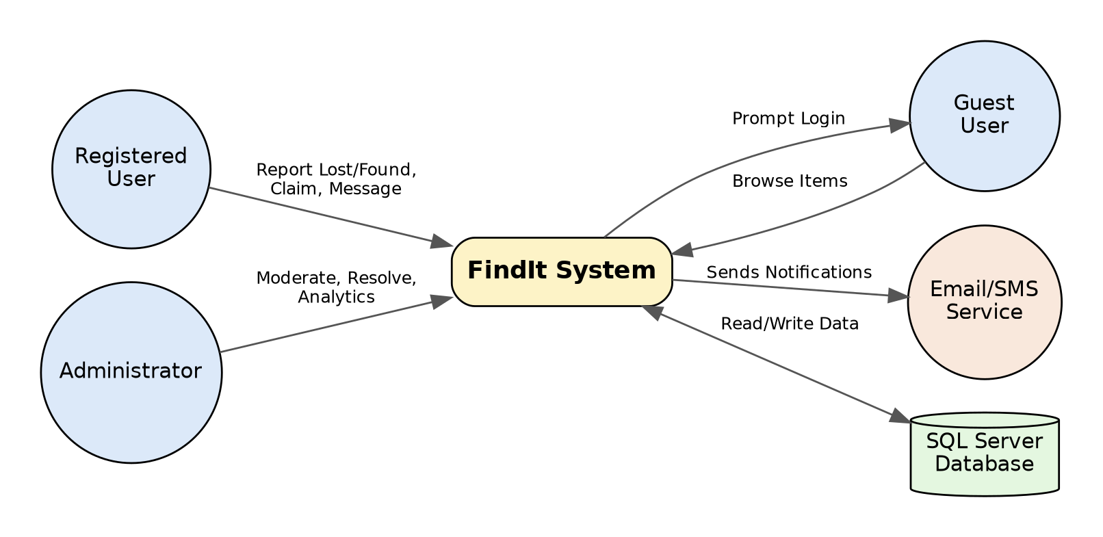
Figure 1: Context Diagram (Level 0)

2. Entity Relationship Diagram (ERD)
Illustrates the database schema and relationships.
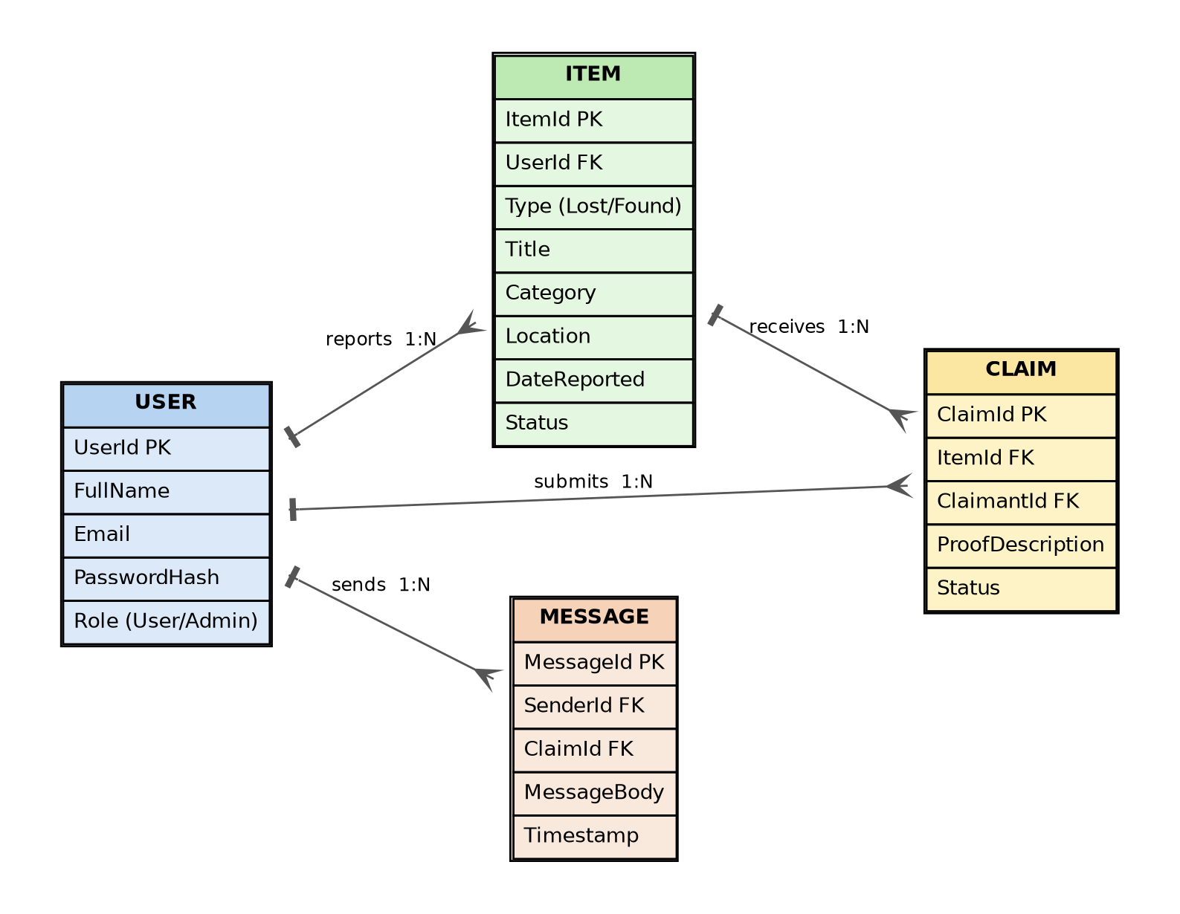
Figure 2: Entity Relationship Diagram

3. Process Flow Diagram: Item Reporting & Smart Matching
Illustrates the automated matching flow when a user submits a lost item.
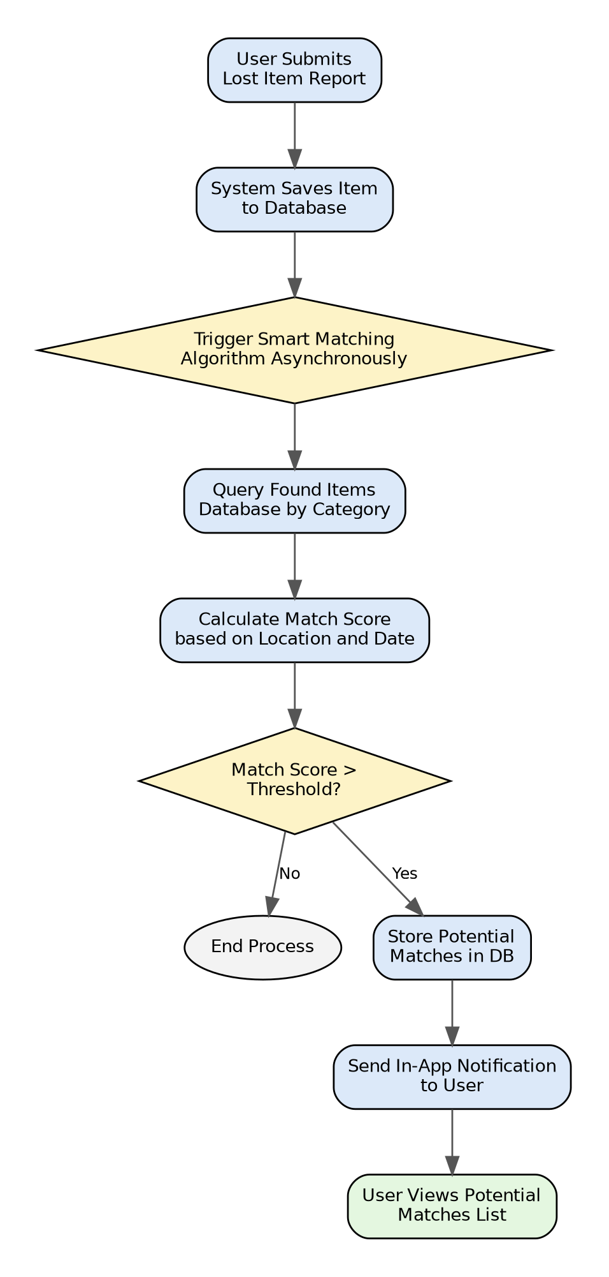
Figure 3: Item Reporting & Smart Matching Process Flow

4. Use Case Diagram
Illustrates key system interactions between actors and use cases.
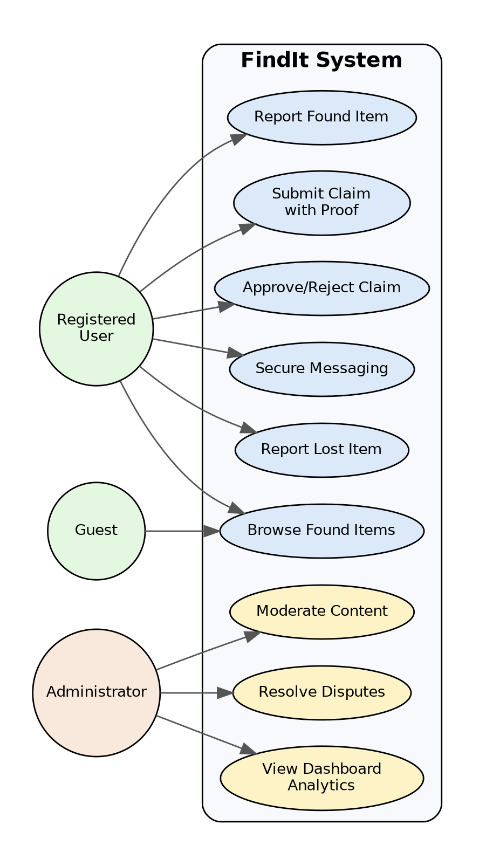
Figure 4: Use Case Diagram

6.4. Appendix B: Issues List
- Matching Algorithm Tuning: The exact weights for the scoring algorithm (Category vs. Location vs. Date) require testing with mock data to determine optimal thresholds.
- Hosting Environment: Decision on whether the final deployment will be on university servers, Azure, or a third-party hosting provider is TBD based on university IT policy.
- Image Storage: Determine whether uploaded item images will be stored directly in the file system or as binary data in the SQL database. (Recommendation: File system with path references in DB).

