% Z transform of 2^n + 2^n*(n - 1)
syms n
f=2^n + 2^n*(n - 1)
ztrans(f)
%output 2*z/(z-2)^2
%%%%%%%%%%%%%%%%%%%%%%%%%%%%
% Inverse Z transform of 2*z/(z-2)^2
syms z
F = 2*z/(z-2)^2;
iztrans(F)
% Output 2^n + 2^n*(n - 1)

EXC: Use the MATLAB command “roots” to determine the poles and zeros of the following systems-
- H(s)=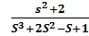
Program :
clc
clear
z=roots([1,0,2])
p=roots([1,2,-1,1])
Output :
z =
0 + 1.4142i
0 - 1.4142i
p =
-2.5468
0.2734 + 0.5638i
  - - 0.5638i

- H(s)= 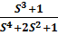

Program :
clc
clear
z=roots([1,0,0,1])
p=roots([1,0,2,0,1])

Output :
z =
-1.0000
0.5000 + 0.8660i
0.5000 - 0.8660i
p =
-0.0000 + 1.0000i
-0.0000 - 1.0000i
0.0000 + 1.0000i
0.0000 - 1.0000i

- H(s)=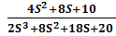
Program :
clc
clear
z=roots([4,8,10])
p=roots([2,8,18,20])
Output :
z =
-1.0000 + 1.2247i
-1.0000 - 1.2247i
p =
-1.0000 + 2.0000i
-1.0000 - 2.0000i
-2.0000
EXC: Use the MATLAB command “pzmap” to plot the poles and zeros of the following systems-
- H(s)=
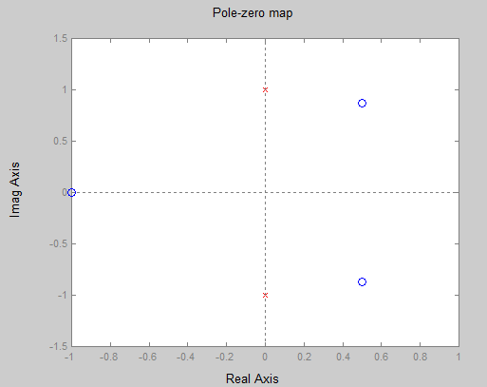
Program :
clc
clear
num=[1,0,0,1];
den=[1,0,2,0,1];
systf=tf(num,den)
pzmap(systf)

