WIFI DEAUTHENTICATION ATTACKS

J Component Project

S. NO. | NAME | REG. NO.
1 | Adarsh Vikram Singh | 20BCI0075
2 | Harsh Bhaskar | 20BCI0144
3 | Prashant Kumar | 20BCI0006
4 | Sayam Sarkar | 20BCE0550


School of Computer Science and Engineering

Vellore Institute of Technology
Vellore
November 2022

INDEX

- ABSTRACT

- INTRODUCTION

- ABOUT PROJECT AREA

- LITERATURE SURVEY

- PROBLEM DEFINITION

- PROPOSED WORK

- PROPOSED METHODOLOGY

- EXPERIMENT RESULT AND ANALYSIS

- CONCLUSION

- FUTURE ENHANCEMENT

- SAMPLE CODE

- REFERENCES
ABSTRACT

The focal point of this project is the Wi-Fi de-authentication attack and to find the vulnerabilities in the different Wi-Fi networks. This paper will show the importance of having a strong and unbreakable password, which will protect our networks from exploitation. These WIFI networks have different levels of security standards and different ways of exploiting them, wherein we try to create an attack surface for each of them. We will test our exploits on Windows and the Wi-Fi networks to be tested will be WEP (Wired Equivalent Privacy), WPA (Wi-Fi Protected Access), WPA2 (Wi-Fi Protected Access 2), and will include WPS, provided we can access those types of networks. We used 2.4 GHz Wi-Fi networks as they’re found often. The goal is to make people aware of the vulnerabilities that exist in the digital world out there. To avoid breaking of the cyber rules, we tried hacking into our own Wi-Fi network implementing different security protocols. All the devices used in this project are owned by our team members. We used Kali Linux as an Operating system for hacking because it contains large suits of tools for penetration testing.

INTRODUCTION

WPA2 protocol is hard to hack. But still, it can be cracked. It is extensively used by all modern-day devices for protection. Some of its vulnerabilities have been discovered. One such vulnerability is it allows disconnecting a device with a single de-authentication packet, for which a person does not even need to be connected. This vulnerability is being misused widely. Along with the DE authentication attack, we have even demonstrated the Denial-of-service attack.

ABOUT PROJECT AREA

A Wi-Fi de-authentication attack is a type of denial-of-service attack that targets communication between a user and a Wi-Fi wireless access point. Unlike most radio jammers, de-authentication acts in a unique way. The IEEE 802.11 (Wi-Fi) protocol contains the provision for a de-authentication frame. Sending the frame from the access point to a station is called a "sanctioned technique to inform a rogue station that they have been disconnected from the network".

An attacker can send a de-authentication frame at any time to a wireless access point, with a spoofed address for the victim. The protocol does not require any encryption for this frame, even when the session was established with Wired Equivalent Privacy (WEP) for data privacy, and the attacker only needs to know the victim's MAC address, which is available in the clear through wireless network sniffing.

RELATED CONCEPTS:

4-WAY HANDSHAKE

4-way handshake is the process of exchanging 4 messages between the authenticator and the client device to generate encryption keys that can be used to encrypt actual data send over the wireless network.
Message 1: AP sends the client his ANONCE. The client creates PTK after getting ANONCE, Message 2: The client sends to AP his SNONCE with a MIC. Here, MIC is mainly for the authenticator to recognize the message is from the client (kind of digital signature). Now the authenticator has everything he needs to create the PTK.
Message 3: The authenticator sends to the client the GTK because, this is the first time the device is get connected to the device,
Message 4: The client sends to the authenticator that it got connected.
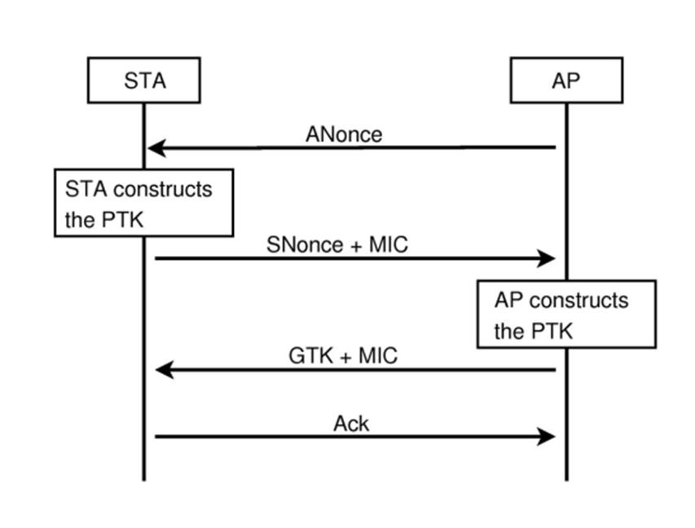

For cracking the password, we pick up the handshake, which hashes the password with a nonce and verifies it with the AP. In the project, we hacked the following security protocols which are commonly used in WiFi routers. For breaking the WEP protocol, we will capture packets in the target network, analyze them to get the IV for every packet, and get the password using an automated statistical attack.In WPA, we can brute into the network using this feature, which enables us to find the original password using the wordlist created using crunch. Then for testing all other passwords from the word crunch without waiting for the authentication from the router

again and again. This is done by disconnecting a device already connected to the router forcibly.

When the device reconnects, the router sends a handshake to the device which is captured.

LITERATURE SURVEY

S. No. | TITLE |  |  |  | CONTRIBUTORS |  |  | SUMMARY
1 | The | Untold | Secrets | of | Tian Xie, Guan-Hua Tu, |  |  | T | his |  | article shows
 | WiFi-Calling |  | Services: |  | Bangjie Yin, Chi-Yu Li, |  |  | how the Wi-Fi calling
 | Vulnerabilities, |  | Attacks, |  | Chunyi Peng, Mi Zhang, |  |  | service |  |  |  |  | can |  | be
 | and Countermeasures |  |  |  | Hui Liu, Xiaoming Liu |  |  | exploited |  |  |  | and subject
 |  |  |  |  |  |  |  | to |  | DoS |  | attacks. A
 |  |  |  |  |  |  |  | solution |  |  |  | is | also made
 |  |  |  |  |  |  |  | to | protect |  |  |  | users |  | from
 |  |  |  |  |  |  |  | those attacks.
2 | Wi-Fi Attack Vectors |  |  |  | Hal | Berghel and Jacob |  | The |  |  | article |  |  |  | here
 |  |  |  |  | Uecker |  |  | discusses |  |  |  |  |  | different
 |  |  |  |  |  |  |  | attack |  |  |  | vectors |  |  | of
 |  |  |  |  |  |  |  | Wi-Fi networks and
 |  |  |  |  |  |  |  | how |  |  | they |  |  | can | be
 |  |  |  |  |  |  |  | exploited
3 | WiFi | networks |  | and | Hao | Hua,b, | Steven | This |  | article discusses
 | malware epidemiology |  |  |  | Myersb, |  | Vittoria | how |  | technology |  |  |  |  | like
 |  |  |  |  | Colizzac, |  | and | the |  | 802.11n |  |  |  | standard
 |  |  |  |  | Alessandro Vespignani |  |  | with |  | flaws |  |  | is | helping
 |  |  |  |  |  |  |  | in | spreading |  |  |  |  | malware
 |  |  |  |  |  |  |  | as | the |  | same |  |  | exploit
 |  |  |  |  |  |  |  | can be used on a wide
 |  |  |  |  |  |  |  | array of devices using
 |  |  |  |  |  |  |  | the same standards
4 | Research Of Wifi Systems, |  |  |  | K. Brima, I. Opurum, R. |  |  | This article showcases
 | Protection Efficiency |  |  |  | Zolotyi |  |  | weaknesses |  |  |  |  | in radios,
 |  |  |  |  |  |  |  | potential |  |  |  | attacks |  |  | over
 |  |  |  |  |  |  |  | the Internet, etc

5 | Real Time Exploitation of |  |  |  |  | Zeeshan | Akram, | This | article |  |  | exploits
 | Security |  | Mechanisms of |  |  | Muhammad | Anwaar | residential |  |  |  | networks
 | Residential WLAN Access |  |  |  |  | Saeed |  | after |  | implementing
 | Points |  |  |  |  |  |  | additional |  |  |  | security
 |  |  |  |  |  |  |  | measures |  |  | on |  | it | to
 |  |  |  |  |  |  |  | provide a 3-layer
 |  |  |  |  |  |  |  | security |  | which |  |  | was
 |  |  |  |  |  |  |  | exploited, |  |  |  | showing
 |  |  |  |  |  |  |  | Wi-Fi networks are
 |  |  |  |  |  |  |  | vulnerable
6 | Research |  | on | Wi-Fi |  | He-Jun Lu, Yang Yu |  | This | article brings |  |  |  |  | to
 | Penetration Testing |  |  |  | with |  |  | attention the |  |  |  | various
 | Kali Linux |  |  |  |  |  |  | methods |  |  |  |  |  | of
 |  |  |  |  |  |  |  | penetration |  |  |  | testing
 |  |  |  |  |  |  |  | Kali | Linux |  | offer. We
 |  |  |  |  |  |  |  | can | explore |  |  | all | kinds
 |  |  |  |  |  |  |  | of vulnerabilities in it
 |  |  |  |  |  |  |  | to carry out attacks.
7 | Denial | of | Service | Attacks |  | Konstantinos |  | This article showcases
 | in Wireless Networks: The |  |  |  |  | Pelechrinis, | Marios | various |  | methods |  |  |  | of
 | case of Jammers |  |  |  |  | Iliofotou and Srikanth V. |  | jamming strategies by
 |  |  |  |  |  | Krishnamurthy |  | exploiting flaws in the
 |  |  |  |  |  |  |  | widespread |  |  | protocols
 |  |  |  |  |  |  |  | distributed |  |  | in wireless
 |  |  |  |  |  |  |  | systems |  | all |  | over |  | the
 |  |  |  |  |  |  |  | world
8 | How | Vulnerable |  | Is | the | Ruming Tang, | Haibin | In this article, an app
 | Public WiFi AP You Are |  |  |  |  | Li, Kaixin Sui, Zihao |  | SAVY |  | is | created |  |  | to
 | Using? |  |  |  |  | Jin, Xiao Yang, Dan Pei, |  | measure |  |  |  |  | how
 |  |  |  |  |  | Beichuan Zhang |  | vulnerable |  |  | a |  | public
 |  |  |  |  |  |  |  | Wi-Fi AP is and create
 |  |  |  |  |  |  |  | awareness |  |  |  | on |  | the
 |  |  |  |  |  |  |  | potential |  |  | threats |  |  | it
 |  |  |  |  |  |  |  | poses, |  | along |  | with a
 |  |  |  |  |  |  |  | report |  |  | to |  |  | the
 |  |  |  |  |  |  |  | developers

9 | WiFi | Data | Leakage | Pranav | Shrivastava, | This paper |  | highlights
 | Detection |  |  | Prerna | Agarwal, Rahul, | the | dangers |  | that
 |  |  |  | Monika |  | wireless |  | networks
 |  |  |  |  |  | present from the data
 |  |  |  |  |  | leaking through them.
 |  |  |  |  |  | As the world becomes
 |  |  |  |  |  | increasingly
 |  |  |  |  |  | dependent on wireless
 |  |  |  |  |  | comms, this
10 | Discovering and exploiting |  |  | Laurent | Butti, Julien | This article follows up
 | 802.11 | wireless | driver | Tinnès |  | on | a previous |  | article
 | vulnerabilities |  |  |  |  | on | vulnerabilities in
 |  |  |  |  |  | standards and |  |  | further
 |  |  |  |  |  | explains how they can
 |  |  |  |  |  | be exploited

PROBLEM DEFINITION

This project aims to:

- Send de-authentication packets to a target Wi-Fi network causing a DoS attack.
- Crack the handshake which is intercepted using a packet sniffer, effectively letting us know the password of the Wi-Fi network

PROPOSED WORK

In these attacks, we sniff out the packets of the target WPA2 network and identify the devices which are attached to the devices.

- Then the DE authentication packets are sent to a particular device causing a DoS attack, which allows the router to send the handshake to the device.
- We capture the handshake and do a dictionary attack to get the password.

Tools being used are

- crunch, creating wordlists.
- airodump-ng, sniffing packets, and eventually the handshake message.
- aireplay-ng, sending de-auth packets to a STA so the handshake is sent again.
- Then a code coded in Python, where we will be trying to hash every password either till the password is found or until the end of the wordlist.
PROPOSED METHODOLOGY

This project is compatible with any OS with python3 or above installed. Native libraries are used which makes it user-friendly.
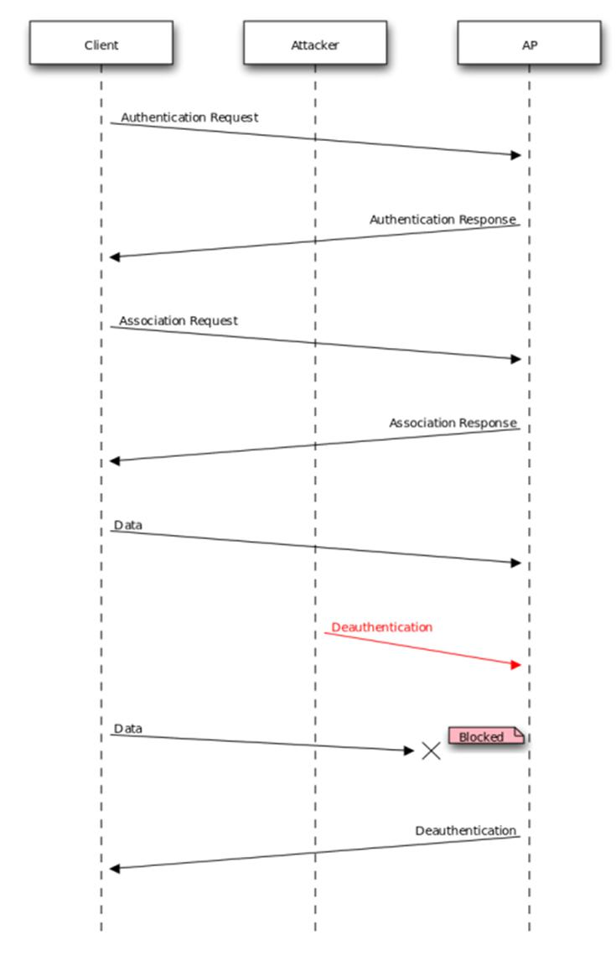
TOOL USED: AIREPLAY and AIRCRACK

AIREPLAY:

Description

Aireplay-ng is used to inject frames.

The primary function is to generate traffic for the later use in aircrack-ng for cracking the WEP and WPA-PSK keys. There are different attacks which can cause deauthentications for the purpose of capturing WPA handshake data, fake authentications, Interactive packet replay, hand-crafted ARP request injection and ARP-request reinjection. With the packetforge-ng tool it's possible to create arbitrary frames.

Some drivers needs to be patched to be able to inject, don't forget to read Installing drivers.

Usage of the attacks

It currently implements multiple different attacks:

- Attack 0: Deauthentication

- Attack 1: Fake authentication
- Attack 2: Interactive packet replay
- Attack 3: ARP request replay attack
- Attack 4: KoreK chopchop attack
- Attack 5: Fragmentation attack
- Attack 6: Cafe-latte attack
- Attack 7: Client-oriented fragmentation attack
- Attack 8: WPA Migration Mode
- Attack 9: Injection test

Usage:

aireplay-ng <options> <replay interface>

AIRCRACK:

Description

Aircrack-ng is a complete suite of tools to assess WiFi network security.

It focuses on different areas of WiFi security:

- Monitoring: Packet capture and export of data to text files for further processing by third party tools
- Attacking: Replay attacks, deauthentication, fake access points and others via packet injection
- Testing: Checking WiFi cards and driver capabilities (capture and injection)
- Cracking: WEP and WPA PSK (WPA 1 and 2)

All tools are command line which allows for heavy scripting. A lot of GUIs have taken advantage of this feature. It works primarily on Linux but also Windows, macOS, FreeBSD, OpenBSD, NetBSD, as well as Solaris and even eComStation 2.

Usage:

aircrack-ng -w password.lst -b 00:14:6C:7E:40:80 psk*.cap

EXPERIMENT RESULT AND ANALYSIS

WPA-2 Vulnerability Attack DOS

Step 1 - Fire up Kali Linux and open a Terminal

By typing ifconfig and the enter key on your terminal you get the following output :
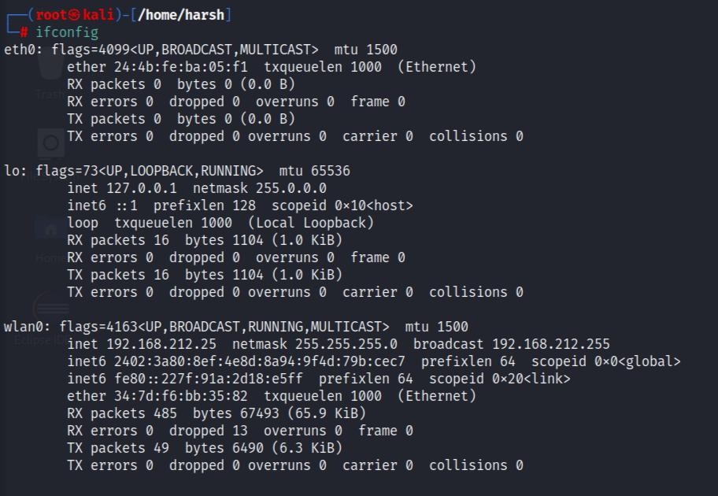

The next command is iwconfig. Type it and execute it on your terminal:
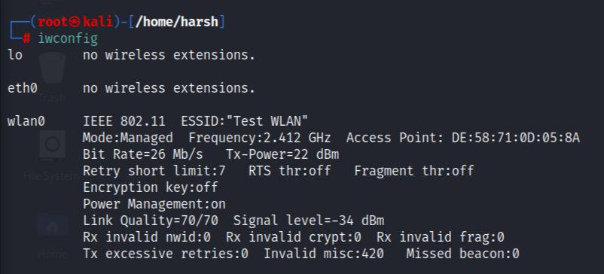

We can see from this output that our wireless card is operating in Managed Mode, when we would want it to be in Monitor Mode. So let's go ahead and do it.

Step 2: Using airmon-ng to configure the wireless adapter to monitor mode
You may put your adapter into monitor mode by performing the airmon-ng start wlan0 command. This command should be done regardless of what the name of your adapter is; it might be wlan1 or wlan2! Take a look at the results:
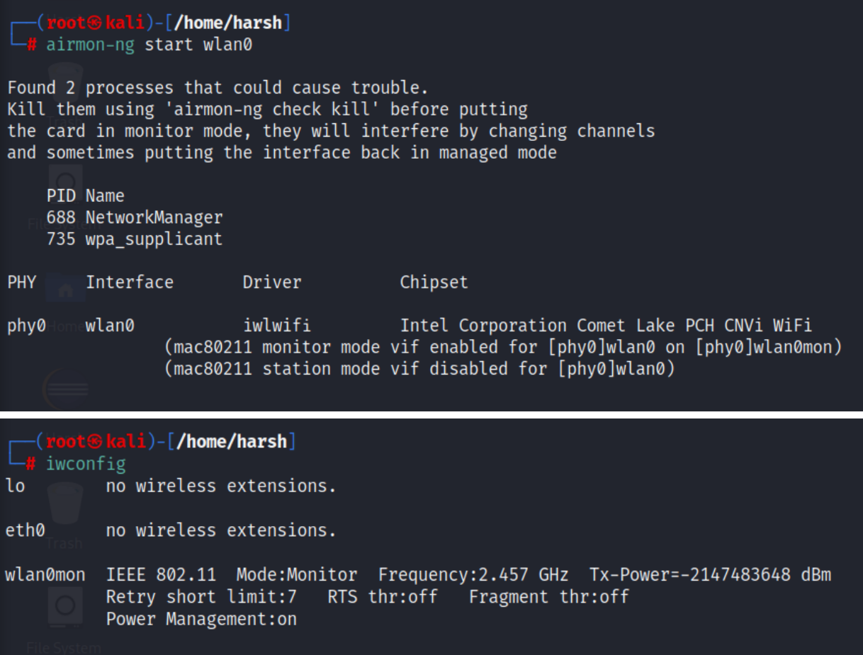

Please refer to the output of iwconfig above. Monitor mode, and the name of this monitor is wlan0mon! You are prepared to get started.

Step 3: Looking for victims using the airodump-ng equipment.

On your terminal, run the command "airodump-ng wlan0mon," and then begin selecting targets to capture.
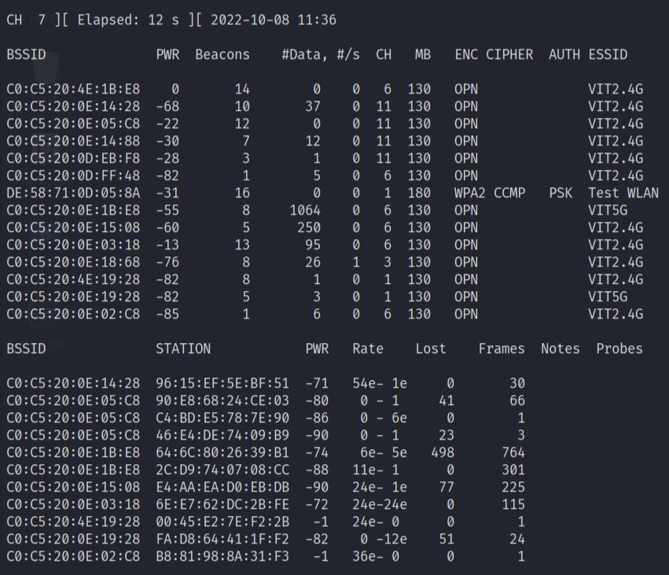

The BSSID and ESSID together may be used to assist hackers in locating certain areas. That is really a phenomenon.

The programme will continue to run and watch the activity of nearby Access Points, but as soon as we identify our target on the list, we can simply stop the monitoring process by pressing the ctrl and the c key simultaneously.

- The BSSID and MAC address of the access point are interchangeable. If the BSSID shown in the Client section is "(not associated)," it indicates that the client is not affiliated with any access point. Currently in a condition of disassociation, it is looking for an AP to which it may attach.

- PWR - The level of the signal that was reported by the card. Its significance is determined by the driver, but in general, a stronger signal indicates that you are getting closer to the access point or the station. If the BSSID PWR value is -1, it indicates that the driver does not allow reporting the signal level. If the PWR is -1 for a restricted number of stations, this indicates that a packet arrived from the AP to the client, but your card is unable to receive transmissions from the client because they are beyond of the card's range. This means that you are only picking up on half of the conversation. In the
event that all clients have PWR set to -1, it indicates that the driver does not enable signal level reporting.

- Beacons - The total amount of announcement packets that have been sent by the AP. Because each access point transmits around ten beacons per second at the lowest rate (1M), they are often able to be picked up from a fairly great distance.

- #Data | The number of data packets that have been successfully collected (if WEP, the count of unique IVs), including any data broadcast packets.
- #/s represents the number of data packets that have been measured per second during the last 10 seconds.
- CH - Channel identification number (taken from beacon packets). Note that due of radio interference, even when airodump-ng is not hopping, it may nevertheless pick up packets from other channels at random intervals.
- MB - The maximum speed that the AP is capable of supporting. If the MB value is 11, then the wireless network is 802.11b; if the MB value is 22, then it is 802.11b+; and higher rates are 802.11g. The dot that appears after number 54 in the previous sentence indicates that a brief prologue is acceptable. If quality of service (QoS) is enabled on the network, a "e" will appear after the MB speed figure.
- ENC | Current algorithm for data encryption. OPN = no encryption; WEP = what's the point? WEP (without the question mark) denotes static or dynamic WEP, and WPA or WPA2 if TKIP or CCMP is available in the network. " = WEP or higher (not enough data to differentiate between WEP and WPA/WPA2).
- Encryption The cypher has been deciphered. Choose CCMP, WRAP, TKIP, WEP, WEP40, or WEP104 as your encryption method. Although it is not required, the TKIP encryption algorithm is commonly used with WPA, whereas the CCMP encryption algorithm is typically used with WPA2. When the key index is larger than 0, the WEP40 algorithm is shown. According to the standard, the value of the index may range from 0 to 3 for a 40-bit system but must be 0 for a 104-bit system.
- AUTH | The protocol for authentication that was used. Choose between MGT (WPA/WPA2 using a separate authentication server), SKA (shared key for WEP), PSK (pre-shared key for WPA/WPA2), or OPN (one-time password for WEP) (open for WEP).
- Displays the name of the wireless network using the ESSID. The so-called "SSID," which may be left blank if the SSID concealing feature is turned on. In such a scenario, airodump-ng will attempt to reconstruct the SSID by analysing the probe answers and association requests.

Step 4: Targeting more narrowly for improved information collection comes next. # airodump-ng -d DE:58:71:0D:05:8A -c 1 wlan0mon
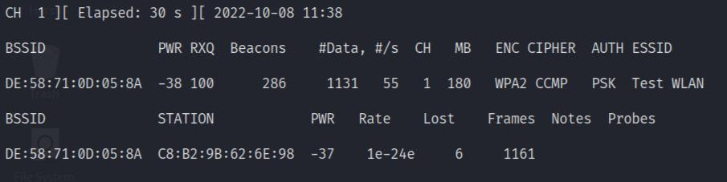

step 5: removing the device's authentication from the network

The last command is as follows:
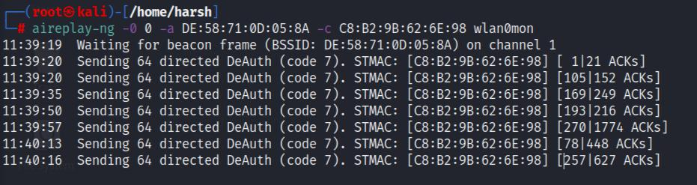

- A value of -0 indicates deauthentication.

- The amount of deauths to send is 0, which indicates that you should send them continually. If you want the target to disconnect and rejoin, you should send 10 deauths instead.
- -a The media access control (MAC) address of the access point that we are attempting to connect.
- If the -c parameter is not included, just the client with the MAC address will have their authentication revoked; otherwise, all clients will be deauthenticated.
- The name of this interface is wlan0mon.

PASSWORD CRACKING

To begin monitoring the network, type airmon-ng start wlan0 into the command prompt. If the name of the wireless network interface on your computer is not wlan0, you will need to change that portion of the command with the appropriate name. This will provide you with a new virtual interface name, which in most cases will be something along the lines of mon0 and will appear next to the phrase "(monitor mode enabled)".

Run the command airmon-ng check kill to terminate the processes in question if you come across the warning "Found processes that might cause issue."
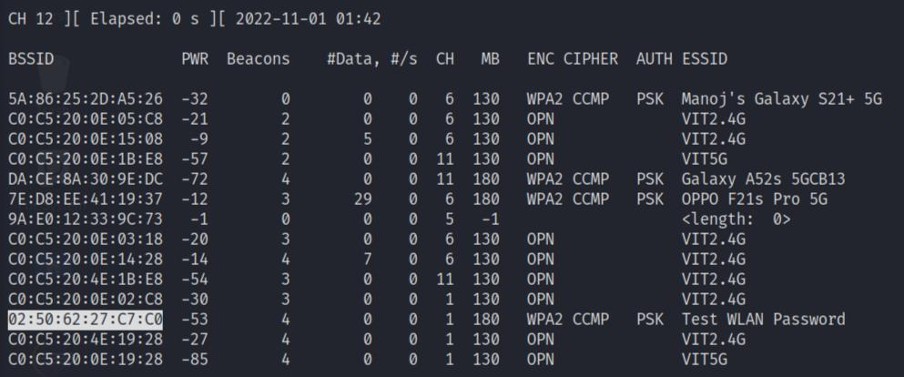

To examine the results, use the airodump-ng wlan0mon command. If you have seen something different in the past, you should replace mon0 with the correct name for the virtual interface. This brings up a data table with information about all of the Wi-Fi routers within range.

Locate the router that you want to hack into. You will find a router's name appended to the very last character of each string of text.

Check that the router is protecting your data with WPA or WPA2 security. You are free to move forward with the process if the "ENC" column contains the words "WPA" or "WPA2."
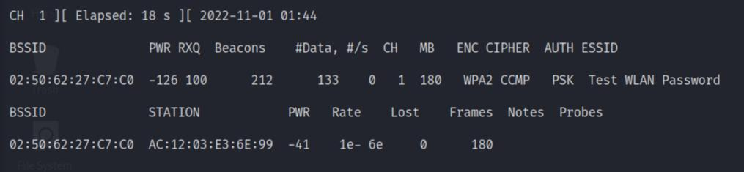

Keep an eye out for a handshake on the network. When an object first joins to a network, a "handshake" takes place (e.g., when your computer connects to a router). You have to be patient and wait for a handshake to take place before you can get the data you need to break the password. Execute the following command to get monitoring up and running:

airodump-ng -c number —bssid is the command to use. xx:xx:xx:xx:xx:xx -w /root/Desktop/ mon0
Switch out the word number for the channel number you observed, and the xx:xx:xx:xx:xx:xx:xx for the BSSID.
You will continue to check for new handshakes and connections so long as you keep this command active in the background.
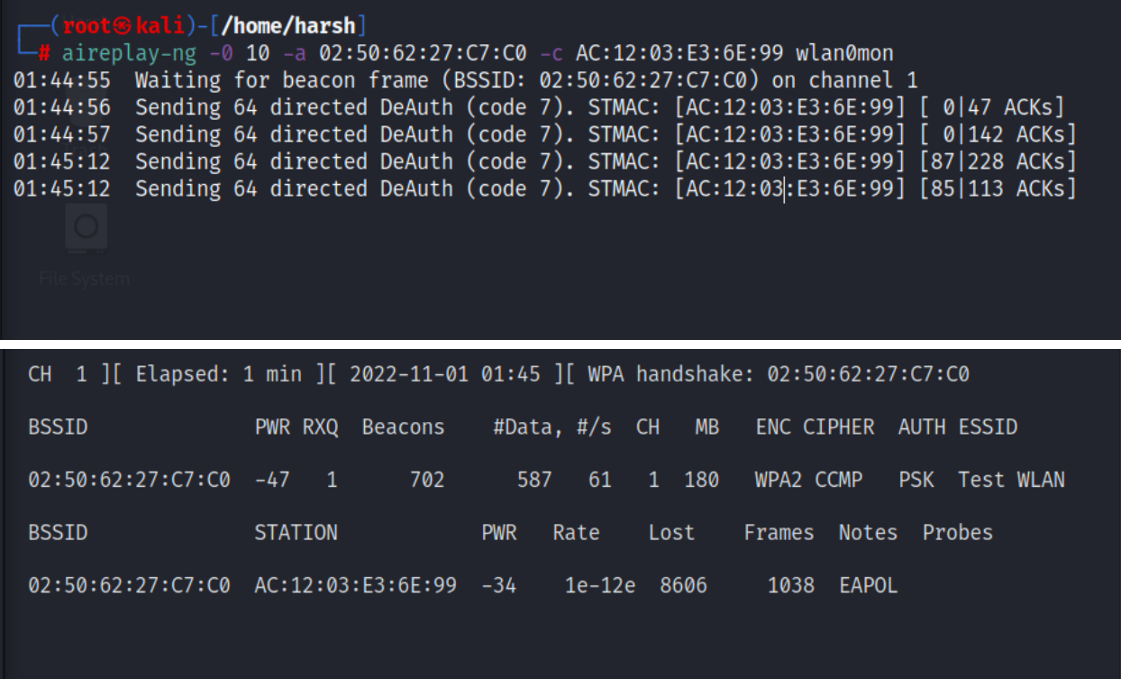

Send the packets to deauth the account. Execute the following command, making sure that the BSSID of the client that connected to the network is substituted for STATION BSSID and that the BSSID of the router is replaced with NETWORK BSSID: aireplay-ng -0 2 -a STATION BSSID -c NETWORK BSSID mon0 is the command that has to be entered.

By issuing this command, two deauth packets will be sent in order to disconnect the client from the network.

- Do not attempt to transmit more than this, since doing so may prevent the client from reconnecting and creating the handshake. Sending more packets than this may also result in an error.
As long as you are near enough to the target client, they will be forced to rejoin with a handshake after being separated from the router as long as you are. If this does not work, you may want to try moving closer to the customer.

The moment the client successfully re-establishes connection, all of the data that you need to decipher the password will become accessible.
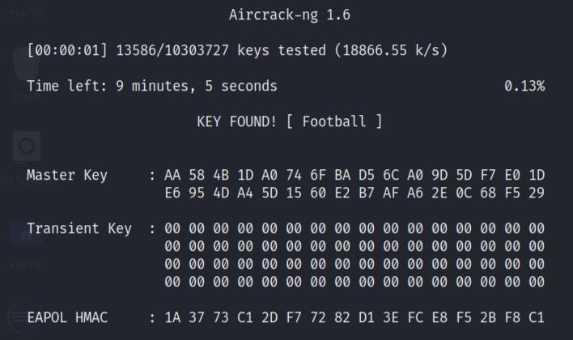

Execute the command to find out what the password is. In order to accomplish this goal, you will need to make use of a programme known as aircrack-ng, which is included with Kali Linux. The programme that has to be executed is aircrack-ng -a2 -b NETWORK BSSID -w /usr/share/wordlists/rockyou.txt /root/Desktop/*.cap. NETWORK BSSID should be replaced with the BSSID that is assigned to the router.

This procedure may take anything from a few hours to a few days to complete, depending on the complexity of the password and the speed of your central processing unit (CPU).
Change the -a2 in the command to the -a1 if you want to breach a static WEP key network rather than a WPA/WPA2-PSK network.

[4]

CONCLUSION

Simple actions to minimize such risks and address system vulnerabilities are insufficient; instead, a seamless policy implementation process supported by solid procedures is required. The process of security development necessitates a detailed understanding. Recognizing different vulnerabilities and threats that can affect a system's assets is followed by identifying different vulnerabilities and threats that can affect a system's assets. It's critical to research the many types of attack actors and figure out which ones are most likely to assault a system. More research is needed to fill the gaps in information about threats and cybercrime, as well as provide the essential methods to prevent possible attacks, in order to lessen both threats.
FUTURE ENHANCEMENT

Building an application that detects and tries to protect the system from any type of deauthentication attacks.

REFERENCES

- Butti, Laurent, and Julien Tinnes. "Discovering and exploiting 802.11 wireless driver vulnerabilities." Journal in Computer Virology 4.1 (2008): 25-37.
- Akram, Zeeshan, Muhammad Anwaar Saeed, and Marriam Daud. "Real time exploitation of security mechanisms of residential WLAN access points." 2018 International Conference on Computing, Mathematics and Engineering Technologies (iCoMET). IEEE, 2018.
- Hu, Hao, et al. "WiFi networks and malware epidemiology." Proceedings of the National Academy of Sciences 106.5 (2009): 1318-1323.
- Berghel, Hal, and Jacob Uecker. "WiFi attack vectors." Communications of the ACM 48.8 (2005): 21-28.
- Brima, K., I. Opurum, and R. Zolotyi. "Research of wifi systems protection efficiency."
Матеріали Ⅵ науково-технічної конференції „Інформаційні моделі, системи та технології “

(2018): 8-8.
- Lu, He-Jun, and Yang Yu. "Research on WiFi Penetration Testing with Kali Linux." Complexity 2021 (2021).
- Shrivastava, Pranav, and Prerna Agarwal. "WiFi Data Leakage Detection." IOP Conference Series: Materials Science and Engineering. Vol. 804. No. 1. IOP Publishing, 2020.

- Xie, Tian, et al. "The Untold Secrets of WiFi-Calling Services: Vulnerabilities, Attacks, and Countermeasures." IEEE Transactions on Mobile Computing (2020).
- Tang, Ruming, et al. "How Vulnerable Is the Public WiFi AP You Are Using?."
[10] Pelechrinis, Konstantinos, Marios Iliofotou, and Srikanth V. Krishnamurthy. "Denial of service attacks in wireless networks: The case of jammers." IEEE Communications surveys & tutorials 13.2 (2010): 245-257

