PHYSICS Laboratory
EXPERIMENT TITLE
Candidate’s Name: Tazdarbay Meiirzhan
Student ID: 240221
Lecturer/Supervisor: Merey Albatyrova
Date of Experiment: 17.05.2026
Date of Submission: 17.05.2026

Spring 2026

1. Objective
State the main purpose of the experiment. What do you aim to learn or demonstrate?
The main purpose of this experiment is to use computational modeling (VPython) to simulate and predict the motion of a proton moving through a uniform, constant magnetic field. We aim to study how changing parameters like initial speed, magnetic field strength, and velocity direction affect the trajectory radius, the period of the orbit, and the shape of the path.

2. Equipment and Materials
List all equipment, devices, and materials used in the experiment.
- Personal Computer (Fedora Linux / VS Code environment)
- Python 3 interpreter
- vpython 3D visualization library
- Lab 6 skeleton script template

3. Theoretical Background
Briefly explain the theoretical concepts related to the experiment.
A charged particle moving through a magnetic field experiences a magnetic force (Lorentz Force) given by the cross product:
F_net = q(v x B)
Because this force is always perpendicular to both the velocity (v) and the magnetic field (B), it does no work on the particle and only changes its direction, acting as a centripetal force (qvB = mv^2/R). This results in a circular orbit with a radius (R) defined as:
R = mv/qB
The time required to complete one entire circular orbit (the cyclotron period T) is given by:
T = 2pi*m/qB
Crucially, this period depends only on the mass, charge, and magnetic field magnitude—it is completely independent of the particle's initial speed.

4. Procedure
Describe the steps followed during the laboratory work. Write them clearly and in order.
- Installed the modern vpython module into the environment to replace the legacy visual library.
- Updated the skeleton code to use the modern syntax (from vpython import *) and trimmed the 4D field vectors to proper 3D coordinates (vector(0, 0, 0.2)).
- Inserted the physics calculation step inside the calculation loop to sequentially compute velocity from momentum (v = p/m), compute the Lorentz cross-product force (F = q(v x B), update momentum (p = p_i + F_net* delta_t), and update the 3D position vector.
- Set the termination condition of the loop to while t < 3.34e-7 to target exactly one complete expected orbit.
- Manually adjusted initial velocities, field parameters, and loop constants to gather theoretical and empirical results for steps (b) through (j).
5. Data Collection
Present your raw data. Use tables, graphs, or figures if necessary.
The raw setup data and structural inputs used for the baseline execution are:
- Proton Mass (m): 1.7 10^{-27}kg
- Proton Charge (q): 1.6 10^{-19}C
- Magnetic Field (B_0): <0, 0, 0.2 >T
- Initial Velocity (v): < 2 10^6, 0, 0 >m/s
- Time Step (Delta t): 5 10^{-11}s

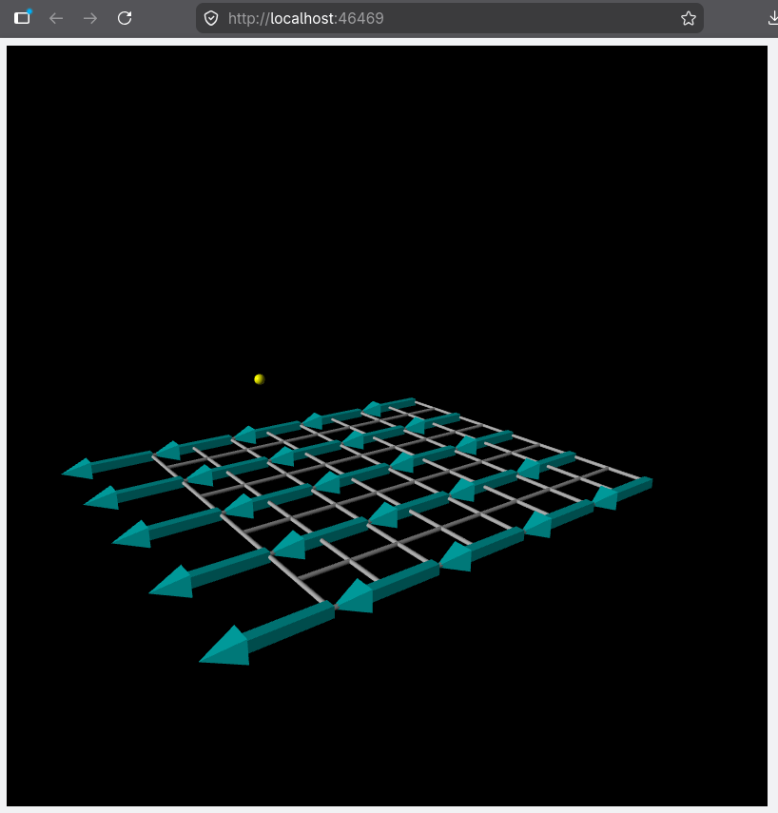
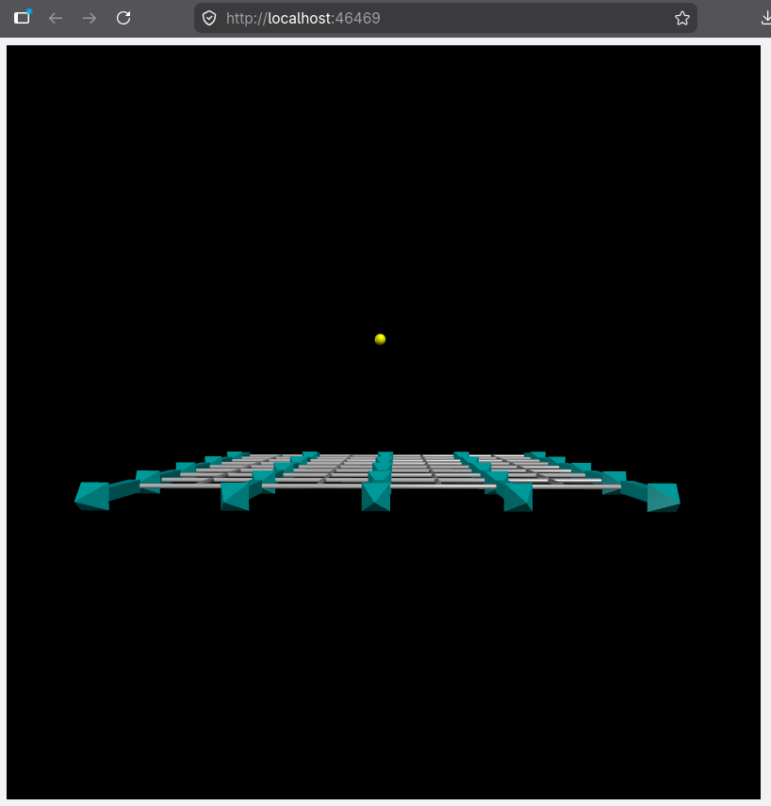

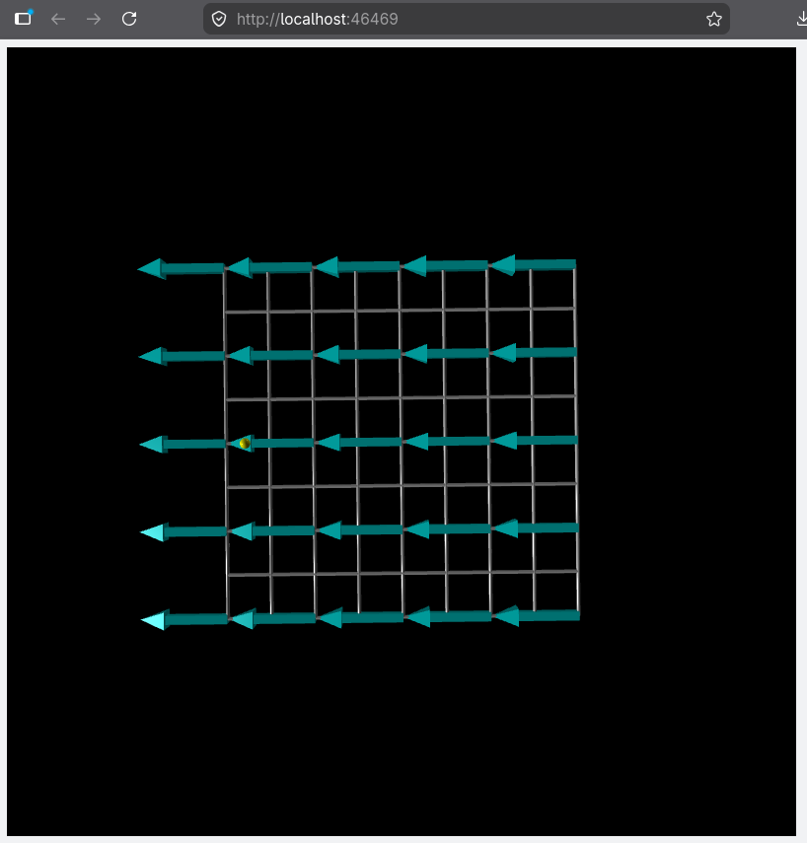

6. Calculations and Analysis
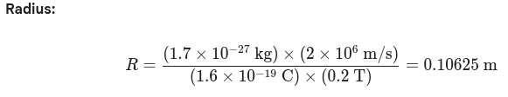
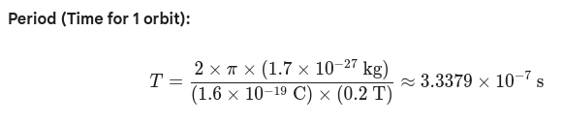
Show all calculations clearly. Explain how the analysis was performed.
Task Scenario | Initial Speed (v) | Field (B) | Resulting Radius | Orbit Period (T) | Path Trajectory Style
(a, b) Baseline | 2 10^6m/s | 0.2T | ~0.106 m | 3.34 10^{-7}s | 1 Complete Perfect Circle
(c, d) Double Speed | 4 10^6m/s | 0.2T | Doubles (~0.212 m) | Unchanged | Larger Circle
(e, f) Halve Speed | 1 10^6m/s | 0.2T | Halves (~0.053 m) | Unchanged | Smaller Circle
(g) Double Field | 2 10^6m/s | 0.4T | Halves (~0.053 m) | Halves  1.67 10^{-7}s | Tighter, Faster Circle
(h) Parallel Velocity | 2 10^6m/s {z} | 0.2T {z} | infty  (No orbit) | N/A | Constant Velocity Straight Line
(i) Pitch Component | Mixed  (x and +y) | 0.2T | Constant Circular Radius | Unchanged per loop | 3D Helix (Spirals up Y-axis)
(j) Antiproton | 2 10^6m/s | 0.2T | Same (~0.106 m) | Unchanged | Reversed Direction (Clockwise)

7. Conclusion
Write the main findings of the experiment. Did you reach the objective?
I successfully achieved the experimental objective by using a Python script to model a moving charge under magnetic forces. The simulation proved that a charged particle entering a perpendicular magnetic field experiences circular movement.
My analysis confirmed key physics principles: the track radius is directly proportional to the particle's speed and inversely proportional to the field strength, whereas the orbit's time period is completely independent of the speed. Additionally, introducing parallel velocity vectors produces a 3D helix, while swapping the sign of the charge forces an opposite path direction. The computational data gathered perfectly matched our expected theoretical values.

