Informe del retículo hexagonal (45 m)

1. Tabla de puntos del polígono
X | Y
131.589761920665 | 153.4422133587537
71.25799381985468 | 146.3164139767683
49.40554238176591 | 105.4618308533849
118.7633230330911 | 57.48144834801611
163.8933857856658 | 101.661404516326
216.1492479202259 | 105.9368841455173
340.8444640262489 | 146.1639323211662
354.2723930977689 | 226.8935551300318
301.1978772778784 | 279.9680709499223
224.2398293390372 | 278.641208054425
187.0876682651139 | 242.8159098759989
79.6117737298357 | 222.91296644354
57.05510450638226 | 193.7219827426002
149.9355071911906 | 204.3368859065783
258.738264621966 | 185.7608053696167
217.6055148615509 | 163.2041361461632
196.3757085335947 | 132.6862895497262

2. Distribución de puntos
Puntos que caen dentro del polígono (Interiores):
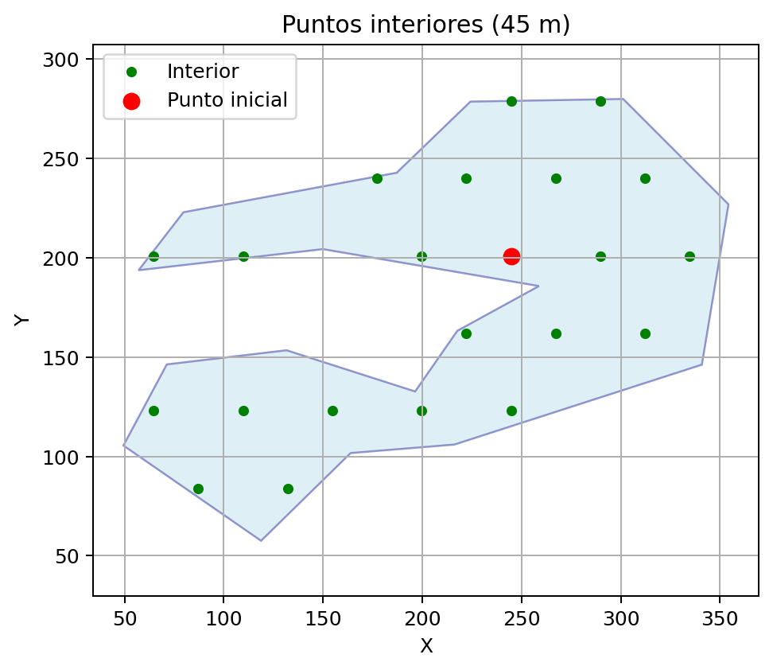
Puntos interiores y auxiliares (BordeAux y BordeAux_Exterior):
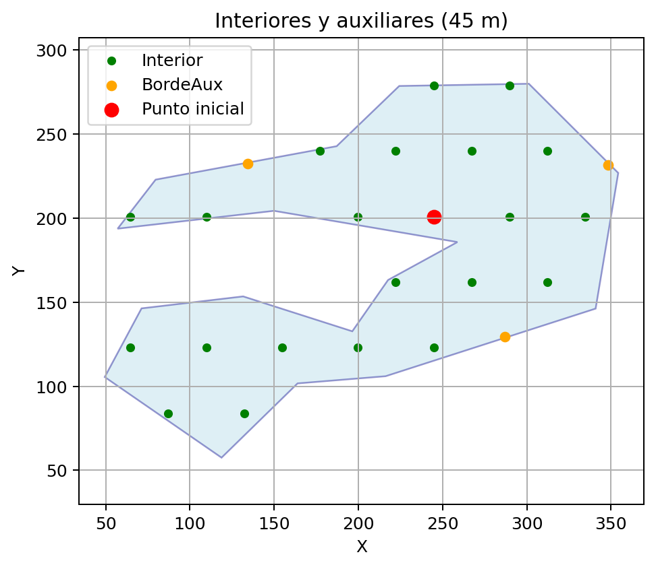

3. Totales por tipología
Interior: 22
BordeAux: 3
BordeAux_Exterior: 0
Total: 25

4. Tabla de puntos finales (ID, X, Y, Tipo) con 2 decimales
ID | X | Y | Tipo
1 | 64.67 | 122.95 | Interior
2 | 64.67 | 200.89 | Interior
3 | 87.17 | 83.98 | Interior
4 | 109.67 | 122.95 | Interior
5 | 109.67 | 200.89 | Interior
6 | 132.17 | 83.98 | Interior
7 | 154.67 | 122.95 | Interior
8 | 177.17 | 239.86 | Interior
9 | 199.67 | 122.95 | Interior
10 | 199.67 | 200.89 | Interior
11 | 222.17 | 161.92 | Interior
12 | 222.17 | 239.86 | Interior
13 | 244.67 | 122.95 | Interior
14 | 244.67 | 200.89 | Interior
15 | 244.67 | 278.83 | Interior
16 | 267.17 | 161.92 | Interior
17 | 267.17 | 239.86 | Interior
18 | 289.67 | 200.89 | Interior
19 | 289.67 | 278.83 | Interior
20 | 312.17 | 161.92 | Interior
21 | 312.17 | 239.86 | Interior
22 | 334.67 | 200.89 | Interior
23 | 134.29 | 232.34 | BordeAux
24 | 286.89 | 129.59 | BordeAux
25 | 348.30 | 231.57 | BordeAux

