**Homework Policy**

* Clearly outline and explain your approach to solving each problem.
* Make ***and state*** any assumptions that you think are necessary in solving problems.
* Provide all solution steps, and clearly mark/box your solutions.
* Start with the general formulation, and simplify all expressions as much as possible.
* Work out symbolic expressions, and plug in numbers only at the end when asked for specific numerical values.
* Show all your results and derivations explicitly worked out by hand. Partial credit is given for intermediate steps of derivations.
* Computer symbolic toolboxes (Maple, Mathematica, Matlab, etc) should not be used for derivations, algebraic steps, ODE’s, etc.
* Attach all non-trivial source code. Code should be ***clearly written and commented*** to explain units, notation, function inputs and outputs, etc.
* You are encouraged to discuss the general approach at the conceptual level in groups; however, you must submit your individual work, including write-up, plots, and code.

**Problem formulation**

The objective of this and the following assignments is to conduct a design and performance analysis of gas turbine engines. The framework is propulsion requirements and design for the HondaJet HA-420, shown below in Figure 1 with some parameters in Table 1. The HondaJet is a small business jet with two turbofan engines and carries 6-7 people (1-2 crew, 4-6 passengers). With its unique design that includes over-the-wing engine mounts, natural laminar flow wing and nose, and carbon-fiber composite fuselage, the HondaJet is a cutting-edge aircraft with increased performance and efficiency (and unfortunately, a lengthy design, testing, and certification process!)

In this homework, you will conduct a basic aircraft performance analysis to evaluate lift, drag, and thrust. These performance data will serve as input parameters that we are developing, with increasing levels of complexity, in subsequent assignments. The initial engine model is an ideal turbojet, which consists of an ideal Brayton cycle gas generator inlet and exhaust nozzles.

|  |  |  |  |  |  |  |  |  |  |  |  |  |  |  |  |  |  |  |  |  |  |
| --- | --- | --- | --- | --- | --- | --- | --- | --- | --- | --- | --- | --- | --- | --- | --- | --- | --- | --- | --- | --- | --- |
| Figure . HondaJet small business aircraft | Table . HondaJet specifications   |  |  | | --- | --- | |  |  | | Wing area, Sref | 17.3 m2 | | Wing span, b | 12.12 m | | Profile Drag Coeff., CD0 | 0.01 | | Oswald Efficiency, e | 0.8 | | Max takeoff weight, MTOW | 41 kN | | Max payload, Wpay | 6230 N | | Fuel weight, Wfuel | 5600 N | | *g*TSFC, static | 0.49 N/hr/N | | *g*TSFC, Mach 0.7 | 0.77 N/hr/N | |

**Problem 1. Aircraft Performance Requirements**

Consider the HondaJet (with relevant parameters given in Table 1) at steady level flight conditions, and assume the thrust is perfectly aligned with the flight path – that is, the thrust angle is zero, or . Assume that the air can be described as calorically perfect with the ratio of specific heats and the gas-constant of J/(kg-K). To simplify your analysis, assume that the wing has no sweep and that the chord is constant and equal to the mean chord. Also, neglect effects of the fuselage, horizontal and vertical tail surfaces, and landing gear; neglect the reduction in aircraft weight due to fuel burn; and neglect compressibility drag. With these assumptions and the given aircraft specifications, answer the following:

1. Evaluate the required thrust as a function of speed, (identical to )[1], for the HondaJet at maximum takeoff weight and three different altitudes (sea level; 30,000 ft; 43,000 ft). First, show the symbolic expression; then, plot all three curves in a single graph of *Trequired* vs *U∞*. To do this, complete the code marked **TODO** in the function thrustRequired and the driver code (problemSet1Driver.m). What is the difference in the required thrust among these three altitudes? What effect do you think this would have on fuel consumption, range, and flight time? Are there any Mach number concerns over the range of flight speeds (and altitudes) you have plotted?
2. Calculate the range for cruise at 30,000 ft and at 43,000 ft, selecting the operating condition near the minimum drag at that altitude. Note that TSFC is a function of Mach number – you can either use the value at Mach 0.7 or choose (and explain your reasoning) a value between the given data for TSFC at static and Mach 0.7 conditions.

**Problem 2. The Ideal Turbojet and the Real Turbofan**

Figure 2 shows the convention for “station numbering” for gas turbine engines. These examples are turbofans, in which a portion of the air mass flows through the low-pressure fan and does not undergo combustion. Note that there can be slightly different conventions for numbering stations involving an afterburner, but we are not dealing with that here.

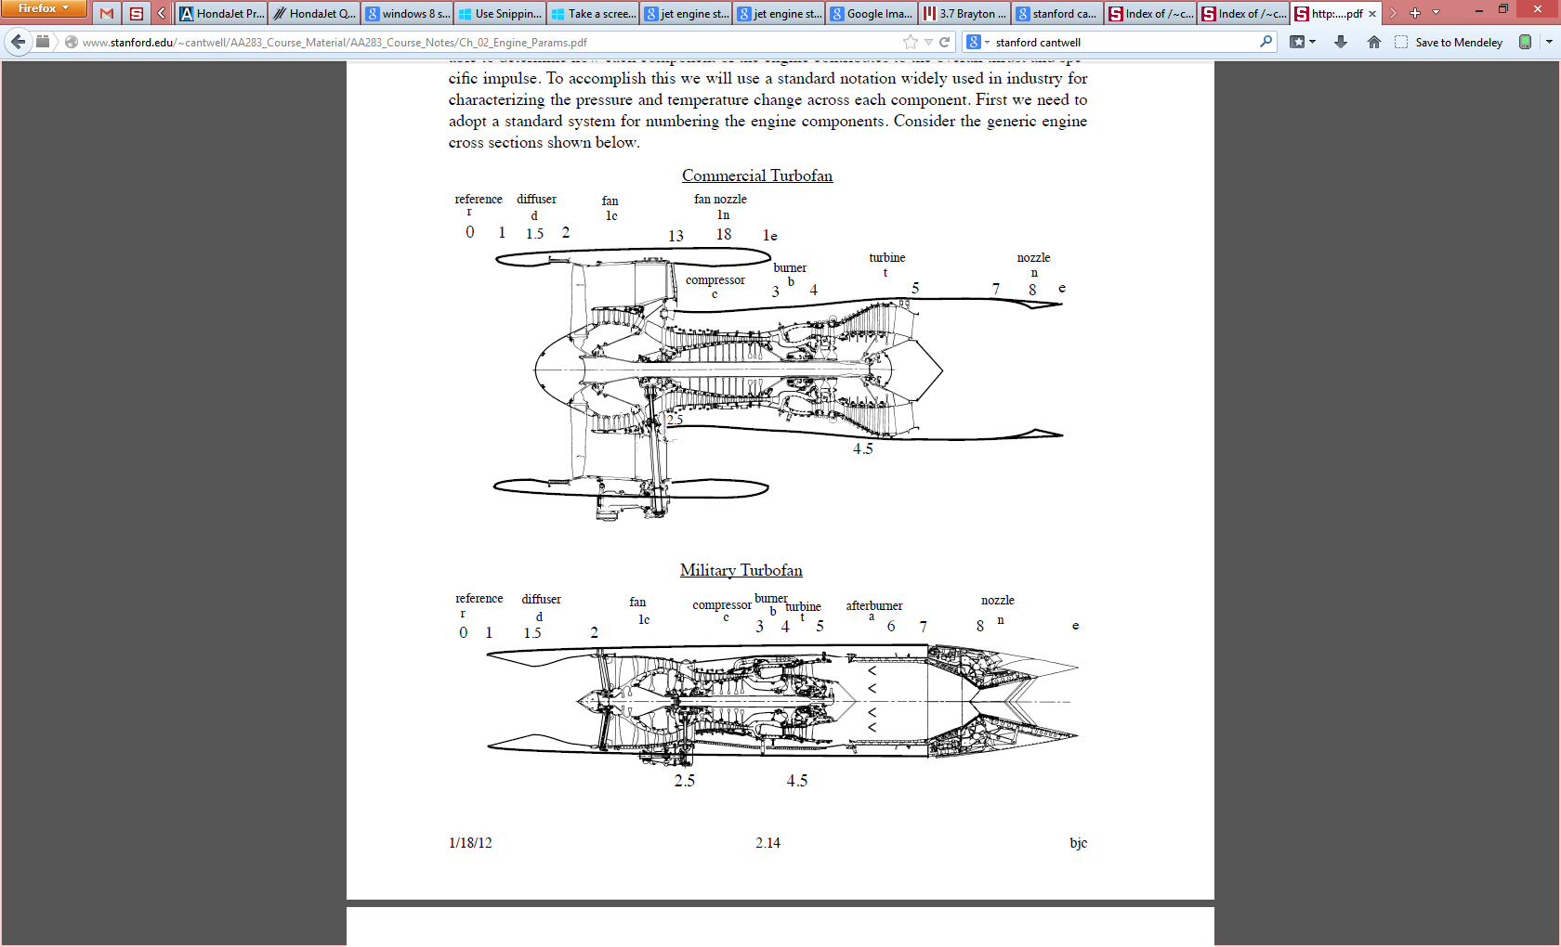

Figure 2. Examples of commercial (high-bypass-ratio) and military (low-bypass-ratio) turbofan engines.

In the following problem, we will consider two models for the Honda HF120 turbofan engine: an ideal turbojet and a real turbofan. The objective here is to build understanding about how the design parameters and operational conditions can affect the performance of the engine.

1. **The Ideal Turbojet**

For this problem we will model the engine as an ideal Brayton cycle with compressor pressure ratio of 24, a turbine inlet temperature of 1600 K, and a mass flow rate (of air) of 8 kg/s at sea level operating conditions.

1. Following the station numbering conventions from Figure 2, sketch a diagram of an ideal turbojet engine reflecting the components in an ideal Brayton cycle with (ideal) inlet diffuser and nozzle.
2. Work through (symbolically), given freestream altitude (*ρ0*, *T0*, *p0*), speed (*U0*), compressor pressure ratio (*P3/P2*), temperature at the turbine inlet (*T4*) and mass flow (, to obtain the exit velocity and thrust of our ideal turbojet.
3. Calculate the sea-level static thrust of this ideal turbojet engine, and compare this value to the GE Honda HF120 engine (images and specs in Figure 3 below). Comment on any differences, and explain why/how you think our model differs from the HF120.
4. **The Real Turbofan**

A turbofan has an additional stage ahead of the high-pressure compressor that produces thrust by blowing “bypass” air that does not undergo combustion. Also, the fan is the first-stage or low-pressure compressor for the air that does flow through the core. To drive the fan, a second turbine stage is added that rotates independently of the high-pressure turbine and compressor we already had in the turbojet gas generator.

For the following analysis, consider a turbofan cycle with a bypass ratio of 2.9, fan pressure ratio of 2.0, overall pressure ratio of 24 (including fan and high-pressure compressor), temperature at the turbine inlet of 1600 K, and a core mass flow rate (of air) of 8 kg/s at sea level operating conditions.

1. Following the station numbering conventions from Figure 2, sketch a diagram of a turbofan engine. Clearly mark the fan exhaust as well as the separation of the two compressor stages (or, fan and compressor) and the two turbine stages. Also, show the shaft connections between the corresponding turbine and compressor stages.
2. Work through (symbolically) to obtain the exit velocity and thrust of a turbofan with losses, given freestream altitude (*ρ0*, *T0*, *p0*), speed (*U0*), fan pressure ratio (*p03_fan/p02*), compressor pressure ratio (*p03/p02*), temperature at the turbine inlet (*T4*), mass flow through the core (, bypass ratio (, and the following adiabatic efficiencies ( in Table 2.
3. Calculate the sea-level static thrust of this non-ideal turbofan engine, and compare this value to the GE Honda HF120 engine (images and specs in Figure 3 below). Comment on any differences, and explain why/how you think our model differs from the HF120.
4. **Comparison of the Ideal Turbojet and the Real Turbofan**

Now, you will compare an ideal turbojet and real turbofan performance as altitude and speed vary. Using your analytical results from part a.ii and b.ii, write a script that computes the thrust as a function of speed (from 0-300 m/s) for each engine and for three altitudes: sea level, 30,000 ft., and 43,000 ft. Assume that the mass flow rate is not a sensitive function of speed/Mach number, and that as a function of altitude the mass flow varies with the density ratio relative to the reference condition – that is, . Complete the functions idealTurbofanThrust and realTurbofanThrust. Use the driver code to generate the plots.

1. Present the results in one plot of thrust available vs. speed, *U0*, with a total of six curves: the ideal turbojet and the real turbofan at each altitude.
2. Comment on the trends of available thrust with changes in altitude and speed. If a turbofan with some bypass ratio is better, what do you think would be some practical limits to increasing bypass ratios to 20, 50, etc.? What is one of the highest bypass ratio engines used in commercial aviation today? From the trends shown in the plots, why might military aircrafts use a lower bypass ratio than a commercial aircraft?

Table 2. Typical turbofan component efficiencies

|  |  |
| --- | --- |
| **Component** | **ηadiabatic** |
| Diffuser | 95 % |
| Fan | 92 % |
| Compressor | 87 % |
| Combustor | 100 % |
| Turbine (HPT & LPT) | 91 % |
| Core Nozzle | 98 % |
| Fan Nozzle | 98 % |

|  |  |
| --- | --- |
| Macintosh HD:Users:mihme:Desktop:01.jpg | Macintosh HD:Users:mihme:Desktop:523-ge-honda.jpg |
| Macintosh HD:Users:mihme:Desktop:Screen Shot 2014-04-08 at 9.48.06 PM.png |

Figure 3 GE Honda HF120 details and specifications

<http://world.honda.com/HondaJet/Background/TurbofanEngine/>

1. Note that is typically used to refer to quantities with respect to the airframe, whereas denotes the station numbering with respect to the engine.