Getting Started with MATLAB

- Where to get MATLAB
  - Stanford Computer Clusters: MATLAB can be accessed on any on-campus computer facility using your SUnet ID under All Programs → MATLAB
  - Purchasing a student version of MATLAB: Visit the Software Licensing website at: https://itservices.stanford.edu/service/softwarelic/matlab. Scroll down to “Ordering” and select the “Software Licensing web store” link. Enter your SUnet ID and password and follow the step-by-step instructions for purchasing.
  - Remote Access: Apart from buying a student's license or going to the SCIEN Lab or Sweet Hall, you can use Matlab remotely from your PC if you can connect to the Stanford network - and your connection is fast enough, for instance if you live on campus.
    - First of all, we assume that you have an application to establish a TELNET connection. We recommend SecureCRT, the standard TELNET application at Stanford, available at http://www.stanford.edu/group/itss/ess/. Recall that to access any Stanford machine you need a Leland account, that is, a Stanford Network ID (SUNetID) and a password.

    - An X-Window server is an application you may install on your PC that allows you to connect to a UNIX machine and see in your PC what you would see if you were working in front of the UNIX machine itself, including not only text, but also graphics. Two examples of such programs are Hummingbird Exceed and M/X. The former is not free, but much better. The latter can be used for free during a limited trial period and can be downloaded from http://www.microimages.com/freestuf/mix/.

    - To establish this connection, you usually need to:
Launch your X-Window server (using for instance, Exceed). Launch your TELNET application (for instance, Samson) and establish a connection to a UNIX machine having MATLAB installed (for instance, elaine.stanford.edu, cardinal.stanford.edu, saga, firebird, forsythe, etc.). Your login and password are those corresponding to your Leland account. If you wish to connect to the ISE machines, please read below.
In your TELNET application, type
>setenv DISPLAY ${REMOTEHOST}:0.0
>xterm &
(optional test, opens a graphical terminal window, it can take minutes over a DSL connection!)
>matlab &
Wait for a few seconds for MATLAB to start.

Not all UNIX machines are properly configured and contain MATLAB properly installed. Save your files frequently in case the connection is lost, and use the Matlab command 'save' in your code to save partial data into MAT files. You can easily recover them later.

Use the UNIX commands 'xterm &' to open new windows and 'ssh' to connect to other machines, if necessary.

(Instructions taken form http://www.stanford.edu/class/ee398b/other.htm)

- Sources for Help
  - MATLAB Help Files: MATLAB has a comprehensive, immensely helpful built-in manual discussing every package or function you could ask for. You can…
    - Select Help in the toolbar at the top of the MATLAB command window, then select Product Help or MATLAB Help depending on the program version to open the help manual.
    - Try the Getting Started section if you aren’t familiar with MATLAB.
    - Type “lookfor keyword” in the command window to search the help sections of all MATLAB built-in functions (m-files) and get a list of functions mentioning your keyword
    - Type “help function_name” in the command window to receive a detailed description and syntax of that function
    - Type “doc function_name” to bring up the same info in the help browser format. Typing just “doc” will open the help browser. You can also search for keywords across a global index in the help browser.
  - The Mathworks MATLAB User Community: This forum of MATLAB users across the globe has posts dealing with a wide variety of MATLAB questions. Search the forums or make your own post asking for help. http://www.mathworks.com/matlabcentral/
  - Google: Of course, the web is awash in MATLAB tutorials for nearly anything under the sun.

- Matrices and Vectors
  - Manipulating Matrices: The best way to get started with MATLAB is to learn how to handle matrices. The matrix is the basic data type in MATLAB; even a single, isolated number is treated as a 1x1 matrix.
    - Differences from other languages:
      - The starting index of a matrix or vector in MATLAB is identified by the number ‘1’ instead of ‘0’
      - New variables can be created and defined at the same time, and data types are automatically determined – there are no long lists of “double this” or “int that” at the beginning of a MATLAB code.
    - Creating or defining matrices
      - The elements contained in a given row are separated by EITHER a comma OR a space
      - New rows are denoted by the semicolon ( ; ), so the commands (the >> indicates the command prompt in MATLAB)
>> x = [1 2 3; 4 5 6];
and
>> x = [1,2,3; 4,5,6];
both produce the following 2x3 matrix
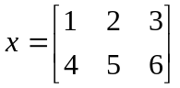
      - To suppress the printed output after each command, you can put a semicolon at the end of the statement
      - Useful commands to create special types of matrices:
        - zeros(N) or zeros(M,N)
          - creates a NxN or MxN matrix of all 0’s. Very useful for preallocating matrices of known size.
        - ones(N) or ones(M,N)
          - creates a NxN or MxN matrix of all 1’s
        - rand(N) or rand(M,N)
          - creates a NxN or MxN matrix of random numbers between 0 and 1
        - eye(N)
          - creates the NxN identity matrix (1’s on the diagonal)
    - Indexing in matrices
      - Row-column format: MATLAB labels elements in matrices in row-column format, so for a matrix A the command A(M,N) specifies the value of A in the Mth row and N^{th} column. For example,
        - >> A = rand(3)
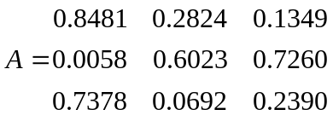
>> A(2,3)
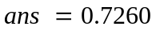
      - Colon Notation: Sometimes you want to specify not just one but several matrix elements at once. The colon in MATLAB lets you specify a range of numbers by only typing in the endpoints.
        - This can be useful in making a vector or matrix with a sequence of numbers…
          - >> b = 1:5
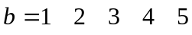
>> c = [1:3; 4:6; 7:9]
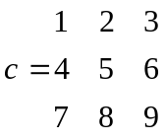
        - …or in specifying a range of elements in a matrix. Using the matrix A of random numbers from before,
          - >> A(2,1:3)
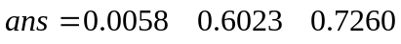
>> A(1:3,2)
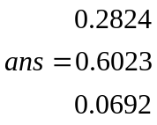
Note how MATLAB preserves row and column orientation!
        - There is an even more compact notation, the colon alone, to specify an entire row or column
          - >> A(1,:)
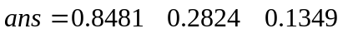
>> A(:,3)
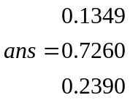
      - The Transpose Operator: To flip a matrix or vector from row to column form, and vice versa, use the transpose operator, the apostrophe (‘). Again using the matrix A from before,
        - >> A(:,3)’
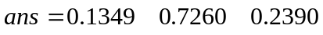
  - Multiplying Matrices: Matrix addition, subtraction, multiplication and division work in MATLAB in the logical way according to the rules of linear algebra. Addition and subtraction are straightforward and can only be performed on matrices with the same dimensions. Multiplication of matrices is performed with the * operator, but the matrix dimensions must be valid according to the rules of linear algebra or MATLAB will return an error
    - Full Matrix Multiplication: multiplying our matrix A from before by the identity matrix B works as you would expect
      - >> B = eye(3)
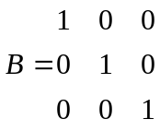
>> A * B
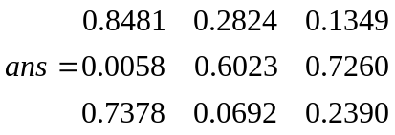
    - Element-wise Matrix Operations (Dot notation): Sometimes it is very convenient to simply multiply each element in one matrix by its corresponding element in another; the dot notation will do this.
      - >> A .* B
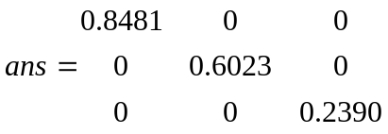
      - The dot notation also works on other operations as well, for example, division or exponentiation
        - >> A ./ B
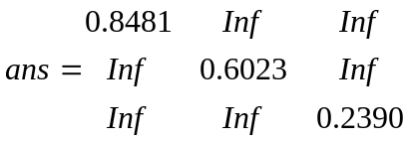
Not surprisingly, dividing by zero gives infinity!
>> A .^ B
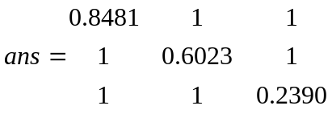
And raising anything to the 0th power gives 1.

- Loops
  - The For Loop: The for loop repeats a task a specified number of times, using an index with the colon notation.
    - We could produce the variable 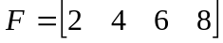 with the following loop, which iterates over the index “i” from 1 to 4.
      - >> for i = 1:4
F(i) = 2*I;
end
  - The While Loop: The while loop repeats a task for an unspecified number of times, until a given condition is no longer true
    - Boolean expressions: The condition the while loop uses is called a Boolean expression, and it is a comparison between two quantities using one of the following symbols. This expression can have a value of 0 (false) or 1 (true), and the loop executes as long as the condition is true.
      - > (greater than)
      - < (less than)
      - == (equal to)
      - <= (less than or equal to)
      - >= (greater than or equal to)
      - ~= (not equal to)
    - Linking Booleans: More than one true/false condition can be enforced at one time using the logical AND (&) and OR(|) operators. The OR operator can be accessed by Shift-Backslash on most keyboards. For example,
      - J > 5 & k < 3 (j less than 5 AND k less than 3)
      - (m ~= 3 | n > 4) & p==5 (either of: m not equal to 3 OR n greater than 4, AND additionally p equal to 5)
    - The following loop will produce the same variable as in the previous example. Note that since this loop does not iterate automatically like the for loop, the while loop needs to explicitly iterate its own index.
      - >> i = 1;
while i <= 4
F(i) = 2*i;
i = i + 1;
end
  - Nested Loops: loops can be stacked inside one another, with the inner-most loop executing to completion before the loop containing it iterates.
    - To produce the following variable G,
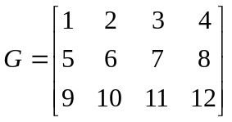
we can use the following loops
      - >> for i = 1:3
for j = 1:4
G(i,j) = j + 4*(i-1);
end
end

Note that we have used the if statement above, which executes a set of commands only if a certain condition is true. In the case above, the two conditions are when i equals to 2, and when i equals to 3. The condition for an if statement is again a set of boolean expressions connected by the logical operators & and/or |, similar to the condition for a while loop.

- Conditional Statements
  - If Statements: Sometimes a statement should be executed only when a specific condition is first met. The if statement handles this situation in MATLAB, as in many other languages. If statements use Boolean expressions to determine whether or not to execute their commands (see the section on while loops). For example, another way to create the matrix G from the previous section would be:
    - >> for i = 1:3
if i == 2
offset = 4;
elseif i == 3
offset = 8;
else
offset = 0;
end
for j = 1:4
G(i,j) = j + offset;
end
end
Note the use of the “elseif” command, which lets you check if another command is true if the first statement is not, and the “else” command, which holds commands to be executed if none of the “if” or “elseif” conditions are met.
  - Switch Statements: When only a few conditions are possible, it is sometimes simpler to use a switch statement, which explicitly instructs what to do in a small number of specific cases. As one final example of how to create the matrix G, a switch statement could be used:
    - >> for i = 1:3
switch i
case 2
offset = 4;
case 3
offset = 8;
otherwise
offset = 0;
end
for j = 1:4
G(i,j) = j + offset;
end
end

- Plotting
  - Basics of the Plot Command: the plot command graphs two vectors of equal length (see “help plot” for a wealth of detail).
    - Syntax:
      - plot(X,Y) will create a simple plot of Y versus X
      - plot(X,Y,S)” where S is an optional MATLAB string (entered as letters encased by apostrophes, i.e., ‘string’) will create a plot with a user-defined style of curve, such as solid or dashed, with various colors and marker types, etc. For example, the following command would plot x vs. y in blue (the ‘b’) with X’s at every data point (denoted by the ‘x’) and with each data point connected by a dotted line (the ‘--‘):
        - >> plot(x,y,’bx--‘)
      - The complete list of options for specifying line styles (And there are a lot!) may be found by searching for LineSpec in the Help documentation.
  - Plotting multiple curves at once
    - Using the plot command: to produce, say, 3 curves at once, with the first curve plotted with style S1, second curve with style S2, type
      - >> plot(X1,Y1,S1,X2,Y2,S2,X3,Y3,S3)
    - Using the hold command: to keep the figure window from refreshing each time a new plot is created, you could produce the same 3 plots as above by typing (in this order)
      - >> plot(X1,Y1,S1)
hold on
plot(X2,Y2,S2)
plot(X3,Y3,S3)
hold off
Note that you want to type “hold off” after you’re done, or else all future plots will go into the same crowded figure!
  - Labeling your plot:
    - Useful commands:
      - title
      - xlabel
      - ylabel
      - legend
      - xlim (sets x axis limits)
      - ylim (sets y axis limits)
  - Automatically generate M-code: In the Figure window, under Edit → Figure Properties and Edit → Axis Properties, you can manually alter almost any feature of a plot using an intuitive graphical interface. When you have the plot the way you like it, go to File → Generate M-File… to create a new m-file with all the commands listed to create your plot directly from the command line. This is a very useful way to learn how to generate plots you will make repeatedly very quickly.
  - Special characters: Greek characters and mathematical symbols can be inserted in your plot title, axes label, legend, etc. A complete list of special characters can be found by going to the plot command help file in MATLAB’s Product Help, and then look under the “See Also” section for “String” property.
    - For instance, this command will title a figure with “Plot for θ”
      - >> title(‘Plot for \theta’)
    - To create superscripts and subscripts, use ^ and _, respectively. This command will title a plot “Plot for T_{e} and θ²”
      - >> title(‘Plot for T_e and \theta^2’)
  - Plot in log space
    - Useful commands:
      - semilogx (log scale on x-axis only)
      - semilogy (log scale on x-axis only)
      - loglog (log scale on both axes)
  - Create x-axis values: often for plotting purposes (among other uses), one wishes to create a vector of values that span from a lower bound to an upper bound.
    - Useful commands:
      - linspace(A,B,N)
        - creates a vector of N equally spaced points between endpoints A and B
      - logspace(A,B,N)
        - creates a vector of N points equally logarithmically spaced between endpoints A and B
      - Both commands can be saved in a vector in the usual way, as for example
        - >> x = linspace(1, 2.5, 4)
- M-Files: Functions and Scripts
  - Creating an M-File: MATLAB lets you save sets of commands you want to run repeatedly so you don’t have to re-type them every time. These MATLAB programs are called m-files, functions, or scripts and are saved with a .m format. To make a new one, you have three options:
    - Go to File → New… → Blank M-File, or
    - Click on the icon in the upper left of the command window
    - Type Ctrl-N in the editor window
  - Defining input and output arguments: One of the most useful things a function can do is manipulate a variable and return it to you. The variables the function takes in and returns are called arguments. The format for starting a function is to write “function [output1, output 2, …] = function_name(input1, input2, …)”
    - Alternately, you can click File → New… → Function m-file to have this template inserted for you
  - Calling and using your function: You can call your function from the command line or from other functions.
    - Save your m-file
    - Type the command “[output] = function_name(input)”
      - MATLAB knows functions by their saved filenames, not the name you put on the first line of the m-file. If the two are different, it will encourage you to change the name on the first line to match the saved filename.
      - When calling a function, you don’t need to use the same variable names for the inputs and outputs as you used in actually writing the function.

- Root Finding
  - Basics of the Root Command: MATLAB’s built-in roots function solves polynomial equations quickly and easily.
    - Syntax:
      - roots(p) finds the roots of the polynomial whose coefficients are given in standard form (descending order of exponents) by the vector p. For example, the polynomial x² + 2x + 1 would be denoted by p = [1 2 1] and solved as
        - >> roots([1 2 1])
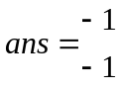
      - Polynomials with a zero coefficient must have the zero included. To find the roots of x³ + 3x² + 5, use p = [1 3 0 5].
  - Basics of the Polyval command: For ease of plotting polynomials, rather than dot-multiplying a vector of x-points out to create a vector of y-values, you can use the polyval command to evaluate a polynomial at points x using the polynomial’s coefficients in the p matrix as above.
    - Syntax
      - polyval(p,x) evaluates the polynomial with coefficients p at the points in x
  - Functional example: See the MATLAB script plotroots.m

- Numerical Integration
  - Basics of the trapz Function: MATLAB’s built-in trapz function does discrete integration using the trapezoidal rule.
    - Syntax:
      - trapz(x,y) finds the discrete integral of y evaluated at the points in the vector x
    - Functional example: see the sample code traprule.m

- Ordinary Differential Equation (ODE) Solver

MATLAB also has built-in numerical solvers for solving ordinary differential equations. The most common solver and the first one you should try when attempting to solve an ODE is the function called ode45. The basic command is as follows,

[T, F] = ode45(odefun, tspan, f0)

where the left hand side tells ode45 to return a vector T containing the time points and a matrix F containing the corresponding solutions for the system of equations. odefun is a function handle that evaluates the right side of the differential equation. The solver solves systems of equations in the form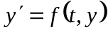. tspan is a vector specifying the interval of integration, [t0, tf]. And finally f0 is a vector of initial condition.

10.1: ODE Example 1

As a simple example, suppose we would like to solve the following differential equation.

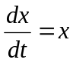 (2)

subject to the following initial condition, 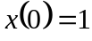. The analytical solution is of course 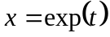. To do this in MATLAB, since the first argument to ode45 is a function handle, we need to define a function that describes the ODE we are trying to solve. A MATLAB function is defined in its own m-file, where the first line of the file is the function declaration having the following syntax.

function returnValue = functionName(list of input arguments)

Thus, for our ODE, one would create a new file in MATLAB with the following contents, where I have decided to call the function ‘xdot’.

function output = xdot(t,x)
dxdt = x;
output = dxdt;

Note that the filename of the above m-file must have the same name as the function name; thus, in this case the file will have the name xdot.m.
Now that we have defined the ODE, we are ready to create another m-file with the ode45 command. While there is no restriction on the filename in this case, it needs to be in the same directory as xdot.m. The following is an example of a MATLAB program that solves the above ODE from t = 0 to t = 5 and plots the solution.

clear all
close all
clc

tspan = linspace(0,5,100);
[T,X] = ode45(@xdot,tspan,1);
plot(T,X)

As mentioned, the time points are returned in the vector T. X in our case has one column, corresponding to the solution at the associated time points.

10.2: ODE Example 2

Now let us look at a more complicated example, where we want to solve a system of coupled ODE’s, namely

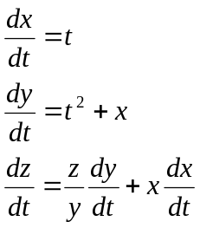 (3)

subject to the following initial conditions: 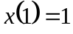 , 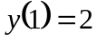 and 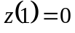. Again, we need to first define a function that describes the above system of ODE’s, which is shown below.

function output = coupledODE(t,vars)

x = vars(1);
y = vars(2);
z = vars(3);

dxdt = t;
dydt = t^2 + x;
dzdt = (z/y)*dydt + x*dxdt;

output = [dxdt;dydt;dzdt];

Here I have decided to name the function ‘coupledODE’. And as before, now we are ready to write a separate code that invokes the ode45 command.

clear all
close all
clc

tspan = linspace(1,3,100);
init = [1;2;0];
[T,S] = ode45(@coupledODE,tspan,init);

plot(T,S(:,1),T,S(:,2),T,S(:,3))
legend('x','y','z','location','NorthWest')

Note that in this case we want to solve the ODE’s from the range of t = 1 to t = 3, and the starting value of the independent variable (i.e. the variable t in our example) is where ode45 will apply the initial conditions.
As before, the time points are returned in the vector T. In this example, however, S has three columns, with the corresponding solution for x in the first column, y in the second column, and z in the third column.
For more explanations and other MATLAB ODE solvers, please refer to MATLAB’s Product Help.

10.3: ODE Example 3

Suppose we would like to solve the following ODE with the following initial conditions.

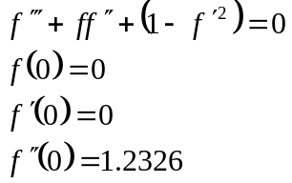 (16)

Recall that since ode45 solves first-order ODE, it is necessary to turn the third-order ODE in Eq. (16) into a system of first-order ODEs. To do this, we define the followings.

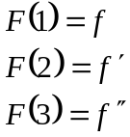 (17)

As a result, the original ODE can now be rewritten as follows,

(18)

Since the first argument to ode45 is a function handle, we need to define a function that describes the ODE we are trying to solve. A MATLAB function is defined in its own m-file, where the first line of the file is the function declaration having the following syntax.

function returnValue = functionName(list of input arguments)

Thus, for our ODE, one would create a new file in MATLAB with the following contents.

function deriv = FS(t, F)
F1dot = F(2);
F2dot = F(3);
F3dot = -F(1)*F(3) – (1-(F(2))^2);
deriv = [F1dot; F2dot; F3dot];

And the system of first-order ODEs solved by ode45 are F1dot, F2dot, and F3dot, i.e. 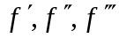. Note that the filename of the above m-file MUST have the same name as the function name. Therefore, the above file must be named FS.m.
Now that we have defined the ODE, we are ready to create another m-file with the ode45 command. While there is no restriction on the filename in this case, it needs to be in the same directory as FS.m, and the function ode45 is invoked using the following syntax.

[t, F] = ode45(@FS, [0 10], [0 0 1.2326]);

As mentioned, the time points are returned in the vector t. F in our case has three columns, with the corresponding solution for f in the first column, 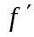 in the second column, and 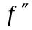 in the third column.
For more explanations and other MATLAB ODE solvers, please refer to MATLAB’s Product Help.

