# WeRateDogs Offers Insight in to the Adorable

You may have heard of the Twitter account WeRateDogs (@dog_rates), who humorously grades every doggo, pupper, fluffer, floofer, and good boy on a scale of 1-10, where they rarely rank less than 11. You might then wonder how much faith you can put in the ratings that WeRateDogs assign (though they did say “I'm aware that I could've said 20/16, but here at WeRateDogs we are very professional. An inconsistent rating scale is simply irresponsible” in a tweet on January 1, 2016).

It appears that WeRateDogs is suffering from grade inflation. Over two years, their median rating has grown by about 3 points. In late 2015, WeRateDogs flirted with conforming to a 10-point scale (though ratings were often near 10). Ratings significantly under 10 were typically given to strange dogs (ones that have no tails and who lay eggs, such as chickens) and dogs behaving badly (such as one who was said to be driving with his eyes closed).

In 2016, the median rating climbed above 10, with fewer than 25% of ratings lower than 10. By late 2016, ratings of 10 or lower became outliers and the median rating rose again. Ratings of 14 remain the domain of a few exceptional good boys, and any ratings higher appear to be one-offs, including:

* Snoop Dogg - 420
* a devilishly dressed doggo - 666
* a patriotic pupper on July 4 - 1776

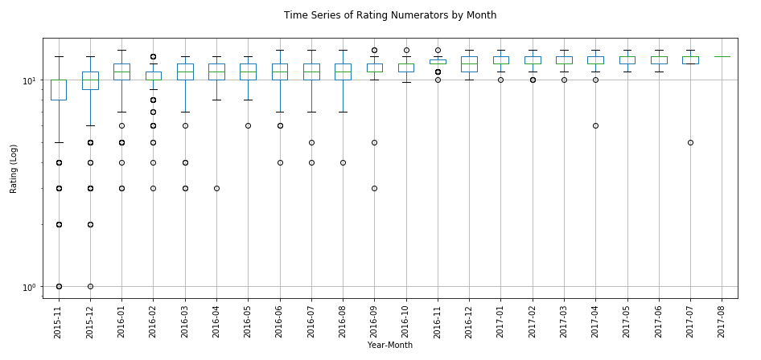

Dog owners who send photos of their best friends to be rated appear to be an imaginative bunch. Of nearly 1400 tweets with dog names in them, half had names that no other dog in the set had, and there were 930 individual names. That means 219 names were used two or more times. The top ten dog names (and the number of times they occurred) on WeRateDogs are:

* 11: Charlie, Lucy
* 10: Oliver, Cooper
* 9: Tucker, Penny
* 8: Winston, Lola, Sadie
* 7: Toby

It appears that WeRateDogs followers tend to agree with the assessment of dog quality, because the tweets with the highest favorites counts score are rated nearly a whole point higher than the median rating of all dogs. This is a significant score difference considering most tweets have ratings of 9-14.