**MDSC-103 Lab**

**End Semester Examination**

**Wilson Problem**:

Wilson Manufacturing produces both baseballs and softballs, which it wholesales to vendors around the country. Its facilities permit the manufacture of a maximum of 500 dozen baseballs and a maximum of 500 dozen softballs each day. The cowhide covers for each ball are cut from the same processed cowhide sheets. Each dozen baseballs require five square feet of cowhide (including waste), whereas, one dozen softballs require six square feet of cowhide (including waste). Wilson has 3600 square feet of cowhide sheets available each day. Production of baseballs and softballs includes making the inside core, cutting and sewing the cover, and packaging. It takes about one minute to manufacture a dozen baseballs and two minutes to manufacture a dozen softballs. A total of 960 minutes is available for production daily. The prices for a dozen baseball and a dozen softball are 7 and 10 dollars respectively.

**Formulate the problem in the Excel file and generate the sensitivity analysis.**

|  |  |  |  |  |  |
| --- | --- | --- | --- | --- | --- |
|  | **x1** | **x2** |  |  |  |
|  | 360 | 300 |  |  |  |
| **z** | 7 | 10 | 5520 |  |  |
| **c1** | 5 | 6 | 3600 | <= | 3600 |
| **c2** | 1 | 2 | 960 | <= | 960 |

**Sensitivity Report:**

|  |  |  |  |  |  |  |  |
| --- | --- | --- | --- | --- | --- | --- | --- |
| Variable Cells | | |  |  |  |  |  |
|  |  |  | **Final** | **Reduced** | **Objective** | **Allowable** | **Allowable** |
|  | **Cell** | **Name** | **Value** | **Cost** | **Coefficient** | **Increase** | **Decrease** |
|  | $G$13 | x1 | 360 | 0 | 7 | 1.333333333 | 2 |
|  | $H$13 | x2 | 300 | 0 | 10 | 4 | 1.6 |
|  |  |  |  |  |  |  |  |
| Constraints | | |  |  |  |  |  |
|  |  |  | **Final** | **Shadow** | **Constraint** | **Allowable** | **Allowable** |
|  | **Cell** | **Name** | **Value** | **Price** | **R.H. Side** | **Increase** | **Decrease** |
|  | $I$16 | c1 | 3600 | 1 | 3600 | 1200 | 720 |
|  | $I$17 | c2 | 960 | 2 | 960 | 240 | 240 |

**Write on cost coefficient sensitivity analysis.**

* From the sensitivity report we can see that the x1 profit(baseball) can be increased to $8.3333333 and can be decreased to $5 without changing the current optimal solution.
* x2 profit(softball) can be increased to $14 and can be decreased to $8.4 without changing the current optimal solution.

**Write on Right Hand Side Sensitivity Analysis**

* From the sensitivity report we can see that the cowhide capacity can be increased to 4800 square feet and can be decreased to 2880 square feet without changing the current optimal solution.
* Production time can be increased to 1200 mins and can be decreased to 720 mins without changing the current optimal solution
* Change in each unit of cowhide will result in $1 change in profit.
  + With the increase of Cowhide profit increases.
  + With the decrease of Cowhide profit decreases.
* Change in each unit of production time will result in $2 change in profit.
  + With the increase of Production time profit increases.
  + With the decrease of Production time profit decreases.

**Consider the following problem:**

**𝑓 (𝑥1, 𝑥2) = 4𝑥1 + 6𝑥2 − 2𝑥12 − 2𝑥1𝑥2 − 2𝑥22**

**Write a program to visualize the above function**

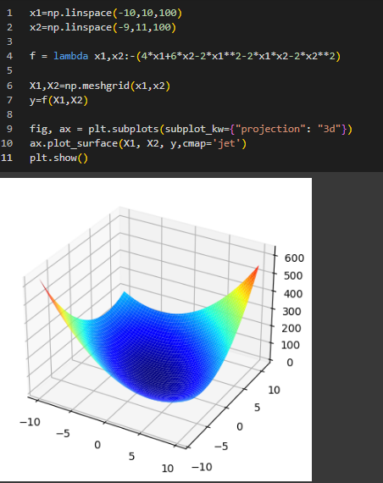

**Write an iterative program to maximize the function**

