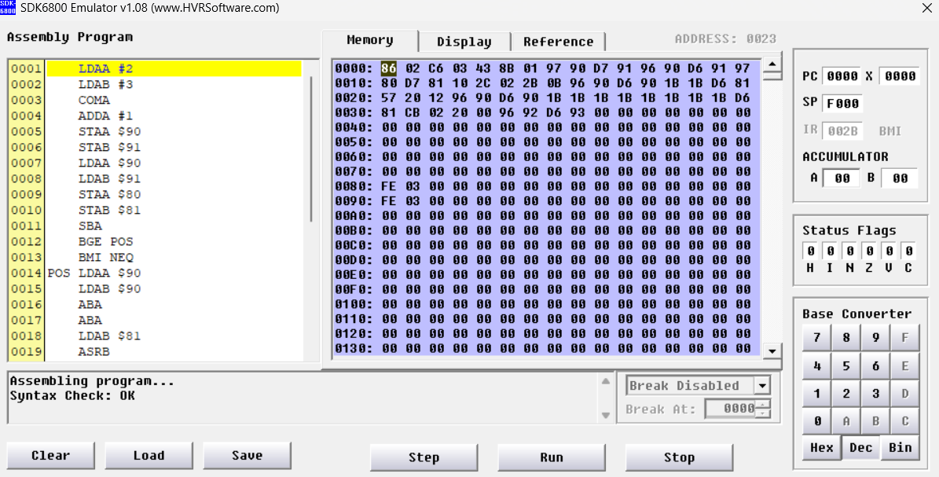

I tested my code with different x and y values, I could not reach the correct result for negative values, I think the program cannot detect the signs of numbers with negative values, it positions them in a different location than it should be in memory during the branching process.

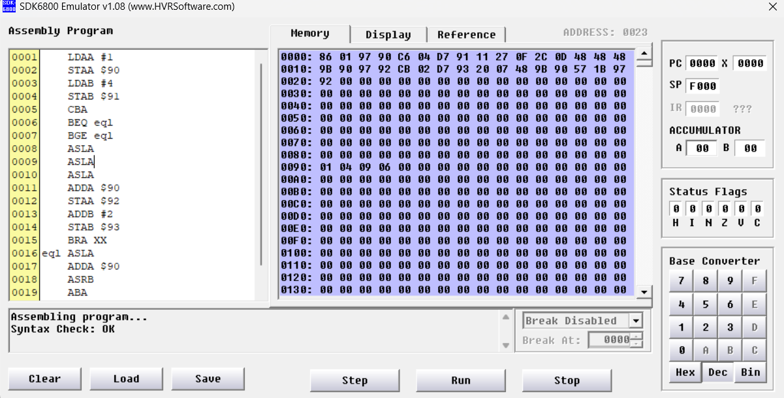

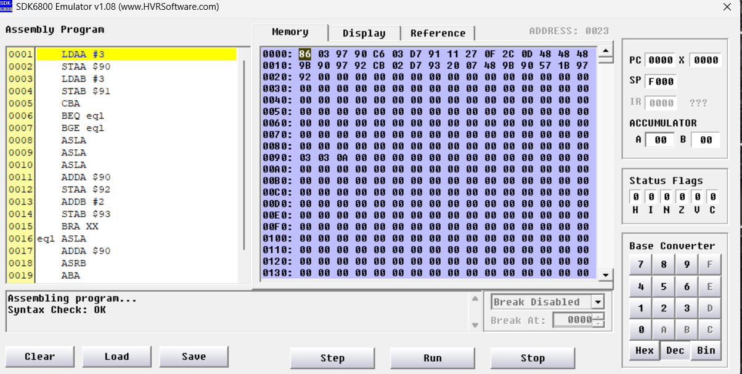

Since the program keeps the given values ​​as integer values, y must be even to obtain results without overflow.

20200702115 Berkay Kuru