

SPL-1 Project Report 2020

**Computerized Adaptive Test System**

SE 305: Software Project Lab I

Submitted by

Name: **Md. Khairul Alam**

Bsse Roll no: 1118

Session: 2018-19

Supervised by

Dr. Zerina Begum

Designation: Professor

Institute of Information Technology

University Of Dhaka

**Table of Contents**

1. Introduction...........................................................................................3

1.1. Background Study..............................................................................3

1.2. Challenges..........................................................................................4

1.3. Objectives…………………………………………………………..5

2. Project Overview..................................................................................5

3. User Manual..........................................................................................6

4. Conclusion ...........................................................................................9

5. Scope....................................................................................................9

References ...............................................................................................9

**1. Introduction**

This project is about special kind of exam test system which is called computerized adaptive test system. This is one kind of computer administered test which adapts to the candidate's ability in real-time by selecting different questions from the bank in order to provide a more accurate measure of their ability level on a common scale. Basically the students will get questions according to their ability where there will be 50% chance of giving correct answer. I create questions for students of class 10-12 and get their ability based on two algorithms (**Rasch** algorithm and **Monte Carlo** algorithm).Computer will generate questions by these algorithms where next question will arrive according to the response of previous question.

**1.1. Background Study**

Some prior study was needed, to implement this project.

**Computer Adaptive Test System**

I studied computer adaptive test system from Wikipedia. This is a form of [computer-based](https://en.wikipedia.org/wiki/Computer-based_assessment) [test](https://en.wikipedia.org/wiki/Test_(student_assessment)) that adapts to the examinee's ability level. In other words, it is a form of computer-administered test in which the next item or set of items selected to be administered depends on the correctness of the test taker's responses to the most recent items administered. So, I had to study some algorithms to learn this test system such as **Rasch** and **Monte Carlo** algorithm.

**Rasch Algorithm**

There were not enough resources about this Rasch model. Fortunately, I found some on internet where **Estimation of a Rasch model** is used to estimate the parameters of the [Rasch model](https://en.wikipedia.org/wiki/Rasch_model). Various techniques are employed to estimate the parameters from matrices of response data. The most common approaches are types of [**maximum likelihood**](https://en.wikipedia.org/wiki/Maximum_likelihood)estimation, **item response theory**. That’s why I have to learn statistical things and item response theory.

**Monte Carlo**

This is another approach to generate CAT system. I studied about this algorithm on Wikipedia where it states that it uses randomized method on samples to get a best result. It also uses probability distribution to predict student’s response. That’s why I had to learn more about probability distribution. Here is used 1RT response theory to estimate the ability and probability of giving correct answer of a student.

**Statistics**

Statistic is most important part in this project. I had to learn main basic things of statistics such as dichotomous variables, variance, standard deviation, maximum likelihood, probability distribution etc.

**1.2. Challenges**

There are a number of challenges in implementing a big project for the first time. There are many challenges I have faced to implement this project. There are some of them –

1. Working with header files for the first time

2. Working with multiple source files

3. Statistical learning –

🡪 Implementing Maximum Likelihood method

🡪 Implementing Estimate measure

4. Finding resources as there were not enough

5. Working with files

6. Making lots of MCQ question

7. Synchronizing questions according to difficulty level

8. Partitioning question file

9. Reading and writing on files in c++

10. Generating user manual

11. Learning OOP in c++.

12. As lockdown as well as I belong to flood affected area breaks my confidence to continue the project.

**1.3 Objectives**

**2. Project Overview**

I have divided my whole project into two different parts. They are__

🡪Teacher

1. Create Account
2. Log In
3. Rasch Result
4. Monte Carlo Result

🡪Student

1. Create Account
2. Log In
3. Test by Rasch Algorithm
4. Test by Monte Carlo Algorithm

**Creating Account**

Teacher/student can create account by giving their 5 tuples (username, first name, last name, email id and password).For creating account, it can check whether username is already taken or not.

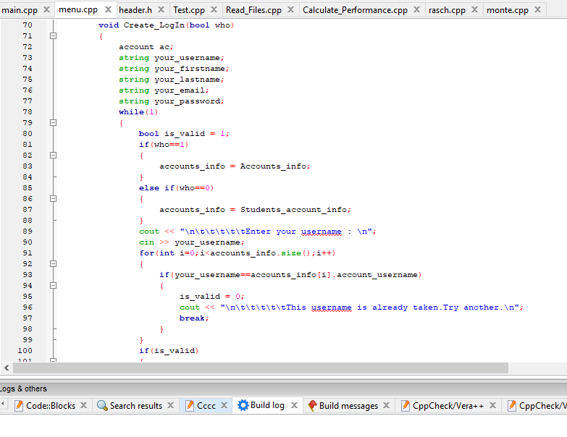

**Figure: Create Account code**

Log In

If teacher or student already has an account, teacher/student can log in. Here it can check whether username and password is correct or not.

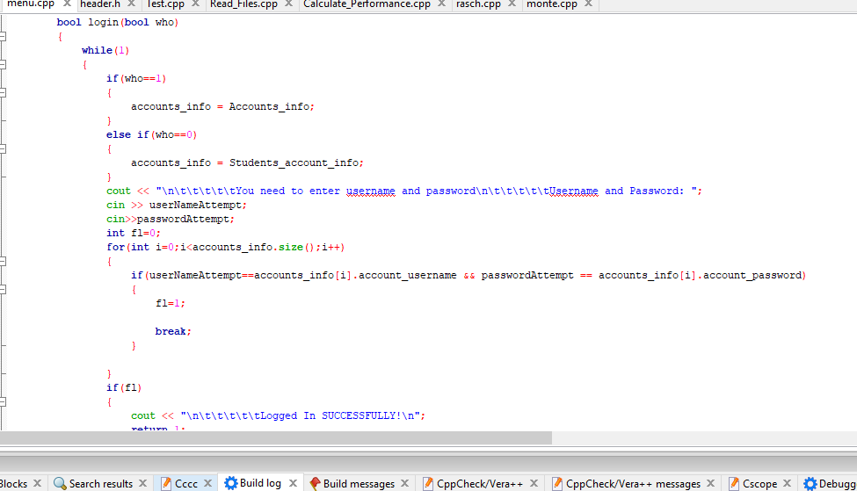

**Figure: Log In code**

**Question Partitioning**

I had to make lots of questions and synchronize them according to their difficulty level. I made a file where questions are attached with solutions and synchronize them to read the file easily.

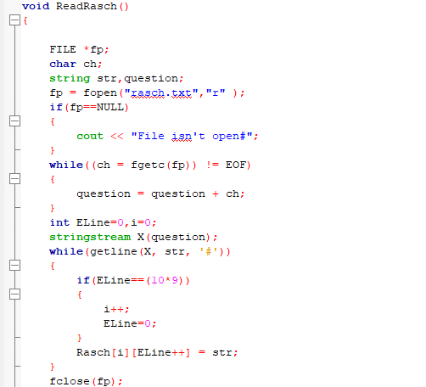

**Figure: Partitioning question file**

**Randomizing questions and multiple choices**

Here questions and multiple options are randomized. It will make students aware of study as plagiarism is going to be tough. There is another feature that is skipping the questions at most 3 times.

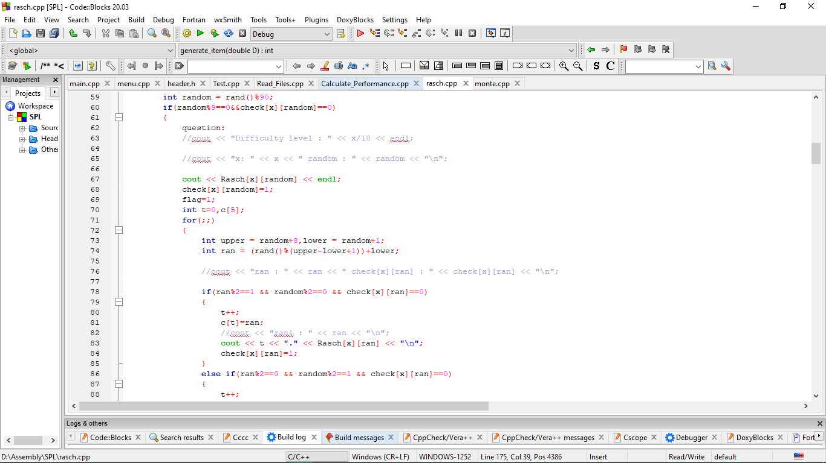

**Figure: Randomizing questions and multiple choices code**

Implementing Rasch Algorithm

In this algorithm, if student’s response is correct, he/she will get a higher level question, otherwise he/she will get lower level question. For example, suppose initial question’s difficulty is D and number of question is L. If student’s response is correct, new difficulty will be D = D + (D/L), otherwise, D = D – (D/L). According to the responses, it will measure probability, estimate ability, variance and standard error.

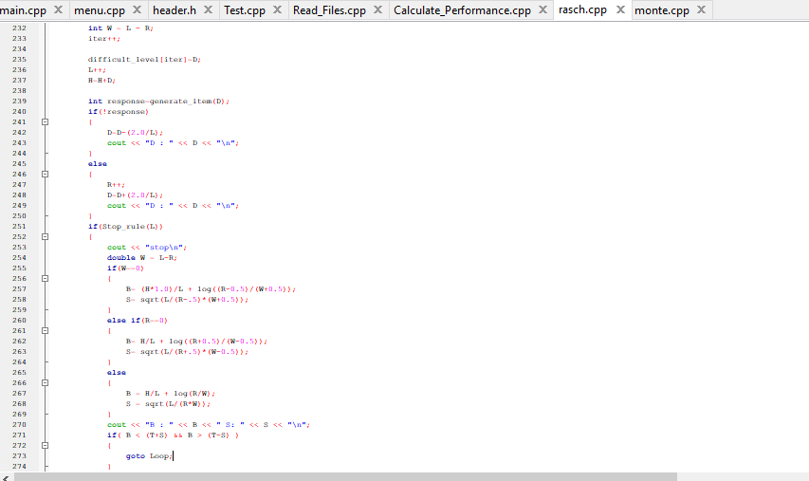

**Figure: Rasch code**

Implementing Monte Carlo Algorithm

In this algorithm, computer will choose difficulty level randomly from a range. For example, if initial difficulty level is 0, it will generate question of difficulty from -5 to +5 randomly. More formally, according to the response it will find estimate ability, after that it will generate question of difficulty from range [estimate ability -5, estimate ability + 5]. It uses probability, variance and information to measure estimate ability of the student.

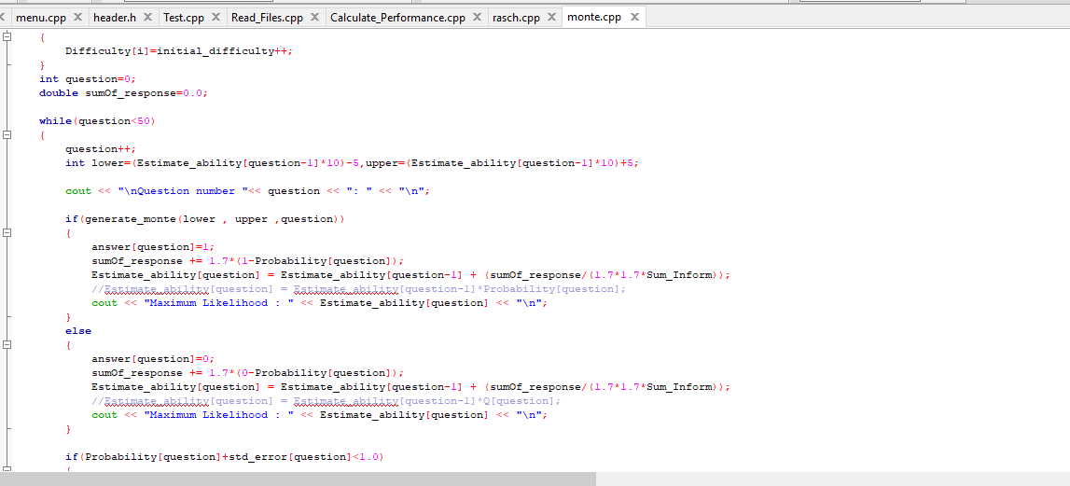

**Figure: Monte carlo code**

**3. User Manual**

A user can create an account either a teacher account or a student account. Teacher will have access to show the result and students are the participants of this test system.

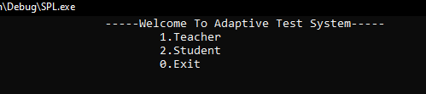

Figure: User manual 1st screen

Enter “1” or “2”: 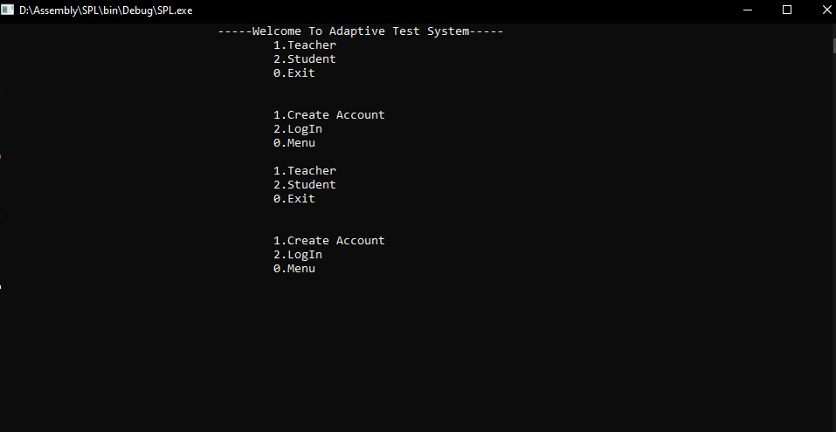

**Figure: Teachers and students LogInManager**

For creating an account one have to provide:

* User name
* First name
* Last name
* Email ID
* Password

After creating an account, one can login from his account. After that, one can able to do the next steps. Students work is to give exam and teachers work is to collect the results of all students.

**4. Conclusion**

By implementing this project, I could learn many topics such as reading and writing in files, creating class and object in c++, randomizing, statistical learning, **Rasch** algorithm, **Monte Carlo** algorithm. It was tough to maintain large amount of codes. It provides confidence to me for working in future projects. This project was quiet challenging and I gained a lot of experience from it. I want to thank my supervisor and other respectable teachers for guiding me a lot during this project.

**5. Scope**

I want to develop this project using machine learning algorithm (Classifier algorithm) to estimate response of the students more accurately in future. In future, I want to add Bangla question facility to this project. For the betterment of this project, I want to create a web application that should be accessed by students of all over the world.

**References**

1.<https://en.wikipedia.org/wiki/Computerized_adaptive_testing>

2.<https://surpass.com/news/2019/computer-adaptive-testing-background-benefits-and-case-study-of-a-large-scale-national-testing-programme/>

3.<https://www.rasch.org/rmt/rmt22g.htm>

4.<https://en.wikipedia.org/wiki/Monte_Carlo_method>

5.<https://www.ncertbooks.guru/>