THE HOTEL PROJECT FOR DBMS

Hotel Database

Project Summary:
Hotel database management system will design to simplify office tasks,
enhance management functions, improve the experience of customers and guest reservations.
With the software, a hotel can improve efficiency and effectively manage operations such as
check-ins, check out and confirmation of reservations. This will be a web-based.
We will use SQL server as DBMS.

CUSTOMER REQUIREMENTS FOR HOTEL DBMS:

- Hotel has employees, rooms, and customers.
- Hotel has name, address, and phone-No.
- Hotel has many employees which work- on one or many departments,
this department can manage by zero or one employee.
- Each employee has employee-ID, name, phone-No, gender, salary,
address, start date, and date of birth.
- Each customer has customer-ID, name, and phone-NO.
- Customer will make one reservation or more from rooms.
- Each reservation has reservation-ID, reservation date, date-In, date-Out,
and payment type.
- Each room has room-NO, room type, floor-NO, price.

ENTITY-RELATIONSHIP DIAGRAM

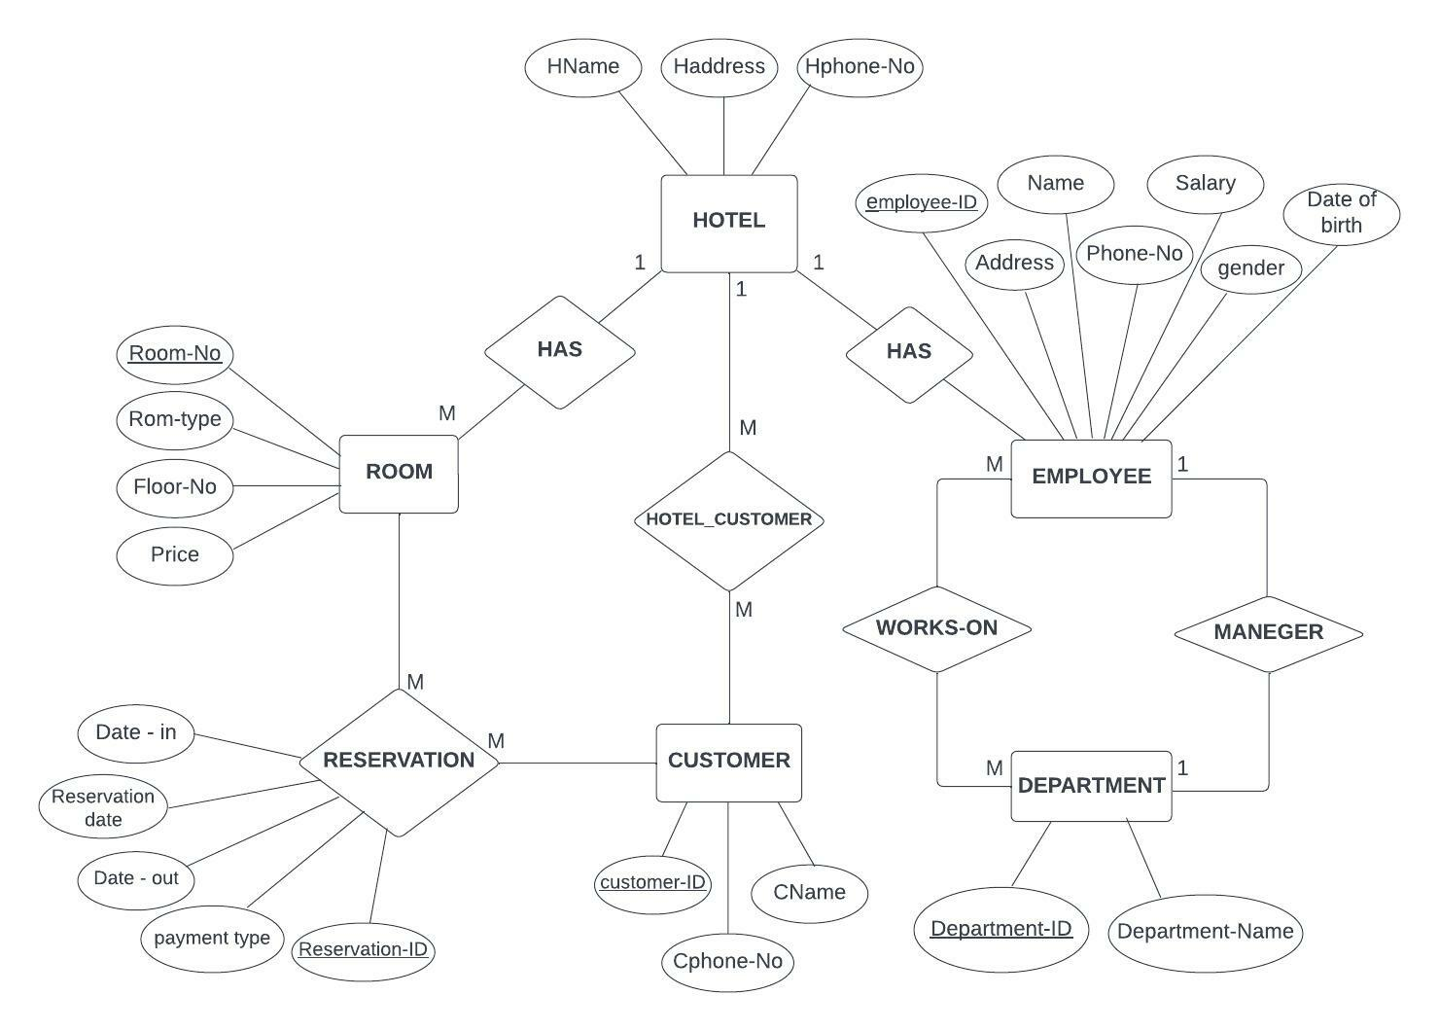

DATABASE SCHEMA

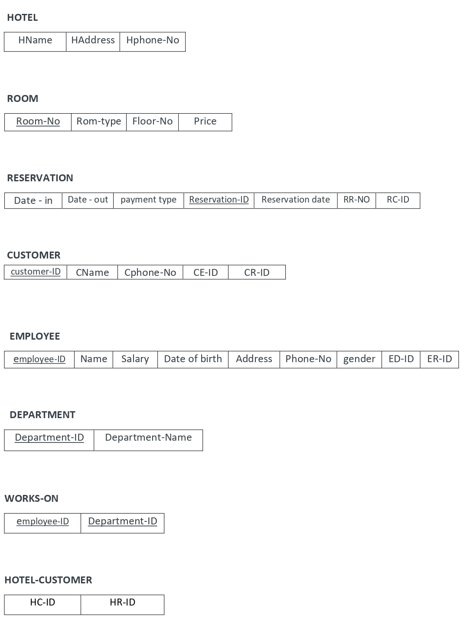

DATABASE SCHEMA WITH ARRWOS
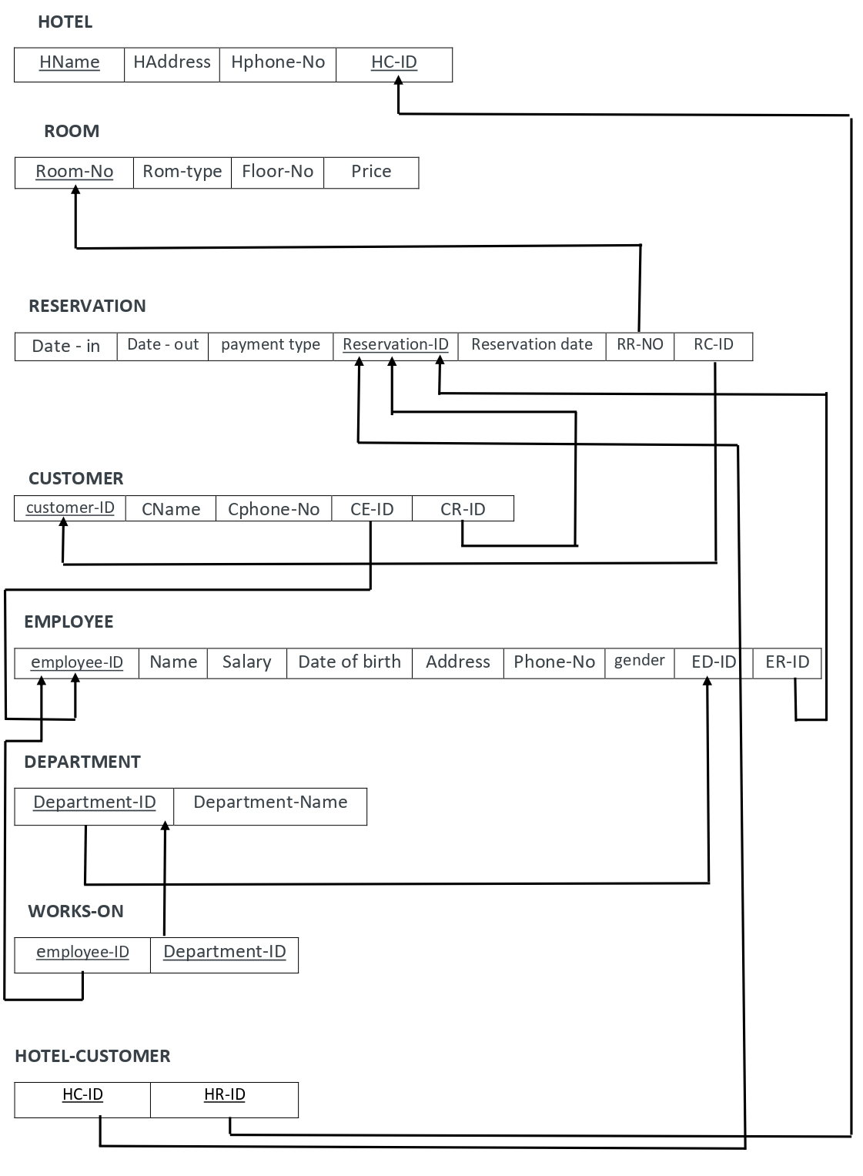

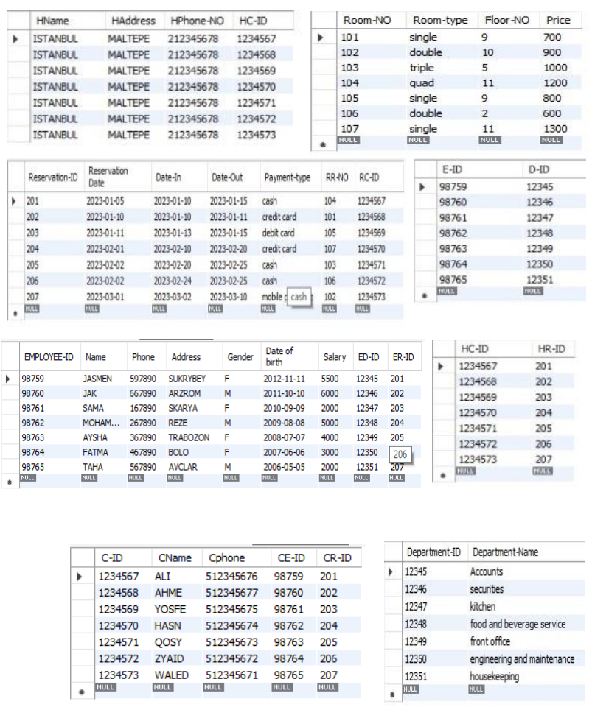
We prepared DB tables for hotel management system by using MySQL

Some Reports Examples

- Situations of hotel employees:

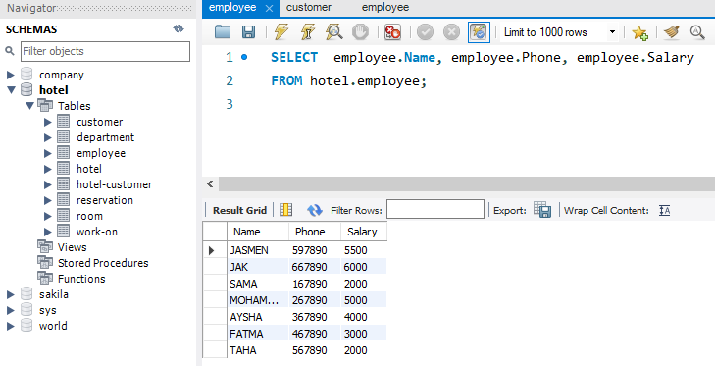

- The total of money that we need to let hotel works on one month:

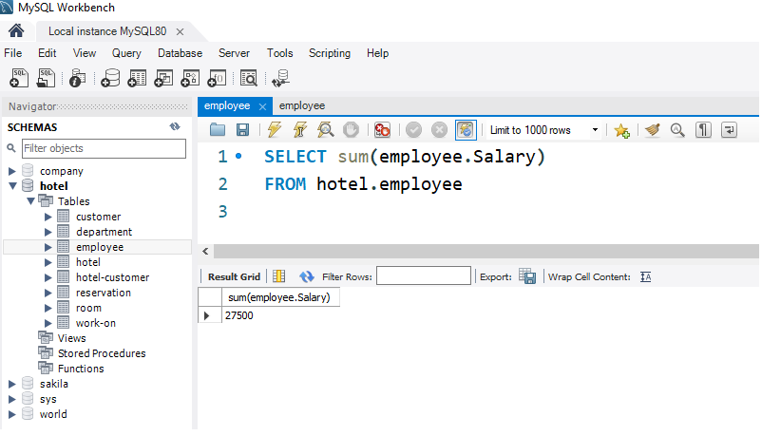

- The department of our hotel and the name of employees:

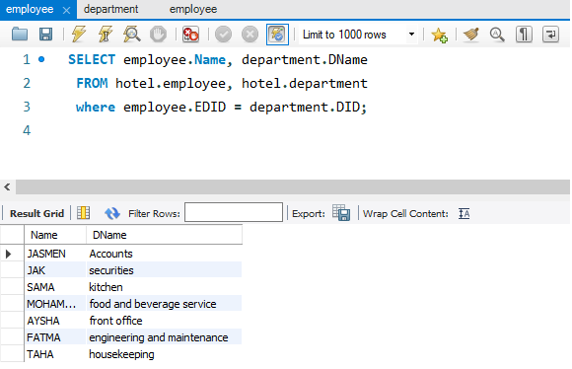

Thank you

Prepared by

Meaad Farag BaYuosef

