VOICE ACTIVATED HOME AUTOMATION

Project report submitted for the award of B.TECH Degree

**Instrumentation and Control Engineering**

**Haldia Institute of Technology**



**Submitted by**

* **Abhay Kumar (**10304015001**)**
* **Abhijeet Prasad (**10304015002**)**
* **Ajay Kumar (**10304015004**)**
* **Akanksha Kumari (**10304015006**)**
* **Babul Raj (**10304015017**)**
* **Dipti Roy Choudhary (**10304015023**)**

UNDER THE SUPERVISION OF

**Mr. Tanmay Sinha Roy**

**(Assistant professor)**

**DEPARTMENT OF INSTRUMENTATION**

**&**

**CONTROL ENGINEERING**

VOICE ACTIVATED HOME AUTOMATION

**HALDIA INSTITUTE OF TECHNOLOGY**

**(**An institute of ICARE)

**(**Government aided Engineering Institute)

**(**Approved by AICTE, Accredited by NBA & NAAC)

**(**Affiliated to Maulana Abul Kalam Azad University of Technology)

P.O HIT Haldia Purba Medinipur Purba Medinipur-721657, West Bengal, India

**DECLARATION**

**This is to certify that the project report entitled**

**“Voice Activated Home Automation”**

Submitted by

* **Abhay Kumar (**10304015001**)**
* **Abhijeet Prasad (**10304015002**)**
* **Ajay Kumar (**10304015004**)**
* **Akanksha Kumari (**10304015006**)**
* **Babul Raj (**10304015017**)**
* **Dipti Roy Choudhary (**10304015023**)**

**Is absolutely based upon their work under the supervision of Mr.Tanmay Sinha Roy and that report nor any part of it has been submitted for any dergree/diploma or any other academic award anywhere before**



**Mr. Tanmay Sinha Roy Mr. Sudipta Burdhan**

**Assistant Professor Head of the Department**

**Instrumentation & Control Instrumentation & Control Engineering**

**Engineering**

**Haldia Institute of Technology Haldia Institute of Technology**

VOICE ACTIVATED HOME AUTOMATION

**Certificate of Approval**

The foregoing thesis entitled **“Voice Activated Home Automation”** is hereby approved as a creditable study of an engineering subject carried out and presented in a manner satisfactory to warrants it’s acceptance as a perquisite for the degree for which it has been submitted. It is understood that by this approval the undersigned do not necessarily endorse or approve any statement made, opinion expressed or conclusion drawn therein but approve the thesis only for the purpose for which it is submitted.



**Mr. Tanmay Sinha Roy Mr. Sudipta Burdhan**

**Assistant Professor** **Head of the Department**

**Instrumentation & Control Instrumentation & Control Engineering**

**Engineering**

**Haldia Institute of Technology Haldia Institute of Technology**

VOICE ACTIVATED HOME AUTOMATION

ABSTRACT

The main inspiration of this project is to develop a home automation system using an Arduino board with Bluetooth being remotely controlled by any Android oS smart phone. As technology is advancing so houses are also getting smarter. Modern houses are gradually shifting from conventional switches to centralized control system, involving remote controlled switches. Presently, conventional wall switches located in different parts of the house makes it difficult for the user to go near them to operate. Even more it becomes more difficult for the elderly or physically handicapped people to do so. Remote controlled home automation system provides a most modern solution with smart phones. In order to achieve this, a Bluetooth module is interfaced to the Arduino board at the receiver end while on the transmitter end, a GUI application on the cell phone sends ON/OFF commands to the receiver where loads are connected. By touching specified location on the GUI, the loads can be turned ON/OFF remotely through this technology. The loads are operated by Arduino board through opto isolators and thyristors using triacs.

VOICE ACTIVATED HOME AUTOMATION

ACKNOWLEDGEMENT

We find this an auspicious moment to express our heartfelt gratitude and sincere thanks to our esteemed teacher and mentor **Mr. Tanmay Sinha Roy** for his untiring endeavor, relentless guidance, invaluable advice perpetual encouragement and constant inducement which made the daunting task much easier to bear.

We also express our sincere thanks to our respected HOD, **Mr. Sudipta Burdhan** for providing us this opportunity and also to all those who were directly or indirectly involved with the project. We also thank ICE department for its continuous support in every possible way.

VOICE ACTIVATED HOME AUTOMATION

Table of Content

**Chapter 1**

1. Introduction
2. Purpose of Project

**Chapter 2**

1. Circuit description and circuit implementation
2. Circuit Design
3. Circuit Operation
4. Arduino coding
5. Overview Model

**Chapter 3**

1. Components used in the circuit

**Chapter 4**

1. Mobile application

**Chapter 5**

1. Objective and scope of the project

**Chapter 6**

1. Limitations
2. Result
3. Discussion
4. References

VOICE ACTIVATED HOME AUTOMATION

**CHAPTER 1**

INTRODUCTION

In today’s world there is a continuous need for automatic appliances with the increase in standard of living, there is a sense of urgency for developing circuits that would ease the complexity of life. This project is all about designing a circuit which automatically controls the home appliances.

The two major components of this project being aurdino and Bluetooth module, we can control different home appliances. In order to achieve this, a Bluetooth module is interfaced to aurdino board at the receiver end while on the transmitter end a GUI application on the cellphone sends ON/OFF commands to the receiver where loads are connected. By touching specified location on the GUI, the loads can be turned ON/OFF remotely through this technology. Built on a single aurdino, this circuit is simple, compact and economical.

VOICE ACTIVATED HOME AUTOMATION

Purpose of the Project

This project is prepared as the part of **B.TECH** final year in **INSTRUMENTATION AND CONTROL ENGINEERING DEPARTMENT**, HALDIA INSTITUTE OF TECHNOLOGY, HALDIA, WEST BENGAL.

The purpose of this project report is to give the detailed description of a voice activated home automation that can control every possible home appliance.

VOICE ACTIVATED HOME AUTOMATION

Chapter 2

System Description & Circuit Implementation

Circuit description of room appliances

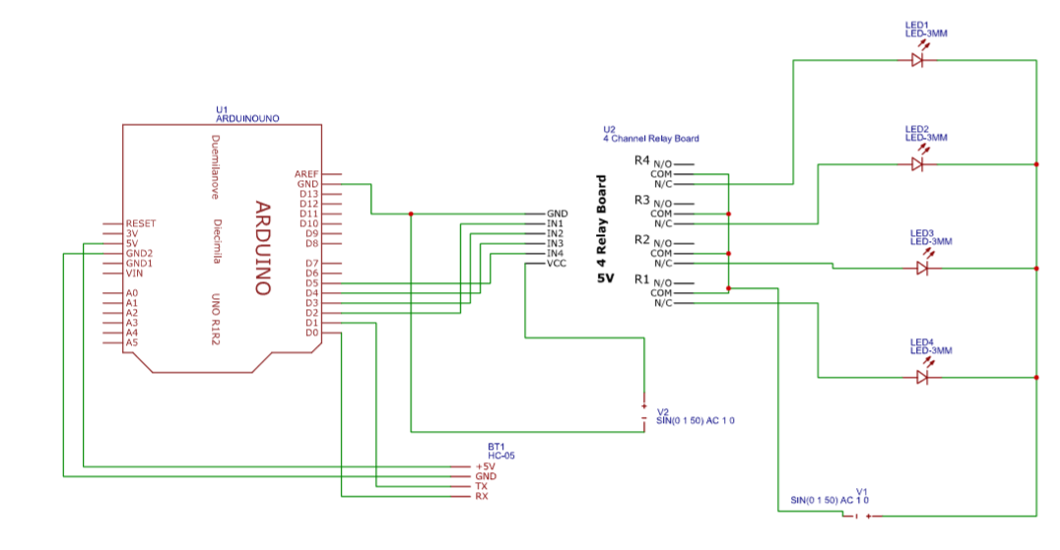

The circuit design of Home Automation based on Arduino and Bluetooth is very simple and is explained below. The Bluetooth module has 4 – pins: VCC, TX, RX and GND. VCC and GND are connected to 5V and ground from Arduino UNO. The Bluetooth module works on 3.3V and it has an on board 5V to 3.3V regulator. The TX and RX pins of the Bluetooth module must be connected to RX and TX pins of the Arduino. In Arduino UNO, we are defining pins 2 and 4 as RX and TX using software. Hence, TX of Bluetooth is connected to pin 4 of Arduino. But when connecting RX of Bluetooth to TX of Arduino (or any microcontroller as a matter of fact), we need to be careful as the pin can tolerate only 3.3V. But the voltage from TX or Arduino will be 5V. So, a voltage divider network consisting of 10K and 20K resistors are used to reduce the voltage to 3.3V approximately.

VOICE ACTIVATED HOME AUTOMATION

Mobile Phone Detector Circuit Diagram 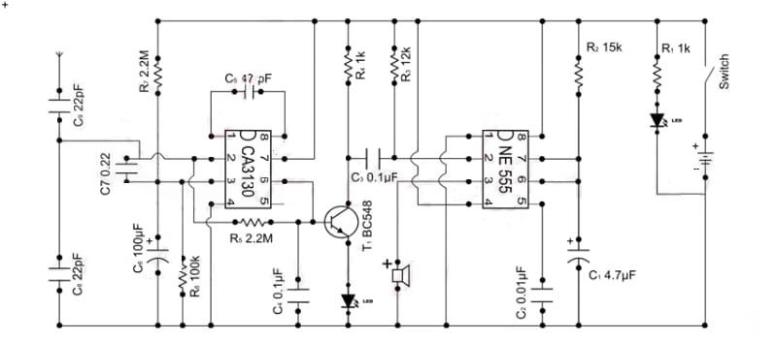

In this circuit we have used a **CA3130 OP-Amp IC** for detecting incoming or outgoing signal around it.  Op-amp non-inverting end is connected to Vcc through 2.2M resistor and it is also connected to the ground through 100K resistor and 100uF Capacitor. Its **inverting terminal is feedback** from its output through a 2.2M resistor for amplify the signal. Two 100nF capacitors are connected between inverting and non-inverting terminal, working as loop antenna for the system. Two 100nF capacitors are connected in series between Pin 1 and 8 of op-amp to boost the gain of the current to voltage converter at its output pin. Output of this op-amp is connected at the base of NPN transistor namely BC547 through a 1k resistor and a LED is connected at its emitter for indication. A **buzzer is also used for sound indication** by using a PNP transistor namely BC557. And a 9 volt battery is used for powering the circuit. Rests of connections are shown in the Circuit Diagram below. n this circuit we have used a **CA3130 OP-Amp IC** for detecting incoming or outgoing signal around it.  Op-amp non-inverting end is connected to Vcc through 2.2M resistor and it is also connected to the ground through 100K resistor and 100uF Capacitor. Its **inverting terminal is feedback** from its output through a 2.2M resistor for amplify the signal. Two 100nF capacitors are connected between inverting and non-inverting terminal, working as loop antenna for the system. Two 100nF capacitors are connected in series between Pin 1 and 8 of op-amp to boost the gain of the current to voltage converter at its output pin. Output of this op-amp is connected at the base of NPN transistor namely BC547 through a 1k resistor and a LED is connected at its emitter for indication. A **buzzer is also used for sound indication** by using a PNP transistor namely BC557. And a 9 volt battery is used for powering the circuit. Rests of connections are shown in the Circuit Diagram below.

VOICE ACTIVATED HOME AUTOMATION

Fire Alarm Circuit Diagram 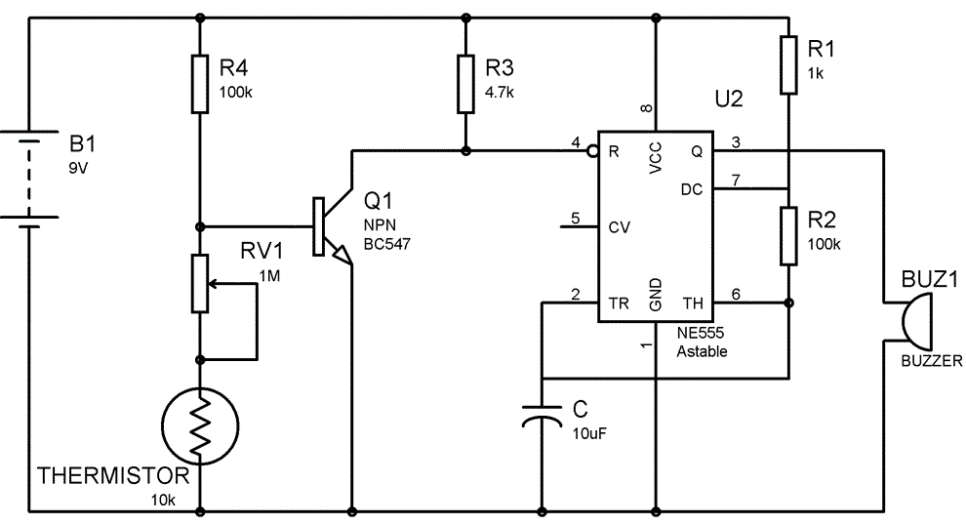

Fire alarms are prime necessities in modern buildings and architectures, especially in banks, data centers and gas stations. They detects the fire in ambiance at very early stage by sensing smoke or/and heat and raise an alarm which warns people about the fire and furnish sufficient time to take preventive measures. It not only prevents a big losses caused by deadly fire but sometimes proves to be life savers. Here we are building one **simple fire alarm system with the help of 555 Timer IC**, which will sense the fire (temperature rise in surrounding), and trigger alarm. The key component of the circuit is Thermistor, which has been used as fire detector or fire sensor. Thermistor is temperature sensitive resistor, whose resistance changes according to the temperature, its resistance decreases with the increase in temperature and vice versa. We have built the circuit using, mainly three components that is, Thermistor, NPN transistor and 555 Timer IC. You can find more such [simple circuits](https://circuitdigest.com/electronic-circuits) here in this electronic circuits section.Here the [**555 timer IC**](https://circuitdigest.com/article/555-timer-ic) has been configured in **[Astable mode](https://circuitdigest.com/electronic-circuits/555-timer-astable-multivibrator-circuit-diagram)** so that Alarm (Buzzer) can produce an oscillating sound. In Astable mode, capacitor C charges though resistance R1 and R2, till 2/3 Vcc and discharges through R2 till it reaches to 1/3Vcc. During the charging time OUT PIN 3 of 555 IC remains HIGH and during discharging it remains LOW, thats how it oscillate. We have connected a Buzzer to OUT pin, so that it produce beep sound, when 555 is high. We can control the oscillation frequency of the alarm by adjusting the value of R2 and/or capacitor C.

VOICE ACTIVATED HOME AUTOMATION

**Arduino Coding**

String voice;

int RED = 2;

int GREEN = 3 ;

int BLUE = 4;

int YELLOW = 5;

int A = 6;

int B = 7 ;

int C = 8;

int D = 9;

int E = 10;

int F = 11 ;

int G = 12;

int H = 13;

void RedOn(){

digitalWrite (RED, LOW);

}

void Redoff(){

digitalWrite (RED, HIGH);

}

void GreenOn(){

digitalWrite (GREEN, LOW);

}

void Greenoff(){

digitalWrite (GREEN, HIGH);

}

void BlueOn(){

digitalWrite (BLUE, LOW);

}

void Blueoff(){

digitalWrite (BLUE, HIGH);

}

void YellowOn(){

digitalWrite (YELLOW, LOW);

}

void Yellowoff(){

digitalWrite (YELLOW, HIGH);

}

void AOn(){

digitalWrite (A, LOW);

}

void Aoff(){

digitalWrite (A, HIGH);

}

void BOn(){

digitalWrite (B, LOW);

}

void Boff(){

digitalWrite (B, HIGH);

}

void COn(){

digitalWrite (C, LOW);

}

void Coff(){

digitalWrite (C, HIGH);

}

void DOn(){

digitalWrite (D, LOW);

}

void Doff(){

digitalWrite (D, HIGH);

}

void EOn(){

digitalWrite (E, LOW);

}

void Eoff(){

digitalWrite (E, HIGH);

}

void FOn(){

digitalWrite (F, LOW);

}

void Foff(){

digitalWrite (F, HIGH);

}

void GOn(){

digitalWrite (G, LOW);

}

void Goff(){

digitalWrite (G, HIGH);

}

void HOn(){

digitalWrite (H, LOW);

}

void Hoff(){

digitalWrite (H, HIGH);

}

void allon() {

digitalWrite (RED, LOW);

digitalWrite (GREEN, LOW);

digitalWrite (BLUE, LOW);

digitalWrite (YELLOW, LOW);

digitalWrite (A, LOW);

digitalWrite (B, LOW);

digitalWrite (C, LOW);

digitalWrite (D, LOW);

digitalWrite (E, LOW);

digitalWrite (F, LOW);

digitalWrite (G, LOW);

digitalWrite (H, LOW);

}

void alloff() {

digitalWrite (RED, HIGH);

digitalWrite (GREEN, HIGH);

digitalWrite (BLUE, HIGH);

digitalWrite (YELLOW, HIGH);

digitalWrite (A, HIGH);

digitalWrite (B, HIGH);

digitalWrite (C, HIGH);

digitalWrite (D, HIGH);

digitalWrite (E, HIGH);

digitalWrite (F, HIGH);

digitalWrite (G, HIGH);

digitalWrite (H, HIGH);

}

void setup() {

Serial.begin(9600);

pinMode(RED, OUTPUT);

pinMode(GREEN, OUTPUT);

pinMode(BLUE, OUTPUT);

pinMode(YELLOW, OUTPUT);

pinMode(A, OUTPUT);

pinMode(B, OUTPUT);

pinMode(C, OUTPUT);

pinMode(D, OUTPUT);

pinMode(E, OUTPUT);

pinMode(F, OUTPUT);

pinMode(G, OUTPUT);

pinMode(H, OUTPUT);

}

void loop() {

while(Serial.available()) {

delay(10);

char c=Serial.read();

if(c=='#')

{break; }

voice += c;

}

if (voice.length() > 0) {

Serial.println(voice);

if (voice == "all on" || voice == "all")

{

allon() ;

}

else if (voice == "switch off" || voice=="switch off all" || voice == "switch of" || voice=="switch of all" || voice=="all off" || voice=="all of")

{

alloff() ;

}

else if(voice =="room LED on" || voice =="bedroom LED on" || voice =="bedroom LED on" || voice =="bedroom light on" || voice =="bedrrom light on"){

RedOn();

}

else if(voice =="switch off bedroom LED" || voice =="switch off bedroom light" || voice =="switch of bedroom LED" || voice =="switch of bedroom light" || voice =="bedroom light off" || voice =="bedroom light of" || voice =="bedroom LED off" || voice =="bedroom LED of"){

Redoff();

}

else if(voice =="fan" || voice =="fan on" || voice =="bedroom fan on"){

YellowOn();

}

else if( voice =="switch off fan" || voice =="fan off" || voice =="switch of fan" || voice =="fan of" || voice =="bedroom fan off" || voice =="bedroom fan of" ){

Yellowoff();

}

else if(voice =="TV" || voice =="TV on" || voice =="TV start"){

BlueOn();

}

else if(voice =="switch off TV" || voice =="TV off" || voice =="switch of TV" || voice =="TV of"){

Blueoff();

}

else if(voice =="AC" || voice =="AC on"){

GreenOn();

}

else if(voice =="switch off AC" || voice =="AC off" || voice =="switch of AC" || voice =="AC of"){

Greenoff();

}

else if(voice =="washroom light on" || voice =="one on"){

AOn();

}

else if(voice =="washroom light off" || voice =="washroom light of"){

Aoff();

}

else if(voice =="conference room light on"|| voice=="2 on"){

BOn();

}

else if( voice =="conference room light off" || voice =="conference room light of"){

Boff();

}

else if(voice =="kitchan room light on" || voice =="3 on"){

COn();

}

else if(voice =="kitchan room light off" || voice =="kitchan room light of"){

Coff();

}

else if(voice =="living room light on" || voice =="4 on"){

DOn();

}

else if(voice =="living room light off" || voice =="living room light of"){

Doff();

}

else if(voice =="camera on" || voice =="5 on "){

EOn();

}

else if(voice =="camera off" || voice =="camera of"){

Eoff();

}

else if(voice =="mobile detector on"){

FOn();

}

else if( voice =="mobile detector off" || voice =="mobile detector of"){

Foff();

}

else if(voice =="fire alarm on"){

GOn();

}

else if(voice =="fire alarm off" || voice =="fire alarm of"){

Goff();

}

else if(voice =="fence light on"){

HOn();

}

else if(voice =="fence light off" || voice =="fence light"){

Hoff();

}

voice="";

}

}

VOICE ACTIVATED HOME AUTOMATION

Overview of the Model

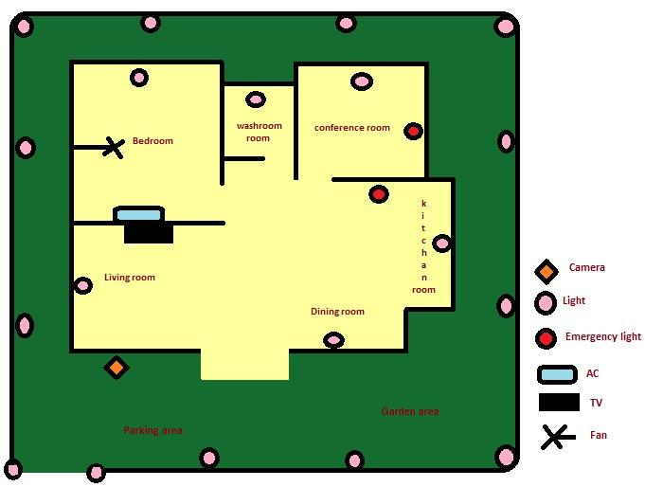

The above picture depicts the picture of the different areas of a house where voice controlled and different security systems can be installed.

VOICE ACTIVATED HOME AUTOMATION

Chapter 3

COMPONENTS USED IN THE CIRCUIT

* Aurdino Uno with Atmega 328P microcontroller.
* HC-05 Bluetooth Module
* 10K ohm Resistor
* 1K ohm Resistor
* BC547 NPN Transistor
* 1N4007 Diode
* SV Relay
* Prototyping board (Bread board)
* 9V Power supply
* Smartphone or tablet (Bluetooth enabled)
* Thermistor
* Variable Resistor(POT)
* Diode
* Capacitor
* Resistor
* Buzzer
* NE555 Timer
* CA 130

VOICE ACTIVATED HOME AUTOMATION

Aurdino Uno with Atmega 328P microcontroller

The high-performance Microchip 8-bit AVR RISC-based microcontroller combines 32KB ISP flash memory with read-while-write capabilities, 1KB EEPROM, 2KB SRAM, 23 general purpose I/O lines, 32 general purpose working registers, three flexible timer/counters with compare modes, internal and external interrupts,serial programmable USART, a byte-oriented 2-wire serial interface, SPI serial port, 6-channel 10-bit A/D converter (8-channels in TQFP and QFN/MLF packages), programmable watchdog timer with internal oscillator, and five software selectable power saving modes. The device operates between 1.8-5.5 volts.

By executing powerful instructions in a single clock cycle, the device achieves throughputs approaching 1 MIPS per MHz, balancing power consumption and processing speed.

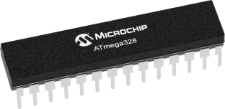

VOICE ACTIVATED HOME AUTOMATION

HC-05 Bluetooth Module

For wireless communication, we used Bluetooth Technology and the module used for this is HC – 05. This module can be interfaced using UART protocol with a wide range of programmable baud rates but the default baud rate is 9600 bps. HC – 05 Bluetooth Module can be configured as either master or slave, whereas another module HC – 06 can work only in slave mode.

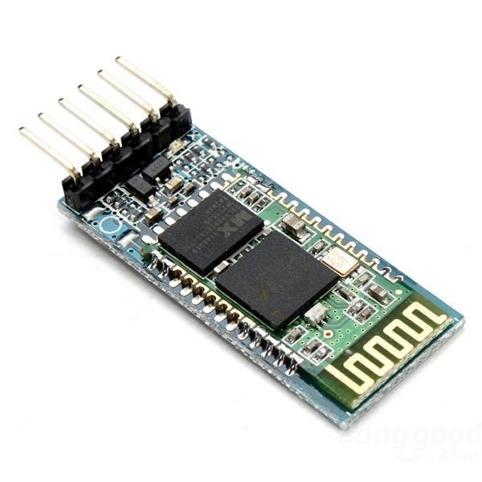

BC 547 NPN Transistor

**BC547** is an NPN bi-polar junction transistor. A transistor, stands for transfer of resistance, is commonly used to amplify current. A small current at its base controls a larger current at collector & emitter terminals. **BC547** is mainly used for amplification and switching purposes. It has a maximum current gain of 800. Its equivalent transistors are BC548 and BC549. The transistor terminals require a fixed DC voltage to operate in the desired region of its characteristic curves. This is known as the biasing. For amplification applications, the transistor is biased such that it is partly on for all input conditions. The input signal at base is amplified and taken at the emitter. BC547 is used in common emitter configuration for amplifiers. The voltage divider is the commonly used biasing mode. For switching applications, transistor is biased so that it remains fully on if there is a signal at its base. In the absence of base signal, it gets completely off.

VOICE ACTIVATED HOME AUTOMATION

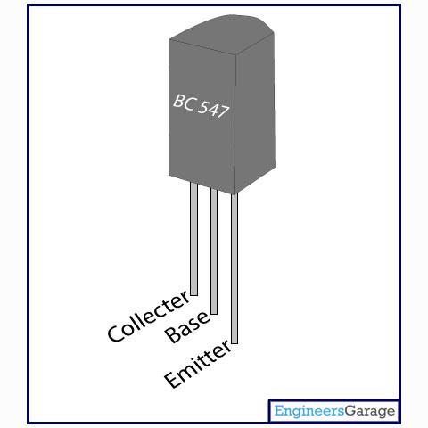

1N4007 Diode

A diode is a device which allows current flow through only one direction. That is the current should always flow from the Anode to cathode. For **1N4007 Diode**, the maximum current carrying capacity is 1A it withstand peaks up to 30A. Hence we can use this in circuits that are designed for less than 1A.  The reverse current is 5uA which is negligible. The power dissipation of this diode is 3W.

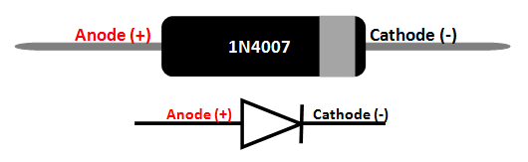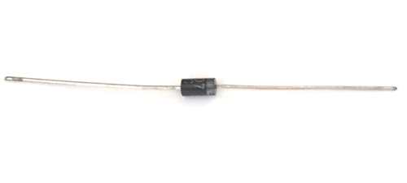

VOICE ACTIVATED HOME AUTOMATION

SV Relay:

Relays are **switches** that open and close circuits electromechanically or electronically. Relays control one electrical circuit by opening and closing contacts in another circuit. Relays are used where it is necessary to control a circuit by a separate low-power signal, or where several circuits must be controlled by one signal. The first relays were used in long distance [telegraph](https://en.wikipedia.org/wiki/Electrical_telegraph) circuits as amplifiers: they repeated the signal coming in from one circuit and re-transmitted it on another circuit. Relays were used extensively in telephone exchanges and early computers to perform logical operations.

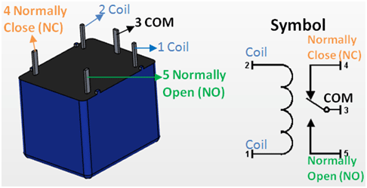

Thermistor:

A **thermistor** is a type of [resistor](https://en.wikipedia.org/wiki/Resistor) whose [resistance](https://en.wikipedia.org/wiki/Electrical_resistance) is dependent on [temperature](https://en.wikipedia.org/wiki/Temperature), more so than in standard resistors.  Thermistors are widely used as temperature [sensors](https://en.wikipedia.org/wiki/Sensors) (negative temperature coefficient or **NTC** type typically), [self-resetting overcurrent protectors](https://en.wikipedia.org/wiki/Resettable_fuse), and self-regulating [heating elements](https://en.wikipedia.org/wiki/Heating_element) (positive temperature coefficient or **PTC** type typically).

VOICE ACTIVATED HOME AUTOMATION

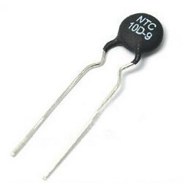

Variable resistor (POT):

A **potentiometer** is a three-[terminal](https://en.wikipedia.org/wiki/Terminal_(electronics)) [resistor](https://en.wikipedia.org/wiki/Resistor) with a sliding or rotating contact that forms an adjustable [voltage divider](https://en.wikipedia.org/wiki/Voltage_divider). If only two terminals are used, one end and the wiper, it acts as a **variable resistor** or [**rheostat**](https://en.wikipedia.org/wiki/Potentiometer#Rheostat). The measuring instrument called a [potentiometer](https://en.wikipedia.org/wiki/Potentiometer_(measuring_instrument)) is essentially a [voltage divider](https://en.wikipedia.org/wiki/Voltage_divider) used for measuring [electric potential](https://en.wikipedia.org/wiki/Electric_potential) (voltage). Potentiometers are commonly used to control electrical devices such as volume controls on audio equipment.

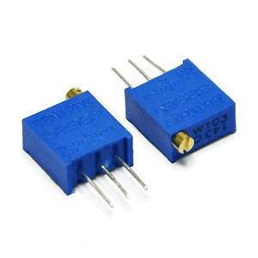

VOICE ACTIVATED HOME AUTOMATION

NE555 Timer:

The **555 timer IC** is an [integrated circuit](https://en.wikipedia.org/wiki/Integrated_circuit) (chip) used in a variety of [timer](https://en.wikipedia.org/wiki/Timer), pulse generation, and [oscillator](https://en.wikipedia.org/wiki/Electronic_oscillator) applications. The 555 can be used to provide time delays, as an [oscillator](https://en.wikipedia.org/wiki/Oscillator), and as a [flip-flop element](https://en.wikipedia.org/wiki/Flip-flop_element).

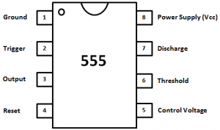

CA 3130:

**CA3130** is an Op-amplifier with hybrid features i.e. combines the advantage of both Bipolar and CMOS. This op-amp is used where fast-switching (high bandwidth) as well as low power consumption is required. The CA3130 Series circuits operate at supply voltages ranging from 5V to 16V, (±2.5V to ±8V). They can be phase compensated with a single external capacitor and have terminals for adjustment of offset voltage for applications requiring offset-null capability. Terminal provisions are also made to permit strobing of the output stage.

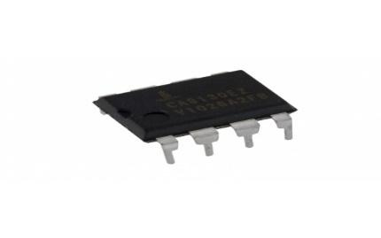

VOICE ACTIVATED HOME AUTOMATION

**Mobile Application:**

In this project, we have developed an application named IceAn Voice. All this has been accomplished with the help of MIT App Inventor. There is no requirement of coding in it as the application can be built easily by just using some basic tools.

**Introduction:**

App Inventor for Android is an open-source web application originally provided by Google, and now maintained by the Massachusetts Institute of Technology (MIT), which allows newcomers to computer programming to create software applications for the Android operating system (OS).

**What is App Inventor?**

App Inventor lets you develop applications for Android phones using a web browser and either a connected phone or emulator. The App Inventor servers store your work and help you keep track of your projects.

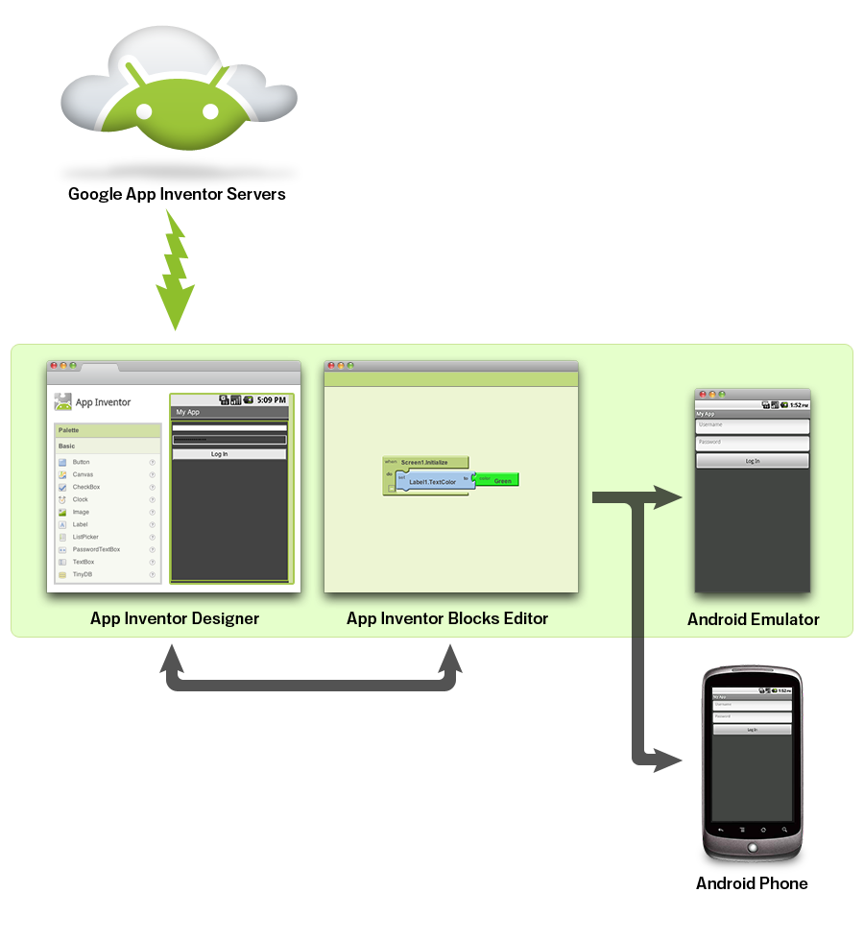

VOICE ACTIVATED HOME AUTOMATION

You build apps by working with:

* The ***MIT App Inventor Designer***, where you select the components for your app.
* The ***MIT*** ***App Inventor Blocks Editor***, where you assemble program blocks that specify how the components should behave. You assemble programs visually, fitting pieces together like pieces of a puzzle.

Your app appears on the phone step-by-step as you add pieces to it, so you can test your work as you build. When you're done, you can package your app and produce a stand-alone application to install.

If you don't have an Android phone, you can build your apps using the ***Android******emulator***, software that runs on your computer and behaves just like the phone.

The App Inventor development environment is supported for Mac OS X, GNU/Linux, and Windows operating systems, and several popular Android phone models. Applications created with App Inventor can be installed on any Android phone.

Before you can use App Inventor, you need to [set up your computer](https://appinventor.mit.edu/explore/content/setup) and install the ***MIT App Inventor Setup*** package on your computer.

**Coding Part:**

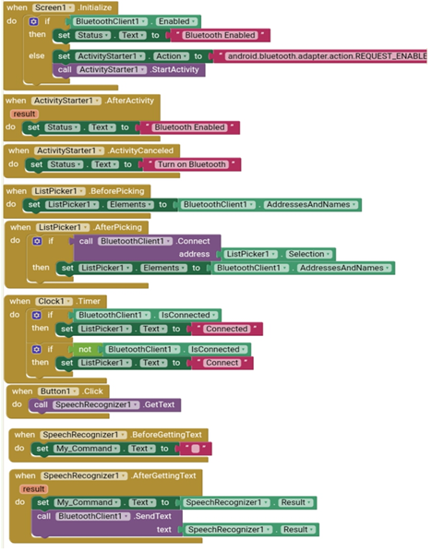

VOICE ACTIVATED HOME AUTOMATION

**Working of App Application:**

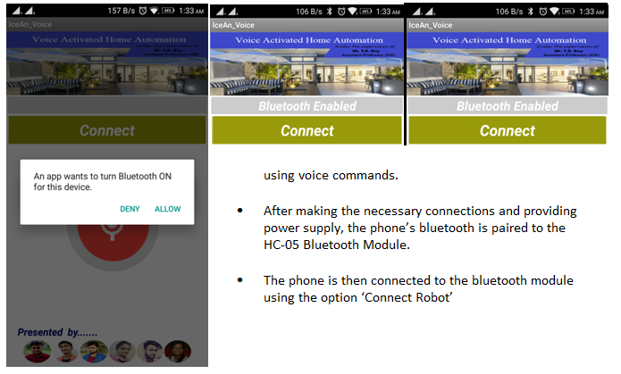

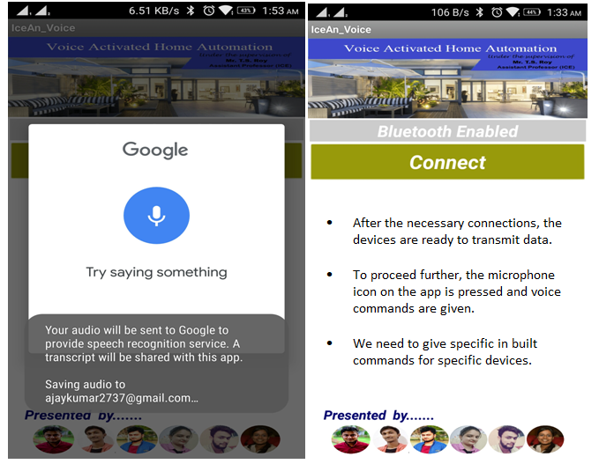

* The Voice Activated Home Automation system will help us control different loads (electrical appliances) with simple voice commands.
* This kind of system is very useful for people with disabilities.
* Further, the project can be expanded by adding different sensors (light, smoke, etc).

VOICE ACTIVATED HOME AUTOMATION

Chapter 4

OBJECTIVE AND SCOPE OF PROJECT

* The main objective of home automation is to help handicapped and old aged people, enabling them to control home appliances and alert them in critical situation.
* The system provides us switching any device ON/OFF.
* Using Node MC , we can avoid installing any app for voice recognition as Google assistance can be used for this purpose.
* If google assistance is used, there will be no restriction of range.

VOICE ACTIVATED HOME AUTOMATION

**LIMITATION**

* Voice assistants support only one-way “conversations” . The appliances cannot talk back, asking for clarification of intent.
* The commands are independent of the state of the device. The user has to know whether an oven is on, when the heat should be turned lower, etc.
* They depend on an internet connection, and the obstacle it has in each home can make it less than reliabl**e**

VOICE ACTIVATED HOME AUTOMATION

RESULTS:

This chapter lists down the results realized from the practical work and examines whether ideas approaches recommended in research are met by the practical implementation.

The results are taken in very stringent environmental conditions. For the circuit to work properly it is very necessary to maintain environmental condition during operation and while taking the output. The circuitry should not be provided with high voltage so that the components get affected. The efficiency of the proposed project can be improved significantly if the strict and suitable conditions are provided.

DISCUSSION

J. Appl. Environ. Biol. Sci., 4(8S)55-64, 2014

4. RESULTS AND DISCUSSIONS

4.1. Methods of Testing

The voice controlled home automation system has been tested in different methods. It has been tested in both noisy

and quite environments, and is found to give better results in quite environments, where it picks less or no noise signals.

The hand-held device is also tested with multiple speakers, speaking onto the device at the same time and separately

as well. The device responds to only the voice, which is used to train the IC HM2007, and not to any other voices. The

system of VCHAS has also been tested with the range of the room it covers.

Another method of testing was, to train IC-HM2007, with different commands to operate the same kinds of devices

located in different rooms, example ‘Fan1-on’ for fan of room 1 and ‘Fan2-on’ for the fan of room 2, without the

commands being mixed or confused by the device.

4.2. Limitations

While working on the system, several limitations are highlighted, such as the system produces error in response to

environmental noise, and requires absolute silence and solitude to work properly, otherwise it can pick noise signals, and

produce error in response to it.

Another thing noticed about the system development is, that since IC-HM2007, sends out a unique address each time

a command is spoken, it must have a separate decoder to match addresses with. This way, there is the requirement to use

many different decoders for each approaching address, which makes the circuit design slightly complicated.

The receiver and transmitter circuits will not work at 7V or below, so batteries used should be of good quality and be

kept under check.

4.3. Results

Controlling of two devices of household appliances are successfully achieved, the fan and light bulb.The fan can be voice

controlled for three levels of speed, full speed, and medium speed and off state. The bulb can be voice operated upon two

levels of ON and OFF, and the same system can also be used to operating heavier loads in household, example, an air

conditioner (refer to Table 2).

Table 2. Results

5. Conclusions

J. Appl. Environ. Biol. Sci., 4(8S)55-64, 2014

4. RESULTS AND DISCUSSIONS

4.1. Methods of Testing

The voice controlled home automation system has been tested in different methods. It has been tested in both noisy

and quite environments, and is found to give better results in quite environments, where it picks less or no noise signals.

The hand-held device is also tested with multiple speakers, speaking onto the device at the same time and separately

as well. The device responds to only the voice, which is used to train the IC HM2007, and not to any other voices. The

system of VCHAS has also been tested with the range of the room it covers.

Another method of testing was, to train IC-HM2007, with different commands to operate the same kinds of devices

located in different rooms, example ‘Fan1-on’ for fan of room 1 and ‘Fan2-on’ for the fan of room 2, without the

commands being mixed or confused by the device.

4.2. Limitations

While working on the system, several limitations are highlighted, such as the system produces error in response to

environmental noise, and requires absolute silence and solitude to work properly, otherwise it can pick noise signals, and

produce error in response to it.

Another thing noticed about the system development is, that since IC-HM2007, sends out a unique address each time

a command is spoken, it must have a separate decoder to match addresses with. This way, there is the requirement to use

many different decoders for each approaching address, which makes the circuit design slightly complicated.

The receiver and transmitter circuits will not work at 7V or below, so batteries used should be of good quality and be

kept under check.

4.3. Results

Controlling of two devices of household appliances are successfully achieved, the fan and light bulb.The fan can be voice

controlled for three levels of speed, full speed, and medium speed and off state. The bulb can be voice operated upon two

levels of ON and OFF, and the same system can also be used to operating heavier loads in household, example, an air

conditioner (refer to Table 2).

Table 2. Results

5. Conclusions

The purpose is to control some major household devices by voice. It is not only aimed at providing a healthy and comfortable lifestyle to the user but also at aiding the sick and the handicapped and people living alone, so that they can easily handle all their task at a convenience. Making the design sleeker and easier to handle, with a method to control more appliances at a time is a future requirement.

We have so far achieved in controlling the same appliances, example, a light bulb, at the same time in two different rooms, and we have been able to control larger loads,for example, air conditioner.

The purpose is to control some of the major household devices by voice. It is not only aimed at providing a healthy

and comfortable lifestyle to the users, but also at aiding the sick or handicapped and people living alone, so that they can

easily handle all their tasks at a convenience. Making the design sleeker and easier to handle, with a method to control

more appliances at a time is the future requirement.

We have so far achieved in controlling the same appliance, example, a light bulb, at the same time in two different

rooms, and we have been able t

The purpose is to control some of the major household devices by voice. It is not only aimed at providing a healthy

and comfortable lifestyle to the users, but also at aiding the sick or handicapped and people living alone, so that they can

easily handle all their tasks at a convenience. Making the design sleeker and easier to handle, with a method to control

more appliances at a time is the future requirement.

We have so far achieved in controlling the same appliance, example, a light bulb, at the same time in two different

rooms, and we have been able t

The purpose is to control some of the major household devices by voice. It is not only aimed at providing a healthy

and comfortable lifestyle to the users, but also at aiding the sick or handicapped and people living alone, so that they can

easily handle all their tasks at a convenience. Making the design sleeker and easier to handle, with a method to control

more appliances at a time is the future requirement.

We have so far achieved in controlling the same appliance, example, a light bulb, at the same time in two different

rooms, and we have been able t

The purpose is to control some of the major household devices by voice. It is not only aimed at providing a healthy

and comfortable lifestyle to the users, but also at aiding the sick or handicapped and people living alone, so that they can

easily handle all their tasks at a convenience. Making the design sleeker and easier to handle, with a method to control

more appliances at a time is the future requirement.

We have so far achieved in controlling the same appliance, example, a light bulb, at the same time in two different

rooms, and we have been able t

The purpose is to control some of the major household devices by voice. It is not only aimed at providing a healthy

and comfortable lifestyle to the users, but also at aiding the sick or handicapped and people living alone, so that they can

easily handle all their tasks at a convenience. Making the design sleeker and easier to handle, with a method to control

more appliances at a time is the future requirement.

We have so far achieved in controlling the same appliance, example, a light bulb, at the same time in two different

rooms, and we have been able t

The purpose is to control some of the major household devices by voice. It is not only aimed at providing a healthy

and comfortable lifestyle to the users, but also at aiding the sick or handicapped and people living alone, so that they can

easily handle all their tasks at a convenience. Making the design sleeker and easier to handle, with a method to control

more appliances at a time is the future requirement.

We have so far achieved in controlling the same appliance, example, a light bulb, at the same time in two different

rooms, and we have been able t

The purpose is to control some of the major household devices by voice. It is not only aimed at providing a healthy

and comfortable lifestyle to the users, but also at aiding the sick or handicapped and people living alone, so that they can

easily handle all their tasks at a convenience. Making the design sleeker and easier to handle, with a method to control

more appliances at a time is the future requirement.

We have so far achieved in controlling the same appliance, example, a light bulb, at the same time in two different

rooms, and we have been able t

The purpose is to control some of the major household devices by voice. It is not only aimed at providing a healthy

and comfortable lifestyle to the users, but also at aiding the sick or handicapped and people living alone, so that they can

easily handle all their tasks at a convenience. Making the design sleeker and easier to handle, with a method to control

more appliances at a time is the future requirement.

We have so far achieved in controlling the same appliance, example, a light bulb, at the same time in two different

rooms, and we have been able t

The purpose is to control some of the major household devices by voice. It is not only aimed at providing a healthy

and comfortable lifestyle to the users, but also at aiding the sick or handicapped and people living alone, so that they can

easily handle all their tasks at a convenience. Making the design sleeker and easier to handle, with a method to control

more appliances at a time is the future requirement.

We have so far achieved in controlling the same appliance, example, a light bulb, at the same time in two different

rooms, and we have been able t

VOICE ACTIVATED HOME AUTOMATION

REFERENCES

* [www.electronicsforu.com](http://www.electronicsforu.com)
* [www.electronicstutorials.com](http://www.electronicstutorials.com)
* [www.wikipedia.com](http://www.wikipedia.com)
* [www.digitalcommons.usu.edu](http://www.digitalcommons.usu.edu)
* Linear Integrated Circuits- D. Roy Choudhary
* Electronic devices and circuit theory – Robert L. Boylestad, Louis Nashelsky

The purpose is to control some of the major household devices by voice. It is not only aimed at providing a healthy

and comfortable lifestyle to the users, but also at aiding the sick or handicapped and people living alone, so that they can

easily handle all their tasks at a convenience. Making the design sleeker and easier to handle, with a method to control

more appliances at a time is the future requirement.

We have so far achieved in controlling the same appliance, example, a light bulb, at the same time in two different

rooms, and we have been able t

The purpose is to control some of the major household devices by voice. It is not only aimed at providing a healthy

and comfortable lifestyle to the users, but also at aiding the sick or handicapped and people living alone, so that they can

easily handle all their tasks at a convenience. Making the design sleeker and easier to handle, with a method to control

more appliances at a time is the future requirement.

We have so far achieved in controlling the same appliance, example, a light bulb, at the same time in two different

rooms, and we have been able t

The purpose is to control some of the major household devices by voice. It is not only aimed at providing a healthy

and comfortable lifestyle to the users, but also at aiding the sick or handicapped and people living alone, so that they can

easily handle all their tasks at a convenience. Making the design sleeker and easier to handle, with a method to control

more appliances at a time is the future requirement.

We have so far achieved in controlling the same appliance, example, a light bulb, at the same time in two different

rooms, and we have been able t

The purpose is to control some of the major household devices by voice. It is not only aimed at providing a healthy

and comfortable lifestyle to the users, but also at aiding the sick or handicapped and people living alone, so that they can

easily handle all their tasks at a convenience. Making the design sleeker and easier to handle, with a method to control

more appliances at a time is the future requirement.

We have so far achieved in controlling the same appliance, example, a light bulb, at the same time in two different

rooms, and we have been able VOICE ACTIVATED HOME AUTOMATION