**Raksha Pipes - Business Analyst Assignment: Report**

**Name - Abhay Kumar | email - meabhaykr@gmail.com**

This report details the process of building a data management and visualization system for Raksha Pipes. It covers data generation, database design, and dashboard creation in Power BI.

**Step 1: Generate Data and Design Database**

**Data Generation (Python Script):**

I used Python libraries like **pandas** and **faker** to generate realistic data for customers, products, sales, orders, payments, profit margins, annual sales, and customer feedback. The script is included in the provided files (not shown here due to security restrictions).

**Colab Link:** [Abhay_Kumar_Raksha_Pipe_Assignment.ipynb](https://colab.research.google.com/drive/1WGTBhEkCoTkjPkNWfFH02tACwzA22yGy?usp=sharing)

**Database Design (MySQL):**

The MySQL database schema consists of eight interrelated tables:

1. **Customers:** Stores customer information (ID, name, address, phone, email).
2. **Products:** Stores product details (ID, type, name, stock, price).
3. **Sales:** Records sales transactions (ID, customer ID, product ID, quantity, price, discount price, total, sale type, order date). Foreign keys connect it to Customers and Products tables.
4. **Orders:** Records order details (ID, customer ID, product ID, quantity, order date). Foreign keys connect it to Customers and Products tables.
5. **Payments:** Records customer payments (ID, customer ID, product ID, amount, payment date, mode of transaction). Foreign keys connect it to Customers and Products tables.
6. **ProfitMargins:** Tracks product-wise profit margins (product type, total quantity, total price, total profit, profit margin).
7. **AnnualSales:** Stores annual sales data by channel (year, online sales, in-store sales, phone order sales, wholesale sales).
8. **CustomerFeedback:** Stores customer feedback information (ID, feedback keyword, feedback score).

**Ensuring Data Integrity:**

* Primary keys uniquely identify each record.
* Foreign keys enforce relationships between tables, preventing redundant data.

**Step 2: Set Up Database in MySQL**

The provided SQL commands create the Raksha Pipes database and the eight tables mentioned above. You can execute these commands in your MySQL environment.

**Sample Queries**:

SELECT * FROM customers;

SELECT * FROM products;

SELECT * FROM sales;

These queries retrieve data from the respective tables.

### **Step 3: Create Dashboard in Power BI**

**Connecting to the Database:**

1. Launch Power BI Desktop.
2. Go to "Get Data" and select "Database."
3. Choose "MySQL" and provide your database connection details.
4. Select the tables you want to import (all eight in this case).

**Creating KPIs and Insights:**

The dashboard will present key performance indicators (KPIs) and insights:

**KPIs:**

* Total Sale
* Total Profit
* Feedback Score

**Insights:**

* Product Availability (stock levels)
* Profit Margin (by product type)
* Monthly Sales Trends
* Payment Mode Distribution
* Cost of Product Categories
* Customer Feedback Graph (visualizing feedback keywords and scores)

**Interactive Features:**

The dashboard will allow users to:

* Filter data by date range, product category, etc.
* Drill down into details for further analysis.

**Benefits:**

This data management and visualization system empowers Raksha Pipes to:

* Track sales performance and profitability.
* Gain insights into customer behavior and preferences.
* Make data-driven decisions to optimize operations and marketing strategies.

### **Documentation: Using the System**

1. **Database Access:**
   * You'll need a MySQL client or interface to access the database.
   * Use the provided SQL commands for reference.
2. **Power BI Dashboard:**
   * Open the Power BI Desktop file (provided).
   * The interactive dashboard displays KPIs and insights.
   * Use filters and slicers to explore the data further.

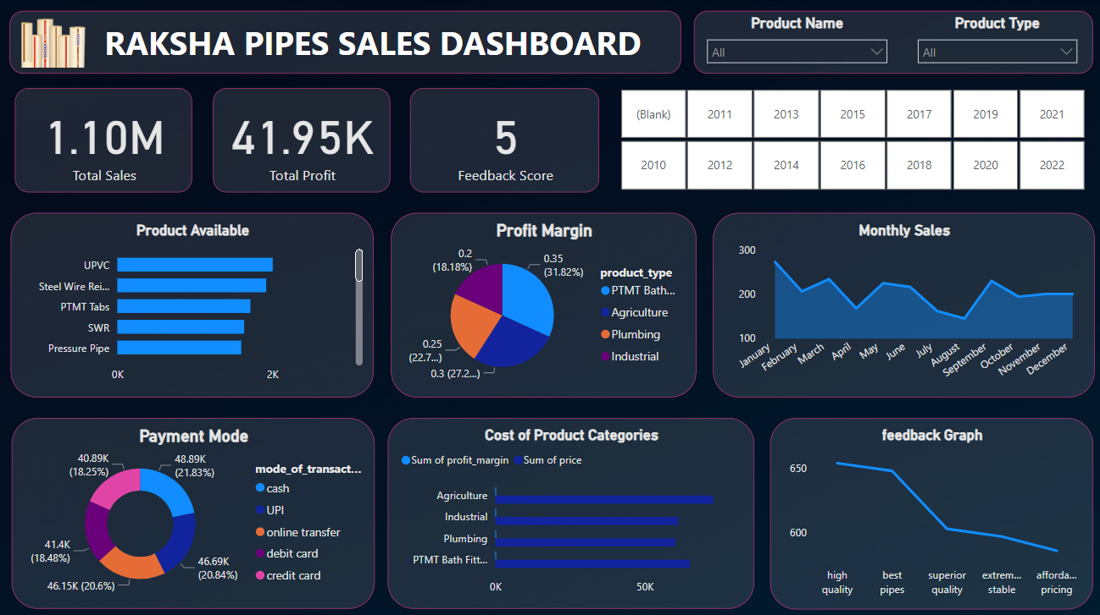

**Further Customization:**

The Power BI dashboard can be customized to include additional metrics and visualizations based on Raksha Pipes' evolving needs.

**Assignment Link:** [Raksha Pipe Assignment](https://drive.google.com/drive/folders/1o13pcNEo71kAT0p7O1KSnyz47NvZMwuw?usp=sharing)