ASSIGNMENT 1
~Introduction to Web Development~

1. Explain the difference between frontend , backend and full-stack development with real world suitable examples.
Frontend development deals with everything a user sees and interacts with in their browser — layout, design, buttons, and forms. Backend development deals with the server-side logic that a user never sees directly — processing requests, applying business rules, and talking to the database. Full-stack development means being able to build both sides: the interface and the engine behind it.
Aspect | Frontend Development | Backend Development
Definition | The part of a website/app the user sees and interacts with directly | The server-side logic that powers the application behind the scenes
Technologies | HTML, CSS, JavaScript, React, Angular, Vue | Java, Node.js, Python, Spring Boot, Express, databases (MySQL, MongoDB)
Responsibility | Layout, styling, user interaction, forms, animations | Business logic, authentication, database operations, APIs, security
Runs on | User's browser (client side) | Web server (server side)
Real-world example | The product listing page, cart UI, and checkout form on Amazon that you see and click | Amazon's servers that check inventory, process payment, and update your order in the database
Real-world example: On an e-commerce site like Amazon, the frontend is the product page, search bar, and 'Add to Cart' button you click. The backend checks stock in the database, calculates the price, and processes your payment when you click 'Buy'. A full-stack developer could build both the Amazon-style product page and the order-processing logic behind it.

2. Create a simple diagram showing how the client server model works in web architecture.
The diagram below shows how a client (browser) and a server communicate over the internet, and how the server talks to a database to fetch or store data.
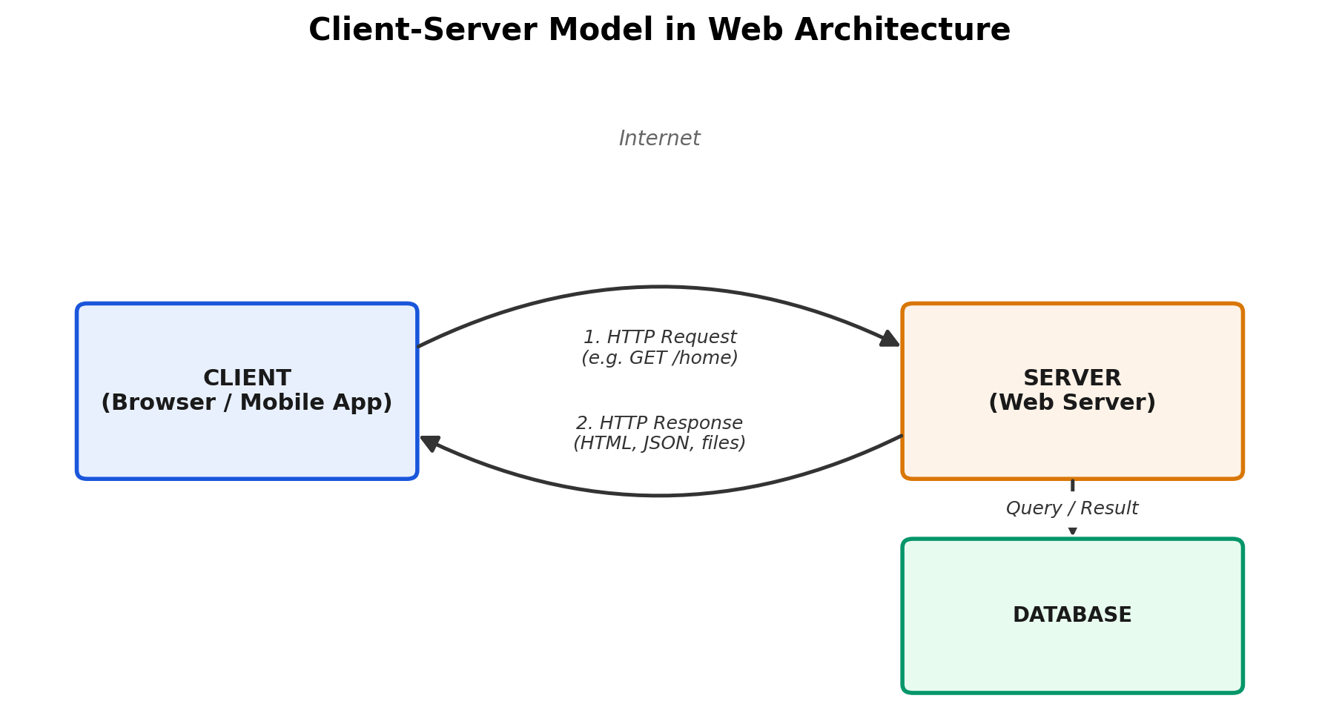

3. Describe how a browser requests and displays a web-page from a web-server.
When a user enters a URL or clicks a link, the browser goes through the following steps to fetch and render the page:
- DNS Lookup: The browser translates the domain name (e.g. google.com) into an IP address using a DNS server.
- Establish Connection: The browser opens a TCP connection to that server (with a TLS handshake if the site uses HTTPS).
- Send HTTP Request: The browser sends an HTTP GET request asking for a specific resource, e.g. GET /index.html.
- Server Processes Request: The web server receives the request, may run backend code, query a database, and prepares a response.
- Server Sends Response: The server returns an HTTP response containing status code, headers, and the page content (HTML/CSS/JS/JSON).
- Browser Parses HTML: The browser builds the DOM (Document Object Model) from the HTML.
- Fetch Additional Resources: The browser requests linked CSS, JavaScript, images, and fonts referenced in the HTML.
- Render the Page: The browser combines the DOM with CSS (CSSOM) to build a render tree, calculates layout, and paints pixels on screen.
- Execute JavaScript: Scripts run, which can further modify the page dynamically (e.g. fetch more data via AJAX/fetch API).

4. Identify and describe the tools required for the web development environment. Explain the purpose of each.
Tool | Purpose | Why it's needed
VS Code (Code Editor) | Write and edit HTML, CSS, JS, Java, etc. with syntax highlighting and debugging | Core tool for writing all project code
Node.js & npm | JavaScript runtime and package manager to run JS outside the browser and install libraries | Needed for React, Express, build tools, npm packages
Git & GitHub | Version control and remote code hosting/collaboration | Track changes, branch per topic, share code, revert mistakes
Web Browser (Chrome/Firefox) | Renders web pages and provides DevTools for debugging | Test and inspect frontend output
Postman | Send and test API requests (GET, POST, etc.) | Verify backend endpoints work before connecting frontend
Database client (MySQL Workbench / MongoDB Compass) | GUI to view, query and manage database tables/collections | Manage and debug application data
Terminal / Command Line | Run commands: git, npm, java, mvn, node | Execute build, run and deployment commands

5. Explain what a web servers is and examples of commonly used web servers.
A web server is software (often running on dedicated hardware) that stores web application files, listens for HTTP/HTTPS requests from clients, processes them, and sends back responses such as HTML pages, JSON data, or files. It can serve static files directly or forward dynamic requests to an application layer.
Commonly used web servers:
- Apache HTTP Server — one of the oldest and most widely used open-source web servers
- Nginx — known for high performance, used heavily as a reverse proxy and load balancer
- Microsoft IIS (Internet Information Services) — used for hosting .NET applications on Windows
- Node.js (Express) — a JavaScript runtime commonly used to build lightweight backend/web servers
- Apache Tomcat — a Java-based server used to run Java Servlets and JSP (relevant since you're working in Java)

6. Define the roles of a frontend , backend and database administrator in a project.
Role | Responsibilities
Frontend Developer | Builds the user interface and user experience — layout, styling, interactivity, and connects to backend APIs to display data. Owns everything the user sees and clicks.
Backend Developer | Builds server-side logic, APIs, authentication, and business rules. Connects the application to the database and ensures data is processed and returned correctly and securely.
Database Administrator (DBA) | Designs the database schema, manages storage, indexing, backups, and performance. Ensures data integrity, security, and availability, and optimizes queries used by the backend.

7. Install VS Code and configure it for HTML , CSS and JS development. Take a screenshot of it.

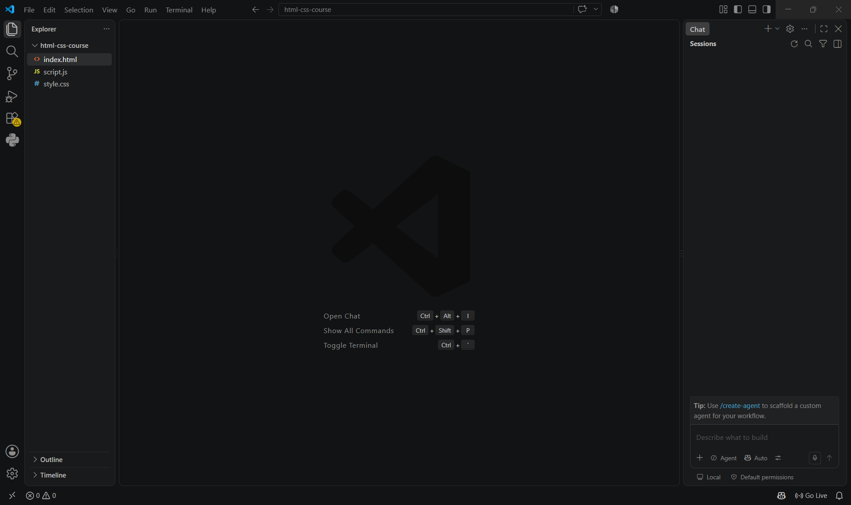

8. Explain the difference between static and dynamic websites. Provide an example of each.
Static websites: Content is fixed and the same for every visitor. Pages are pre-built HTML/CSS files served exactly as they are stored, with no server-side processing of data per request.
Dynamic websites: Content changes based on user input, database data, or logic executed on the server (or client) at request time — different users can see different content.
Example — Static: A personal portfolio site built with plain HTML/CSS showing a fixed resume and project list; it looks identical to every visitor and only changes when the developer edits and re-uploads the files.
Example — Dynamic: An e-commerce site like Flipkart, where the homepage shows personalized recommendations, live stock/price data, and a different cart for every logged-in user, generated fresh from the database on each request.

9. Research and list five browsers. Explain how rendering engines differ between them.
Browser | Rendering Engine | Notes
Google Chrome | Blink | Fast, huge extension library, most widely used; Blink is a fork of WebKit maintained by Google
Mozilla Firefox | Gecko | Open-source, strong privacy tools and developer tools; uses its own Gecko engine, not Blink/WebKit
Safari | WebKit | Default browser on macOS/iOS, optimized for Apple hardware and battery efficiency
Microsoft Edge | Blink (Chromium-based) | Built on Chromium since 2020, so it renders pages almost identically to Chrome
Opera | Blink (Chromium-based) | Chromium-based with extra features like a built-in VPN and ad blocker
A rendering engine is the component that parses HTML/CSS and paints the visual page. Browsers sharing the same engine (e.g. Chrome, Edge, Opera all using Blink) tend to render pages almost identically, while Firefox (Gecko) and Safari (WebKit) can occasionally show minor differences in CSS handling, font rendering, or support for newer web standards — which is why cross-browser testing matters.

10. Draw a labelled diagram showing the base architecture workflow -- client , server , database and APIs.
The diagram below shows the full flow between client, server, API layer, and database in a typical web application.
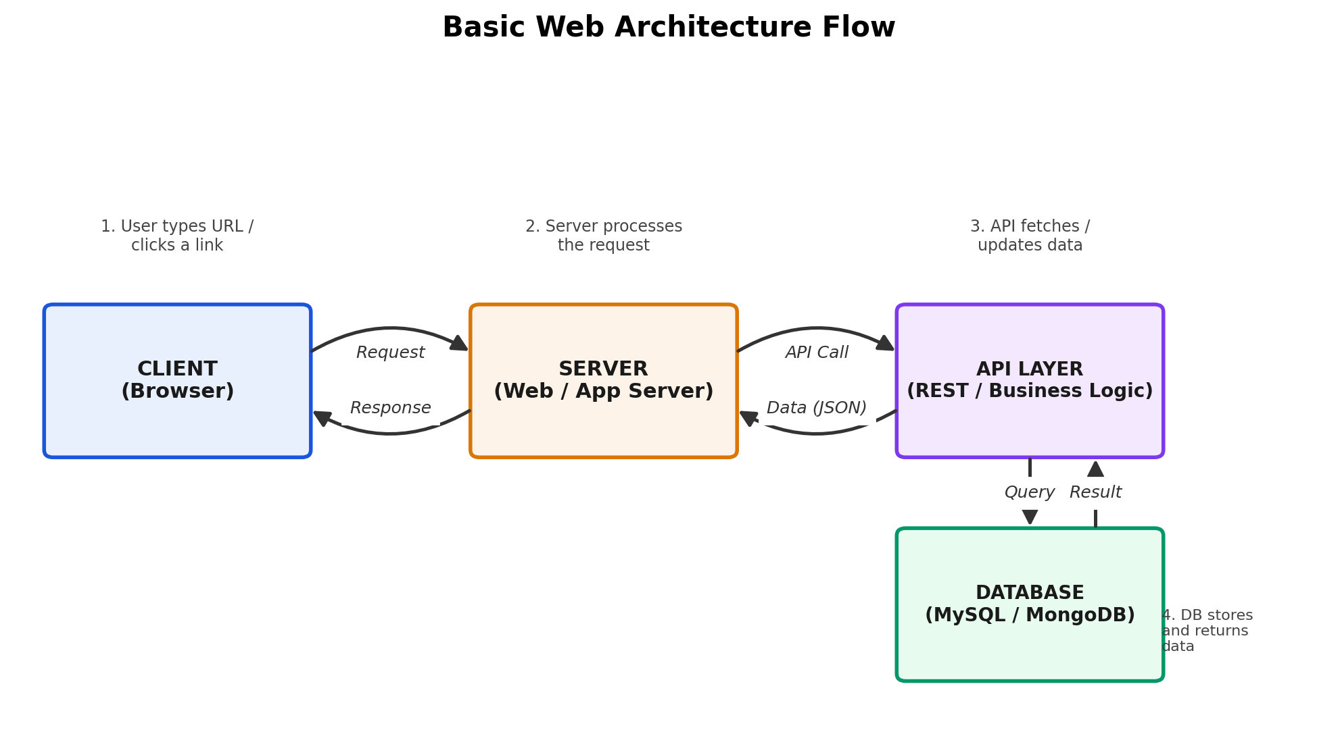
Flow explanation: the client sends a request to the server → the server (or a dedicated API layer) processes it and, if needed, calls the database to fetch or update data → the database returns the result → the server/API sends a response (often JSON) back to the client, which renders it for the user.

