### Graphics

**Q1**

**Log-Linear**

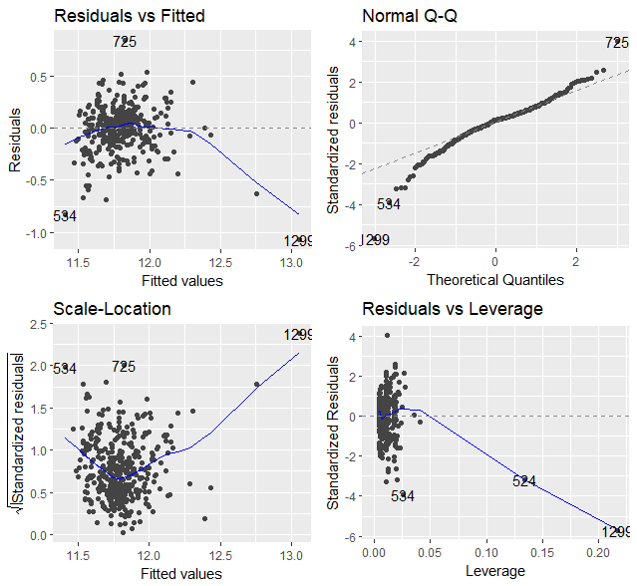

**Linear - Log**

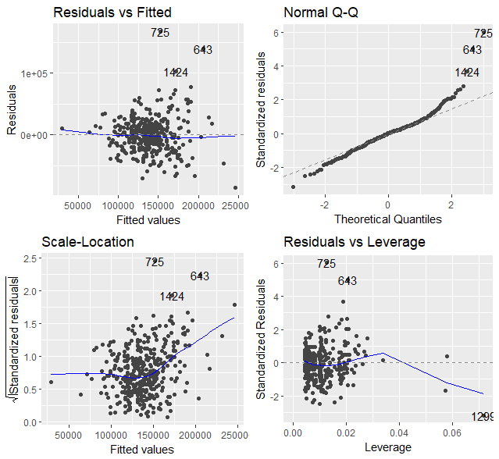

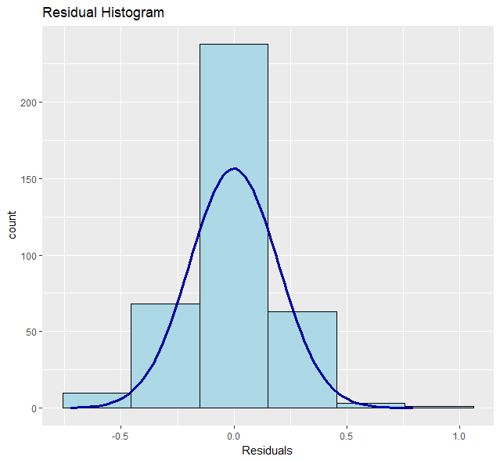

**Fig 5.** Linear – Linear Residuals Histogram

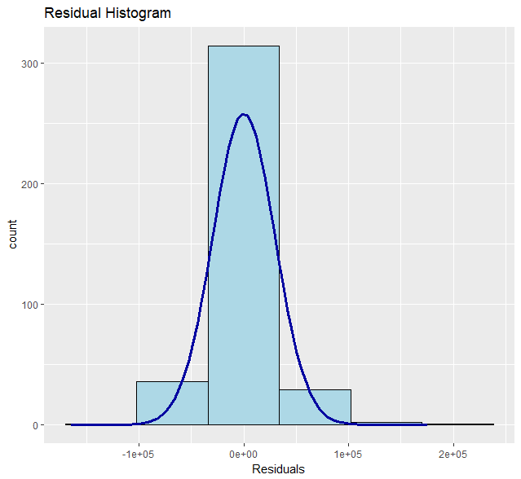

**Fig 6.** Log – Log Histogram using olsr::ols_rsd_hist

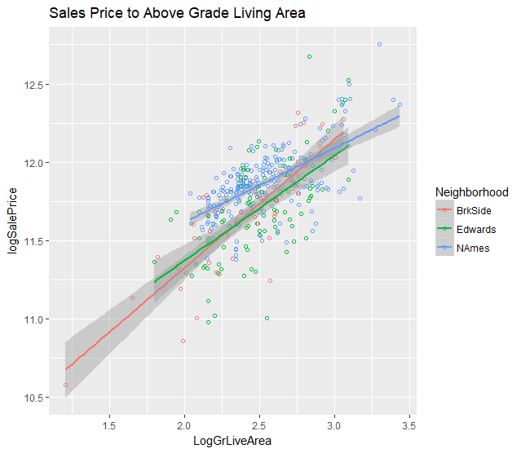

**Fig. 4.** Multiple Regression Plot with Interaction between “GrLivArea” and Neighborhood using ggplot2.

**Q2**

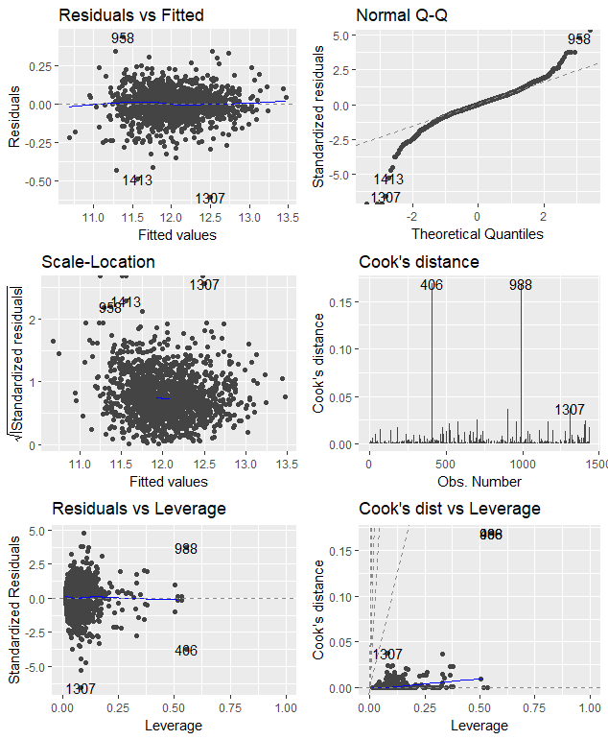

Diagnostic plots post transformation

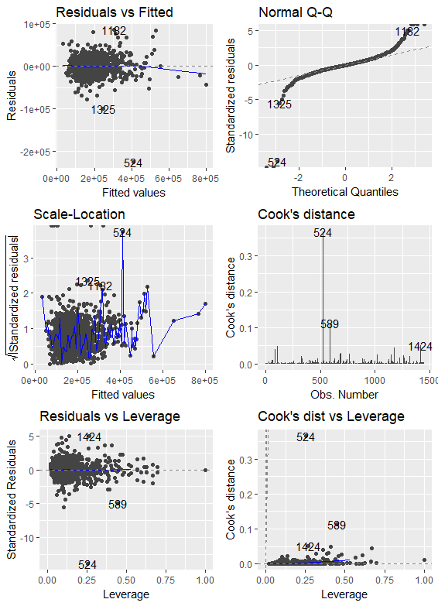

Diagnostic plot pre-transformation