**/pol/ and Donald Trump: From doubt to love**

Nikolas Mead

12/12/2022

**Table of Contents**

**Introduction** 2

**Literature Review** 3

**User’s Political Viewpoints: Are they all far-right?** 4

**User’s Initial Opinions on Donald Trump: Only doubts?** 6

**Idea Circulation: The joke becomes America’s only hope** 8

**Conclusion** 11

**Recommendations** 12

**References** 13

**Appendix 1: Archived 4chan threads from 4plebs** 14

**Stylesheet** 16

**Abstract**

While 4chan’s /pol/ board is often noted as one of the reasons Donald Trump was able to win the 2016 presidential election, the users of /pol/ did not support him from the beginning. Through a mix of despair at the current political climate, an immense dislike for Hillary Clinton, and Trump’s increasingly radical views, 4chan users began to slowly shift their opinions on the controversial candidate. This paper uses data analysis on a multitude of posts from the /pol/ board to help explain what made the users warm up to Trump. The concept of idea circulation creating a sense of community among the Trump-supporting users is also explored as a reason why supporting the republican party’s president-elect became common on the /pol/ board.

# **Introduction**

Donald Trump’s win in the 2016 presidential election often is attributed to support and memes from the /pol/ board of the anonymous message board 4chan. However, what is seldom mentioned is that the users on 4chan initially did not support Trump. The users were wary of him because of how he ran his various businesses and thus held a poor opinion of him. Despite this, when he became the 2016 Republican nominee, they saw him as the lesser of two evils compared to Hillary Clinton and slowly began to warm up to him. The amount of dislike the users had for Clinton and a common idea that American politics were already a mess led to them deifying Trump as someone closer to their values. This paper aims to analyze when 4chan users began to start honestly supporting Trump, and how the circulation of their memes and views influenced the site’s overall opinion on Trump, leading to 4chan’s influence on the election.

# **Literature Review**

Despite how recent the election was, there is a notable amount of scholarly literature on 4chan about its role in the 2016 election. However, due to the severity and sensitivity of the subject matter, there are some problems with the current published works. The two main issues are not understanding 4chan itself and letting pre-existing bias define research rather than empirical findings. While these works are not to be discredited, the emotional nature of the topic has led some scholars to provide overly biased articles that do not properly analyze the topic.

4chan is an objectively different site from many of the websites that populate the internet today. Mike Wendling (2018) said that “Part of the appeal of the website lies in its vintage design and overall mood” (p. 52) as well as mentioning “how different the internet was in the 1990s and early 2000s” (p. 52). 4chan represents a time when the internet was not as moderated as it is today. Users are allowed to say much more offensive and harsh things than most sites now would allow on their platforms today. Because of the site’s different values, it can be difficult for anyone not accustomed to it to look at it objectively. People seeing racial epithets said casually is shocking to the degree that many people do not want to read any posts on 4chan. However, any researcher be somewhat accustomed to the website and be able to look for information. Researchers must understand the thoughts going through the users’ heads that even with the difficulties of seeing harmful language. Angela Nagle (2017) mentioned that “A frustrating contradiction and hypocrisy you find in many of these online spaces and subcultures is that they want the benefits of tradition without its necessary restraints and duties” (p. 96). It is noteworthy that one thing 4chan, at least the /pol/ board, is noteworthy for is the intense value of tradition. While other boards do have more liberal views, like the /lgbt/ board, it is critical to note that the overlap in these boards with varying values is minimal. The groups of people on the /pol/ board are fans of tradition; they do not want to change to match liberal values. This harkens back to the nostalgic design and mood of the website since many of the users of 4chan want to keep up their traditions. The users of /pol/ have no common desire to change to match the current internet. Dale Beran (2019) talked about “Trump’s obsession with humiliation” (p. 151) and how he was able to relate to 4chan users by “emit(ting) signals of an… insecure, loser beta” (p. 151). Despite this claim, Trump being insecure is something assigned to him by his detractors since it does not align with his presentation of himself to be a loser in any way. This idea of him being a beta male, which means someone weak, is mainly from people not believing he could be a good president and the disadvantage he had from not having a political background. Claims like these come off much more as attacks on Trump’s character rather than a fact. What /pol/ users latched onto was his conservative politics, not a relatable beta male character.

# **User’s Political Viewpoints: Are they all far-right?**

Far-right viewpoints have gained traction on the website because of the dislike of change. When these users see things like far-left values, which often are starkly different from societal norms held for many years, being incorporated or accepted into society, they feel upset and start to develop a sense of isolation. When these users see the world changing from what they value to something they directly oppose, they not only get upset, but they lose hope for the future. Many users who held these views felt the future of America was hopeless, and some felt it did not matter who won the election, as seen in Figures 1 through 3.

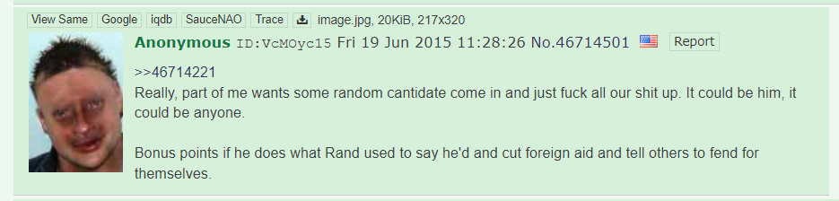

Figure 1. A post on 4chan before Trump’s election where a user expresses how they want “some random can[d]idate” to “fuck all our shit up”.

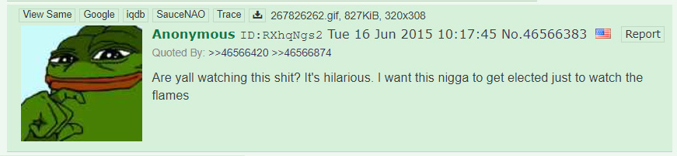

Figure 2. A pre-election post where a user says they want Trump elected “just to watch the flames”.



Figure 3. A pre-election post where a user mentions how people would be “absolutely mortified” at Trump being elected but says to elect him anyway for the reaction.

However, despite this lack of faith in US politics, there was a strong desire that Clinton not be elected. Even though many users did not honestly believe Trump would be elected, they clearly would prefer him over Clinton. There were multiple reasons behind the dislike for Clinton, but the largest was her overtly progressive politics. Clinton did not represent almost any of the users’ views, so the idea of having her as the president of the United States was upsetting for them, as seen in Figures 4 through 6.

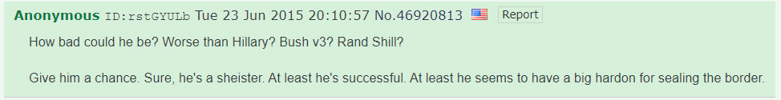

Figure 4. A pre-election post where a user mentions how Trump could not be worse than Clinton.



Figure 5. A pre-election post where a user mentions the Whitewater loan scandal that Hillary and Bill Clinton were involved in to infer Hillary would not be a good president.

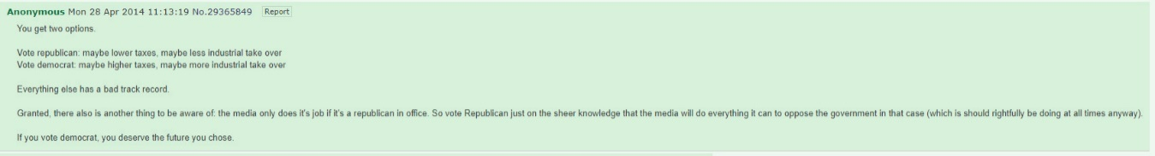

Figure 6. A pre-election post where a user mentions how voting Democrat will be a worse choice than voting Republican due to less “industrial takeover” and taxes.

# **User’s Initial Opinions on Donald Trump: Only doubts?**

Donald Trump and his history as a rich businessman were well known by the users of 4chan, but they did not hold high opinions of him, questioning his business tactics and intelligence. Even though Trump held conservative viewpoints, some users at the time were partial to Rand Paul. However, even the support for Rand Paul was not overwhelming, and many users did not seem to like any of the candidates much, as seen in Figure 7.

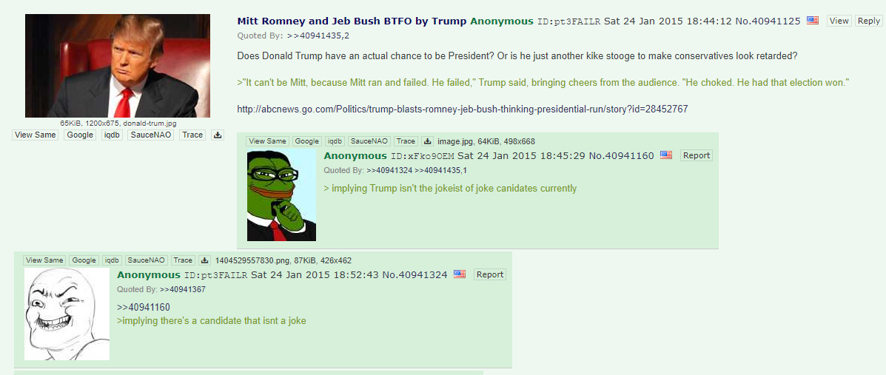

Figure 7. Multiple posts in an early Trump thread where users mention he and all of the candidates are a “joke”.

The unappealing pool of candidates combined with the lack of faith in America’s politics led users to be somewhat uninterested in the election. While threads were constantly made on /pol/ about the upcoming election, users seemed resigned and did not have high hopes for the future.

However, this lack of common direction led to a massive change in how people viewed Trump. As Trump came out with more plans for the future, like building a wall between Mexico and the US, people gave him more attention. While the concept seemed odd and unlikely to happen, users on /pol/ were receptive to the idea, as it was funny and there was a large dislike for immigrants getting across the border into America, as seen in Figure 8.

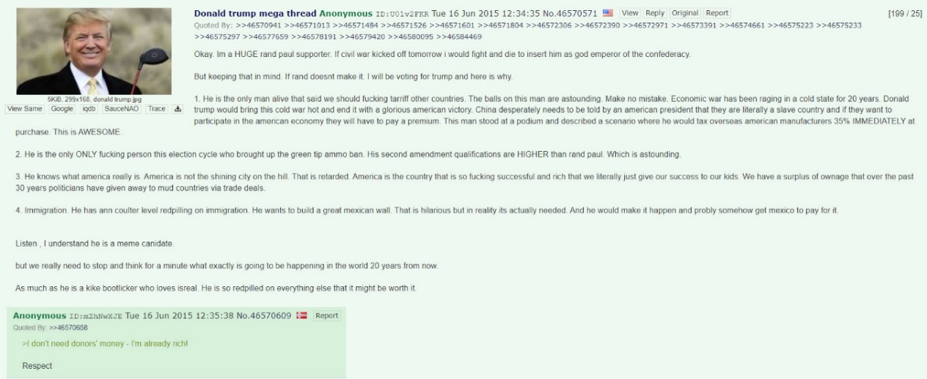

Figure 8. An opening post from a Trump “megathread” where the original poster mentions how Trump cares about immigration.

Relating to their lack of faith in American politics, they saw Trump as an interesting candidate who could at least upset the people they disliked, far-left liberals. The /pol/ users believed that if America was not going to stick to the values they cared about, it was better to let it be damaged by bad politicians was a driving factor in initial support of Trump. While 4chan’s /pol/ board logs the country a user is posting in, it is surprising to note how many people from America held this destructive viewpoint.

# **Idea Circulation: A joke becomes America’s only hope**

As users saw Trump’s rise in pre-election votes alongside his campaign promises of making America great again, they began to honestly support him. The morose attitude toward American politics, the intense dislike for Clinton, and Trump’s increasingly radical values created a perfect breeding ground for Trump supporters. Kathleen Hall Jamieson (2018) talked about how some Republican Americans thought about Trump; “by making America great again, he would restore their jobs and standing in the nation and the world” (p. 82). Even if users did not know if Trump really could improve America by making it match older values and bring back its world standing, they thought he was an okay choice and supported his efforts, as seen in Figure 9. Of course, not all users felt this way about Trump, but one thing 4chan does commonly is shun opposing opinions. Users who did not support Trump would receive replies about how they were wrong, further building the common narrative that Trump was the best candidate in the 2016 election.

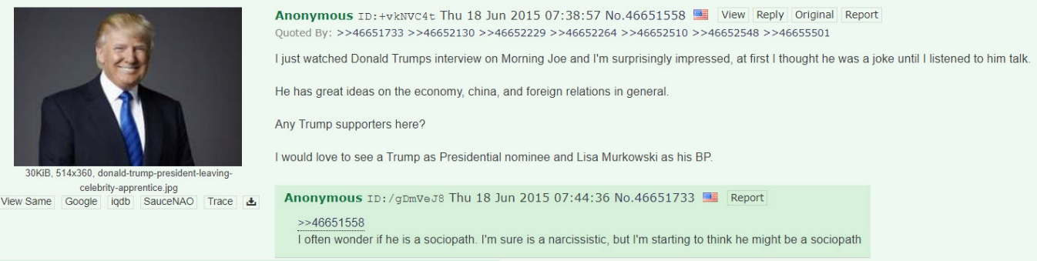

Figure 9. A pre-election post where a user mentions reevaluating their views on Trump after hearing about his ideas for foreign relations, with another user calling Trump a sociopath in the replies.

The memes that came from the election also helped create a sense of community, with users feeling like they were part of a group that shared the same values by sharing them on the boards. This sudden feeling that there was a candidate that represented these users made them start to support him. While some users still only saw Trump as a joke, the majority began to believe he would be an okay president, at least better than Clinton. The /pol/ user’s positive opinions of Trump and memes in support of him can be seen in Figures 10 through 14.

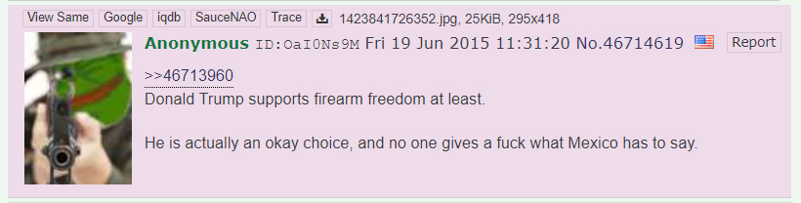

Figure 10. A pre-election post where a user mentions how Trump is an “okay choice” because he supports firearm freedom.

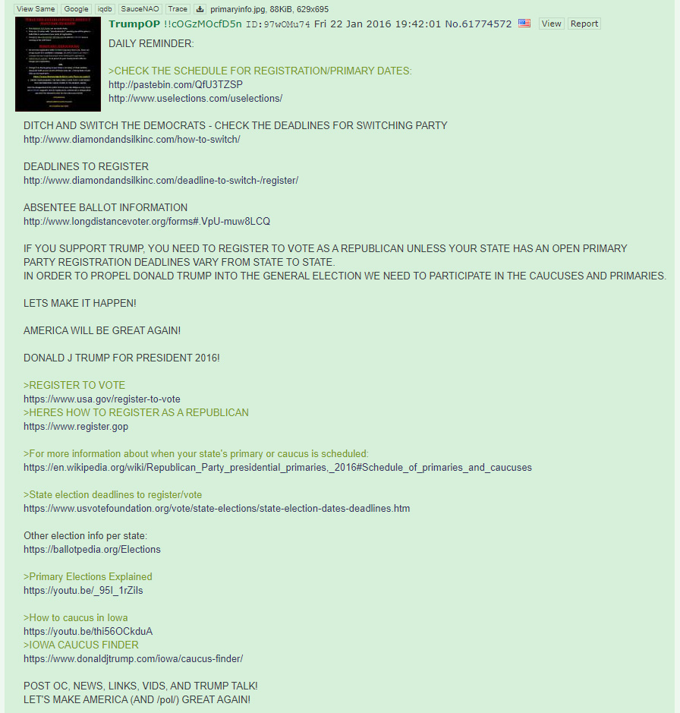

Figure 11. A post that was reposted daily in the current “Trump General” thread gave users information on how to vote for Trump.

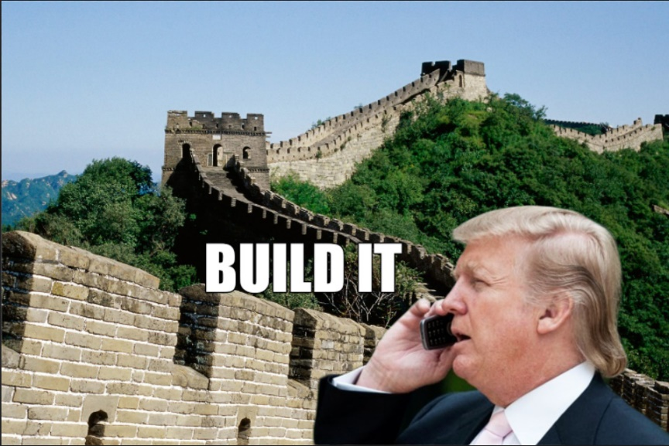

Figure 12. A meme from /pol/ referencing the proposed wall between Mexico and the USA.



Figure 13 & Figure 14. Two memes of anime girls with a “Make America Great Again” hat were edited on. This format of adding MAGA hats to anime girls was popular, referencing some overlap between /pol/ and /a/, which is the anime board of 4chan.

When Trump won the Republican nominee, /pol/ users continued their support for him and hoped he could beat Clinton. While memes containing sometimes questionable information were made by users on the site were shared on other platforms, /pol/ users’ support for Trump was relatively self-contained. Trump’s campaign often enlisted people to create memes or spread information that supported him and worked with social media companies like Facebook directly rather than relying on 4chan. Shawn Walker and colleagues (2019) mentioned how the Cambridge Analytica scandal involved “monetizing social-psychological user traits and using granular trace data to micro-target political advertisements on the platform” (p. 1535) which had a much larger impact on influencing people outside 4chan than any posts users on /pol/ made.

# **Conclusion**

While the users of /pol/ initially did not support Donald Trump, they began to slowly warm up to him as they realized his potential to at least upset people on the far left. Some users started to find Trump shared the same values as them, which made them support him. Due to /pol/ users’ mainly conservative user base, users found themselves rooting for Trump because of how badly they disliked Clinton and her progressive left politics.

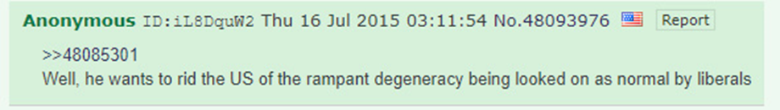

Figure 15. A post saying Trump “wants to rid the US of the rampant degeneracy being looked on as normal by liberals”.

Even though there were still a significant number of users who did not like Trump, their dissenting opinions were criticized as /pol/ found a candidate they felt represented their traditional values. Users on /pol/ initially viewed Trump as the lesser of two evils, but in time began to honestly support him through his values and the sense of community that being a “Trumper” brought with it on the board.

# **Recommendations**

This research topic is relatively difficult because of 4chan users’ personalities. The attitudes of users can be very harsh and abrasive, making it hard to look at posts without getting emotionally involved. Seeing hurtful words and being upset about that is not wrong, but any future researchers need to be able to stay as unbiased as possible with this topic. Another hurdle in this research is 4chan’s archives. While the site keeps post archives, each board only keeps the most recent 3000 threads, which often only a couple months of postings.

To view older posts, I used archive.4plebs.org, which is a dedicated 4chan archive that goes back to around 2013 for certain boards. Another problem with this research is that there is a huge amount of data. When searching “Donald Trump” on the 4plebs archive of /pol/, there are 526057 results. Searching through the data is difficult because 4plebs’ only sorting options are by newest or oldest. Future researchers need to dedicate a significant amount of time to searching through the archives, as there are currently no other archives of /pol/ online. The history of these 4chan archives being deleted is long, resulting in many archives starting and ending relatively quickly. As time passes, information from before the election and right after it will become increasingly hard to access, so researchers should start any projects on this topic sooner rather than later.

What posts are real and what posts are troll posts is another issue that those unfamiliar with how users on the site communicate may run into. A few trends this research shined a light on was that overuse of swear words or slurs often meant the post was “bait,” a post made to get people angry. Another sign was the flags that are on each post which show what country a user is posting from. If a user was talking about how they were voting for Trump, or how they earnestly supported him but did not have an American flag on their post, it was likely bait. While truly determining which posts are honest and which are bait is likely impossible, researchers should look for small details like the ones mentioned to not accidentally fill their research with joke posts.

# **References**

Beran, D. (2019). *It came from something awful: How a toxic troll army accidentally memed Donald Trump into office* (First ed.). New York: All Points Books.

Jamieson, K. (2018). Cyberwar: How Russian hackers and trolls helped elect a president: What we don't, can't, and do know. New York, NY: Oxford University Press.

Nagle, A. (2017). *Kill all normies: The online culture wars from Tumblr and 4chan to the alt-right and Trump*. Winchester, UK; Washington, USA: Zero Books.

Walker, S., Mercea, D., & Bastos, M. (2019). The disinformation landscape and the lockdown of social platforms. *Information, Communication & Society, 22*(11), 1531–1543. https://doi-org.ezp1.lib.umn.edu/10.1080/1369118X.2019.1648536

Wendling, M., & ProQuest. (2018). *Alt-Right: From 4chan to the White House*. London: Pluto Press.

# **Appendix 1: Archived 4chan threads from 4plebs**

Due to the immense amount of data searched through and the lack of any APA documentation on how to cite 4chan, I have provided the links to all the posts I referenced for this project here.

https://archive.4plebs.org/pol/thread/45784177/#q45784177

https://archive.4plebs.org/pol/thread/45780559/#q45785165

https://archive.4plebs.org/pol/thread/46007064/#q46011296

https://archive.4plebs.org/pol/thread/46217685/#q46217811

https://archive.4plebs.org/pol/thread/46537428/#q46537428

https://archive.4plebs.org/pol/thread/46566312/#q46566312

https://archive.4plebs.org/pol/thread/46570571/#q46570571

https://archive.4plebs.org/pol/thread/43662762/#q43666029

https://archive.4plebs.org/pol/thread/45574885/#q45574885

https://archive.4plebs.org/pol/thread/45658938/#q45658938

https://archive.4plebs.org/pol/thread/45784177/#q45784177

https://archive.4plebs.org/pol/thread/40941125/#q40941125

https://archive.4plebs.org/pol/thread/40970136/#40976011

https://archive.4plebs.org/pol/thread/41731638/#q41741340

https://archive.4plebs.org/pol/thread/41955579/#q41963336

https://archive.4plebs.org/pol/thread/41997243/#q41997243

https://archive.4plebs.org/pol/thread/42514994/#q42514994

https://archive.4plebs.org/pol/thread/42700377/#q42700377

https://archive.4plebs.org/pol/thread/42851436/#q42854397

https://archive.4plebs.org/pol/thread/28407389/#q28409746

https://archive.4plebs.org/pol/thread/28912424/#q28920498

https://archive.4plebs.org/pol/thread/28912424/#q28929625

https://archive.4plebs.org/pol/thread/28939681/#q28940729

https://archive.4plebs.org/pol/thread/29195950/#q29199051

https://archive.4plebs.org/pol/thread/29365614/#q29365614

https://archive.4plebs.org/pol/thread/29519844/#q29520017

https://archive.4plebs.org/pol/thread/29656301/#q29658668

https://archive.4plebs.org/pol/thread/34998348/#q34998348

https://archive.4plebs.org/pol/thread/35022285/#q35022531

https://archive.4plebs.org/pol/thread/35799671/#q35801095

https://archive.4plebs.org/pol/thread/36151870/#q36153109

https://archive.4plebs.org/pol/thread/36221541/#q36221541

https://archive.4plebs.org/pol/thread/38464207/#q38464207

https://archive.4plebs.org/pol/thread/38464207/#q38465470

https://archive.4plebs.org/pol/thread/39670506/#q39670506

https://archive.4plebs.org/pol/thread/40428156/#q40436360

https://archive.4plebs.org/pol/thread/46570571/#q46570571

https://archive.4plebs.org/pol/thread/46566312/#q46570710

https://archive.4plebs.org/pol/thread/46688066/#q46688249

https://archive.4plebs.org/pol/thread/46919903/#q46919903

https://archive.4plebs.org/pol/thread/46923063/#q46923063

https://archive.4plebs.org/pol/thread/46945098/#q46945098

https://archive.4plebs.org/pol/thread/46746339/#q46746339

https://archive.4plebs.org/pol/thread/46759599/#q46759599

https://archive.4plebs.org/pol/thread/46889663/#q46889663

https://archive.4plebs.org/pol/thread/46732215/#q46732215

https://archive.4plebs.org/pol/thread/46713960/#q46714619

https://archive.4plebs.org/pol/thread/46712321/#q46712321

https://archive.4plebs.org/pol/thread/24712132/#q24714146

https://archive.4plebs.org/pol/thread/25169897/#q25171506

https://archive.4plebs.org/pol/thread/34998348/#q34998348

https://archive.4plebs.org/pol/thread/40970136/#q40976011

# **Stylesheet**

|  |  |  |
| --- | --- | --- |
| **A–E** | **F–J**  Far-right (adj)  Far-left (adj)  Far right (noun)  Far left (noun) | **K–N**  /lgbt/ (noun) |
| **O–R**  /pol/ (noun)  /pol/ users (noun)  President elect (noun)  Pre-election (noun) | **S–U**  Social-psychological (adj) | **V-Z** |
| **numbers**  1 through 10 all written out.  All data in integers only. | **style**  Headers: Times New Roman, 18point, bol. Sentence case for subtitles  Body: TNR, 12pt.  Figure Labels: TNR, 9pt, italics.  Citations: APA | **miscellaneous**  4chan (noun)  4plebs (noun)  All links are in the appendix without formatting. |