**The COVID-19 Pandemic and the Large-chain Grocery Industry: Impacts and Changes**

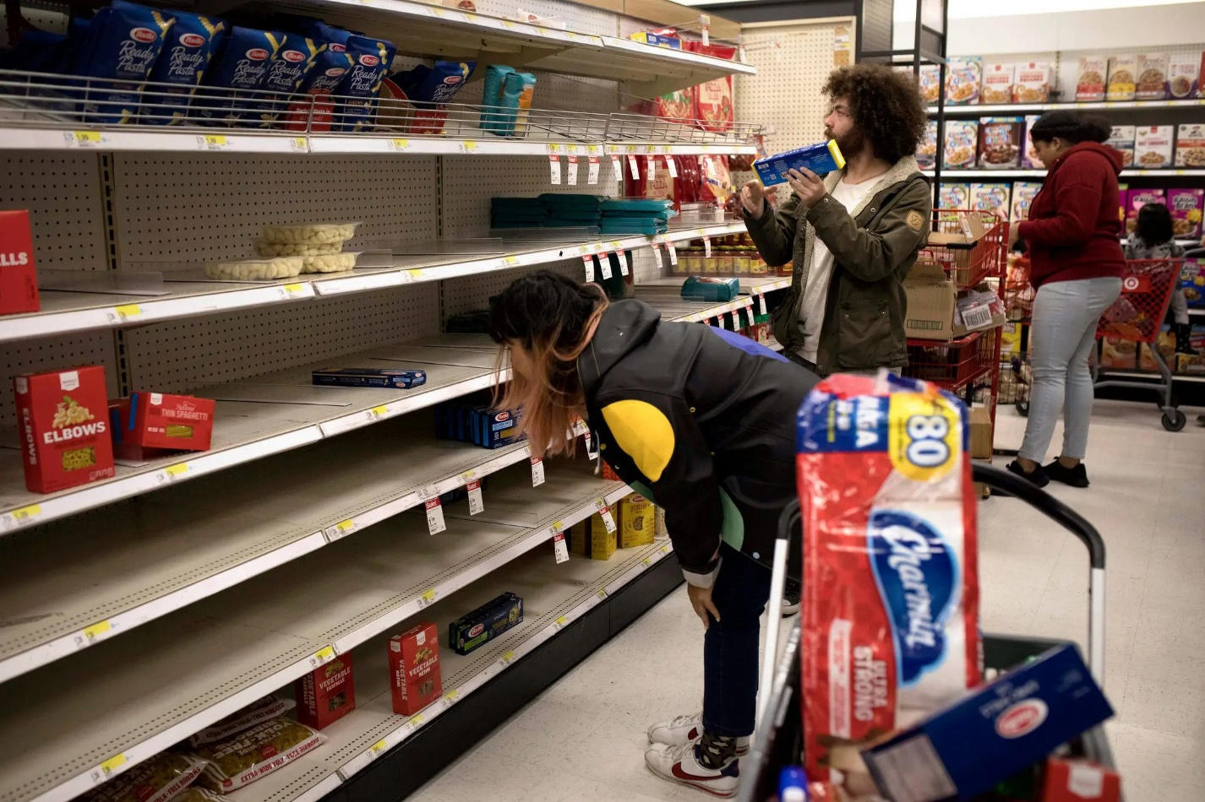

Nikolas Mead

12/12/2022

**Table of Contents**

**Introduction** 2

**Methods** 4

**Results** 5

**Discussion** 9

**Conclusion** 10

**Recommendations** 10

**References** 11

**Appendix 1: Interview Questions** 13

**Appendix 2: Notes from Interviews** 13

**Abstract**

The COVID-19 pandemic has impacted the large-chain grocery industry in multiple ways, causing a need to make changes to properly accommodate workers and continue to supply products throughout all stores. As time has passed, it has become more apparent that many of these adjustments to the industry will be long-standing, requiring accurate assessments of the current industry to help further adapt for success now and in the future. A set of interviews of six employees at a large-chain grocery store about how their working experience and the industry as a whole have been affected by the pandemic is synthesized alongside scholarly and news sources to identify the largest issues in the industry along with providing possible solutions.

# **Introduction**

Due to the ongoing COVID-19 pandemic, the grocery industry has been impacted heavily due to the need to still operate at the same capacity, as it is an essential service. Duffy and colleagues say that “The grocery retail sector is critical for public health intervention given 68 % of all foods consumed are consumed at home” (p. 1) so the relationship between public health and this industry is strong. Since the pandemic has caused significant changes that will undoubtedly affect the productivity and profits of the grocery industry, it is important to analyze those changes so future business plans can use that information to keep the industry successful. Employees and management can also use the information to help make their stores succeed against difficult circumstances. Duffy and colleagues also cited a “rapid shift in grocery shopping behaviors created by COVID-19” (p. 1) which also implies there are many new changes in the industry that need to be analyzed. In my project, I want to research how the grocery industry, specifically large-chain stores, has adapted to the pandemic.

Since the pandemic began in 2019, the grocery industry has been trying to adapt to the current market landscape. There have been some successes, considering that EMSI Burning Glass says that “as of April 14, job postings for grocery stores are up 12% from a year ago” (p. 1) The industry has also had to deal with struggles, like issues in the supply chain not bringing enough product to stores. On the contrary, Jaewon Kang mentions that “Russia’s invasion of Ukraine drove wheat prices to record-high levels earlier this year.” (p. 1) reflecting that the issues in the supply chain have led to prices drastically increasing. Large chains have had to raise prices to still make a profit, causing customers to refrain from buying anything nonessential. However, as there have been over two years since these changes have sprung on the industry, there is research that can help the grocery industry find ways they can be more successful and analyze how the previous changes work in the long run. Riediger and colleagues said “It is critical to document these operational changes within the sector and conduct a policy analysis to learn what worked, and why it worked, to inform future responses in similar emergency situations” (p. 1) which builds on the idea that analyzing these changes will be beneficial for the future of the grocery industry. Large chain stores especially need to know about what works in these situations, as they will need to make changes among many stores at the same time. Priymvada and Aalok Kumar mentioned “The long-term impacts [on the grocery industry] are related to online grocery buying as treat and opportunity, safety concerns, and growing reliance on online grocery shopping” (p. 2) which helps show the importance of studying the changes and being able to adapt to the in the industry, as online grocery shopping has become a mainstay in the business. While the pandemic has not ended, a significant amount of the measures that were made because of it have been implemented already, so the grocery industry can afford to spend time thinking about the future. Making sure to properly analyze the trends and information from the onset of the pandemic now is important to be able to handle another emergency.

# **Methods**

This report uses information from various scholarly sources, as well as from news outlets. The scholarly articles give credible information about statistics, mainly on topics like employee retention, current sales figures, and other information about a variety of large-chain grocery stores. The news articles help fill in some of the gaps with information like how the public responded to these changes, and which are resonating as long-term adjustments in their shopping experiences. These two types of articles will help provide a balanced and nuanced look at the topic.

The empirical research used in this report is six interviews with people actively involved in the grocery industry who have been working since before the pandemic. Two managers at a grocery store, which is the second highest position at that establishment were interviewed. Two store supervisors, who have similar responsibilities but spend more time helping customers, were also interviewed. Interviews with people from other departments, like the produce assistant manager, who is lower as they only can work in one department, and a cashier were also covered. The interviews with managers and supervisors aim to add the perspective of a senior-level worker who still is at the main store, as they will have some of the most first-hand experience with the changes in store due to the pandemic. The interviews with the produce assistant manager and cashier help to give a specific look at a single department’s situation, as managers and supervisors are moving around the whole store and may not notice problems specialized workers have.

# **Results**

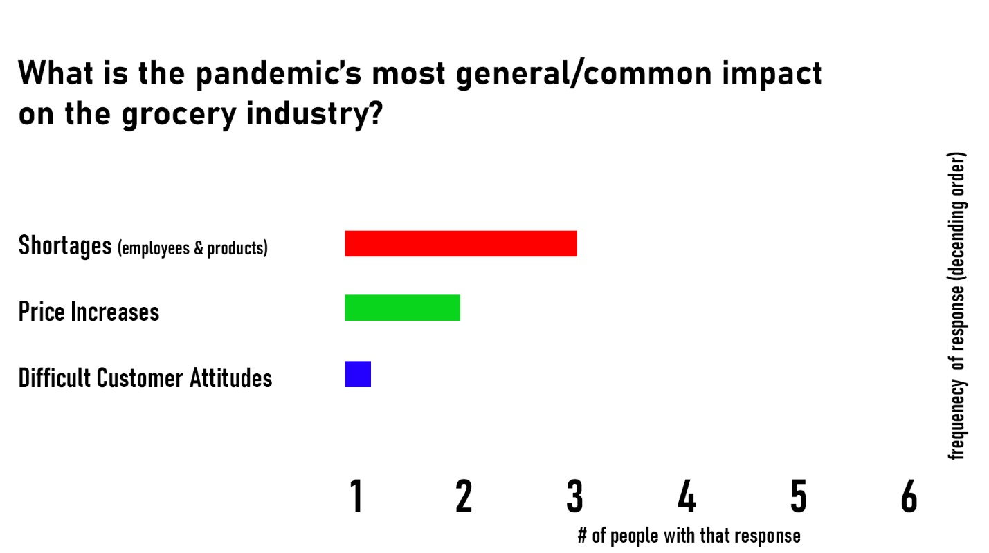

Figure 1. Results from interviews about Question 1 “What is the pandemic’s most general/common impact on the grocery industry?”

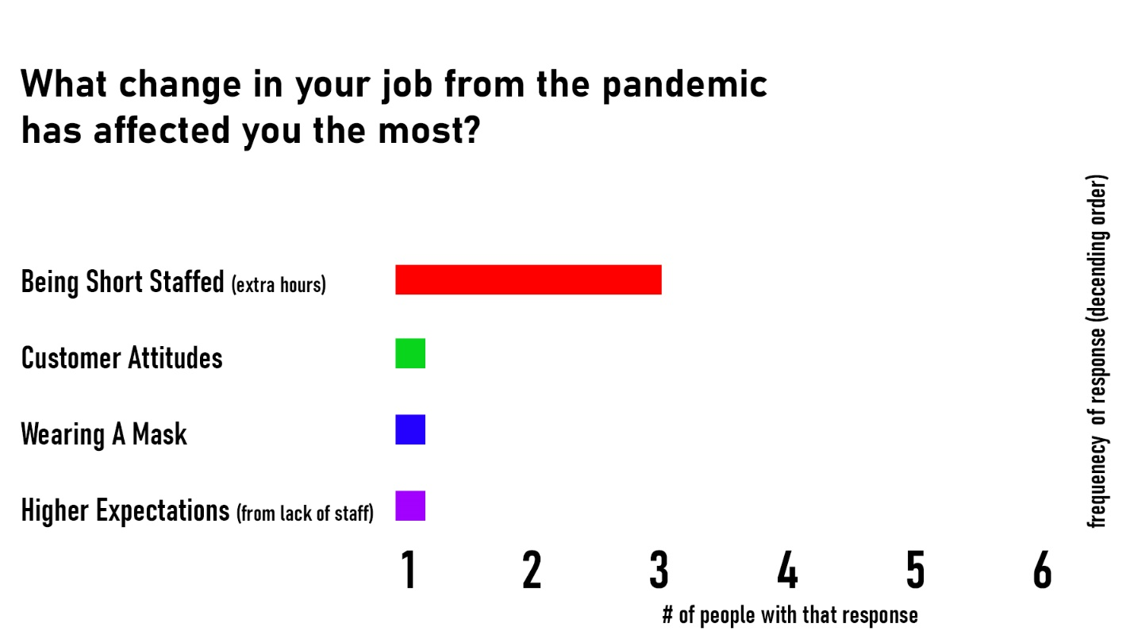

Figure 2. Results from interviews about Question 2 “What change in your job from the pandemic has affected you the most?”

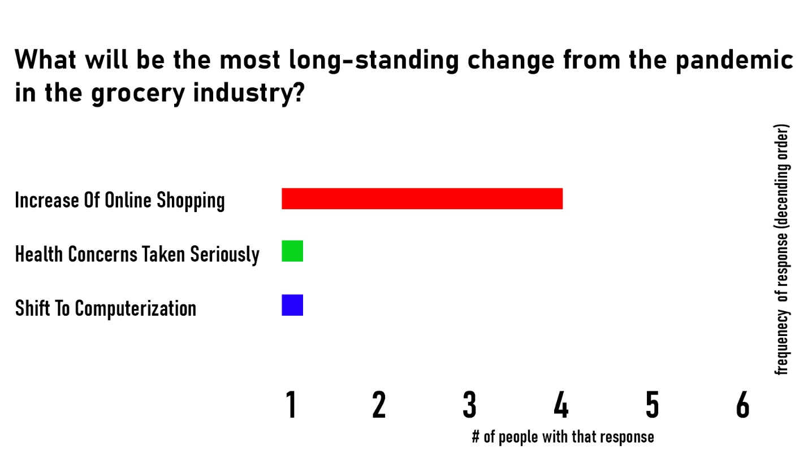

Figure 3. Results from interviews about Question 3 “What will be the most long-standing change from the pandemic in the grocery industry?”

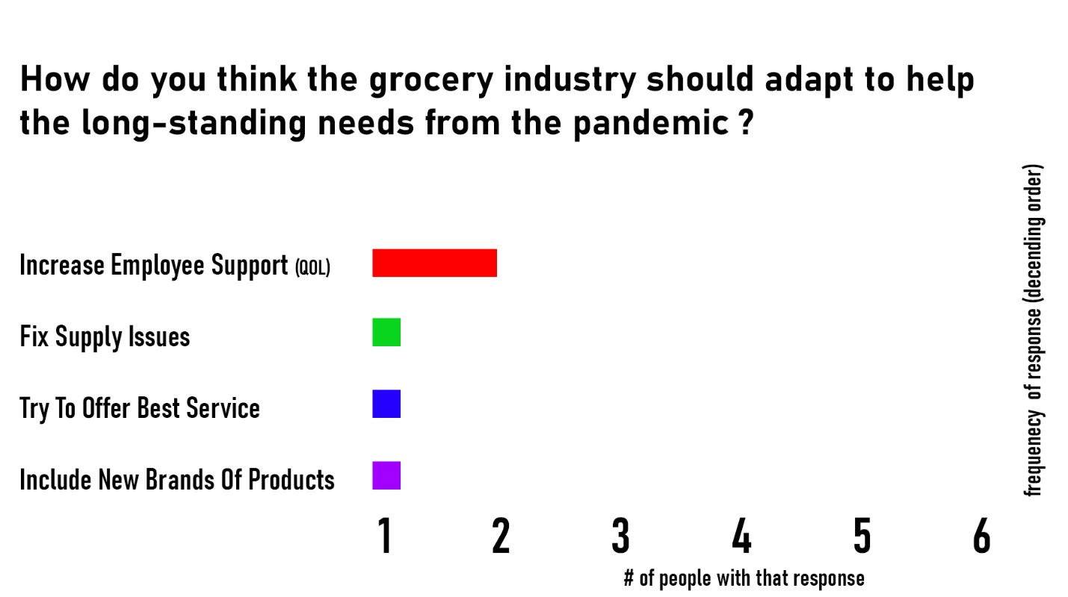

Figure 4. Results from interviews about Question 4 “How do you think the grocery industry should adapt to help the long-standing needs from the pandemic?”

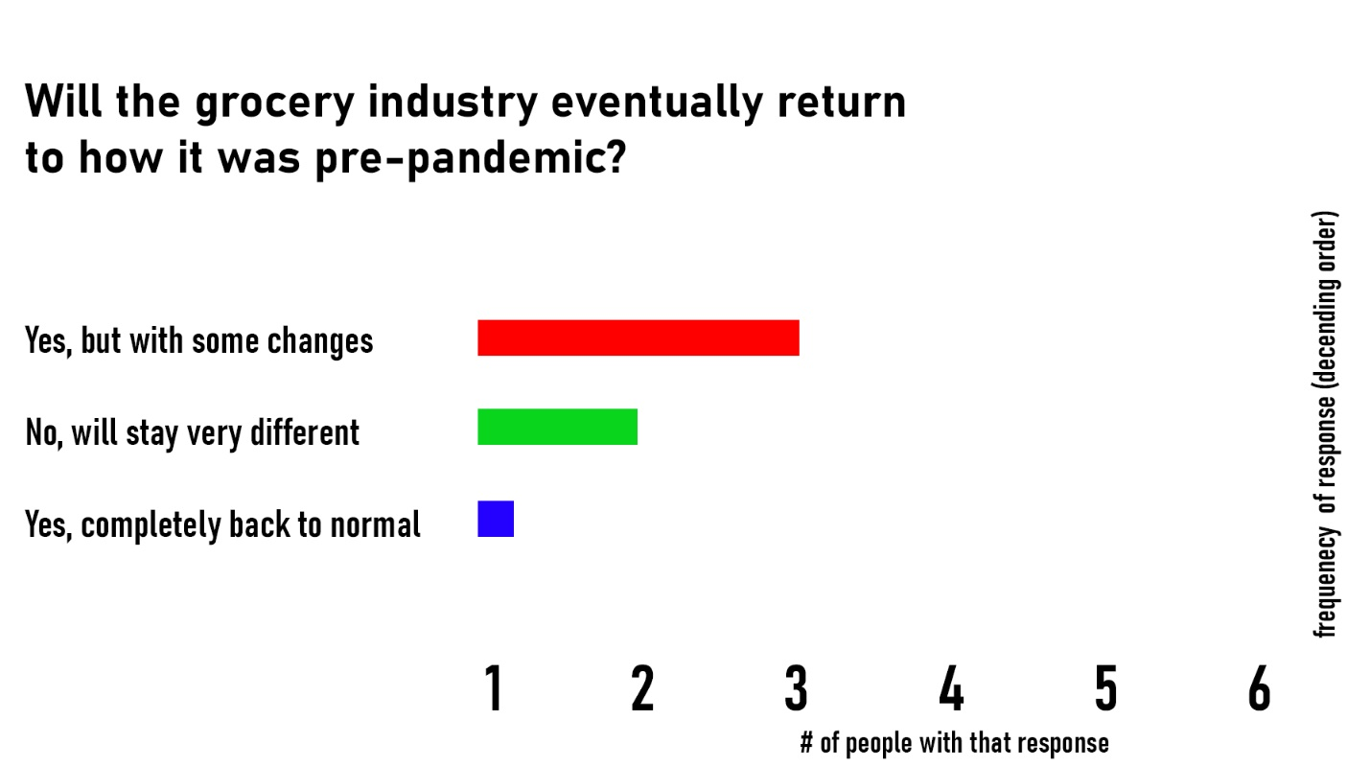

Figure 5. Interview results about Question 5 “Will the grocery industry eventually return to how it was pre-pandemic?”

After interviewing 6 people from various departments at a grocery store, I was able to gather some data on five questions I had about how the grocery industry has been impacted and is adapting due to the pandemic. The people who were interviewed were Manager A, Manager B, Supervisor A, Supervisor B, Produce Assistant Manager A, and Cashier A. There were many common answers, so they have been grouped in the five bar graphs above, see Figures 1 through 5. The list of questions and the notes on each interviewee’s responses can be found in Appendices 1 and 2.

Supply chain issues were a common concept mentioned, and Produce Assistant Manager A said the store had been “shopped to hell” when the pandemic first began. The rise in popularity of online shopping was also a recurring topic. Supervisor B mentioned being trained on how to complete online orders due to the high demand. Staff shortages, for reasons of health and fear, led many employees to feel strained. Supervisor A said that “only pre-pandemic people stay in this job” in relation to the difficulties that arose from the pandemic. Supervisor A also touched on the discrepancies in pay and amount of work, saying that the store should be “paying people for what they do,” as they felt people had to take on extra work because of the pandemic without receiving any pay increase. Employee support was also brought up by Cashier A, who said the store needed “more employees.” Produce Assistant Manager A talked about quality-of-life improvements for employees, and how the store needs to “allow [workers] proper time and space to take care of themselves physically and mentally.” Increasingly difficult customer attitudes were a main point of contention for Manager A, who said that “a lot of customers were angry and pointed fingers at [employees] like [they] were to blame for [the customer’s] hardships.” Telling customers about stocking shortages, shortened store hours and price increases were also common issues employees faced. Supervisor B told a story about how they had to tell a customer they “couldn’t double bag everything because of supply issues.” Most employees agreed that the grocery industry would eventually return to how it was pre-pandemic but with some changes. Supervisor A said that “[employees] learned things [they] can’t unlearn, good changes too, like wiping down carts.” Manager A said that “online shopping will always be relevant now.” Manager B said that the store “never could go back to normal-normal,” and that some people will always be cautious.

# **Discussion**

The interviews worked well at gathering data and personal anecdotes that illustrate the ways the large-chain grocery industry has changed and adapted from the pandemic. The fact that many of the answers were similar shows that even among different departments, there are common concerns. The common concerns are good places for the industry to hone in on and try to make positive changes in the future. Supply chain issues were brought up often, showing these problems have affected every department. While these issues are representative of a much bigger problem that the grocery industry is not solely responsible for, Supervisor B brought up the idea of introducing new brands of products to customers. Supervisor B mentioned having to tell a customer the store “didn’t have the product she’d been using in her holiday recipe for over 20 years,” and referenced how new brands could be an answer to the issue of always lacking certain products. The increase in popularity of online shopping has a big impact on profits. Andreea Pop (2021) outlined how “By shopping for groceries in physical stores, you’re also more likely to overspend: you don’t have a real-time calculator of your cart like you do if you opt for digital commerce” (p. 1). The lack of employees is a large issue, and Supervisor A's quote “Only pre-pandemic people stay in this job” outlines how there is a critical need for improvement in the conditions of grocery workers. People who work at grocery stores are frontline workers, which means they have had to keep working throughout the pandemic, inevitably struggling with all of the changes in their jobs. Since the grocery industry cannot only rely on people who are already working in this line of work, they need to fix some of the main issues that are causing new hires to quit.

# **Conclusion**

The large-chain grocery industry has adapted to the long-standing changes from the COVID-19 pandemic with varying degrees of success. New shopping behaviors mean the industry needs to quickly and efficiently adjust to serve the changing needs of their customers. While online shopping’s sudden rise in popularity suggests focusing on online orders to be a priority, other needs like improved quality-of-life for employees and fixing supply chain issues are also major changes employees want the industry to make. As workers predict that the large-chain grocery industry will be forever changed by the pandemic, it is detrimental that large chains continue to consult research on how they can address issues in their industry, and achieve success despite difficulties caused by the pandemic. More research will need to be done both soon and years down the line to help accurately identify how the industry has adapted and changed in large-chain grocery stores across the nation.

# **Recommendations**

These interviews were all conducted with people from one large-chain grocery store. Because there are issues that will affect a certain location more than another, it is important for future research to diversify the reach of interviewees to multiple locations. Different chains may be facing different issues, so expanding future research to gather information from multiple large chains would be beneficial to determine which issues are the most widespread throughout all chains. The concept of supply chain issues is a central theme throughout the interviewee’s responses and scholarly research on this topic, so more research on possible solutions for those issues would help build on ways the large-chain grocery industry can improve on one of its most prevalent issues. A quote from Supervisor B about “introducing new brands” brings up an interesting idea of how new brands may be a viable solution to certain products becoming hard to stock. Further research on bringing in new brands of products to replace older brands would be an intriguing concept researchers can explore. The need for quality-of-life improvements that was mentioned could be another facet of post-pandemic changes to the grocery industry that should be researched, as the topic directly relates to maintaining workers in the industry.

# **References**

Delasay, M., Jain, A., & Kumar, S. (2022). Impacts of the COVID-19 pandemic on grocery retail operations: An analytical model. *Production and Operations Management*, 31, 2237– 2255. https://doi.org/10.1111/poms.13717

Duffy, E. W., Lo, A., Hall, M. G., Taillie, L. S., & Ng, S. W. (2022). Prevalence and demographic correlates of online grocery shopping: results from a nationally representative survey during the COVID-19 pandemic. *Public Health Nutrition, 25*(11), 3079–3085. https://doi-org.ezp3.lib.umn.edu/10.1017/S1368980022001756

EMSI Burning Glass. “Covid-19's Impact on Grocery Stores.” *Lightcast*, Lightcast, 3 Nov. 2022, https://lightcast.io/resources/blog/covid-19-s-impact-on-grocery-stores.

Kang, J. (2022, November 17). This Thanksgiving, What Prices to Expect at Your Grocery Store. *Wall Street Journal - Online Edition*, N.PAG. https://www.wsj.com/articles/this-thanksgiving-what-to-expect-at-your-grocery-store-11668607206

Pop, A. (2021, August 23). How COVID-19 forever changed the Grocery Industry. *VTEX.* https://vtex.com/en/blog/strategy/how-covid-19-forever-changed-the-grocery-industry/

Priyamvada, & Kumar, A. (2022). Modeling retail inventory pricing policies under service level and promotional efforts during COVID-19. *Journal of Cleaner Production, 381*, N.PAG. https://doi-org.ezp1.lib.umn.edu/10.1016/j.jclepro.2022.134784

Riediger, N. D., Slater, J. J., Mann, K., Pilli, B., Derksen, H., Perchotte, C., & Penner, A. L. (2022). Policy responses to the COVID-19 pandemic in the Manitoba grocery sector: a qualitative analysis of media, organizational communications, and key informant interviews. *BMC Public Health, 22*(1), 1–13. https://doi-org.ezp3.lib.umn.edu/10.1186/s12889-022-13654-3

Sanders, D. [Jason Krigsfeld, 31, and his wife, Yukie Huchi, 39, shopped at a Target in Brooklyn on Friday morning. They bought the last 20-pack of Charmin toilet paper on the shelf.] [Photograph]. *New York Times.* https://static01.nyt.com/images/2020/03/13/nyregion/13nyvirus-panicbuying/13nyvirus-panicbuying-superJumbo.jpg

# **Appendix 1: Interview Questions**

1. What do you think is the pandemic’s most general/common impact on the grocery industry?
2. What specific change in your job due to the pandemic has affected you the most?
3. What do you think will be the most long-standing change due to the pandemic in this industry?
4. What is a way that you think the grocery industry should adapt to help the new long-standing needs the pandemic has caused?
5. Do you think that the grocery industry will eventually return to how it was pre-pandemic?

# **Appendix 2: Notes from Interviews**

These notes were originally taken on paper during the interviews, and have been digitally scribed for greater accessibility. The interview of Manager A was recorded digitally alongside my paper notetaking, so the full transcript of their answers is provided instead of the notes.

**Manager A**

1. I think there are two big impacts on the grocery industry…one being a shortage of labor due to illness and general fear/unknown of what the pandemic was when it first hit, and secondly patience and understanding from some customers was very lacking and difficult for the industry…a lot of customers were angry and pointed fingers at us like we were to blame for their hardships.
2. This one is again related to customers; the level of patience and going above for customers became progressively more necessary throughout the first year of the pandemic. A significant lack of patience and blame came from customers, and we had to learn to navigate that challenge more as time went on.
3. Online shopping for groceries was not nearly as big of a deal before the pandemic; however, now it is a mainstay in our industry.
4. The industry continues to have to navigate supply shortages and labor issues and moving forward should be more open and transparent with their own teams and client base.
5. I think things are return to normal slowly…inflation and supply shortages have lengthened the recovery timeframe, but things are on the track to return to normal…however the new normal will be dealing with covid (just with more knowledge and protocols in place). Online shopping will always be relevant now.

**Supervisor A**

1. Smaller containers, but higher prices.
2. More expectations since turnover is high. “People aren’t lasting as long” “Only pre-pandemic people stay in this job”
3. How serious we take health concern, take calling out more seriously (don’t accuse of lies) The store is doing that now.
4. More employee support, pay more. “Paying people for what they do” (People who don’t do as much work get the same wages as people who are trying hard)
5. No, what we’ve been through, we’ve learned things we can’t unlearn, good changes too, like wiping down carts.

**Cashier A**

1. Shields at registers
2. Wearing a mask
3. Distancing in general
4. More employees
5. Yes, but will take a long time

**Manager B**

1. Supply shortage, hard to get items because of mass stocking up.
2. When employees call in, need additional help. Short staffed.
3. More shopping online, still wear masks.
4. Customers are a challenge now more than ever, try to offer best service, hard to understand when we don’t have something for a while.
5. Not necessarily, people are cautious, wearing masks. “Never could go back to normal-normal” Shortened hours are permanent (used to be until midnight, now is 10pm) Some people will always wear masks.

**Produce Assistant Manager A**

1. At first, rush to stock, people spending $100s at the grocery store. “we were shopped to hell” currently, prices are up from supply issues.
2. More used to saying no and sorry about prices being up, not having something, and shortened hours for the store. Importing is difficult, getting citrus from South Africa cheaply and timely. Had to reject rotten fruit pallets because they got delayed so long.
3. Shift to computerization, look at the orders the computer makes and check them over rather than from scratch. “The unpredictability of the world made companies realize humans are less consistent”
4. People lean to premade things. Investing in Quality-Of-Life for employees, this is a stressful and physical job (lifting 50-pound boxes all the time). Allow proper time and space to take care of themselves physically and mentally.
5. More or less, people want to go back to normal, normal is comfortable.

**Supervisor B**

1. Shortages, negative impacts is saying we don’t have things, find new brands & ingredients. Switch from ones used for 20+ years
2. (IN DELI) Rise in covid and fear. Switching to online shopping (she was strained & transferred), spike in online orders, more hectic days, had to pick up hours, leave of absence due to fears from other coworkers, training other people, come in early and stay late.
3. Rise in online orders, people started to see the convenience
4. Helping with getting new products, stuck with brand from 20 years ago, introducing new brands to replace old ones, do demos to get them in customer’s hands.
5. No, even 2 years after still having supply issues. Can’t double bag as often. Still trying to catch up, but never can catch up. Sales in online are up, people don’t want to come in anymore.