Driving Tutor Requirements Specification

Team Not Yet

Version 1.0

October 10, 2019

**Table of Contents**

1. Executive Summary 3

1.1 Project Overview 3

1.2 Purpose and Scope of this Specification 3

2. Product/Service Description 4

2.1 Product Context 4

2.2 User Characteristics 4

2.3 Assumptions 4

2.4 Constraints 4

2.5 Dependencies 4

3. Requirements 4

3.1 Functional Requirements 4

3.2 User Interface Requirements 4

3.3 Learnability 4

3.4 Reliability 5

3.5 Performance 5

3.6 Correctness 5

3.7 Usefulness 5

4. User Scenarios/Use Cases 5

4.1 User Scenarios 6

4.2 Use Cases 6

4.2.0 UC1:U1:Road Signs 6

4.2.1 UC2:U2:Drivers Safety 9

4.2.2 UC3:U3:Special Scenarios 11

4.2.3 UC4:U4:Car Parts 13

4.2.4 UC5:U5:User Progress 15

4.2.5 UC6:U6:Quizzes 17

4.2.6 UC7:U7:DMV 19

4.2.7 UC8:U8:Notifications 21

4.2.8 UC9:D1:Feedback 23

4.2.9 UC10:D2:Updates 25

*4.2.9.1 UC11:P1:Parent Progress……….………………………………………………………………..*27

# Executive Summary

## Project Overview

Nowadays, when the technology is developed, most people in the world prefer using technology to work communicate, save the materials because of its convenient. For example, most of young people choose technology to find resources because it is easy to find the stuff they need. Some of the managers can use some software to manage their organization everywhere because it is easy to access to the cloud storage. By a smartphone or a laptop with an internet connection, people can easily access their storage, and find resources to support their business.

We conducted a mini survey and most of people said that they felt tired when they were reading the license handbook for young drivers because of the length and inconvenient to bring it all the time; also, their parents felt tired to find out the track of their kid’s learning process in school. That problem made a lot of people not understand the rules and the signs, but they still get in traffic because moving is needed for each person. Misunderstanding the law means the risk is high when they are in traffic. Some people who don’t have experiences can’t solve the problem on the road when they get in trouble.

We have discussed, and we will solve that problem by creating an app which is “Driving tutor”. This app works on all platforms such as Android, IOS, Windows, and Linux. It is a simple app which can help the user access the materials included in the license handbook and also additional information.

It is free to create an account with some roles. These roles included: young learner, parents, teacher, and admin. Student’s role is the most important role. By the student role, they will have some options to learn and access to the materials from the handbook, they can choose to learn, and practice. As a student, they can learn about special scenarios, general rules, and parts of a car. They will also be able to take quizzes on each section of the app. As a parent, you can easily register and take a look at the things their kids have already studied and track their progress.

This app can be downloaded easily in the store, work on API level 15 and above for mobile version. We can learn the road sign, the rules, and the examples on the road everywhere and whenever we want to, the internet connection is not required to study and practice right after studying.

Overall, we want to give students and young adults the option to study for their learners or drivers license at their own convenience. The DMV manuals are old and outdated for the new age of technology and people do not want to read those anymore.

## Purpose and Scope of this Specification

In Scope:

This document addresses requirements related to “Driving tutor”

* Students can learn by themselves over the app
* They can practice themselves to review the materials
* They can take a quiz to prove their result after learning

Out of Scope:

* Parents can take a look at their kid’s tracking process of learning by themselves
* Parents can see the grades of their kid’s quiz and suggest them based on the result

# Product/Service Description

## Product Context

This application is almost fully self-contained. The only systems it will be interacting with is the app store it will be placed on for download, as that is where updates and such will come from. Aside from that, the application will only be receiving input from the user and displaying the correct responses to that input.

## User Characteristics

1. Teenager – Looking to study for upcoming learners exam.
2. Young Adult – Looking to study for upcoming drivers exam.
3. Parent of Teenager/Young Adult – Can track the progress of child while they study for exams.

## Assumptions

As a team we are assuming we will be able to write the code for this application with little experience in creating mobile apps. We would have to change our platform if we cannot implement our ideas correctly on mobile.

## Constraints

* Lack of knowledge in application development.
* Lack of knowledge in the use of user accounts.
* Lack of knowledge in how to put application onto stores for mobile download.

## Dependencies

There are no real dependencies for this application aside from the user having to have a mobile device and an internet connection to download the app.

# Requirements

## Functional Requirements

* The application should be able to display the content for the user to learn how to drive in a clear and organized way.
* The app should be able to save and display the user’s progress in the app
* For better results, the app’s learning and testing interfaces should be able to randomize the type of questions the user is going to either learn or respond to.
* Based on future feedback, we may add functionality to share your progress info with anybody you want throughout social media (on hold).
* Based on future feedback, we may add functionality to give the user a way to contact and interact with a tutor or other users about topics they are confused about.

## User Interface Requirements

Organized by priority to fit the needs of this project.

## Learnability

Learnability is important to all parts of our software because of the need to teach our users. Since our app is revolved around teaching the user about the basic rules of driving, learnability is crucial in its success. This could be tested by quizzing young drivers before they even use our app to learn about driving. Then, after they use our app and use the learning features, we could quiz them again to test how much they have learned. Of course, this is a difficult thing to measure since people have varying ways in how well they learn. This will be just a basic measurement, however it will still be important to us.

## Reliability

The app should behave the way it is expected every time the user runs it. All this comes down to the testing phase of our software. The only way we think we can measure the reliability of our will be to test it multiple times on different devices before being released to the public.

## Performance

Refers to the aspect of the system that is the limiting factor in the end usability of the system. For our program, we are looking for the program to be able to respond to the actions of our users in about a split-second. Because of this, it is important that our program does not use too much CPU and RAM on the device the user will access the program on. In this case, the device will be a smartphone and/or tablet. We don’t believe spike testing is important since we will have the questions and answers installed on the user’s device on the app install. This avoids the problem of sudden performance drops caused by multiple users because we are not using a database server. However, stress testing is a must for our program to ensure that the program can perform under situations where a lot of RAM is being used. Load testing is important as well since our program will use several loads caused by user actions, such as tapping on an option, or going to a new menu. Testing environments like LoadRunner, OpenSTA, and JMeter can be useful for testing performance.

## Correctness

It can be defined as the adherence to the specifications that determine how users can interact with the software and how the software should behave when it is used correctly. For our software, one of the biggest places where correctness is needed is the practice and quiz sections. In order to test for correctness, I believe it is important to have our stakeholders double as quality assurance (QA) testers. This will allow us to make sure the program runs and behaves as our stakeholders require, and we will be able to get more input about the program in general.

## Usefulness

This refers to the aspect of the system being useful for the purpose for which the program was developed. For our program to be considered useful, we need to make it possible for users to be able to pass their learner’s exams if they study by using our application for a certain length of time per day. The DMV website includes a practice test for learners to attempt, which will be useful for testing the application’s usefulness. Therefore, by having our testers complete the practice test after they already had practiced with our app, we would be able to asses if it is useful. For example, If the scores obtained from the practices test improved, we can consider the app useful.

# User Scenarios/Use Cases

U – User

D – Developer

P – Parent

Priorities – Red = low, Yellow = Medium, Green = High

## User Scenarios

|  |  |  |
| --- | --- | --- |
| **Name** | **Story/Priority** | **Use Case** |
| U1 | As a user – I can learn about road signs. | See  **UC1:U1:Road Signs** below |
| U2 | As a user – I can learn about drivers safety. | See  **UC2:U2:Drivers Safety**  below |
| U3 | As a user – I can learn about special scenarios. | See  **UC3:U3:Special Scenarios**  Below |
| U4 | As a user – I can learn about the parts of a car. | See  **UC4:U4:Car Parts** below |
| U5 | As a user – I can track my progress. | See  **UC5:U5:User Progress**  Below |
| U6 | As a user – I can quiz myself on information I have learned. | See  **UC6:U6:Quizzes** below |
| U7 | As a user – I can see my DMV drivers manual. | See  **UC7:U7:DMV**  Below |
| U8 | As a user – I can sometimes forget to study. (notifications) | See **UC8:U8:Notifications** below |
| D1 | As a developer – I can receive feedback. | See **UC9:D1:Feedback** below |
| D2 | As a developer – I can update the app. | See **UC10:D2:Updates** below |
| P1 | As a parent – I can track the progress of my child. | See  **UC11:P1:Parent Progress**  Below |

## Use Cases

### *UC1:U1:Road Signs*

|  |  |
| --- | --- |
| **Summary:** | The user wants to open the app to learn about road signs. |
| **Rationale:** | The user wants to learn about road signs for an upcoming learners test at DMV. |
| **Users:** | Teenagers (age group of 13-17) / Young Adults (age group of 18-25) |
| **Pre-Conditions:** | User must have a phone with the mobile app installed already. User must tap on the app to open it. |
| **Basic Course of Events:** | The user taps on the app on their mobile device. The UI then shows the main menu of the app. User must swipe over to the “General Rules” category and tap on it. The user then must tap on the “Road signs” button. To learn about road signs, the user must then tap on the “Learn” button. The user then should be able to scroll through the pictures of road signs and learn about each one. |
| **Alternate Paths:** | User may not know that “Road Signs” is within the “General Rules” category. Could tap on other places to try and find road signs specifically. |
| **Post Conditions:** | After learning about road signs, the user should be able to go back to the “Learn/Quiz” selection menu, the “General Rules” selection menu, or choose to go back to the main menu. Alongside that they may also close the app at any time before, between, or after these actions. |
| **Chart:** | See **C1:UC1:Road Signs** below |

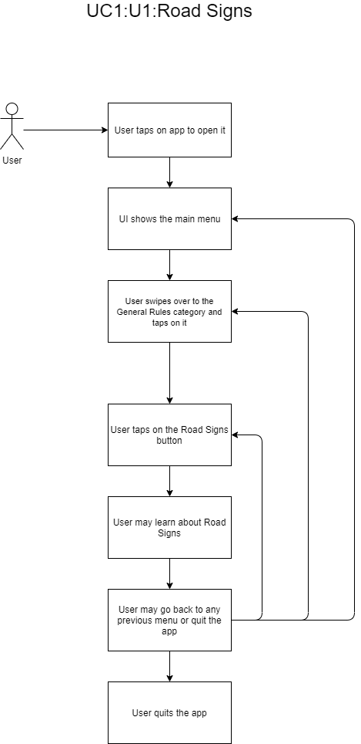

**C1:UC1:Road Signs**

### *UC2:U2:Drivers Safety*

|  |  |
| --- | --- |
| **Summary:** | The user wants to learn about how to be a safe driver. |
| **Rationale:** | The user is studying for their learner’s exam and needs to know about ways to be a safe driver. |
| **Users:** | Teenagers (age group of 13-17) / Young Adults (age group of 18-25) |
| **Pre-Conditions:** | User must have a phone with the mobile app installed already. User must tap on the app to open it. |
| **Basic Course of Events:** | The user taps on the app on their mobile device. The UI then shows the main menu of the app. User must swipe over to the “General Rules” category and tap on it. The user then must tap on the “Drivers Safety” button. To learn about Drivers Safety, the user must then tap on the “Learn” button. The user then should be able to scroll through the information about being a safe driver and learn. |
| **Alternate Paths:** | User may not know that “Drivers Safety” is within the “General Rules” category. Could tap on other places to try and find Drivers Safety specifically. |
| **Post Conditions:** | After learning about Drivers Safety, the user should be able to go back to the “Learn/Quiz” selection menu, the “General Rules” selection menu, or choose to go back to the main menu. Alongside that they may also close the app at any time before, between, or after these actions. |
| **Chart:** | See **C2:UC2:Drivers Safety** below |

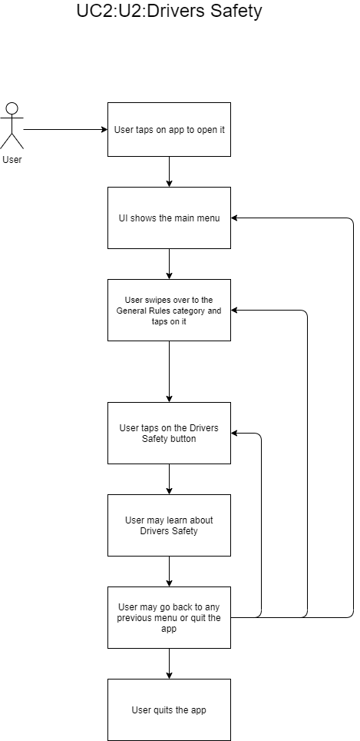

**C2:UC2:Drivers Safety**

### *UC3:U3:Special Scenarios*

|  |  |
| --- | --- |
| **Summary:** | The user wants to learn about how to handle special scenarios that may occur while driving that generally are not taught to new drivers. |
| **Rationale:** | The user is studying for their learner’s exam and needs to know about ways to handle special scenarios when driving. |
| **Users:** | Teenagers (age group of 13-17) / Young Adults (age group of 18-25) |
| **Pre-Conditions:** | User must have a phone with the mobile app installed already. User must tap on the app to open it. |
| **Basic Course of Events:** | The user taps on the app on their mobile device. The UI then shows the main menu of the app. User must swipe over to the “Special Scenarios” category and tap on it. To learn about Special Scenarios, the user must then tap on the “Learn” button. The user then should be able to scroll through the information about the special scenarios they may encounter while driving. |
| **Alternate Paths:** | User may not know that “Special Scenarios” is its own category. Could tap on other places to try and find Special Scenarios specifically. |
| **Post Conditions:** | After learning about Special Scenarios, the user should be able to go back to the “Learn/Quiz” selection menu or choose to go back to the main menu. Alongside that they may also close the app at any time before, between, or after these actions. |
| **Chart:** | See **C3:UC3:Special Scenarios** below |

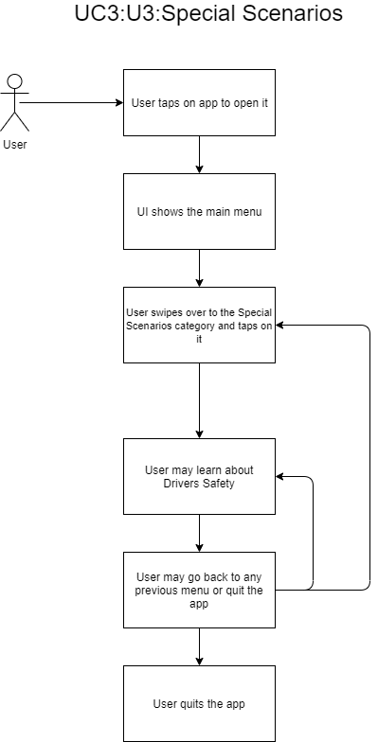

**C3:UC3:Special Scenarios**

### *UC4:U4:Car Parts*

|  |  |
| --- | --- |
| **Summary:** | The user wants to learn about the different parts of a car and what they do. |
| **Rationale:** | The user is studying for their learner’s exam and needs to know about the parts of a car and what they do. |
| **Users:** | Teenagers (age group of 13-17) / Young Adults (age group of 18-25) |
| **Pre-Conditions:** | User must have a phone with the mobile app installed already. User must tap on the app to open it. |
| **Basic Course of Events:** | The user taps on the app on their mobile device. The UI then shows the main menu of the app. User must swipe over to the “Parts of the Car” category and tap on it. To learn about the Parts of the Car, the user must then tap on the “Learn” button. The user then should be able to scroll through the information about the parts of the car and learn about them. |
| **Alternate Paths:** | User may not know that “Parts of the Car” is its own category. Could tap on other places to try and find Parts of the Car specifically. |
| **Post Conditions:** | After learning about the Parts of the Car, the user should be able to go back to the “Learn/Quiz” selection menu or choose to go back to the main menu. Alongside that they may also close the app at any time before, between, or after these actions. |
| **Chart:** | See **C4:UC4:Car Parts** below |

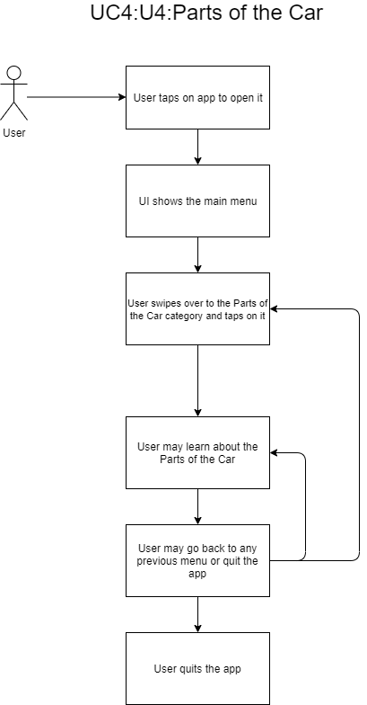

**C4:UC4:Car Parts**

### *UC5:U5:User Progress*

|  |  |
| --- | --- |
| **Summary:** | The user wants to be able to track their progress by being able to see things they have already studied or by seeing past quiz scores. |
| **Rationale:** | The user is studying for their learner’s exam and needs to know what they have already studied and what they should focus on more. |
| **Users:** | Teenagers (age group of 13-17) / Young Adults (age group of 18-25) |
| **Pre-Conditions:** | User must have a phone with the mobile app installed already. User must tap on the app to open it. |
| **Basic Course of Events:** | The user taps on the app on their mobile device. The UI then shows the main menu of the app. User must swipe over to the “Progress” category and tap on it. The user will then see the subjects they have visited in the “Learn” portion of the app. Also, if the user has taken any quizzes, the user will see their most recent quiz score in the individual subjects they have taken quizzes on. |
| **Alternate Paths:** | User may not know that “Progress” is its own category. Could tap on other places to try and find their Progress specifically. |
| **Post Conditions:** | After checking their progress, the user should be able to choose to go back to the main menu. Alongside that they may also close the app at any time before, between, or after these actions. |
| **Chart:** | See **C5:UC5:User Progress** below |

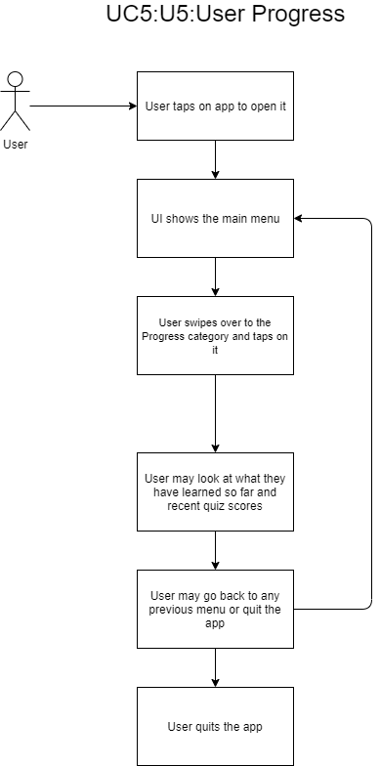

**C5:UC5:User Progress**

### *UC6:U6:Quizzes*

|  |  |
| --- | --- |
| **Summary:** | The user wants to be able to test their knowledge on various driver’s education topics by quizzing themselves. |
| **Rationale:** | The user is currently studying for the learner’s exam and needs to know how well their knowledge on various topics is |
| **Users:** | Teenagers (age group of 13-17) / Young Adults (age group of 18-25) |
| **Pre-Conditions:** | User must have a phone with the mobile app installed already. User must tap on the app to open it. |
| **Basic Course of Events:** | The user opens the app on their mobile device. The UI then shows the main menu of the app. The user must swipe over to the topic they want to quiz themselves on, tap the topic, and then tap the “Quiz” option. The UI then shows a quiz based on the topic selected, with different types of questions, ranging from multiple choice, drag and drop, and fill in the blank. The user must input their response before moving to the next question, and the user does not know how well they did until they finish the quiz. |
| **Alternate Paths:** | The user could tap on the topic itself and accidentally tap on something else, like the “Practice” or “Learn” option. |
| **Post Conditions:** | After the quiz, the user should see how well they did on it, and they should get a feedback comment based on how well they did. The user could then either return to the main menu by tapping the “Exit Quiz” option, or retry the quiz by tapping the “Retry Quiz” option. |
| **Chart:** | See **C6:UC6:Quizzes** below |

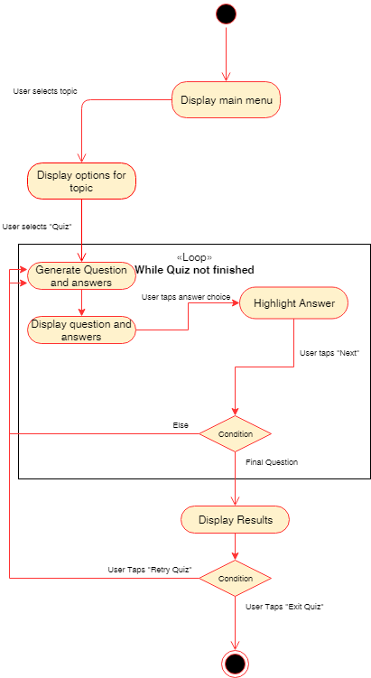

**C6:UC6:Quizzes**

### *UC7:U7:DMV*

|  |  |
| --- | --- |
| **Summary:** | The user wants to view their state’s DMV licensing handbook. |
| **Rationale:** | There could be different laws for driving, depending in which state you live in. The user wants to know about these specific laws. |
| **Users:** | Teenagers (age group of 13-17) / Young Adults (age group of 18-25) |
| **Pre-Conditions:** | User must have a phone with the mobile app installed already. User must tap on the app to open it. |
| **Basic Course of Events:** | The user opens the app on their mobile device. The UI shows the main menu of the app. The user must swipe over to the “DMV Manual” topic and tap on it. From there, the UI gives the user a list of states in the United States of America and the District of Columbia (D.C.). The user taps on the state they live in, and the UI sends a request to the user’s default web browser to open their state’s DMV licensing handbook from their state’s DMV website. The user is taken to the website to view the DMV licensing handbook. |
| **Alternate Paths:** | International users may not be able to use this feature since the application focuses on driving laws in the United States of America. |
| **Post Conditions:** | After the user is finished viewing their state’s DMV manual, the user can tap the “back arrow” button on their mobile device to return to the application. The user can then back out of the list of states by tapping the back button in the top left corner of the UI. |
| **Chart:** | See **C7:UC7:DMV** below |

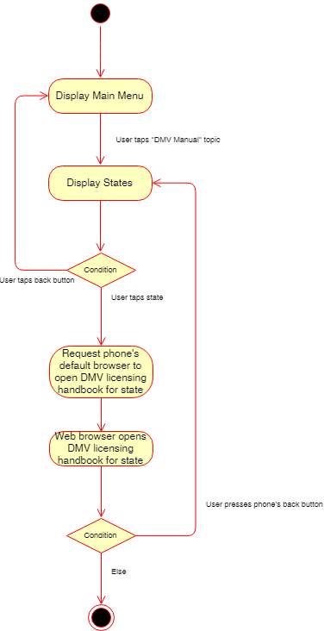

**C7:UC7:DMV**

### *UC8:U8:Notifications*

|  |  |
| --- | --- |
| **Summary:** | The user needs to be reminded to study using our app. |
| **Rationale:** | The user may sometimes forget to study after a long period of time using the app. |
| **Users:** | Teenagers (age group of 13-17) / Young Adults (age group of 18-25) |
| **Pre-Conditions:** | User must have a phone with the mobile app installed already. User must tap on the app to open it. |
| **Basic Course of Events:** | The user opens the app for the first time. The app communicates with the user’s phone interface to request the usage of push notifications. The user sees the request to enable push notifications, and the user can either choose to allow the app to send push notifications, or the user can deny the request. If the user has not used the app for 24 hours (1 day), the app can communicate with the user’s phone interface and request to send a push notification. The user then receives the push notification from the phone’s UI. |
| **Alternate Paths:** | The user could deny the request to allow push notifications. This means that the user would have to go to their phone’s settings to change the app’s permissions to allow push notifications. |
| **Post Conditions:** | The user is now reminded to study using the app after 24 hours of inactivity. |
| **Chart:** | See **C8:UC8:Notifications** below |

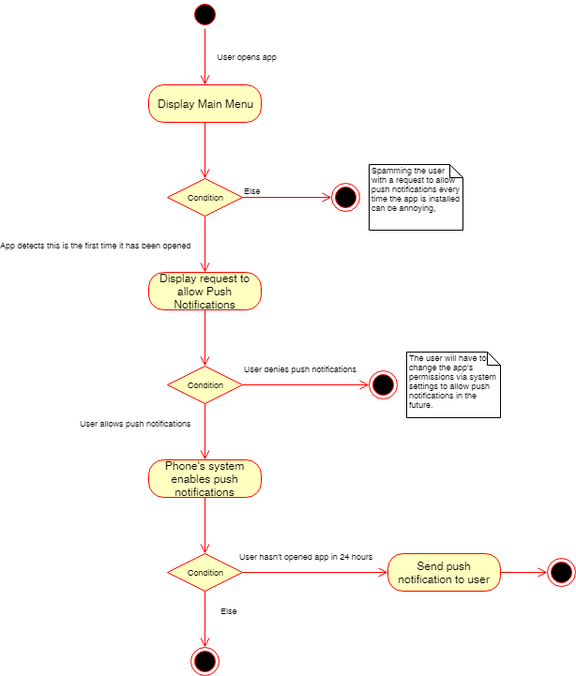

**C8:UC8:Notifications**

### *UC9:D1:Feedback*

|  |  |
| --- | --- |
| **Summary:** | The developers will want to be able to receive feedback through the app somehow so that they may add things later on in the apps lifecycle. |
| **Rationale:** | The developers may miss something or a user may not be able to use something properly. By having a feedback system, developers will be able to address the concerns of their users. |
| **Users:** | Developers |
| **Pre-Conditions:** | User must have a phone with the mobile app installed already. User must have the mobile store they got the app from. |
| **Basic Course of Events:** | The user taps on the store app that they downloaded our app from. Once there, they must go to our app and scroll below the app. There should be a comment section where the user may rate and leave a comment |
| **Alternate Paths:** | User may not know that the “Feedback” option is under the app in the app store. Could tap on other places to try and find their Feedback specifically. |
| **Post Conditions:** | After posting their comment and rating our app, the developers may look at them and act accordingly. |
| **Chart:** | See **C9:UC9:Feedback** below |

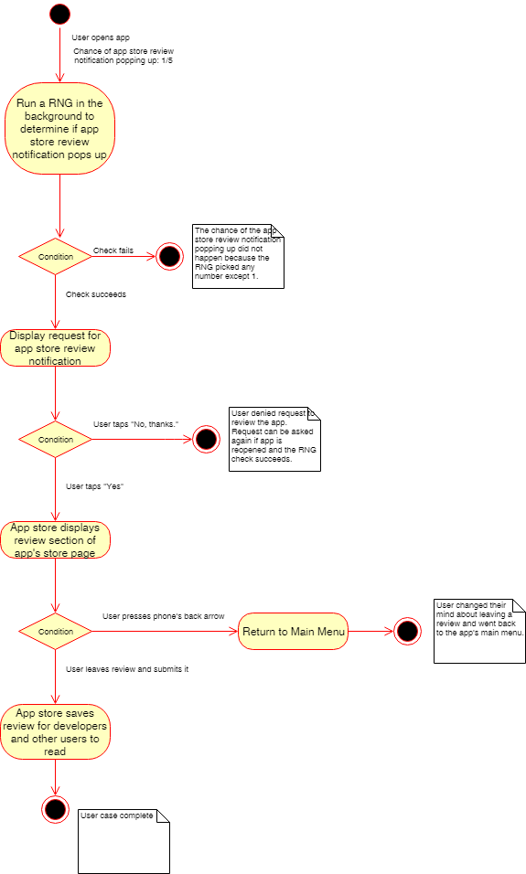

**C9:UC9:Feedback**

### *UC10:D2:Updates*

|  |  |
| --- | --- |
| **Summary:** | Once a developer sees feedback from the users or sees a problem themselves, they should be able to update the app. |
| **Rationale:** | The developers should be able to update the app so that the users are happy with the app. |
| **Users:** | Developers |
| **Pre-Conditions:** | The developers must have already corrected the mistake in the app and have it ready to be sent out to the users for the update. |
| **Basic Course of Events:** | The developers will send out the update to whatever app store the app is on. The users will then be notified that the app is ready to be updated. Once the user has updated the app, the next time the app is opened the user will be notified about the changes on the main menu. |
| **Alternate Paths:** | The user may miss the update and not be able to use the app until it is updated, which they will be notified to do so. |
| **Post Conditions:** | After the user reads the new changes, they should be able to use the app normally. |
| **Chart:** | See **C10:UC10:Updates** below |

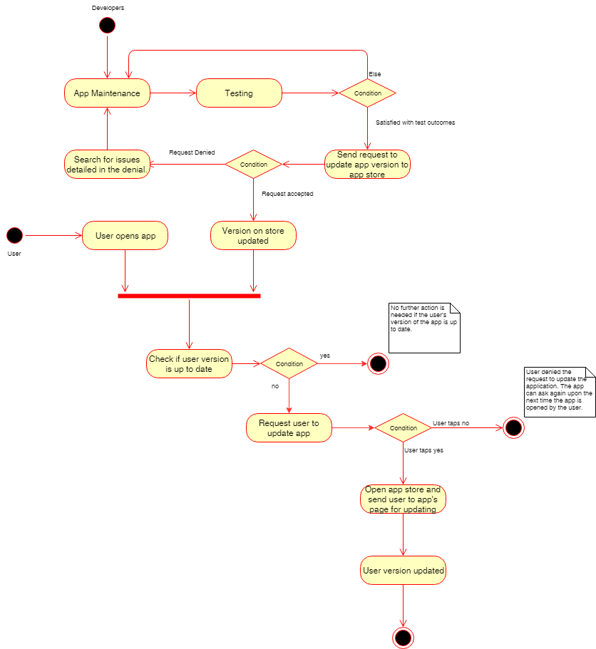

**C10:UC10:Updates**

#### ***UC11:P1:Parent Progress***

|  |  |
| --- | --- |
| **Summary:** | The parent of the user wants to be able to track the progress by being able to see things they have already studied or by seeing past quiz scores. |
| **Rationale:** | The user is studying for their learner’s exam and the parent needs to know what they have already studied and what they should focus on more. |
| **Users:** | Parents of young drivers |
| **Pre-Conditions:** | User must have a phone with the mobile app installed already. User must tap on the app to open it. |
| **Basic Course of Events:** | The parent must have the app opened. The parent will then be able to log into their child’s account and go to the “Progress” section on the main menu. Once they tap on “Progress,” the parent should be able to check their progress just like the normal user could. |
| **Alternate Paths:** | User may not know that “Progress” is its own category. Could tap on other places to try and find their Progress specifically. |
| **Post Conditions:** | After checking their progress, the parent should be able to choose to go back to the main menu. Alongside that they may also close the app at any time before, between, or after these actions. |
| **Chart:** | See **C11:UC11:Parent Progress** below |

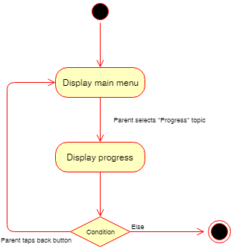

**C11:UC11:Parent Progress**