**Driving laws  
Interactive Learning app**

(Name of the app TBA)

**Content**

**Introduction** ……………………………………………………………………………………………2

**Summarization**…………………………………………………………………………………………2

**Problem**…………………………………………………………………………………………………3

**App**

Your car……………………………………………………………………………………….4

General Rules……………………………………………………………………………….5

Special Scenarios……………………………………………………………………………6

**Conclusion**…………………………………………………………………………………………...7

**Introduction**

There is nothing like the thrill of being able to drive your own car. The wind in your hair, the radio turned up loud, and the feeling of independence make driving one of the most enjoyable activities for young drivers.

 However, there is a real risk of driving, and the risk can be fatal. According to the Centers for Disease Control and Prevention, 2,433 teens in the United States, aged 16-19, were killed and 292,742 were treated in emergency departments for injuries suffered in motor vehicle crashes in just 2016 alone. The total cost of such accidents for the US that year is an estimated $13.6 billion. That is almost ten times the net worth of the current US president!

So, our problem is this: how do we help younger drivers learn safe driving habits and decrease their chances of having a serious car accident? Well, look no further than the wonders of modern technology!

In a day and age where cutting-edge technology is literally at our fingertips, the way we learn has evolved. Long gone are the days of getting your research information at the local library. Now, if you ever want to learn about any subject, you can just use your search engine to find millions of articles on millions of topics instantly. You can even find plenty of study guides online to help yourself memorize what you learn.

So, our goal is clear. We must find a way to modernize the process of learning how to drive safely. However, with so many topics to cover on driver safety, where do we start?

**Summarization**

 of Stakeholder Interviews In order to answer the question on what subjects need to be covered the most, we asked a Division of Motor Vehicles (DMV) employee, a police officer, a driver’s education class instructor, an experienced driver, a young driver, and the parents of the younger driver several questions regarding what they believe younger drivers should learn. This group of interviewees will be referred to as stakeholders.

The stakeholders agreed that the following subjects need to be paid attention to more by young drivers: right-of-way, basic speed laws, road signs, and driver behavior laws. The stakeholders also agree that not many young drivers read the driver’s licensing handbook, and a more interactive way of learning how to drive would help younger drivers learn driver safety laws and regulations. The team sees the subjects mentioned as a “must cover” for our program.

**Problem**

Most young drivers made a lot of mistakes. That is a risk for everybody, most of the accidents come from young drivers because of careless and unknowledgeable. There are some solutions such as opening some courses about driving skills and driving laws or making the test more difficult. However, most young drivers don't read the instruction book and laws. Honestly, there are about 99% of young people didn’t spend time reading to understand the rules. Most of them used all their experiences in their lives or the driving feel. They got in a lot of trouble, some small problems don’t matter to them, but these problems increased the risk of accidents for other people on the road. For example, someone drove off the road all the time, it doesn’t matter if no one is on the road; however, they may hit someone if they are driving from the opposite lane. When they get in trouble, they didn’t know how to figure out because they don’t know the rules.

So now, we obtained some data in a survey from a lot of different people, most of them answered that the instruction book is boring, and most of the people who we have interviewed said that. Also, someone said that taking some science classes should be better than class for driving skills because people over 18 don’t have to take this class, and they can still take the driving test and drive. In research, only 30-35% of students have a driver's license in high school, so not many people prefer coming to driving class. If we are over 18, the only reason we need to come to driving school is failing the test for several times. It is a rare case. The test was too easy for most of the people who are taking the test. Most of them don’t understand the rules, but they still pass. The difficulty of the test was not hard enough to make people study the rules. Making the test harder should make people study to pass the test. However, that shouldn’t be applied because driving is needed by everyone to move. In a developed country, driving is the most important to keep in contact with society, solve every personal problem by coming to some places. Driving is becoming more popular in every place in the world. If people don’t have a license, they can use public transportation, but some people have problems that they can’t solve by using public transportation. For example, the buses in West Virginia work only in business hours. People need to get out of work or class in school to go somewhere. Therefore, driving by themselves is required for everyone to keep in contact with society in this state.

We came up with an app idea that people can spend time playing with to learn about the rules and driving skills.

After the interviews, we discussed how we would try to help people learn to drive. After discussing the feedback obtained out of the interviews, we decided that our program for now should be a mobile app, maybe later we come up with a desktop version. But for now, a mobile app would be the most accessible way for young drivers to learn. Our stakeholders mentioned some things that we felt like needed focused on more than others. those include learning about your car, Special Scenarios and General Rules as shown below.

**Your Car**

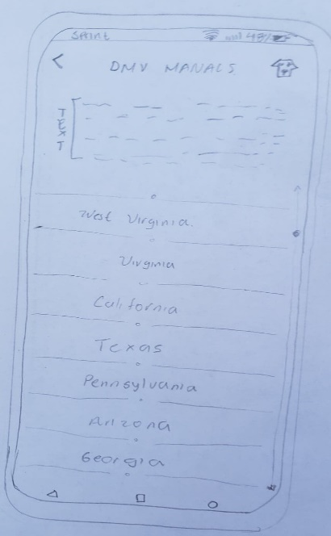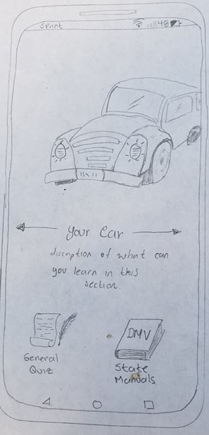The picture on the left is our main interface, the user will see a picture with its respective section title underneath. You can either click on the image to go that section or click the arrow (maybe we add a sliding feature) to iterate between the other sections in the app. We also have two buttons; one will let you take a general quiz with questions about every section and the other “DMV manual” button will take to a list of all the different states manuals and its respective hyper link to take to the respective web site.

By clicking on “your car” section, the app will take you to the following interface

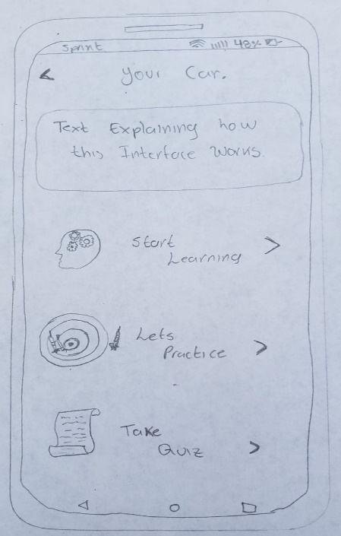

Here you will be able to choose between three different options Learn, Practice and Quiz. Just like their names imply you would able to learn content related to the section you are in and quiz yourself to put on practice what you have learned. The following pictures will show what type of system we may use.

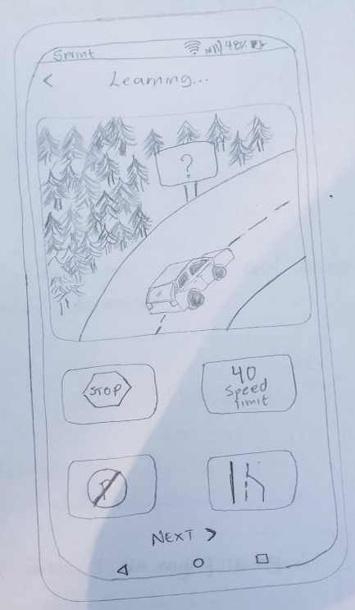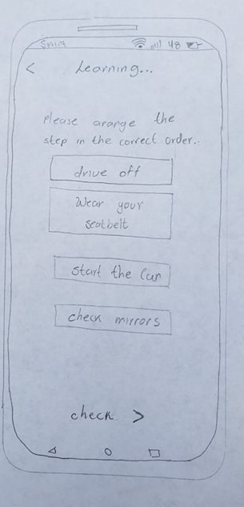

How you can see on these pictures, if we decide to go for this method, we will use a drag and drop type of interactive questions. Also, one member of the team also thought about another type of questions we can make such as arranging the words in the right order. We still need to come up with better ideas for our methodology teaching.

**General Rules**

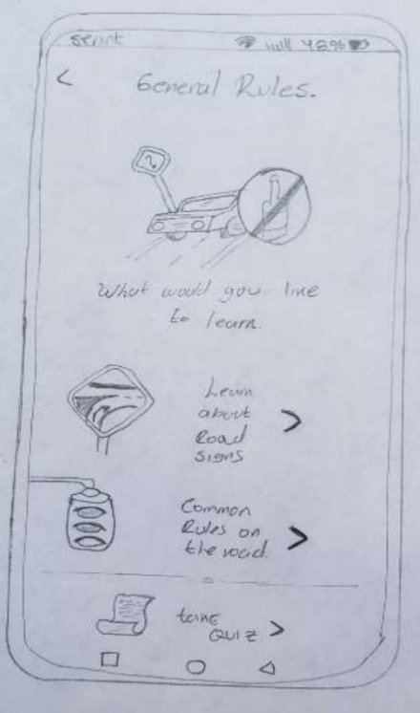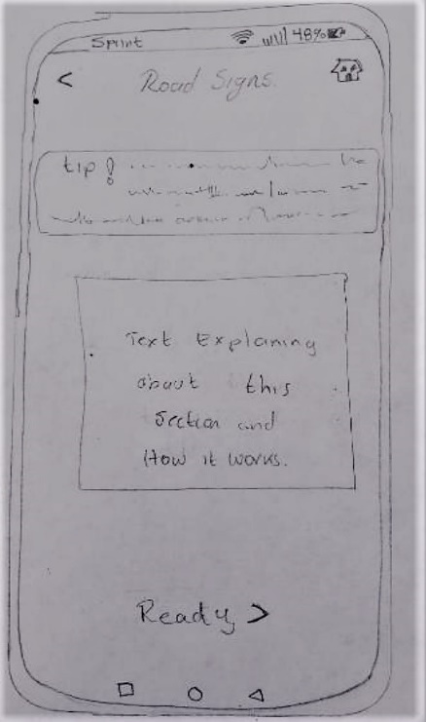

The ‘General Rules’ part of our app allows the user to learn and take quizzes on the 2 sections we have. We divided the two sections into ‘Learn About Road Signs’ and ‘Common Rules on the Road.’ When the user clicks on ‘Learn About Road Signs’ they will be taken to something like the picture on the right. Just like the image shows, on this interface there will be a text displaying a short tip about road signs, randomly generated. Right below, the user can click the ready button and start learning using the method we used on “Your car” section.

**Special Scenarios**

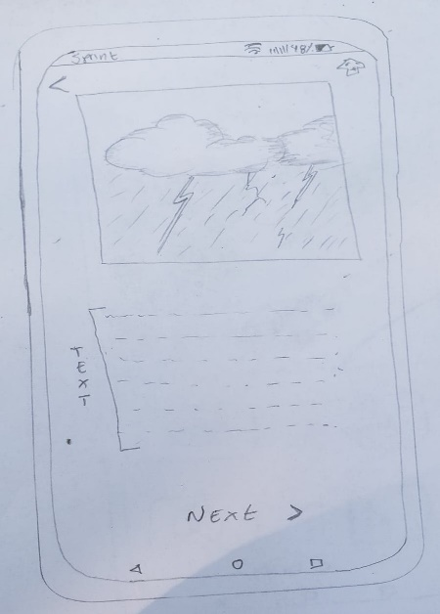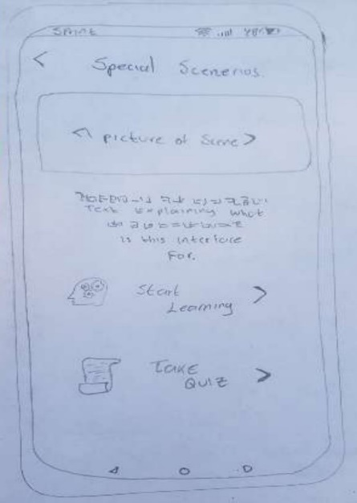Along with this we have a ‘Special Scenarios’ section that focuses on putting the user in a situation that could possibly happen that is not common such as inclement weather (snow, storms). This was one thing we felt that would be a problem for most people. Our first menu for this would look like the picture below.

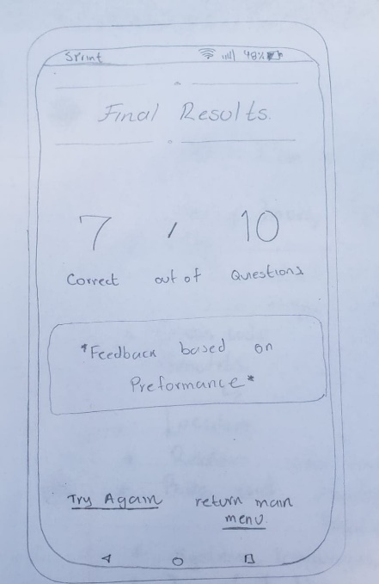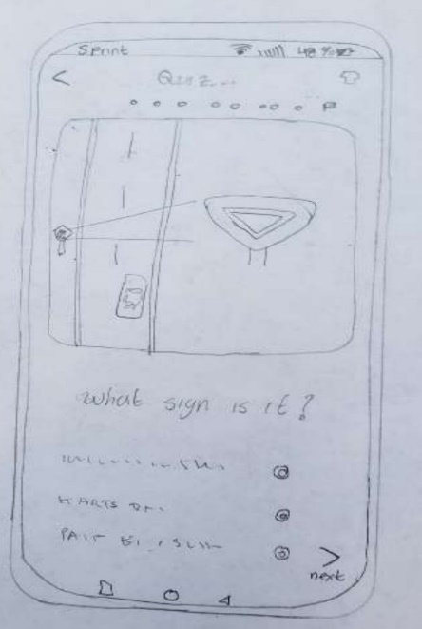Just like our other section, the user can learn about some special scenarios or take a quiz on them. The learn section will just have a scenario in text form and then tell the user what the correct thing to do would be. In the quiz section, the user will be given a scenario and then asked to choose between 4 answers. Their total questions answered correctly will be given to them at the very end. The quizzes for all sections of our app will look like the picture below.

Overall, we believe our app is the best way to contribute and help people to learn how about driving rules and other things.

**Conclusion**

The current prototype we’ve provided is an interactive, less boring alternative to learning about driving as opposed to the conventional instruction book. With this project prototype, we’ve been able to address common driving mistakes with the knowledge we gathered from interviewing several stakeholders, in order to provide a means of correcting common driving mistakes and help the user understand most driving regulations. This driving tutor app prototype we created makes it easy to learn and sharpen any drivers’ skills, ranging from learners to experienced drivers, anywhere and anytime. This is a far more effective way of learning how to drive as there is a projected number of 227,754,100 licensed drivers and over 315,902,320 smartphone users in the United States this year, covering over 95% of the demographic, hence making learning how to drive more effective and accessible.