David Meadows

Setup Guide

DriveSmart

Contents

1. Find the Application on GitHub 2

2. Navigate to the APK file. 2

3. Download the APK 3

4. Install the Application 4

# Find the Application on GitHub

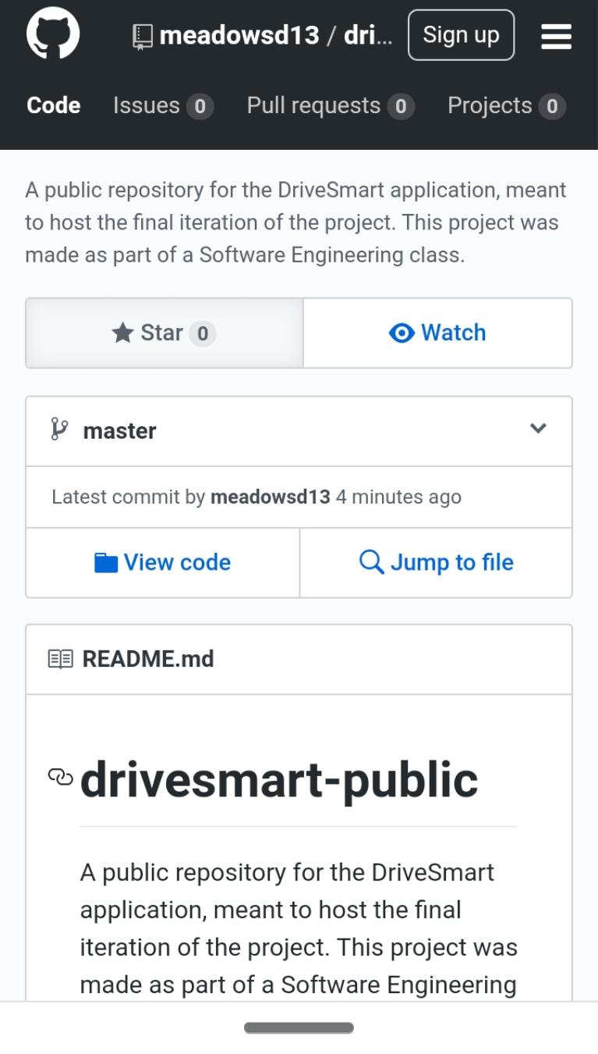Using your favorite mobile internet browser, go to <https://github.com/meadowsd13/drivesmart-public>. You will be taken to a public repository that hosts the DriveSmart application.

# Navigate to the APK file.

On the page you are on, you will see a section titled “Releases”. Inside the Releases section, you will see the latest release version of DriveSmart. Click on it to go to the download page for the latest version.

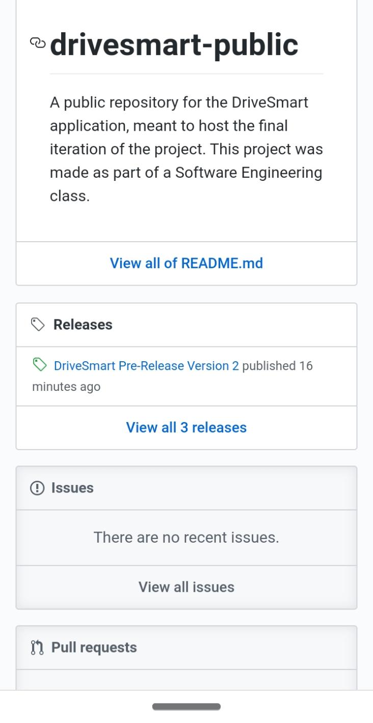

# Download the APK

Once you get to the download page, click “Assets” to see the APK. You may download the source code if you wish to contribute to future versions of the project, but for now let’s focus on getting the application set up.

Click “DriveSmartInstall.apk” to download the APK to your mobile device. You may see a security warning appear. Allow the download to run anyway and wait for the download to complete. Once the download is complete, open the APK.

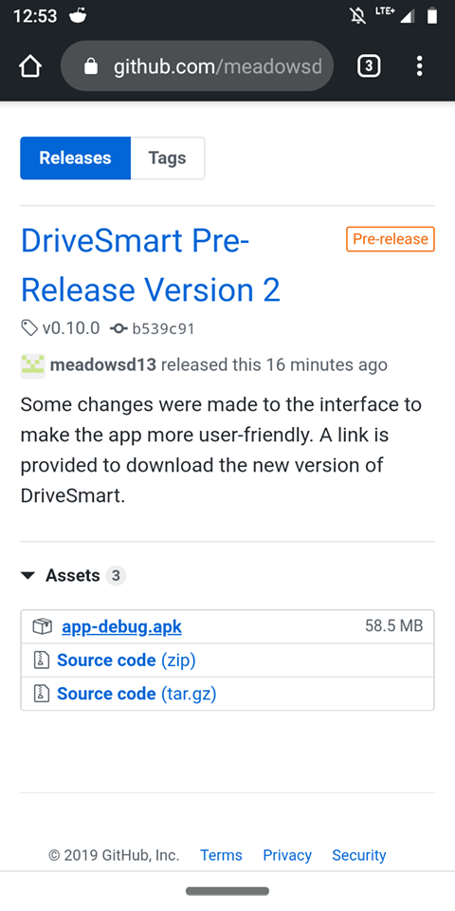

# Install the Application

The APK will stage the app to prepare it for installation. You may see a security warning telling you that installation is blocked due to your settings. Open the settings and toggle the “allow from this source” switch to on. Tap the back button to return to the installation page.

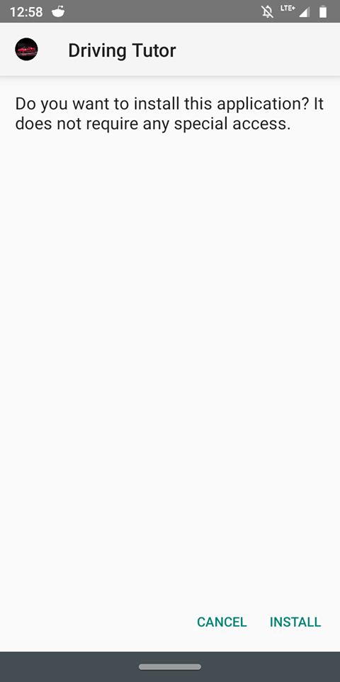

When staging is complete, tap the “Install” button to install the app. Wait for the installation to complete. Once it’s completed, tap the “Open” button to open DriveSmart. Congratulations, you can now use the app!

