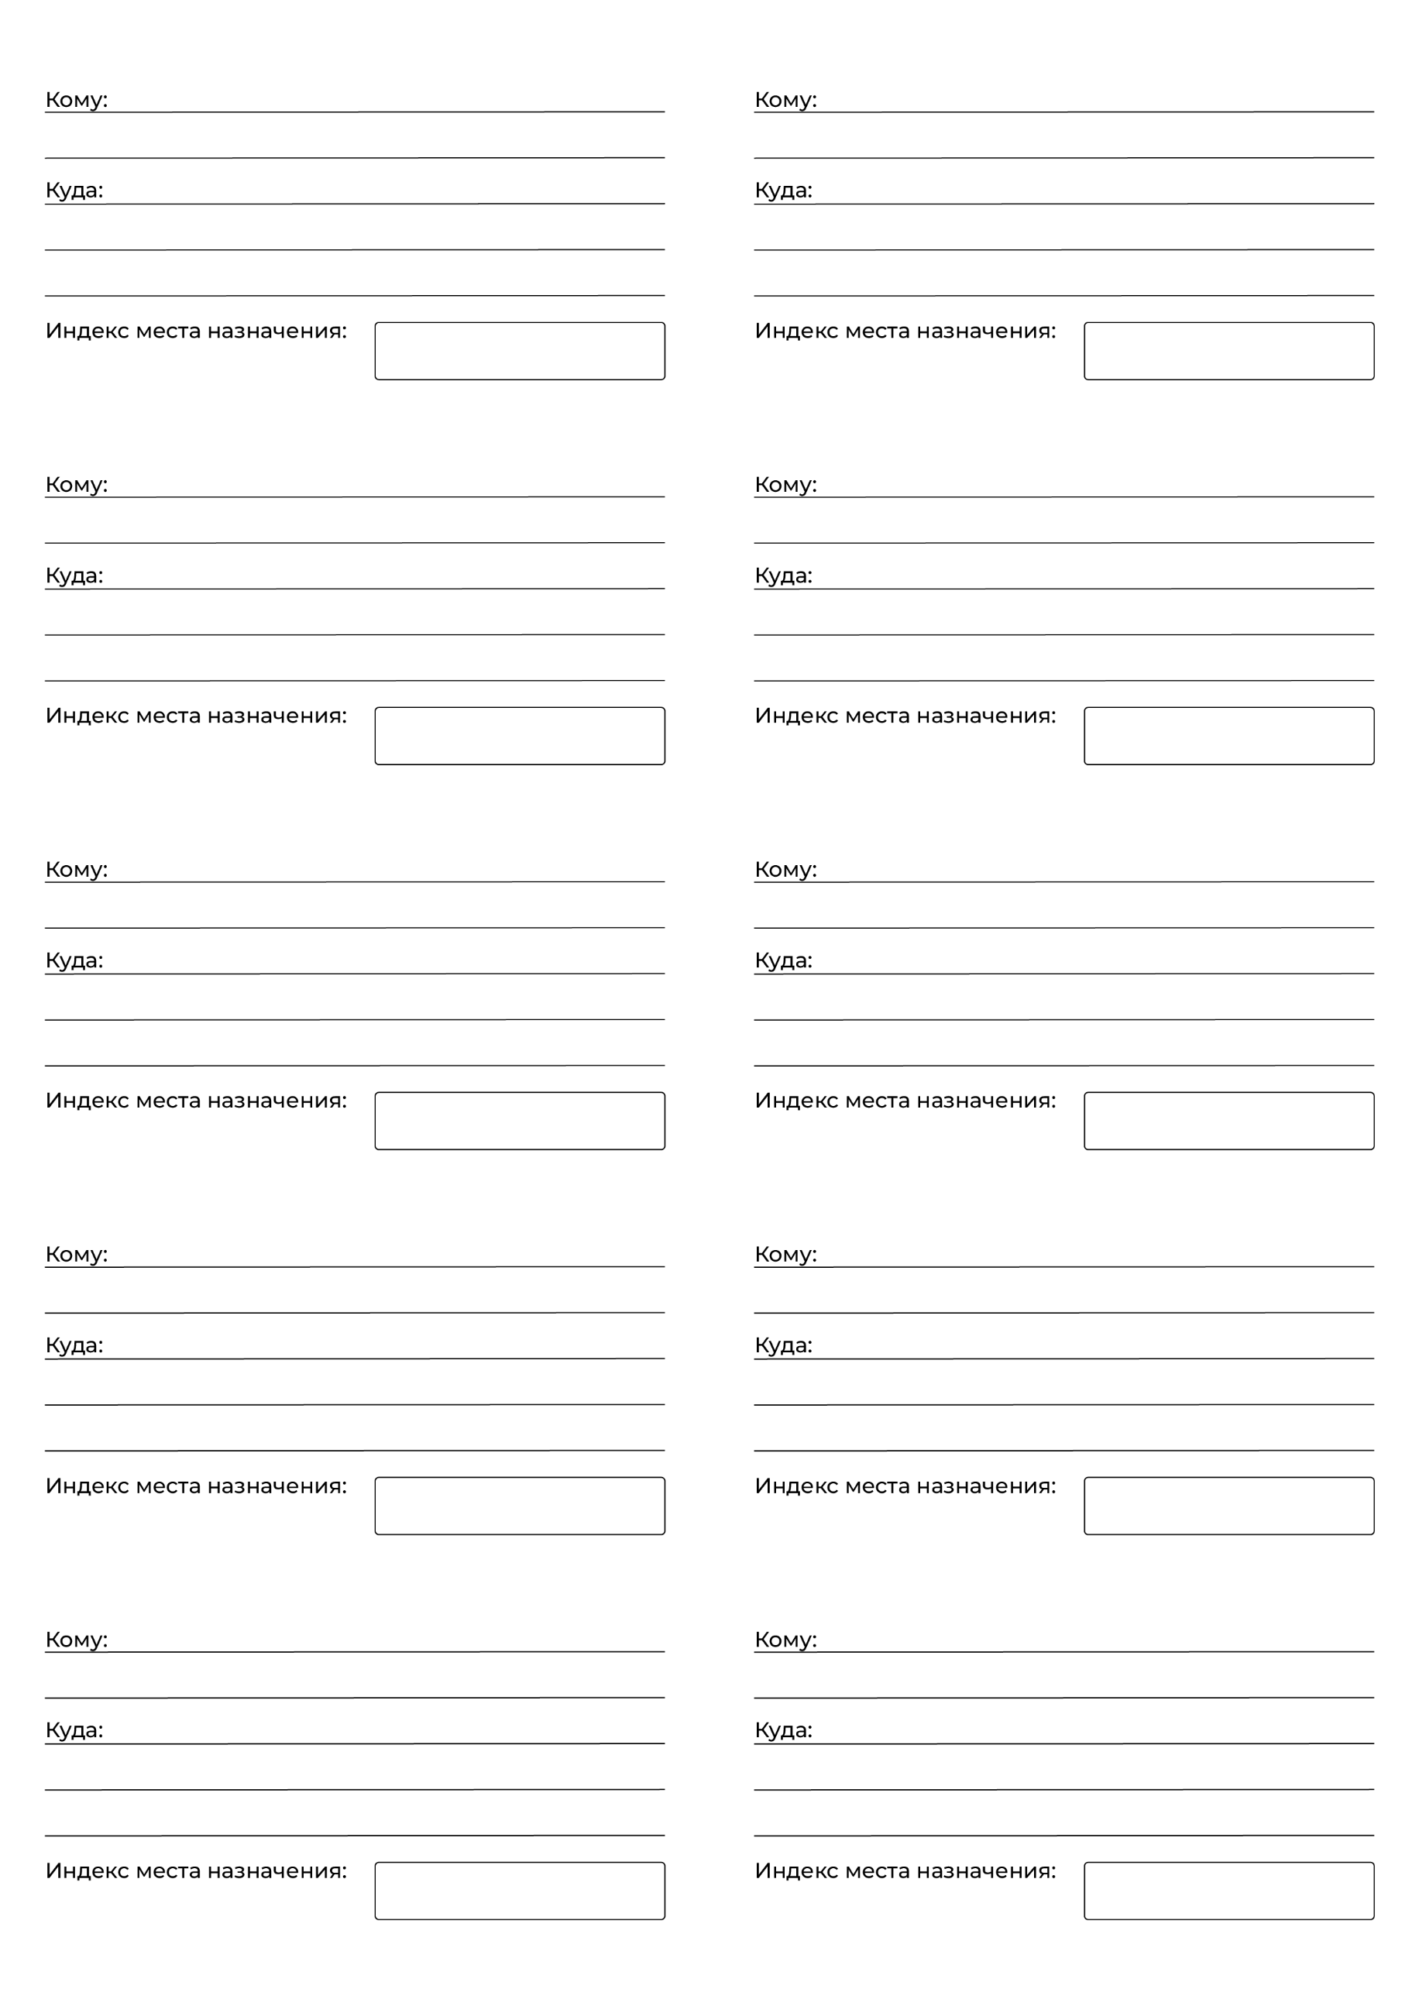

{{address2}}

{{name2}}

{{index2}}

{{number2}}

{{index1}}

{{address1}}

{{name1}}

{{number1}}