HW5: Visual Analytics
Individual assignment
(Total Points: 36 points)

Name: Meagan Green

Submission Guidelines:
- Please note that this assignment contain 12 questions (each question is worth 3 points).
- Please name your file HW5_lastname_firstname (e.g., HW5_Chen_Peiyu.doc), and submit your file containing the answers as well as the tableau file in twbx format (following appropriate hw submission link) by the specified deadline.

By submitting your homework, you acknowledge that it is submitted as individual work according to the Academic Integrity Policy and the W.P. Carey Honor Code to the best of your ability. Please put the following sentence after your name: “This homework is submitted as individual work according to the Academic Integrity Policy and the W.P. Carey Honor Code to the best of my ability”. If it is not true, explain why it is not true. You will be taken one point off without any acknowledgement or explanation.
Sales Analysis
You’ve been asked to help better understand sales patterns in DS’s Fine Foods Emporium. They sell a variety of fine products, such as Gustaf's Knäckebröd, Pâté Chinois, and Maxilaku. Their motto is “Food so good even we don’t know what it is!”
Specifically, you’ve been asked to answer a series of questions, which are listed below. You will perform the analysis on Tableau to answer each of these questions. The Excel spreadsheet “Sales analysis.xlsx” has already been created for you. This is the single-table, joined data cube and is ready for analysis. In the spreadsheet, “Full Price” is the base price of the line item without a discount. The “Extended Price” is the discounted price offered to the customer (i.e., what they actually pay). The “Total Discount” is the difference between the Full Price and the Extended Price.
NOTE:
Some of the questions require some exploration and will be graded based upon whether you can show convincing evidence to support your answers.

Questions:
- Who are the five best customers based on total sales (i.e., Extended Price)?
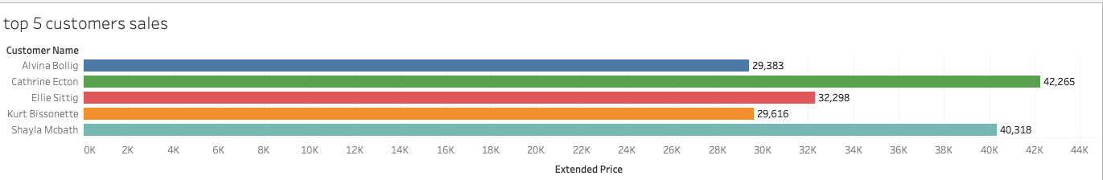Alvina Bollig, Catherine Ecton, Ellie Sittig, Kurt Bissonette, Shayla Mcbath

- What are the five top and worst selling products based on quantity sold? How different are the top selling and worse selling products?

- Please show sales by state and label the best-selling states. Any comments you can make based on your graph?
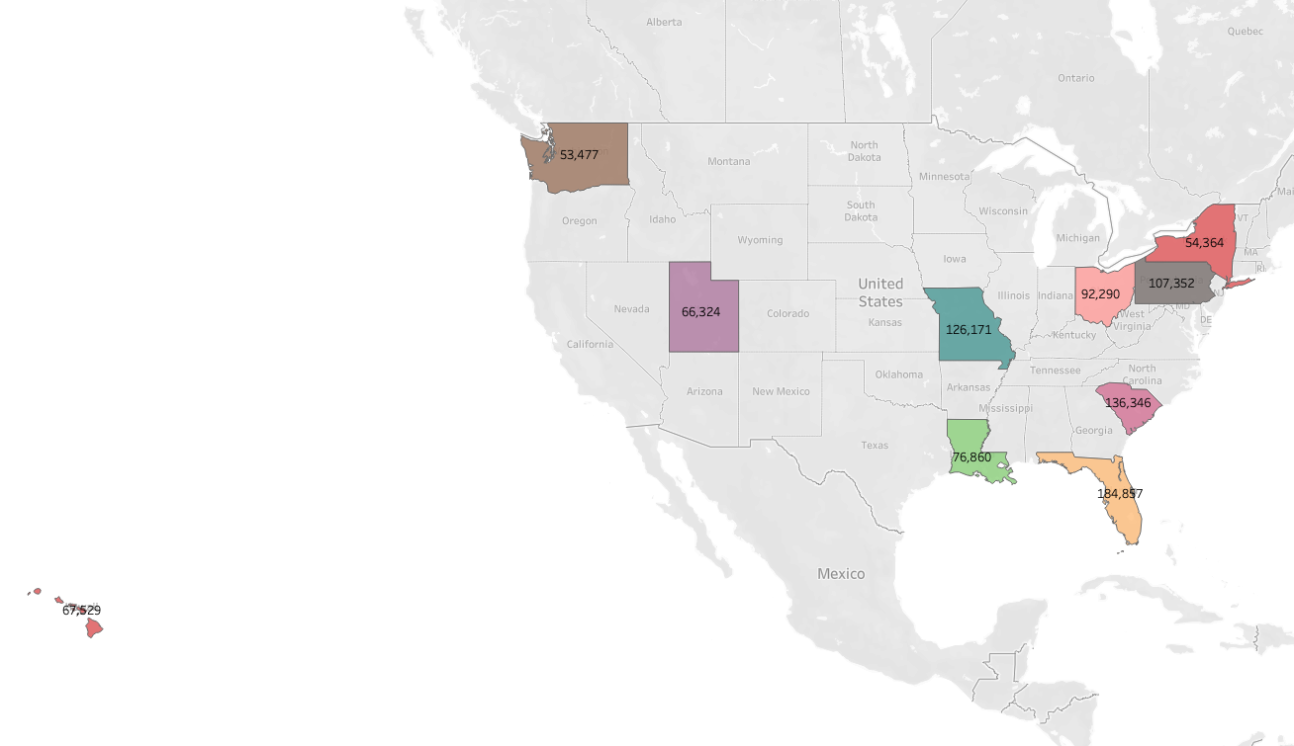
- Please show sales by city and label the best-selling cities. Any comments you can make based on your graph?
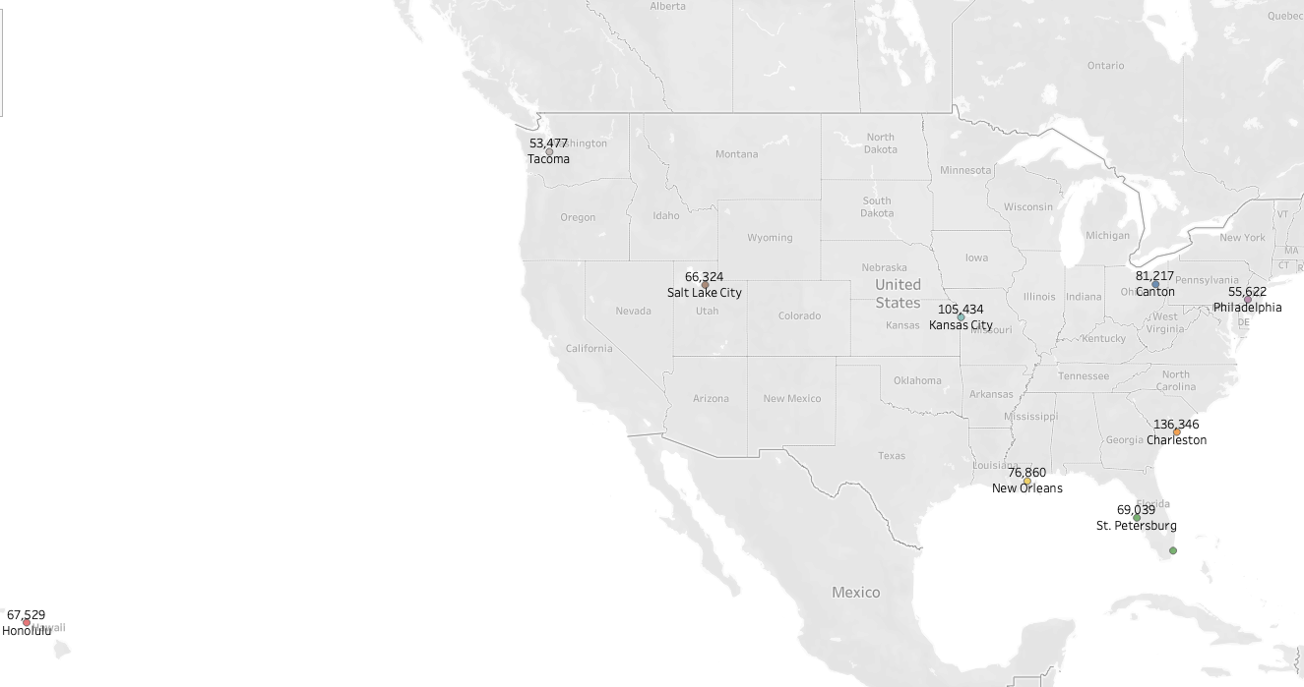
- Show product sales in a pie chart and show the % sales of total for each product. Please make sure the top 5 products are labeled. What’s the % of sales represented by the top 5 selling products in terms of sales?
Camembert Pierrot 3.6%
Cote de Blaye 11.17%
Raclette Courdavault 5.6%
Tarte au sucre 3.7%
Thuringer rostbratwurst 6.3%
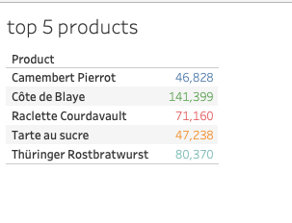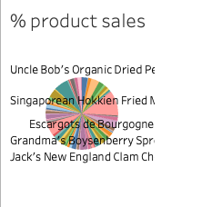
- Do people with higher status receive higher discount? Note: Platinum is higher than Gold, which is higher than Silver.
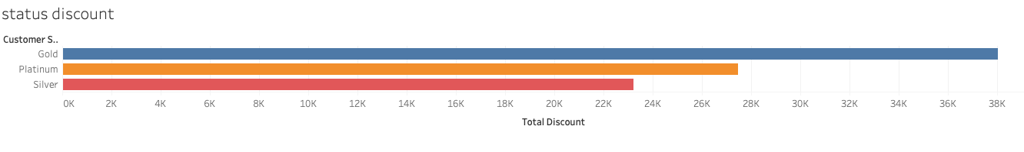
Gold status received the highest overall discount

- Do people with higher status purchase more? Note: Platinum is higher than Gold, which is higher than Silver
. 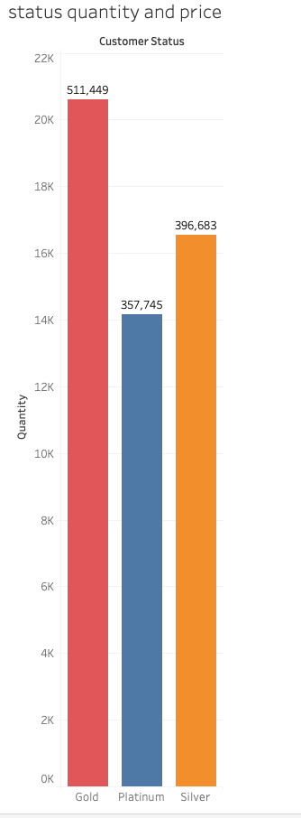 People with gold status purchase the most.

- Are the sales seasonal (look at total sales in dollars)?
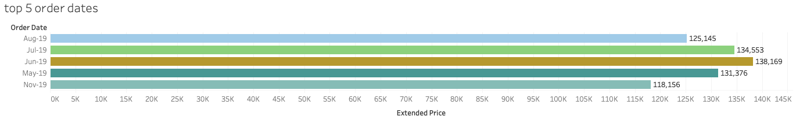
The highest number of sales are generated in the summer months, May, June, July and August

- If so, what is the nature of the seasonality? Do people purchase more during high season or more people are purchasing during high season?
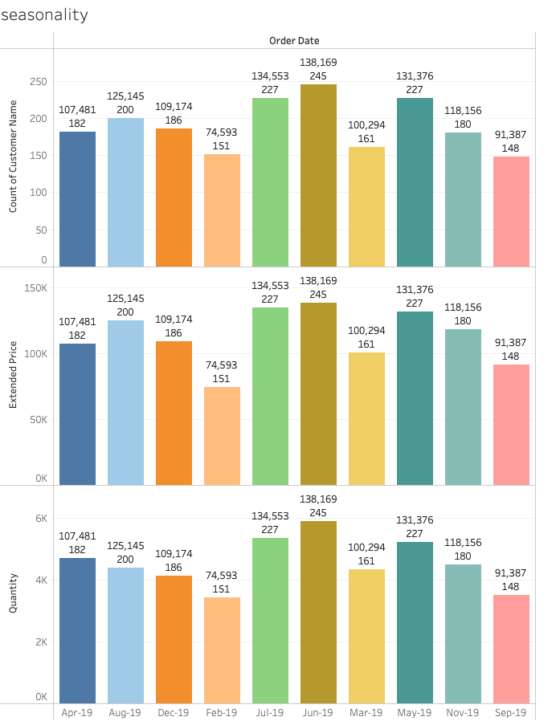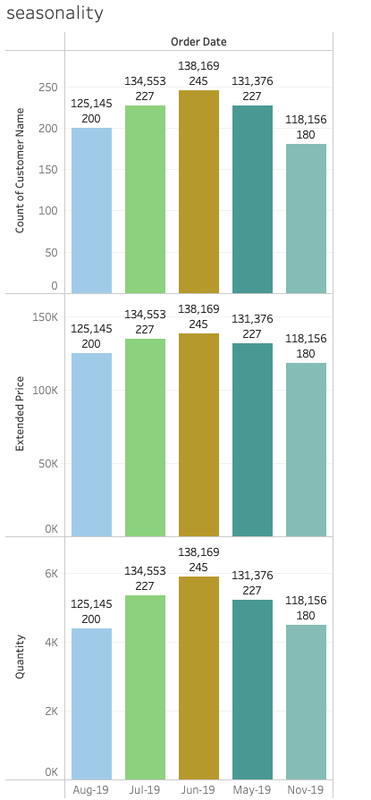Both more people purchasing and people purchasing more.
- What are the most heavily discounted products (by percentage discount)?
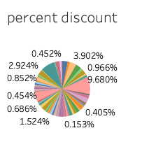
Cote de blaye is the most discounted followed by Thuringer rostbratwurst

- Based on the data we have, does our discount policy appear to help sales?
Yes, since the top discounted items from the previous question are also the top selling items from question 5.

- Create a dashboard containing your five best customers (in total sales) and five best selling products (in total sales) and sales by state in a map.

